# Navigating the AI Frontier

# Wardley Mapping for GenAI Startups

### **WARNING: This content was generated using Generative AI. While efforts have been made to ensure accuracy and coherence, readers should approach the material with critical thinking and verify important information from authoritative sources.**

# Table of Contents

Introduction: The GenAI Revolution and Strategic Mapping 5

The Rise of Generative AI and Its Impact on Startups 5

Defining Generative AI and Its Potential 5

The Unique Challenges and Opportunities for GenAI Startups 7

The Need for Strategic Thinking in a Rapidly Evolving Landscape 10

Introduction to Wardley Mapping 13

The Origins and Principles of Wardley Mapping 13

Why Wardley Mapping is Crucial for GenAI Startups 15

Overview of the Mapping Process 18

Chapter 1: Understanding the GenAI Landscape 21

Mapping the GenAI Value Chain 21

Identifying Key Components of GenAI Services 21

Positioning Components on the Evolution Axis 23

Analysing Dependencies and Flows 26

Market Dynamics in the GenAI Space 29

Identifying Anchor Tenants and Market Leaders 29

Mapping Competitive Forces and Potential Disruptors 32

Anticipating Market Movements and Shifts 34

Regulatory and Ethical Considerations 37

Mapping Current and Potential Future Regulations 37

Ethical Considerations in GenAI Development and Deployment 40

Positioning Your Startup in the Ethical Landscape 42

Chapter 2: Crafting Your GenAI Startup Strategy 46

Identifying Your Unique Value Proposition 46

Mapping Your Core Competencies and Assets 46

Analysing Gaps in the Market 49

Positioning Your Offering on the Value Chain 51

Developing a Sustainable Business Model 54

Mapping Revenue Streams and Cost Structures 54

Identifying Key Partnerships and Collaborations 57

Balancing Innovation and Sustainability 60

Planning for Scale and Growth 63

Mapping Potential Growth Trajectories 63

Identifying Scalability Challenges and Solutions 65

Preparing for Market Expansion and Diversification 68

Chapter 3: Navigating Technical Challenges and Opportunities 72

Mapping Your Technical Stack 72

Identifying Core GenAI Technologies and Their Evolution 72

Mapping Infrastructure and Platform Requirements 74

Balancing Build vs. Buy Decisions 77

Data Strategy and Management 80

Mapping Data Sources and Quality 80

Addressing Data Privacy and Security Concerns 82

Strategies for Continuous Learning and Model Improvement 85

Innovation and R&D Planning 88

Mapping Potential Technological Advancements 88

Identifying Areas for Focused Research 90

Balancing Short-term Needs with Long-term Innovation 93

Chapter 4: Building and Managing Your GenAI Startup Team 96

Mapping Skill Requirements 96

Identifying Critical Roles and Competencies 96

Balancing Technical and Business Expertise 98

Planning for Skill Evolution and Training 101

Organisational Structure and Culture 104

Designing an Agile and Adaptive Org Structure 104

Fostering a Culture of Innovation and Ethical AI Development 106

Managing Remote and Distributed Teams in the AI Era 109

Talent Acquisition and Retention Strategies 112

Mapping the AI Talent Landscape 112

Developing Compelling Value Propositions for Top Talent 115

Creating Growth and Development Pathways 118

Chapter 5: Executing and Iterating Your GenAI Strategy 121

Implementing Wardley Mapping in Decision Making 121

Using Maps for Strategic Planning and Pivots 121

Communicating Strategy Across the Organization 123

Integrating Mapping into Agile Development Processes 126

Monitoring and Adapting to Market Changes 129

Establishing Key Performance Indicators (KPIs) 129

Continuous Market Sensing and Map Updates 132

Strategies for Rapid Adaptation and Pivoting 134

Building a Culture of Strategic Thinking 137

Training Teams in Wardley Mapping Techniques 137

Encouraging Collaborative Mapping and Strategy Sessions 140

Conclusion: Thriving in the GenAI Future 143

Recap of Key Strategies and Insights 143

Summary of Critical Success Factors for GenAI Startups 143

Appendix: Further Reading on Wardley Mapping 145

Core Wardley Mapping Series 145

Practical Resources 149

Specialized Applications 149

# Introduction: The GenAI Revolution and Strategic Mapping

## The Rise of Generative AI and Its Impact on Startups

### Defining Generative AI and Its Potential

Here’s the content reviewed and corrected for UK English:

Generative AI (GenAI) represents a paradigm shift in artificial intelligence, marking a transition from systems that merely analyse and classify existing data to those that can create entirely new content. As we embark on this exploration of Wardley Mapping for GenAI startups, it is crucial to establish a clear understanding of what GenAI entails and the vast potential it holds for transforming industries and creating new opportunities.

At its core, Generative AI refers to a class of machine learning models capable of generating novel content across various domains, including text, images, audio, and even code. These models are trained on vast datasets and learn to identify patterns and structures within the data, which they can then use to produce new, original content that mimics the characteristics of their training data.

* Natural Language Processing (NLP) models that can write human-like text
* Image generation models that can create photorealistic images from textual descriptions
* Audio synthesis models capable of generating speech or music
* Code generation models that can assist in software development

The potential of GenAI extends far beyond mere content creation. Its applications are vast and varied, with the power to revolutionise industries ranging from healthcare and finance to entertainment and education. For startups, this presents an unprecedented opportunity to innovate and disrupt established markets.

Generative AI is not just another technological advancement; it’s a fundamental shift in how we interact with and leverage artificial intelligence. It has the potential to augment human creativity and productivity in ways we’re only beginning to imagine.

One of the most significant potentials of GenAI lies in its ability to automate and enhance creative processes. For instance, in content creation, GenAI can assist writers by generating initial drafts, suggesting plot ideas, or even creating entire narratives. In the visual arts, it can produce concept art, design variations, or even complete artworks based on specific prompts or styles.

In the realm of software development, GenAI models can accelerate coding processes by generating boilerplate code, suggesting optimisations, or even creating entire functions based on natural language descriptions. This has the potential to dramatically increase developer productivity and lower the barriers to entry for software creation.

The healthcare sector stands to benefit enormously from GenAI’s potential. These models can assist in drug discovery by generating and evaluating potential molecular structures, or in personalised medicine by creating tailored treatment plans based on individual patient data. In medical imaging, GenAI can generate synthetic datasets for training diagnostic models, potentially improving the accuracy of disease detection.

Financial services are another area ripe for GenAI-driven innovation. These models can be employed to generate sophisticated financial models, predict market trends, or create personalised investment strategies. They can also enhance fraud detection by generating synthetic fraud scenarios to train more robust security systems.

However, with great potential comes great responsibility. The power of GenAI also raises significant ethical considerations and potential risks that startups must navigate carefully. These include issues of bias in generated content, the potential for misuse in creating deepfakes or misinformation, and questions of copyright and ownership for AI-generated works.

The true potential of Generative AI lies not just in what it can create, but in how it can augment and enhance human capabilities. Startups that can effectively harness this potential while addressing the associated challenges will be at the forefront of the next wave of technological innovation.

As we delve deeper into Wardley Mapping for GenAI startups, it’s crucial to keep this vast potential in mind. The ability to strategically position oneself within this landscape of opportunity, while navigating the technical, ethical, and market challenges, will be key to success in the GenAI revolution.

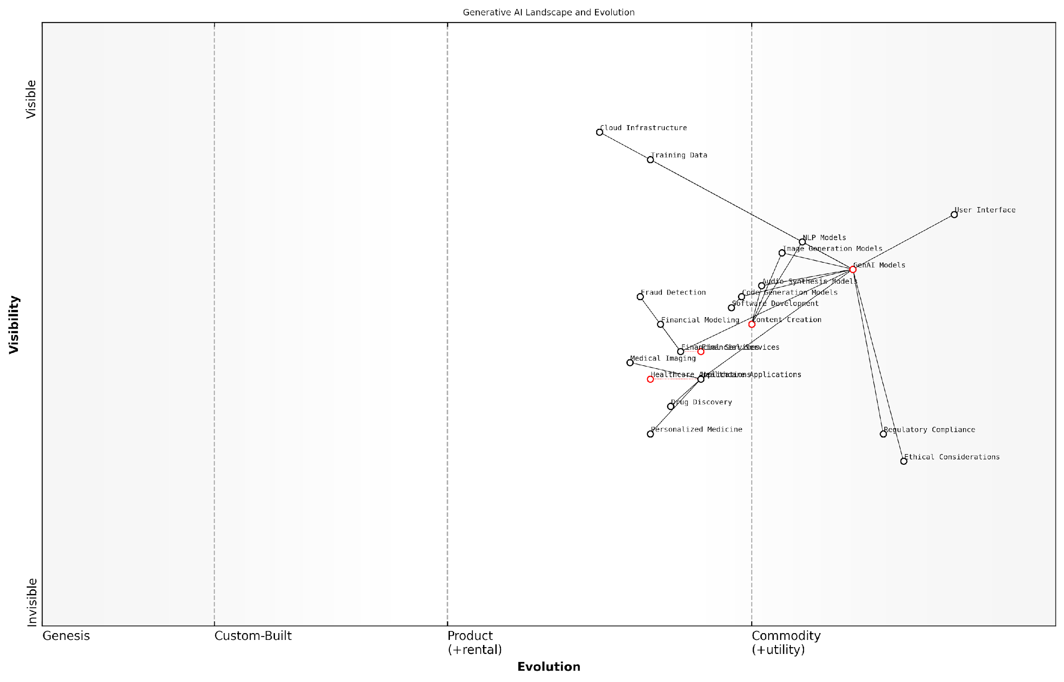

*Draft Wardley Map: [Insert Wardley Map: Defining Generative AI and Its Potential]*

[Edit this draft Wardley Map](https://create.wardleymaps.ai/#clone:0671e4c9381ae20add)

Wardley Map Assessment

This Wardley Map reveals a dynamic and rapidly evolving Generative AI landscape with significant potential across multiple industries. The strategic focus should be on balancing technological advancement with ethical considerations and regulatory compliance. There are substantial opportunities for innovation in healthcare, finance, and content creation, but success will depend on developing robust, ethical AI systems with user-friendly interfaces. Companies should prioritise cross-industry collaborations, invest in specialised AI applications, and proactively address ethical and regulatory challenges to maintain a competitive edge in this transformative field.

[View full Wardley Map report](http://markdown/wardley_map_reports/wardley_map_report_01_Defining_Generative_AI_and_Its_Potential.md)

### The Unique Challenges and Opportunities for GenAI Startups

As we delve into the world of Generative AI (GenAI) startups, it’s crucial to understand the unique landscape they navigate. These ventures find themselves at the forefront of a technological revolution, facing a distinct set of challenges and opportunities that set them apart from traditional tech startups. The rapidly evolving nature of GenAI technology, coupled with its far-reaching implications across various sectors, creates a dynamic environment that demands strategic agility and foresight.

One of the primary challenges GenAI startups face is the breakneck pace of technological advancement. The field of AI, particularly generative models, is progressing at an unprecedented rate. This rapid evolution presents a double-edged sword for startups. On one hand, it offers immense opportunities for innovation and breakthrough applications. On the other, it requires constant vigilance and adaptation to remain relevant and competitive.

* Keeping pace with state-of-the-art models and techniques
* Balancing innovation with practical implementation
* Managing the high computational resources required for GenAI development
* Navigating the complex landscape of AI ethics and responsible development

Another significant challenge lies in the realm of data. GenAI models are notoriously data-hungry, often requiring vast amounts of high-quality, diverse data for training. For startups, acquiring or generating such datasets can be a formidable task, both in terms of resources and legal considerations. Moreover, ensuring data privacy and security adds another layer of complexity, especially in light of evolving regulations like GDPR and CCPA.

The ethical implications of GenAI technology present both a challenge and an opportunity for startups. As public awareness and scrutiny of AI’s societal impact grow, startups must navigate complex ethical considerations. This includes addressing biases in AI models, ensuring transparency in AI decision-making processes, and considering the potential misuse of their technology. However, this challenge also presents an opportunity for startups to differentiate themselves by prioritising ethical AI development and positioning themselves as responsible innovators in the field.

The startups that will thrive in the GenAI space are those that can not only push the boundaries of technical innovation but also navigate the complex ethical landscape with integrity and foresight.

On the opportunity side, the potential applications of GenAI are vast and largely untapped. From healthcare and finance to creative industries and beyond, GenAI has the power to transform virtually every sector of the economy. This presents an unprecedented opportunity for startups to create groundbreaking solutions and capture significant market share in emerging niches.

* Developing novel applications in underserved markets
* Creating more efficient and personalised user experiences
* Revolutionising content creation and creative processes
* Enhancing decision-making in complex domains like healthcare and finance

The increasing democratisation of AI technology also presents a unique opportunity for GenAI startups. As tools and platforms for AI development become more accessible, startups can leverage these resources to accelerate their innovation cycles and reduce time-to-market. This democratisation also opens up possibilities for collaboration and integration with other emerging technologies, such as blockchain or IoT, creating new avenues for innovation.

Furthermore, the growing interest in GenAI from venture capitalists and large tech companies presents funding and partnership opportunities for startups. However, this also intensifies competition and raises the bar for what constitutes a truly innovative or disruptive GenAI solution.

In the GenAI startup ecosystem, those who can effectively balance cutting-edge innovation with practical business acumen will be best positioned to capitalise on the immense opportunities while navigating the unique challenges of this dynamic field.

As we progress through this book, we will explore how Wardley Mapping can serve as a powerful tool for GenAI startups to navigate these challenges and capitalise on the opportunities. By providing a visual and strategic framework for understanding the evolving landscape, Wardley Mapping enables startups to make informed decisions, anticipate market shifts, and position themselves for success in the rapidly changing world of Generative AI.

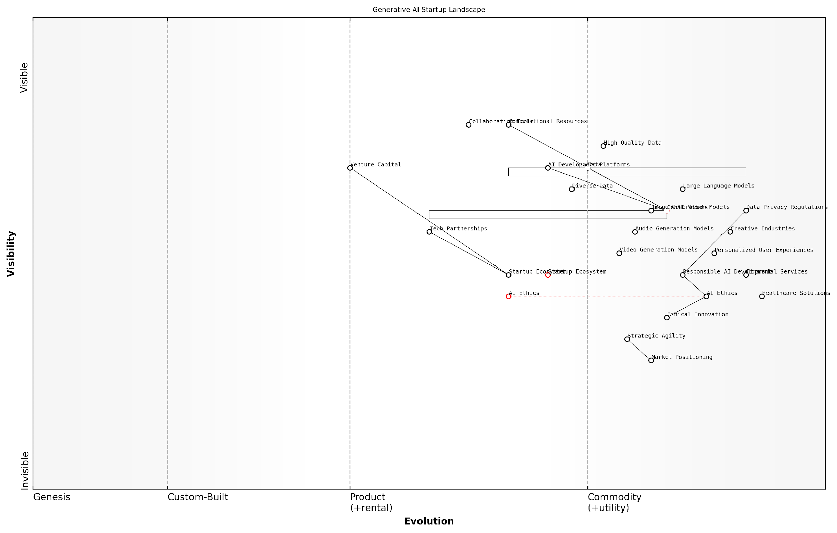

*Draft Wardley Map: [Insert Wardley Map: The Unique Challenges and Opportunities for GenAI Startups]*

[Edit this draft Wardley Map](https://create.wardleymaps.ai/#clone:cdd566b73ee42ca1b2)

Wardley Map Assessment

The Wardley Map reveals a dynamic and rapidly evolving landscape for GenAI startups, with significant opportunities in developing advanced AI models and applications across various sectors. However, success hinges on effectively navigating ethical considerations, regulatory challenges, and the need for responsible AI development. Startups that can balance technological innovation with ethical practices, while strategically positioning themselves in specific market applications, are likely to thrive. The ecosystem’s future will be shaped by the ability to develop trust-worthy, efficient, and highly personalized AI solutions that address real-world needs across industries.

[View full Wardley Map report](http://markdown/wardley_map_reports/wardley_map_report_02_The_Unique_Challenges_and_Opportunities_for_GenAI_.md)

### The Need for Strategic Thinking in a Rapidly Evolving Landscape

In the dynamic realm of Generative AI (GenAI), the need for strategic thinking has never been more critical. As an expert who has advised numerous startups and government bodies on navigating this complex landscape, I can attest that the rapid pace of technological advancement, coupled with shifting market dynamics and regulatory frameworks, demands a level of strategic acumen that goes beyond traditional business planning.

The GenAI landscape is characterised by its volatility, uncertainty, complexity, and ambiguity (VUCA). Startups entering this space face a unique set of challenges that require a robust strategic framework to navigate successfully. The ability to anticipate market shifts, identify emerging opportunities, and adapt quickly to changing circumstances can mean the difference between breakthrough success and rapid obsolescence.

In the GenAI startup ecosystem, those who fail to think strategically are essentially planning to fail. The landscape shifts beneath our feet daily, and only those with a clear vision and adaptable strategy will survive and thrive.

Strategic thinking in the GenAI space encompasses several critical dimensions:

* Technology Foresight: The ability to anticipate and prepare for technological advancements that could disrupt or enable your business model.
* Market Intelligence: Continuously monitoring and analysing market trends, competitor movements, and customer needs to inform decision-making.
* Regulatory Awareness: Staying ahead of the curve on evolving regulatory frameworks and ethical standards in AI development and deployment.
* Resource Allocation: Making informed decisions about where to invest limited resources for maximum impact and competitive advantage.
* Ecosystem Navigation: Understanding and leveraging the complex network of partners, competitors, and stakeholders in the GenAI landscape.

The rapidly evolving nature of GenAI technology presents both opportunities and threats. On one hand, breakthroughs in areas such as natural language processing, computer vision, and reinforcement learning are opening up new possibilities for innovative applications and services. On the other hand, these advancements can quickly render existing solutions obsolete, requiring startups to constantly reassess and refine their value propositions.

Moreover, the GenAI landscape is characterised by a complex interplay of large tech giants, agile startups, academic institutions, and government bodies. Navigating this ecosystem requires a nuanced understanding of each player’s motivations, capabilities, and potential impact on your startup’s trajectory. Strategic thinking enables founders to identify potential collaborations, anticipate competitive threats, and position their startups advantageously within this ecosystem.

In my experience advising GenAI startups, those that excel at strategic thinking don’t just react to changes – they anticipate and shape them. They’re constantly scanning the horizon, questioning assumptions, and reimagining their role in the evolving landscape.

The ethical and societal implications of GenAI add another layer of complexity to the strategic landscape. Startups must not only consider the technical feasibility and market potential of their solutions but also grapple with questions of bias, privacy, transparency, and societal impact. Strategic thinking in this context involves anticipating potential ethical challenges and proactively developing frameworks to address them, thereby building trust and resilience into the core of the business model.

Furthermore, the funding landscape for GenAI startups is evolving rapidly, with investors becoming more discerning and looking for startups that demonstrate not just technical prowess but also strategic foresight. The ability to articulate a compelling vision, backed by a well-thought-out strategy for navigating the complexities of the GenAI landscape, has become a key differentiator in attracting investment and partnerships.

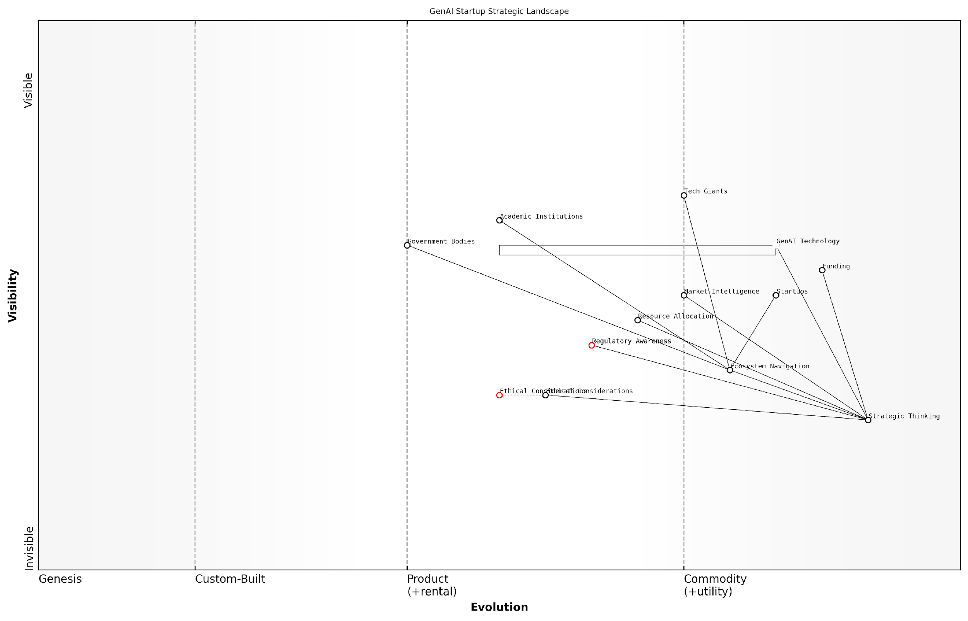

*Draft Wardley Map: [Insert Wardley Map: The Need for Strategic Thinking in a Rapidly Evolving Landscape]*

[Edit this draft Wardley Map](https://create.wardleymaps.ai/#clone:22a87f33cc53c6f0bc)

Wardley Map Assessment

The map reveals a dynamic and complex landscape for GenAI startups, where success hinges on the ability to balance rapid technological innovation with ethical considerations and regulatory awareness. Strategic Thinking is paramount, serving as the linchpin for navigating the ecosystem, allocating resources, and driving innovation. Startups must develop strong capabilities in Ecosystem Navigation and Market Intelligence while proactively addressing Ethical Considerations and Regulatory Awareness to ensure long-term success and sustainability in this rapidly evolving field.

[View full Wardley Map report](http://markdown/wardley_map_reports/wardley_map_report_03_The_Need_for_Strategic_Thinking_in_a_Rapidly_Evolv.md)

In conclusion, the need for strategic thinking in the rapidly evolving GenAI landscape cannot be overstated. It is the compass that guides startups through the turbulent waters of technological change, market dynamics, and ethical considerations. As we delve deeper into the principles of Wardley Mapping in the subsequent chapters, we will explore how this powerful tool can enhance strategic thinking and provide a structured approach to navigating the complexities of the GenAI startup journey.

## Introduction to Wardley Mapping

### The Origins and Principles of Wardley Mapping

Here’s the content reviewed and corrected for UK English:

Wardley Mapping, a strategic planning technique that has gained significant traction in the technology sector, particularly among startups and innovative enterprises, finds its roots in the work of Simon Wardley. This powerful methodology emerged from Wardley’s frustration with traditional strategic planning tools that failed to capture the dynamic nature of technological evolution and market landscapes. As we delve into the origins and principles of Wardley Mapping, it becomes clear why this approach is particularly relevant for GenAI startups navigating the complex and rapidly evolving artificial intelligence landscape.

The genesis of Wardley Mapping can be traced back to the early 2000s when Wardley, then a CEO grappling with strategic decisions, realised the limitations of existing strategic frameworks. He sought a method that could visually represent the components of a business or technology ecosystem, their relationships, and their evolution over time. This led to the development of Wardley Maps, which are essentially value chain maps set against an evolution axis.

Wardley Mapping filled a crucial gap in strategic thinking by providing a visual, dynamic representation of business landscapes. It’s not just a tool, but a new language for strategy that is particularly suited to the fast-paced world of technology and innovation.

The fundamental principles of Wardley Mapping are rooted in several key concepts that make it uniquely suited for strategic planning in dynamic environments like the GenAI sector:

* Visibility of components: Mapping out all the components that make up a business or technology ecosystem, from user needs to the underlying infrastructure.
* Positioning on the value chain: Arranging these components based on their value to the end user, from the most visible (user needs) to the most invisible (underlying technologies).
* Evolution axis: Plotting components along an axis that represents their evolutionary stage, from genesis (novel and poorly understood) to commodity (well-understood and easily replicable).
* Movement and dynamics: Recognising that components naturally evolve over time, moving from left to right on the map as they become more commoditised.
* Dependencies and connections: Identifying and visualising the relationships and dependencies between different components.
* Anchoring: Using well-known, stable components as reference points to position other, less certain elements.
* Patterns of change: Recognising common patterns in how landscapes evolve and how successful strategies can be applied.

These principles combine to create a powerful framework for understanding and navigating complex business environments. For GenAI startups, Wardley Mapping offers a unique lens through which to view the AI landscape, identify opportunities, and craft robust strategies.

One of the key strengths of Wardley Mapping is its ability to reveal hidden assumptions and dependencies. In the rapidly evolving field of GenAI, where new technologies and use cases are constantly emerging, this visibility is crucial. It allows startups to anticipate changes, identify potential bottlenecks, and make informed decisions about where to focus their resources.

Wardley Mapping is not just about creating a static picture of your business landscape. It’s about understanding the forces of change and using that understanding to navigate towards your desired future. For GenAI startups, this dynamic perspective is invaluable in a field where the pace of innovation is relentless.

Moreover, the evolutionary aspect of Wardley Mapping aligns particularly well with the nature of AI technologies. As machine learning models, data processing techniques, and AI applications evolve from cutting-edge innovations to widely available tools, Wardley Maps can help startups anticipate and adapt to these shifts. This foresight is critical in making strategic decisions about technology adoption, product development, and market positioning.

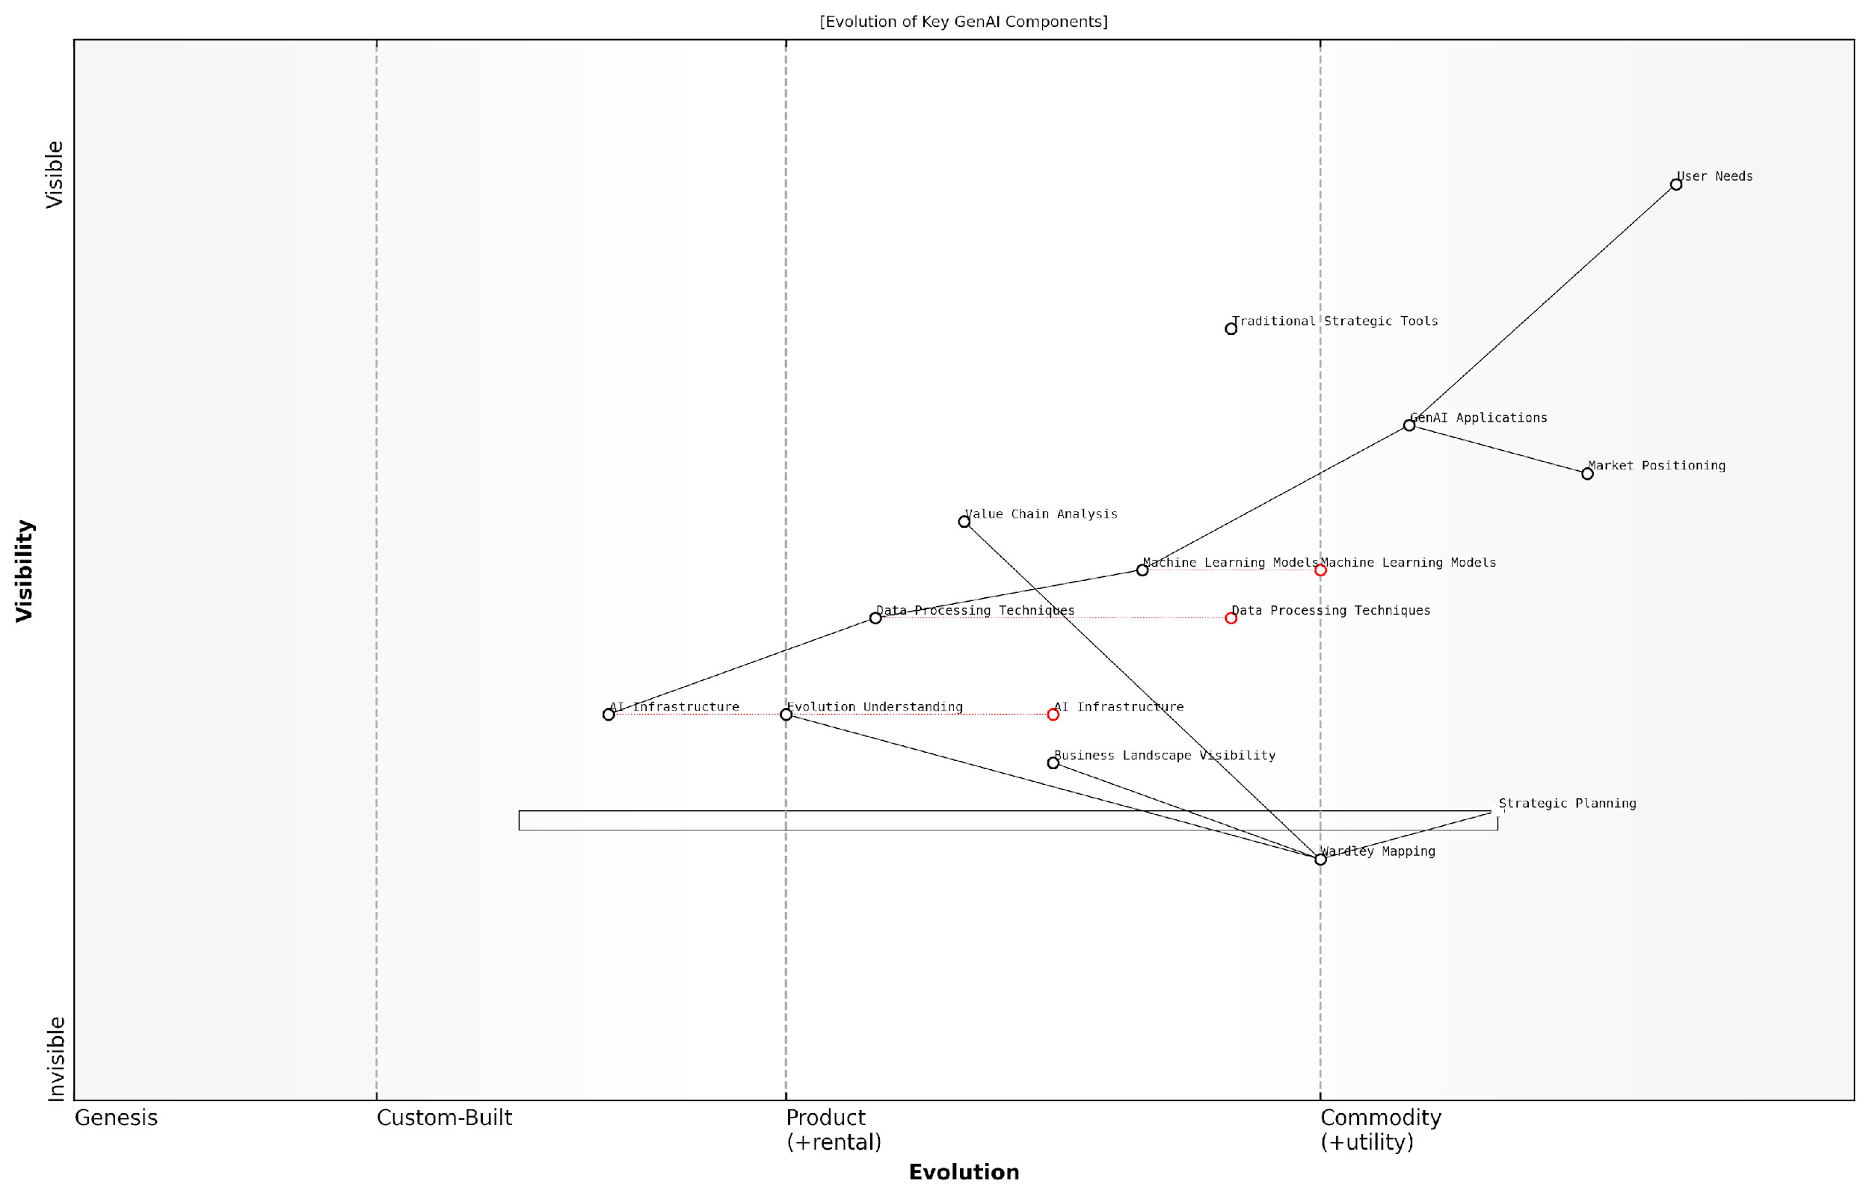

*Draft Wardley Map: [Insert Wardley Map: The Origins and Principles of Wardley Mapping]*

[Edit this draft Wardley Map](https://create.wardleymaps.ai/#clone:a4e544790b0440878d)

Wardley Map Assessment

The map reveals a dynamic GenAI landscape with significant opportunities for startups that can effectively leverage emerging strategic tools like Wardley Mapping while innovating in GenAI Applications. The key to success lies in balancing technological advancement with strategic foresight, continuously adapting to the rapidly evolving components while maintaining a strong focus on User Needs.

[View full Wardley Map report](http://markdown/wardley_map_reports/wardley_map_report_04_The_Origins_and_Principles_of_Wardley_Mapping.md)

As we progress through this book, we will explore how these principles can be applied specifically to the challenges and opportunities faced by GenAI startups. From mapping out the AI value chain to identifying strategic moves and anticipating market shifts, Wardley Mapping will serve as a powerful tool in your strategic arsenal. By mastering this methodology, GenAI startups can gain a significant advantage in navigating the complex, fast-moving landscape of artificial intelligence, positioning themselves for long-term success in this transformative field.

### Why Wardley Mapping is Crucial for GenAI Startups

In the rapidly evolving landscape of Generative AI (GenAI), startups face unprecedented challenges and opportunities. The dynamic nature of this field demands a strategic approach that goes beyond traditional business planning methods. This is where Wardley Mapping emerges as an indispensable tool for GenAI startups, offering a unique blend of visual representation, strategic foresight, and situational awareness that is particularly well-suited to the complexities of the AI industry.

Wardley Mapping provides GenAI startups with a powerful framework to navigate the intricate ecosystem of AI technologies, market forces, and competitive landscapes. By visually representing the value chain and evolution of components within the GenAI space, startups can gain critical insights that inform strategic decision-making and resource allocation.

* Visualising the Competitive Landscape: Wardley Maps enable GenAI startups to plot their position relative to competitors, suppliers, and potential partners, providing a clear view of the market dynamics.
* Anticipating Technological Evolution: The evolution axis in Wardley Mapping helps startups predict how different components of their GenAI solutions might evolve, allowing for more informed R&D and product development strategies.
* Identifying Strategic Opportunities: By mapping the entire value chain, startups can spot gaps in the market and identify unique value propositions that set them apart from established players.
* Risk Management and Mitigation: Wardley Mapping helps in identifying dependencies and potential points of failure, crucial for managing the inherent risks in developing cutting-edge AI technologies.
* Aligning Business and Technology Strategies: The visual nature of Wardley Maps facilitates better communication between technical and business teams, ensuring that technological development aligns with business goals.

For GenAI startups, the ability to adapt quickly to technological advancements and market shifts is paramount. Wardley Mapping provides a dynamic tool that can be continuously updated as the landscape changes, ensuring that strategies remain relevant and effective.

Wardley Mapping has become an essential strategic tool in our toolkit. It allows us to visualise the complex AI ecosystem and make informed decisions about where to focus our resources and how to position ourselves in this rapidly evolving market.

Moreover, Wardley Mapping is particularly valuable for GenAI startups in addressing some of the unique challenges they face:

* Ethical Considerations: By mapping out the ethical implications of AI technologies, startups can proactively address potential concerns and build trust with stakeholders.
* Regulatory Navigation: Wardley Maps can help visualise the current and potential future regulatory landscape, allowing startups to prepare for compliance challenges.
* Talent Acquisition and Retention: By mapping the skills and competencies needed at different stages of evolution, startups can develop more effective talent strategies.
* Funding and Investment: Wardley Maps can be powerful tools for communicating strategy to potential investors, demonstrating a deep understanding of the market and a clear vision for growth.

In the context of GenAI, where the pace of change is exceptionally rapid and the potential for disruption is high, Wardley Mapping provides a structured approach to strategy that can be the difference between success and failure. It enables startups to move beyond reactive decision-making to a more proactive, informed approach to navigating the AI frontier.

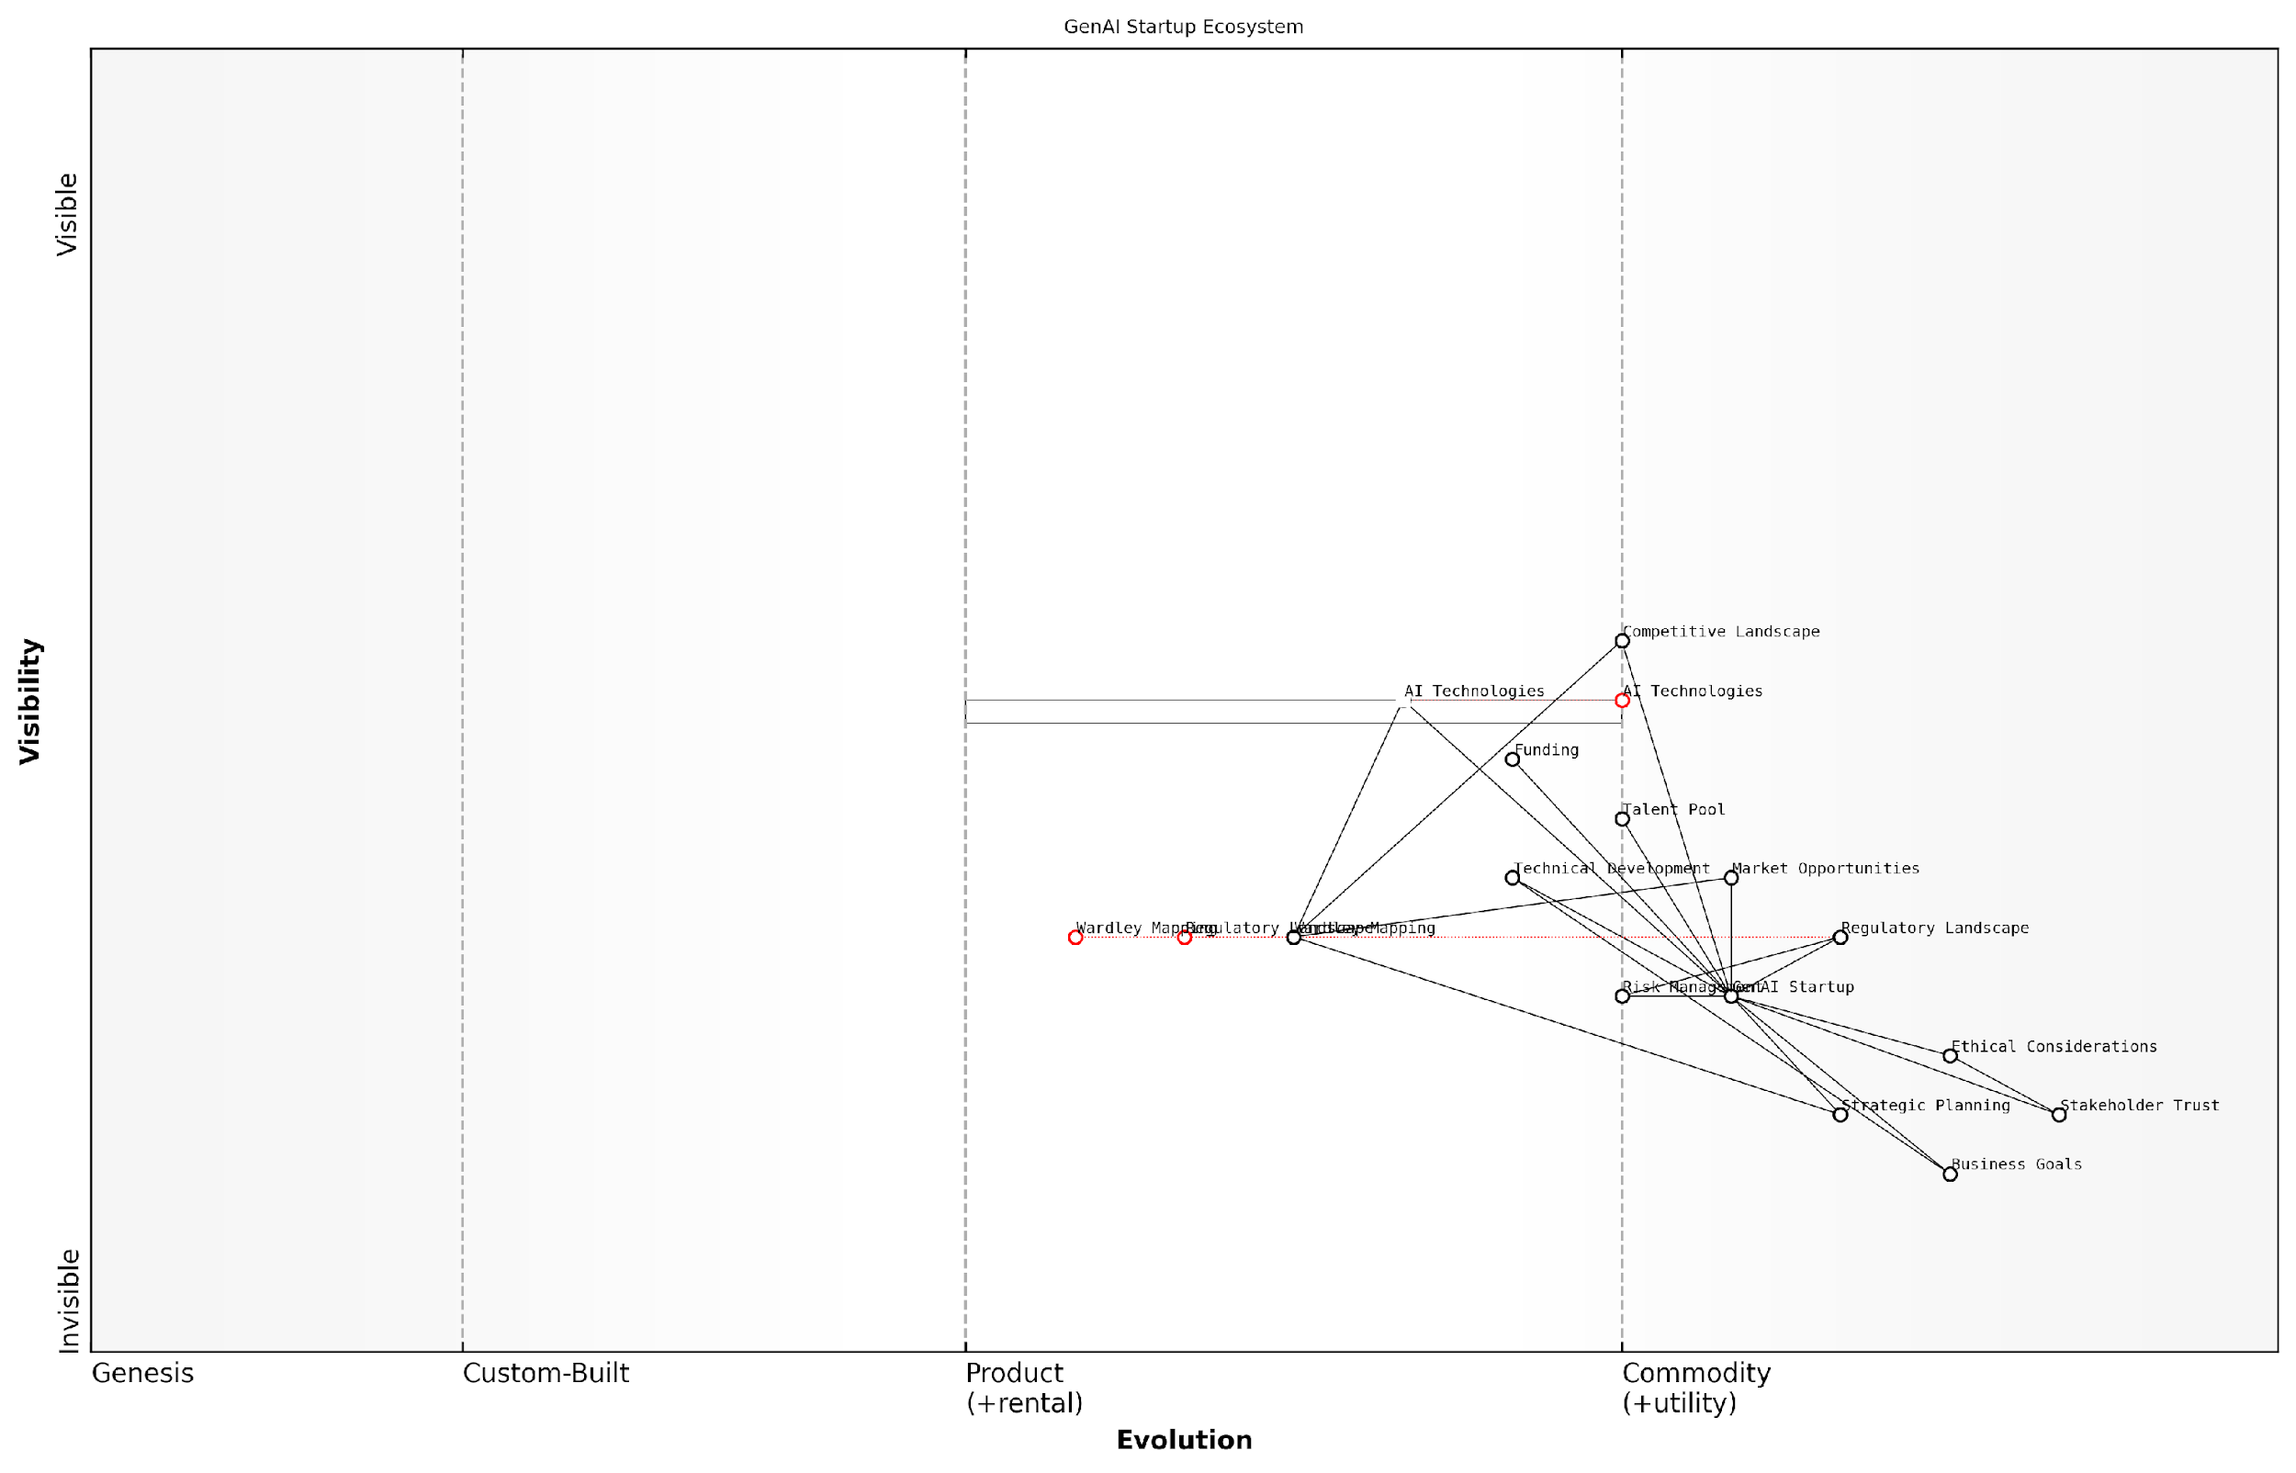

*Draft Wardley Map: [Insert Wardley Map: Why Wardley Mapping is Crucial for GenAI Startups]*

[Edit this draft Wardley Map](https://create.wardleymaps.ai/#clone:f0920699bcb07ed77b)

Wardley Map Assessment

The GenAI Startup is well-positioned in a dynamic and challenging ecosystem. Its focus on strategic planning, ethical considerations, and stakeholder trust provides a strong foundation. To succeed, it must navigate rapid technological evolution, intense competition for talent and funding, and an evolving regulatory landscape. The use of Wardley Mapping for strategic insight is a significant advantage. Key priorities should include developing proprietary technologies, establishing thought leadership in ethical AI, and building a robust ecosystem of partnerships. The startup’s success will depend on its ability to innovate responsibly, adapt quickly to market changes, and maintain a strong ethical stance while delivering compelling AI solutions.

[View full Wardley Map report](http://markdown/wardley_map_reports/wardley_map_report_05_Why_Wardley_Mapping_is_Crucial_for_GenAI_Startups.md)

As we delve deeper into the application of Wardley Mapping for GenAI startups in subsequent chapters, we will explore how this powerful tool can be leveraged at every stage of a startup’s journey, from initial concept to market leadership. By mastering Wardley Mapping, GenAI startups can gain a significant competitive advantage, positioning themselves to not just survive, but thrive in the AI-driven future.

### Overview of the Mapping Process

Here’s the content reviewed and corrected for UK English:

Wardley Mapping, a strategic tool of immense value for GenAI startups, offers a structured approach to visualising the business landscape and informing strategic decisions. As an expert who has guided numerous startups and government bodies through this process, I can attest to its transformative power in navigating the complex and rapidly evolving world of Generative AI. The mapping process, while deceptively simple in its core principles, requires a nuanced understanding and careful application to yield its full benefits.

At its heart, the Wardley Mapping process involves creating a visual representation of your business ecosystem, plotting components along two axes: value chain and evolution. This visual representation serves as a powerful tool for understanding your current position, anticipating future movements, and making informed strategic decisions. Let’s delve into the key stages of the mapping process, drawing from my extensive experience in applying this methodology to GenAI ventures.

* Identify the User Need: Begin by clearly defining the user need your GenAI service addresses. This forms the anchor of your map and ensures all subsequent components are aligned with delivering value to your users.
* Map the Value Chain: List out all the components required to meet this need, from the user-facing elements to the underlying infrastructure and data sources. For GenAI startups, this might include components like user interfaces, AI models, training data, and cloud computing resources.
* Determine Component Evolution: Position each component along the evolution axis, from genesis (novel and rapidly changing) to commodity (standardised and widely available). In the GenAI space, this step is crucial as it helps identify areas of potential innovation and competitive advantage.
* Add Movement and Dependencies: Indicate how components are likely to evolve over time and map the dependencies between them. This step is particularly vital in the fast-paced GenAI field, where technological advancements can rapidly shift the landscape.
* Identify Opportunities and Threats: Analyse the map to spot areas of strategic importance, potential disruptions, and opportunities for innovation or efficiency gains.
* Develop Strategic Options: Use the insights gained from the map to formulate strategic options, considering factors like build vs. buy decisions, potential partnerships, and areas for focused research and development.

It’s important to note that Wardley Mapping is not a one-time exercise but an iterative process. In the dynamic world of GenAI, regular revisiting and updating of your maps is essential to maintain their relevance and strategic value. As you become more proficient in the mapping process, you’ll find it becomes an invaluable tool for ongoing strategic planning and decision-making.

Wardley Mapping is not just about creating a static picture of your business landscape. It’s about developing a dynamic understanding of your environment that evolves as rapidly as the technology itself. In the GenAI space, this adaptability is not just beneficial—it’s essential for survival and success.

One of the key strengths of Wardley Mapping for GenAI startups is its ability to cut through the hype and buzzwords that often surround emerging technologies. By focusing on the fundamental components and their evolution, it provides a clear-eyed view of where real value can be created and captured. This is particularly crucial in the GenAI field, where distinguishing between genuine innovations and passing fads can be the difference between success and failure.

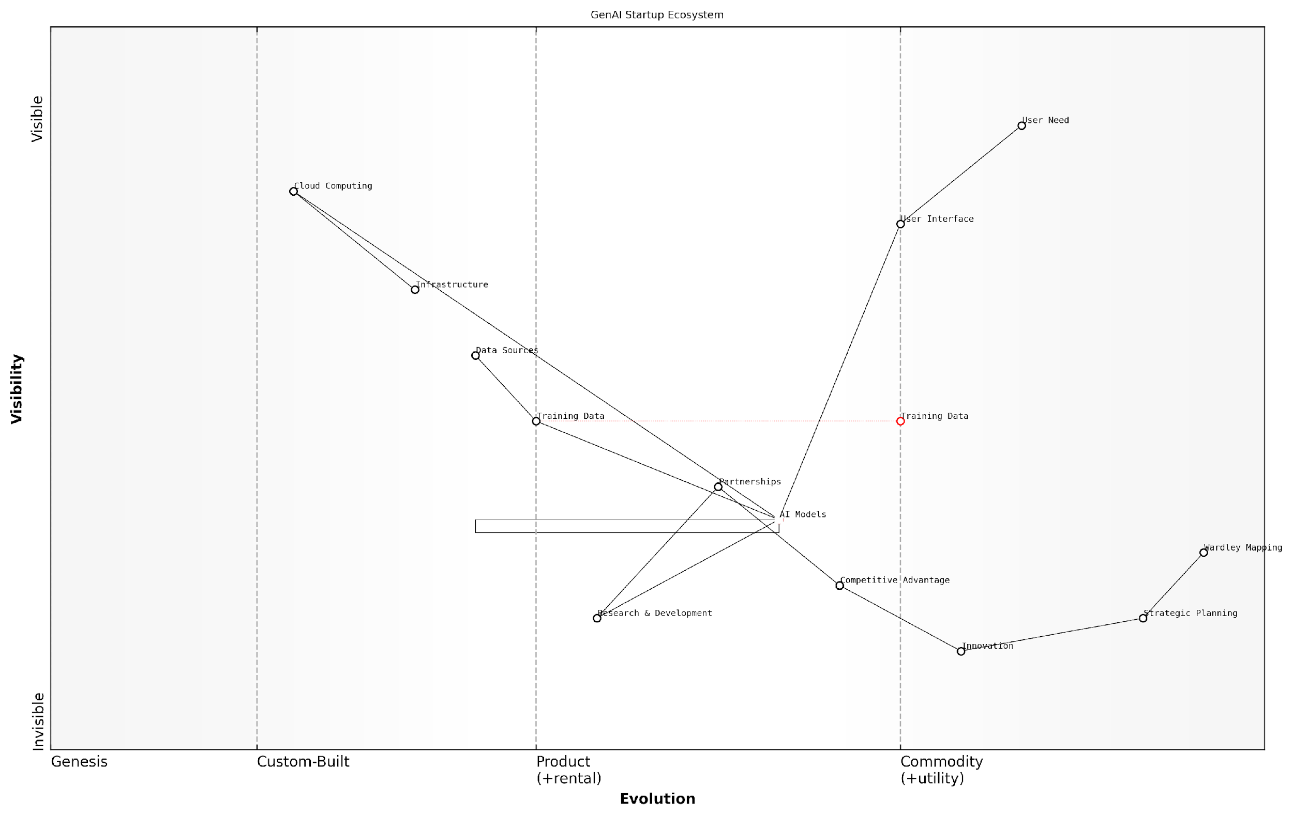

*Draft Wardley Map: [Insert Wardley Map: Overview of the Mapping Process]*

[Edit this draft Wardley Map](https://create.wardleymaps.ai/#clone:babb6e67a71d6553a0)

Wardley Map Assessment

The GenAI startup is well-positioned with a strong focus on core AI capabilities and strategic planning. To maintain and enhance its competitive position, the startup should focus on accelerating AI Model development, securing unique Training Data sources, and gradually building proprietary infrastructure. The explicit use of Wardley Mapping for Strategic Planning is a significant advantage, enabling continuous strategic adaptation in the fast-evolving GenAI landscape. The key challenges lie in managing the rapid evolution of AI technologies while building sustainable competitive advantages beyond the core AI Models.

[View full Wardley Map report](http://markdown/wardley_map_reports/wardley_map_report_06_Overview_of_the_Mapping_Process.md)

As you embark on your Wardley Mapping journey, remember that the process is as valuable as the final product. The discussions, debates, and insights generated during the mapping process often lead to breakthrough realisations about your business and its place in the wider ecosystem. Embrace this collaborative aspect of mapping, involving team members from various disciplines to ensure a comprehensive and well-rounded view of your GenAI venture.

In the subsequent chapters, we’ll delve deeper into each stage of the mapping process, exploring how to apply these principles specifically to GenAI startups. We’ll examine real-world examples, discuss common pitfalls, and provide actionable strategies for leveraging Wardley Mapping to drive your startup’s success in this exciting and challenging field.

# Chapter 1: Understanding the GenAI Landscape

## Mapping the GenAI Value Chain

### Identifying Key Components of GenAI Services

In the rapidly evolving landscape of Generative AI (GenAI), identifying and mapping the key components of GenAI services is crucial for startups aiming to position themselves strategically. This process forms the foundation of a comprehensive Wardley Map, enabling startups to visualise their value chain and make informed decisions about their product development, market positioning, and competitive strategy.

To effectively map the GenAI value chain, we must first break down the service into its constituent components. These components typically fall into several categories, each playing a vital role in the overall functionality and value proposition of a GenAI service:

* Core AI Models
* Data Infrastructure
* Compute Resources
* API and Integration Layer
* User Interface and Experience
* Domain-Specific Knowledge
* Security and Privacy Measures
* Ethical AI Frameworks

Let’s delve deeper into each of these components:

Core AI Models: At the heart of any GenAI service are the underlying AI models. These could range from large language models (LLMs) for text generation to diffusion models for image creation. The sophistication and capabilities of these models often determine the overall performance and uniqueness of the service. For startups, the decision between developing proprietary models or leveraging existing ones (like GPT or DALL-E) is crucial and depends on factors such as resources, expertise, and target market needs.

Data Infrastructure: The lifeblood of GenAI services is data. This component encompasses data collection, storage, preprocessing, and management systems. A robust data infrastructure ensures that the AI models have access to high-quality, relevant, and diverse data for training and inference. Startups must consider aspects like data scalability, real-time processing capabilities, and compliance with data protection regulations.

Compute Resources: GenAI services are computationally intensive, requiring significant processing power for both training and inference. This component includes hardware (like GPUs and TPUs), cloud computing services, and optimisation techniques. Startups need to balance performance requirements with cost considerations, often leading to hybrid solutions combining on-premise and cloud resources.

API and Integration Layer: For GenAI services to be useful, they need to integrate seamlessly with existing systems and workflows. This layer provides the necessary interfaces and protocols for other applications to interact with the GenAI service. RESTful APIs, GraphQL endpoints, and SDKs are common elements of this component. The design of this layer significantly impacts the service’s adoptability and scalability.

User Interface and Experience: While some GenAI services operate entirely in the background, many require direct user interaction. This component covers the design and implementation of user interfaces, be they web-based, mobile apps, or voice interfaces. The UX/UI design plays a crucial role in making complex AI capabilities accessible and intuitive for end-users.

Domain-Specific Knowledge: GenAI services often need to be tailored to specific industries or use cases. This component represents the domain expertise and specialised knowledge required to make the AI outputs relevant and valuable in specific contexts. For startups, this often becomes a key differentiator in the market.

Security and Privacy Measures: As GenAI services often handle sensitive data and can potentially generate harmful content, robust security and privacy measures are essential. This component includes encryption, access controls, content filtering, and compliance with relevant regulations like GDPR or CCPA.

Ethical AI Frameworks: With growing concerns about AI bias, fairness, and transparency, implementing ethical AI frameworks is becoming increasingly important. This component involves developing guidelines, monitoring systems, and governance structures to ensure responsible AI development and deployment.

Understanding and mapping these key components is not just an academic exercise. It’s the foundation of strategic decision-making in the GenAI space. By visualising where each component sits on the value chain, startups can identify opportunities for innovation, potential partnerships, and areas where they can create unique value.

When mapping these components onto a Wardley Map, consider their current level of evolution and their importance to your specific use case. Some components, like core AI models, may be rapidly evolving, while others, like data infrastructure, might be more stable. Understanding these dynamics helps in predicting future shifts and planning accordingly.

Remember, the goal of this exercise is not just to create a static representation of your GenAI service but to develop a dynamic tool for ongoing strategic analysis. As the GenAI landscape continues to evolve at a breakneck pace, regularly revisiting and updating your component map will be crucial for maintaining a competitive edge and identifying new opportunities for innovation and growth.

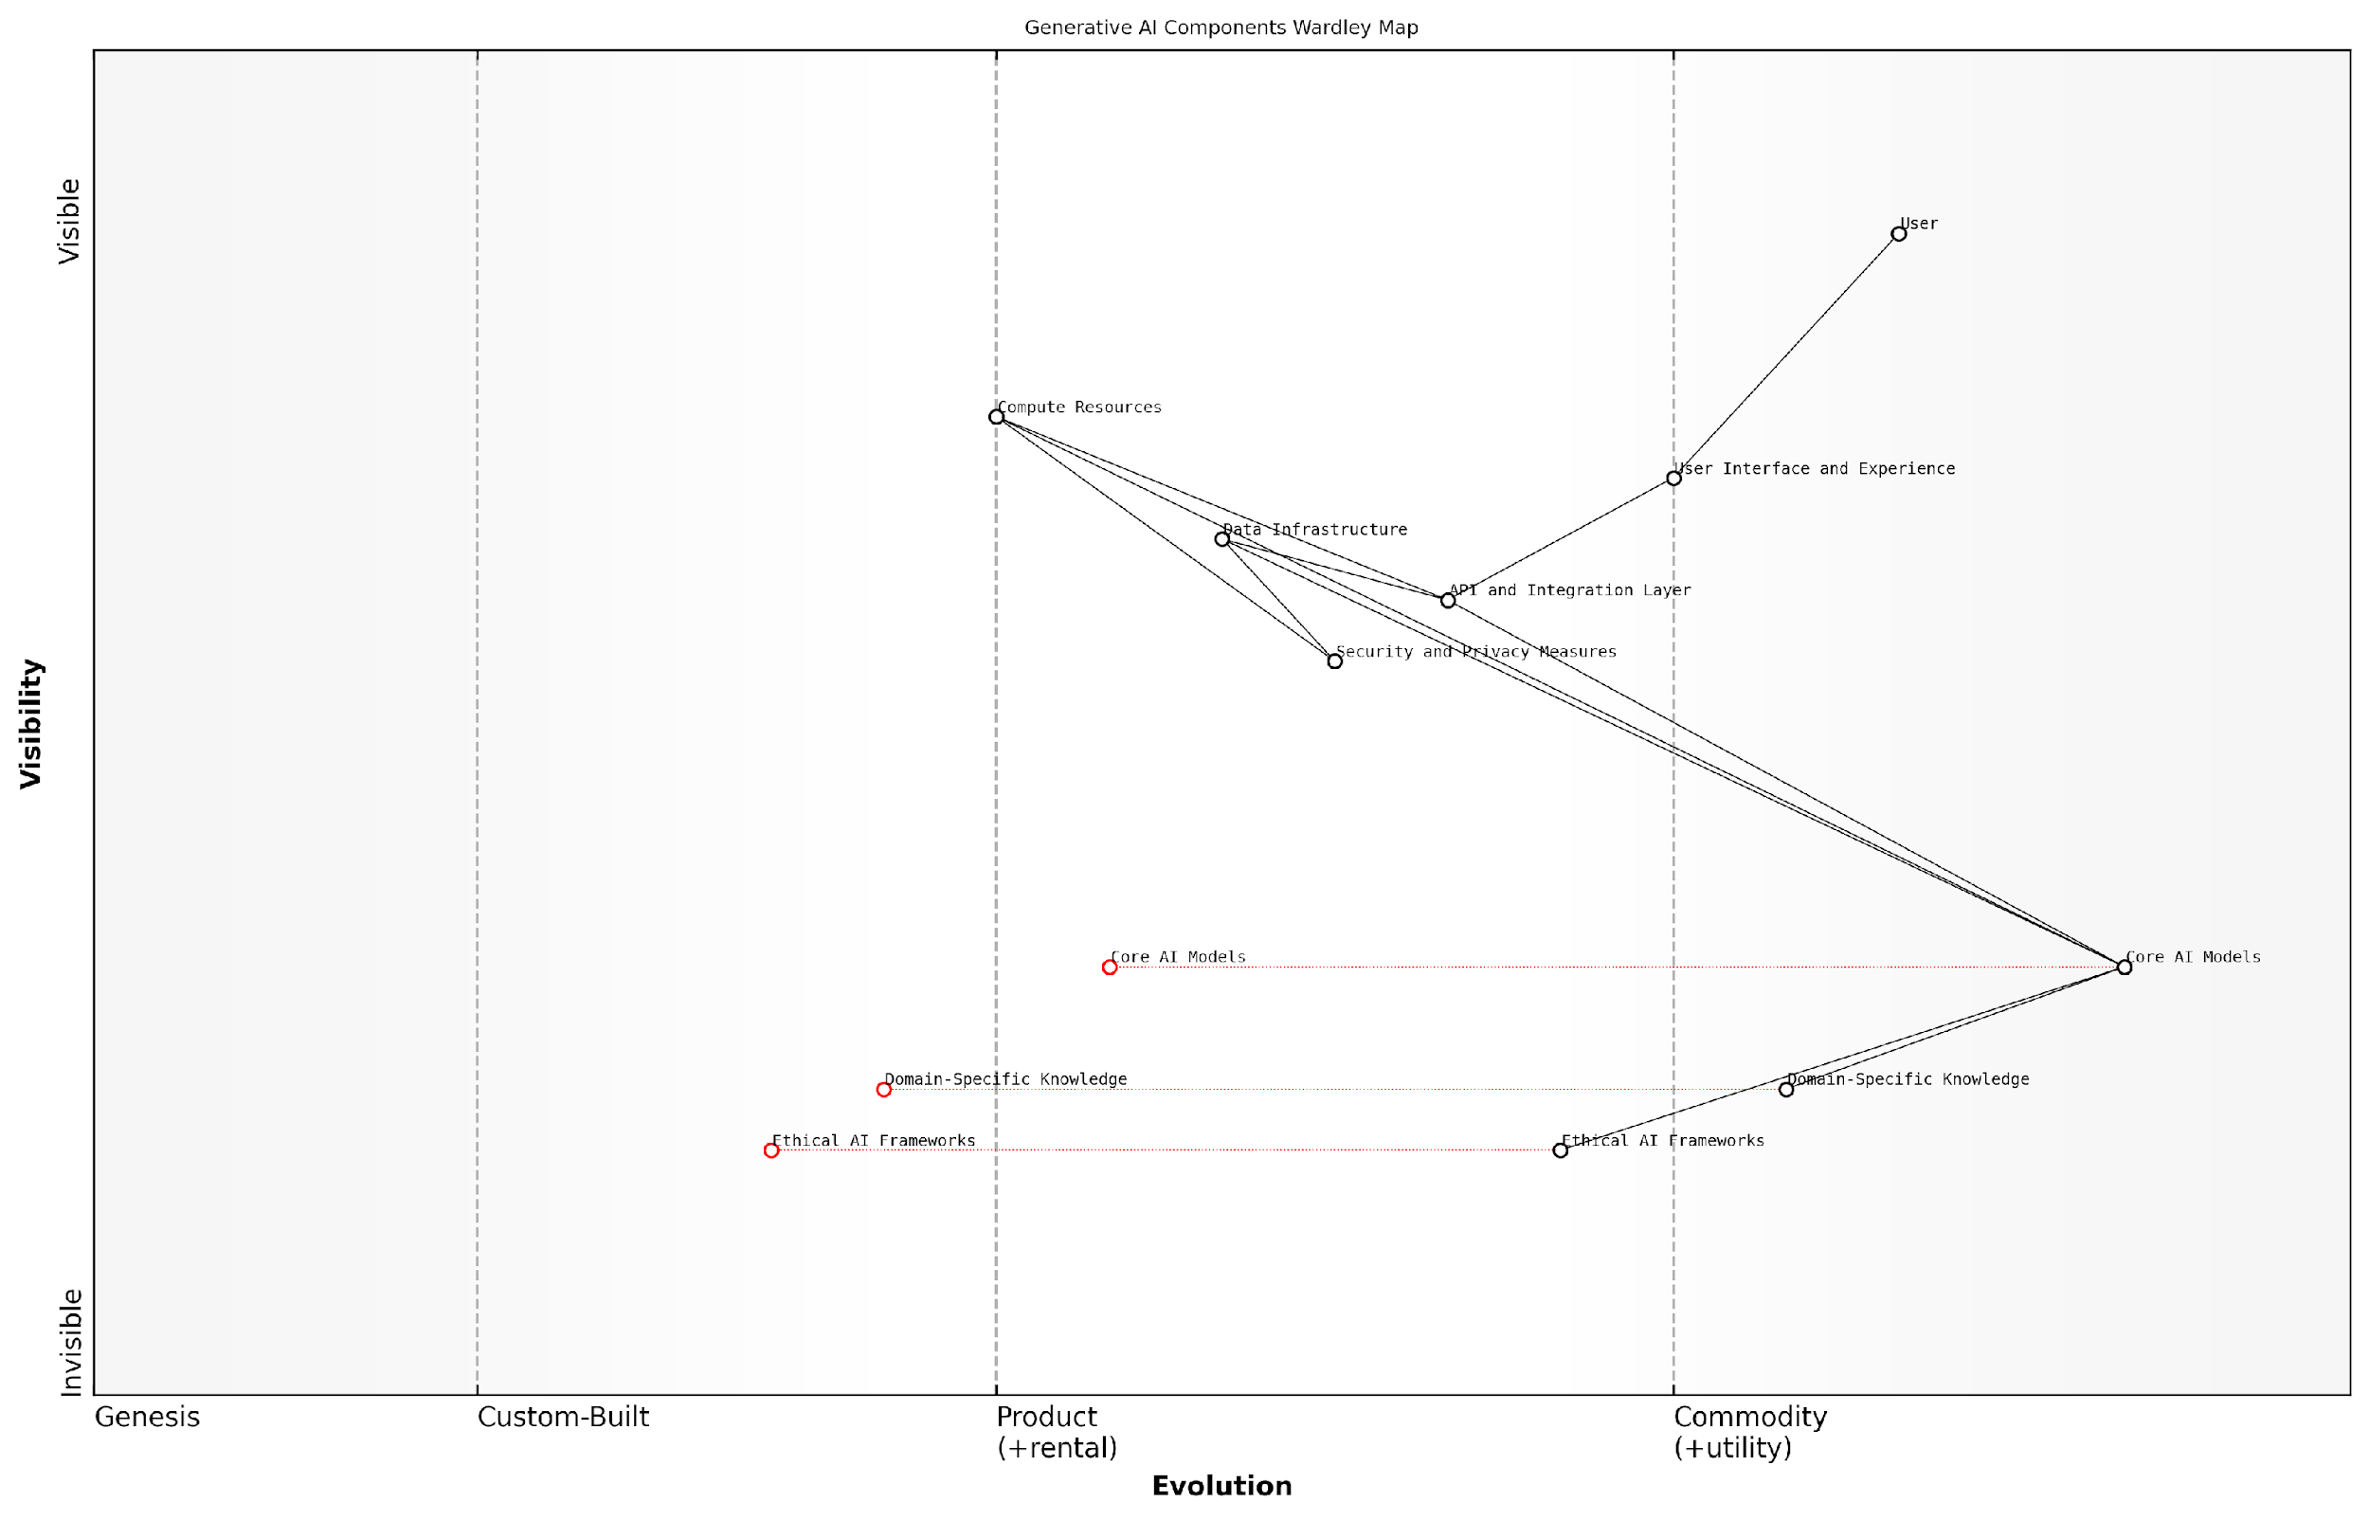

*Draft Wardley Map: [Insert Wardley Map: Identifying Key Components of GenAI Services]*

[Edit this draft Wardley Map](https://create.wardleymaps.ai/#clone:3ab60c041b363b20f7)

Wardley Map Assessment

This Wardley Map reveals a GenAI service with strong core capabilities and user focus, but with critical needs for improvement in ethical frameworks, data infrastructure, and security measures. The strategic priority should be to maintain the competitive edge in AI models and user experience while rapidly advancing ethical AI practices and modernising underlying infrastructure. This balanced approach will position the service for long-term success in an evolving and increasingly scrutinised AI landscape.

[View full Wardley Map report](http://markdown/wardley_map_reports/wardley_map_report_07_Identifying_Key_Components_of_GenAI_Services.md)

### Positioning Components on the Evolution Axis

In the context of Wardley Mapping for GenAI startups, positioning components on the evolution axis is a critical step that provides invaluable insights into the maturity and potential future trajectories of various elements within the GenAI ecosystem. This process allows startups to gain a strategic advantage by understanding where different technologies, services, and market offerings stand in their evolutionary journey.

The evolution axis in Wardley Mapping typically ranges from Genesis (novel, uncertain) to Custom-Built, Product (+ Rental), and finally to Commodity (+ Utility). For GenAI startups, accurately placing components along this spectrum is crucial for informed decision-making and strategic planning.

* Genesis: Cutting-edge AI research, novel algorithms, or emerging AI applications
* Custom-Built: Tailored AI solutions for specific industry problems
* Product (+ Rental): Established AI platforms and tools, off-the-shelf AI models
* Commodity (+ Utility): Widely available AI services, cloud-based AI infrastructure

When positioning GenAI components, it’s essential to consider several factors that influence their placement on the evolution axis:

* Technological maturity: How established and reliable is the technology?
* Market adoption: How widely used is the component across the industry?
* Standardisation: Are there industry standards or best practices associated with the component?
* Competitive landscape: How many providers offer similar solutions?
* Pace of innovation: How rapidly is the component evolving?

For GenAI startups, accurately positioning components can reveal strategic opportunities and potential pitfalls. For instance, identifying a component in the early stages of evolution (Genesis or Custom-Built) might present an opportunity for innovation and market leadership. Conversely, recognising that a component is approaching commodity status might signal the need to differentiate or pivot to avoid competing solely on price.

Understanding the evolutionary stage of each component in the GenAI value chain is like having a crystal ball for your startup. It allows you to anticipate market shifts, identify areas ripe for disruption, and align your resources with the most promising opportunities.

Let’s consider some practical examples of positioning GenAI components:

* Large Language Models (LLMs): Currently transitioning from Custom-Built to Product, with increasing standardisation and availability
* AI Ethics Frameworks: Still in the Genesis to Custom-Built stage, with ongoing development and lack of universal standards
* Cloud GPU Infrastructure: Rapidly moving towards Commodity status, with multiple providers offering similar services
* Domain-Specific AI Applications: Often in the Custom-Built to Product stage, depending on the specific industry and use case

It’s crucial to note that the positioning of components is not static. The GenAI landscape is rapidly evolving, and startups must regularly reassess and update their maps to reflect the changing reality. This dynamic approach allows for agile strategy adjustments and helps maintain a competitive edge in a fast-paced market.

When positioning components, GenAI startups should also consider the interplay between different elements on the map. For instance, the evolution of one component (e.g., more powerful GPUs) can accelerate the development of another (e.g., more sophisticated AI models). Understanding these relationships can provide valuable insights into potential future developments and strategic opportunities.

In the world of GenAI, today’s cutting-edge innovation can become tomorrow’s commodity. The key to success is not just understanding where components are now, but anticipating where they’re headed and positioning your startup accordingly.

To effectively position components on the evolution axis, GenAI startups should employ a combination of market research, expert consultation, and continuous monitoring of technological advancements. This multifaceted approach ensures a comprehensive and up-to-date understanding of the GenAI landscape, enabling more informed strategic decisions.

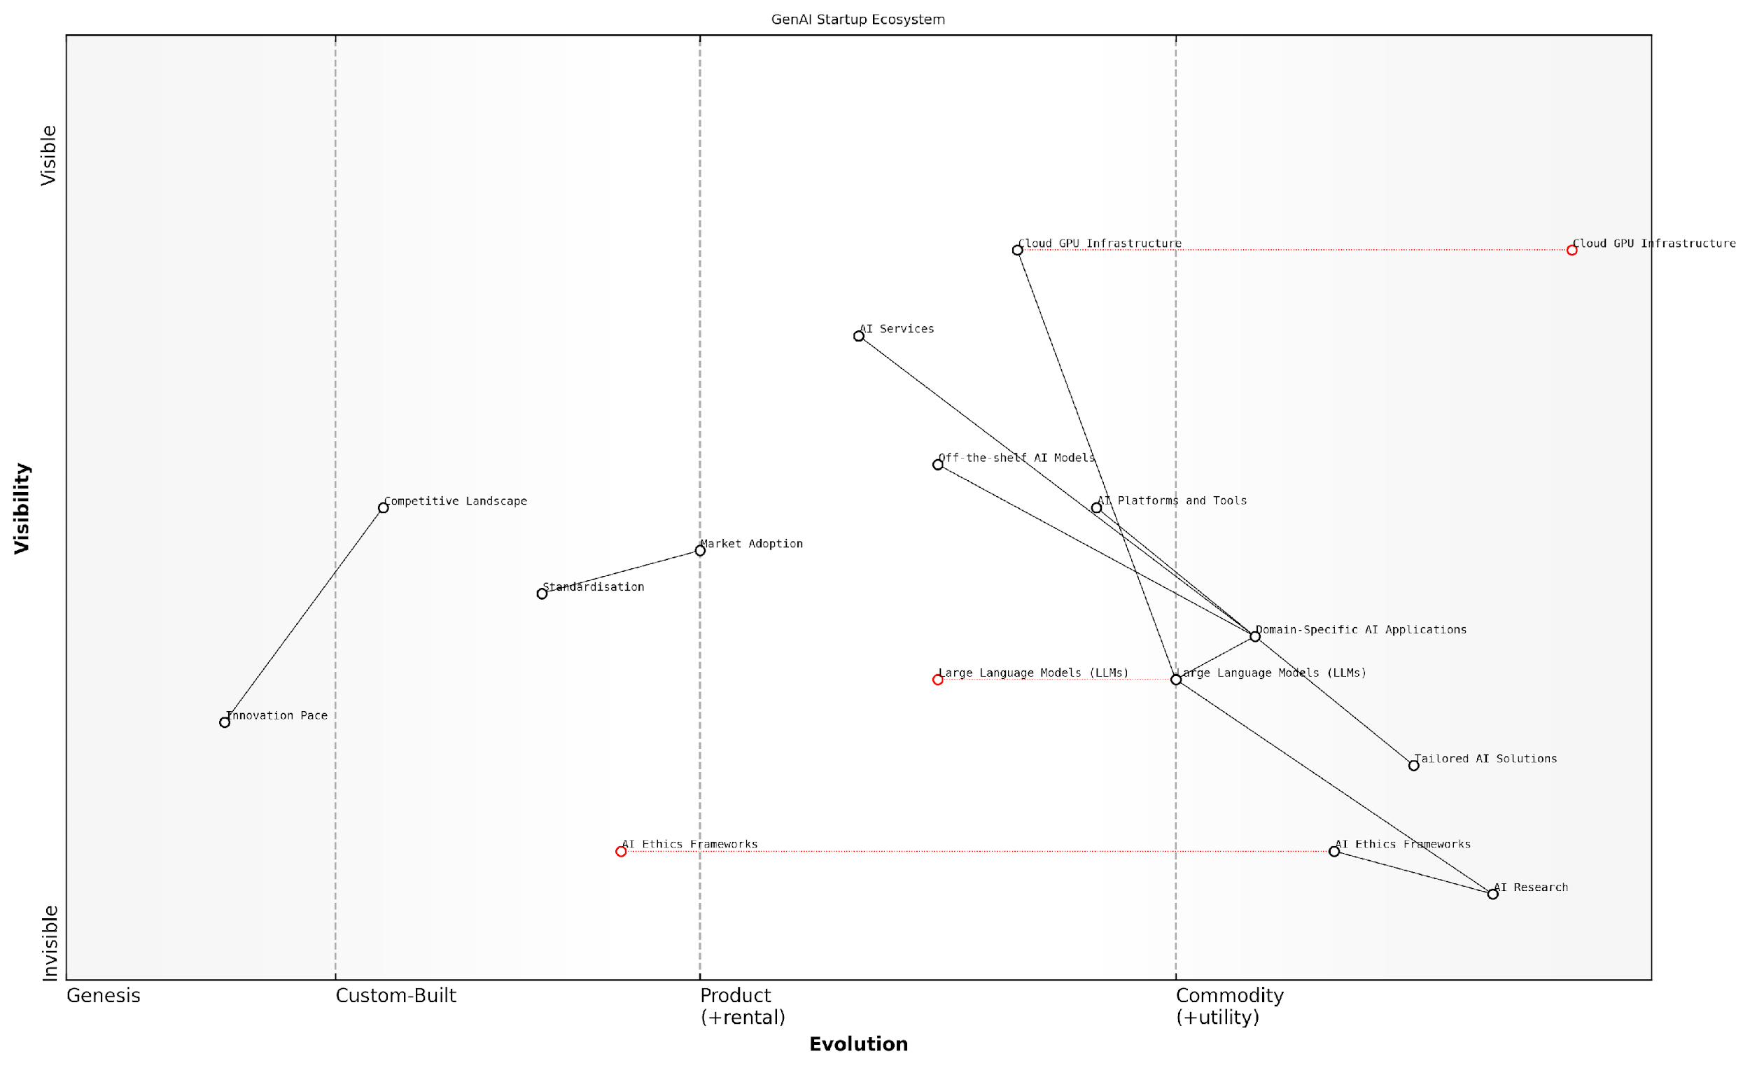

*Draft Wardley Map: [Insert Wardley Map: Positioning Components on the Evolution Axis]*

[Edit this draft Wardley Map](https://create.wardleymaps.ai/#clone:bc3990aab48a6383cd)

Wardley Map Assessment

The GenAI Startup Ecosystem map reveals a dynamic and rapidly evolving landscape with significant opportunities in domain-specific applications and ethical AI development. The strategic focus should be on leveraging commoditized infrastructure to create unique, ethically-sound AI solutions while investing in research and development to maintain a competitive edge. Key challenges include navigating the fast-paced competitive environment, addressing ethical concerns, and achieving widespread market adoption. Success will likely depend on balancing innovation with responsible AI development and effectively translating advanced technologies into tangible market value.

[View full Wardley Map report](http://markdown/wardley_map_reports/wardley_map_report_08_Positioning_Components_on_the_Evolution_Axis.md)

In conclusion, positioning components on the evolution axis is a fundamental skill for GenAI startups utilising Wardley Mapping. It provides a visual and intuitive way to understand the maturity of various elements within the GenAI ecosystem, informing strategic decisions, resource allocation, and innovation focus. By mastering this aspect of Wardley Mapping, startups can navigate the complex and rapidly evolving GenAI landscape with greater confidence and strategic foresight.

### Analysing Dependencies and Flows

In the complex ecosystem of Generative AI (GenAI) startups, understanding and mapping dependencies and flows is crucial for strategic decision-making and competitive positioning. This analysis forms a critical component of Wardley Mapping, enabling startups to visualise the intricate web of relationships within their value chain and the broader GenAI landscape.

Dependencies in the GenAI context refer to the reliance of one component or service on another, while flows represent the movement of data, resources, or value between these components. By meticulously mapping these elements, startups can gain invaluable insights into potential bottlenecks, opportunities for optimisation, and areas of strategic importance.

* Identify key dependencies: Begin by listing all critical components of your GenAI service and their interdependencies.
* Map data flows: Trace the movement of data through your system, from input sources to output endpoints.
* Analyse resource flows: Examine how computational resources, APIs, and other assets are utilised across your value chain.
* Evaluate value flows: Determine how value is created, captured, and distributed among different components and stakeholders.

When analysing dependencies, it’s crucial to consider both direct and indirect relationships. For instance, a GenAI startup developing a natural language processing (NLP) service might directly depend on a large language model (LLM) provider, but indirectly on the quality and diversity of training data used by that provider. Understanding these multi-layered dependencies can reveal potential risks and opportunities that might otherwise remain hidden.

Mapping dependencies and flows is like creating a detailed blueprint of your GenAI ecosystem. It reveals not just the individual components, but the vital connections that bring the whole system to life.

Flow analysis in GenAI is particularly important due to the data-intensive nature of these technologies. By mapping data flows, startups can identify potential bottlenecks in data processing, opportunities for parallelisation, and areas where data privacy and security measures need to be strengthened. This is especially critical in light of increasing regulatory scrutiny around AI and data protection.

Moreover, analysing resource flows can help startups optimise their infrastructure and reduce costs. For example, by mapping the flow of computational resources, a startup might identify opportunities to shift certain processes to edge computing or to implement more efficient load balancing strategies.

Value flow analysis is equally crucial. It helps startups understand where and how value is created within their GenAI system and identify potential areas for monetisation or value capture. This could involve mapping the flow of insights generated by the AI, the creation of intellectual property, or the accumulation of valuable datasets through system usage.

* Identify potential single points of failure in your dependency chain
* Assess the impact of upstream changes on your GenAI service
* Evaluate opportunities for vertical integration or strategic partnerships
* Analyse the potential for creating proprietary datasets or algorithms
* Identify areas where open-source components could be leveraged

It’s important to note that dependencies and flows in the GenAI landscape are often dynamic and can change rapidly as the technology evolves. Regular reassessment and updating of your dependency and flow maps is essential to maintain their relevance and utility in strategic decision-making.

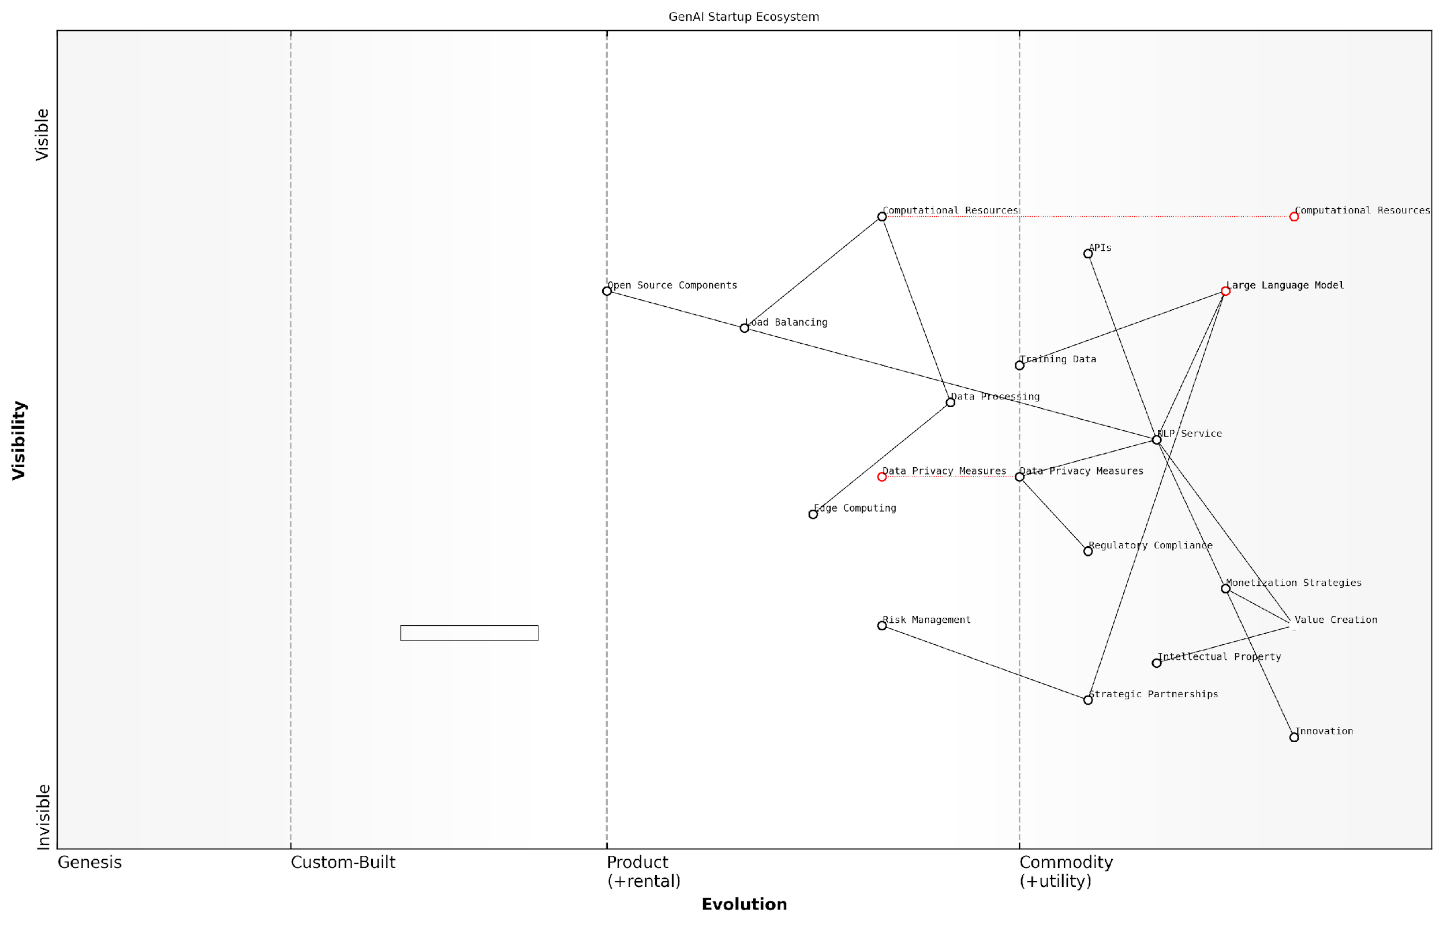

*Draft Wardley Map: [Insert Wardley Map: Analysing Dependencies and Flows]*

[Edit this draft Wardley Map](https://create.wardleymaps.ai/#clone:b823102a6ccfd18bbd)

Wardley Map Assessment

The GenAI Startup Ecosystem map reveals a mature yet rapidly evolving landscape with significant opportunities for innovation and growth. Key strategic imperatives include continuous AI technology advancement, robust data management and privacy practices, and proactive regulatory compliance. Success will hinge on balancing cutting-edge innovation with responsible AI development, while building strategic partnerships and leveraging both proprietary and open-source components. The ability to navigate complex regulatory environments while delivering unique value through specialised AI applications will be crucial for long-term success in this highly competitive field.

[View full Wardley Map report](http://markdown/wardley_map_reports/wardley_map_report_09_Analyzing_Dependencies_and_Flows.md)

By thoroughly analysing dependencies and flows, GenAI startups can gain a comprehensive understanding of their position within the broader ecosystem. This knowledge enables more informed strategic decisions, from choosing technology partners to identifying areas for innovation and differentiation. It also helps in risk management by highlighting critical dependencies that may require redundancy or alternative solutions.

In the rapidly evolving GenAI landscape, your competitive advantage often lies not just in what you build, but in how well you understand and leverage the complex web of dependencies and flows surrounding your innovation.

As we navigate the complexities of the GenAI landscape, the ability to effectively analyse and map dependencies and flows becomes a key differentiator for startups. It provides the foundation for agile strategy formulation, efficient resource allocation, and the identification of unique value propositions in this highly competitive and fast-moving field.

## Market Dynamics in the GenAI Space

### Identifying Anchor Tenants and Market Leaders

In the rapidly evolving landscape of Generative AI (GenAI), identifying anchor tenants and market leaders is crucial for startups to position themselves strategically. This process involves mapping the current ecosystem, understanding the dynamics of power and influence, and recognising the key players shaping the industry. By leveraging Wardley Mapping techniques, startups can gain invaluable insights into the market structure and make informed decisions about their own positioning and strategy.

Anchor tenants in the GenAI space are typically large, established organisations that have a significant impact on the ecosystem. These could be major tech companies, research institutions, or government bodies that drive innovation, set standards, or control critical resources. Market leaders, on the other hand, are companies that have achieved a dominant position in specific GenAI applications or technologies. Both anchor tenants and market leaders play crucial roles in shaping the competitive landscape and influencing the direction of technological development.

* Identify key players: Map out the major companies, institutions, and organisations active in the GenAI space.
* Assess market share and influence: Evaluate the relative size, reach, and impact of each player.
* Analyse technological capabilities: Determine which entities possess cutting-edge GenAI technologies or unique intellectual property.
* Examine partnerships and collaborations: Identify strategic alliances and ecosystem relationships.
* Monitor investment patterns: Track significant funding rounds, acquisitions, and R&D investments in the GenAI sector.

When mapping anchor tenants and market leaders, it’s essential to consider their position along the evolution axis of Wardley Mapping. Some organisations may be pioneers in emerging GenAI technologies, while others may dominate more mature, commoditised areas of the field. Understanding this positioning helps startups identify potential gaps in the market and opportunities for differentiation.

In the GenAI landscape, the true anchor tenants are often those who control the foundational models and datasets. Their gravitational pull shapes the entire ecosystem.

It’s crucial to recognise that the GenAI market is highly dynamic, with rapid technological advancements and shifting competitive landscapes. Startups must continuously update their maps to reflect these changes. This might involve tracking the emergence of new players, the consolidation of existing ones, or the pivot of established companies into the GenAI space.

When identifying anchor tenants and market leaders, startups should also consider the following factors:

* Control over key resources: Who has access to vast amounts of high-quality data or significant computing power?
* Regulatory influence: Which entities have the power to shape policy and standards in the GenAI space?
* Talent concentration: Where are the top AI researchers and engineers clustered?
* Platform dominance: Which companies provide the most widely used tools and frameworks for GenAI development?
* Market perception: Who is perceived as a thought leader or innovator in the industry?

By thoroughly mapping these aspects, startups can gain a comprehensive understanding of the power dynamics in the GenAI space. This knowledge is invaluable for identifying potential partners, competitors, or acquisition targets, as well as for spotting areas of opportunity where current market leaders may be vulnerable to disruption.

Understanding the landscape of anchor tenants and market leaders is not just about knowing your competition; it’s about seeing the entire chessboard and planning your moves accordingly.

It’s important to note that in the GenAI space, market leadership can be highly contextual. A company might be a leader in natural language processing but a follower in computer vision applications. Startups should therefore create detailed, nuanced maps that reflect these complexities and avoid oversimplification.

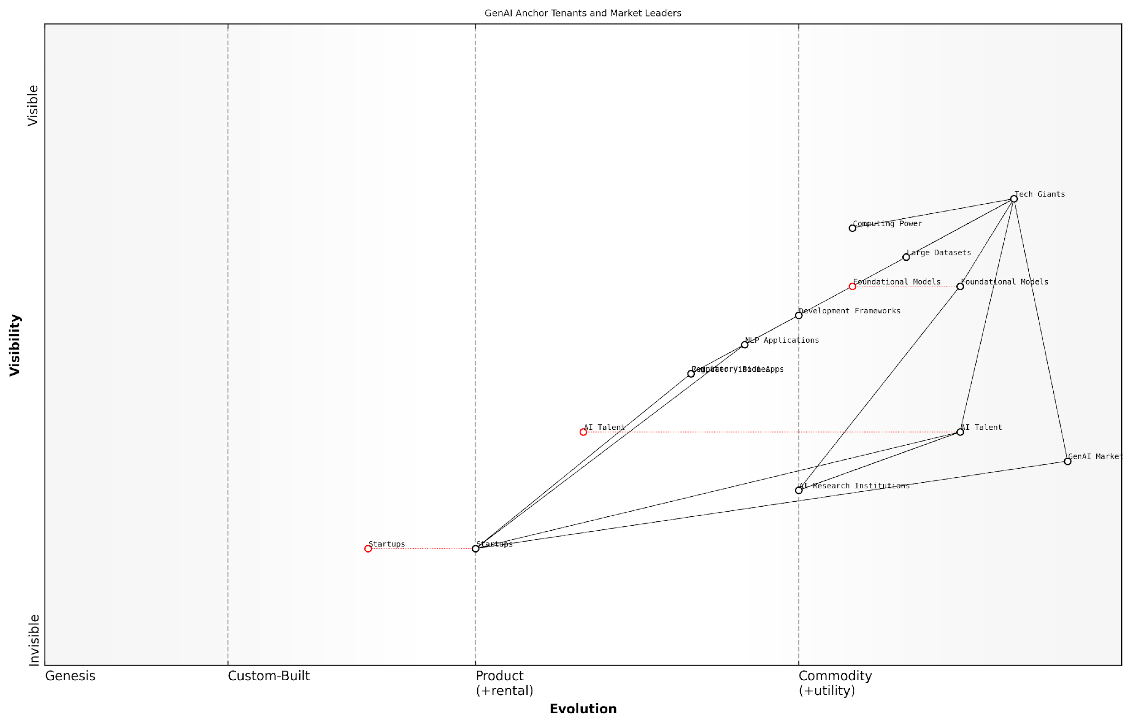

*Draft Wardley Map: [Insert Wardley Map: Identifying Anchor Tenants and Market Leaders]*

[Edit this draft Wardley Map](https://create.wardleymaps.ai/#clone:517d64748bc24f4afb)

Wardley Map Assessment

The GenAI ecosystem is dynamic and rapidly evolving, with significant opportunities for innovation and growth. While Tech Giants currently dominate, there’s potential for disruption through specialised applications and emerging technologies. Key strategies should focus on talent development, ethical AI practices, and fostering a balanced ecosystem that encourages both innovation and responsible development.

[View full Wardley Map report](http://markdown/wardley_map_reports/wardley_map_report_10_Identifying_Anchor_Tenants_and_Market_Leaders.md)

Finally, startups should use their understanding of anchor tenants and market leaders to inform their own strategic decisions. This might involve choosing to compete directly in underserved niches, partnering with established players to gain market access, or developing complementary technologies that enhance existing solutions. By leveraging Wardley Mapping to gain a clear view of the competitive landscape, GenAI startups can navigate the complex ecosystem more effectively and position themselves for long-term success.

### Mapping Competitive Forces and Potential Disruptors

In the rapidly evolving landscape of Generative AI (GenAI), understanding and mapping competitive forces and potential disruptors is crucial for startups aiming to carve out their niche and maintain a competitive edge. Wardley Mapping provides an invaluable framework for visualising these dynamics, enabling startups to anticipate market shifts and strategically position themselves for success.

To effectively map competitive forces in the GenAI space, startups must first identify the key players and their positions on the value chain. This includes established tech giants, emerging startups, research institutions, and open-source communities. Each of these entities exerts different competitive pressures and offers unique opportunities for collaboration or disruption.

* Identify major players in the GenAI ecosystem
* Analyse their current market positions and trajectories
* Assess their strengths, weaknesses, and unique value propositions
* Map relationships and dependencies between different entities

Once the current landscape is mapped, the next step is to anticipate potential disruptors. In the GenAI field, disruptors can emerge from various sources, including technological breakthroughs, innovative business models, or shifts in regulatory environments. Startups must remain vigilant and agile, constantly updating their maps to reflect new entrants and evolving competitive dynamics.

In the GenAI space, today’s collaborator could be tomorrow’s competitor. Startups must be prepared to pivot quickly as the landscape shifts beneath their feet.

When mapping potential disruptors, consider the following factors:

* Emerging technologies that could render current solutions obsolete
* New entrants with innovative approaches or significant resources
* Shifts in user behaviour or market demand
* Changes in data availability or accessibility
* Evolving ethical considerations and regulatory frameworks

It’s crucial to note that in the GenAI landscape, the line between competitor and collaborator is often blurred. Many startups find success by strategically positioning themselves within the ecosystem, leveraging the strengths of larger players while offering unique value. This could involve building on top of existing platforms, filling niche gaps, or providing specialised services that complement broader offerings.

When mapping competitive forces, pay close attention to the evolution axis of your Wardley Map. Components that are currently in the ‘custom-built’ or ‘product’ phases may rapidly move towards commoditisation, potentially disrupting existing business models. Conversely, new custom-built solutions may emerge, presenting opportunities for startups to establish themselves in nascent markets.

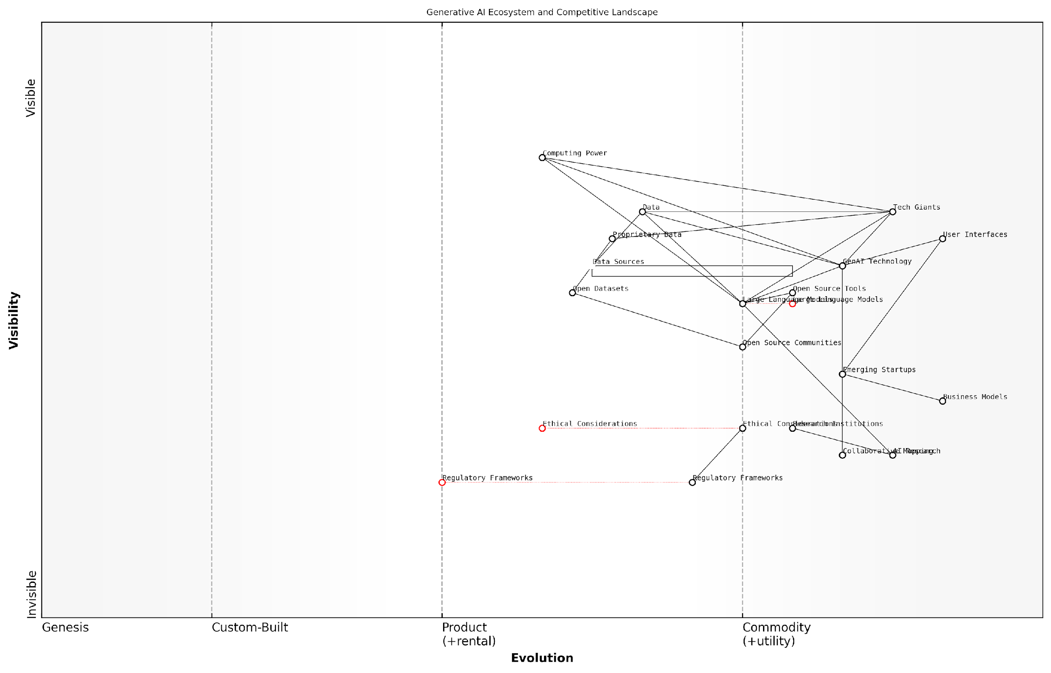

*Draft Wardley Map: [Insert Wardley Map: Mapping Competitive Forces and Potential Disruptors]*

[Edit this draft Wardley Map](https://create.wardleymaps.ai/#clone:a72b873f61a4a5f2ab)

Wardley Map Assessment

The GenAI ecosystem is at a critical juncture, balancing rapid technological advancement with growing ethical and regulatory considerations. Success in this landscape will require a strategic approach that combines technological innovation, ethical leadership, and adaptive business models. Companies should focus on developing unique value propositions, fostering collaborative ecosystems, and preparing for a more regulated future. The ability to navigate the complex interplay between open source developments, proprietary innovations, and evolving market demands will be crucial for long-term success in the GenAI space.

[View full Wardley Map report](http://markdown/wardley_map_reports/wardley_map_report_11_Mapping_Competitive_Forces_and_Potential_Disruptor.md)

Another critical aspect to consider when mapping competitive forces is the role of data. In the GenAI space, access to high-quality, diverse datasets can be a significant competitive advantage. Startups should map out data sources, considering both proprietary and open datasets, and assess how different players are leveraging these resources.

Regulatory forces also play a crucial role in shaping the competitive landscape. As governments worldwide grapple with the implications of GenAI, new regulations could significantly impact market dynamics. Startups must anticipate these changes and position themselves to either benefit from or mitigate the effects of evolving regulatory frameworks.

The most successful GenAI startups will be those that not only develop cutting-edge technology but also navigate the complex web of competitive forces, regulatory challenges, and ethical considerations.

To effectively use Wardley Mapping for competitive analysis, startups should regularly engage in collaborative mapping exercises. These sessions can help teams develop a shared understanding of the competitive landscape and identify potential blind spots or opportunities that might otherwise be overlooked.

* Conduct regular mapping sessions with cross-functional teams
* Encourage diverse perspectives and challenge assumptions
* Use scenario planning to explore potential future states
* Continuously update and refine your maps as new information emerges

By diligently mapping competitive forces and potential disruptors, GenAI startups can develop more robust strategies, anticipate market shifts, and position themselves for long-term success in this dynamic and rapidly evolving field. Remember, in the world of GenAI, the only constant is change, and Wardley Mapping provides a powerful tool for navigating this uncertainty.

### Anticipating Market Movements and Shifts

In the rapidly evolving landscape of Generative AI, anticipating market movements and shifts is crucial for startups aiming to establish a foothold and thrive. Wardley Mapping provides a powerful framework for visualising and predicting these dynamics, enabling GenAI startups to stay ahead of the curve and make informed strategic decisions.

To effectively anticipate market movements and shifts in the GenAI space, startups must consider several key factors:

* Technology evolution and maturity
* Changing user needs and expectations
* Regulatory landscape and policy shifts
* Competitive pressures and market consolidation
* Emerging use cases and industry applications

By mapping these factors and their potential trajectories, GenAI startups can gain valuable insights into future market dynamics. Let’s explore each of these aspects in detail:

Technology Evolution and Maturity: In the GenAI space, technological advancements occur at a breakneck pace. Startups must continuously monitor and map the evolution of key technologies, such as natural language processing, computer vision, and reinforcement learning. By positioning these technologies on the evolution axis of a Wardley Map, startups can anticipate when certain capabilities will become commoditised or when new, disruptive technologies might emerge.

As a seasoned AI researcher notes, ‘The GenAI landscape is characterised by rapid technological leaps. What seems cutting-edge today may be commonplace tomorrow. Startups that can anticipate and prepare for these shifts will have a significant advantage.’

Changing User Needs and Expectations: As GenAI technologies become more prevalent, user expectations evolve. Startups must map current user needs and project how these might change over time. For instance, as users become more accustomed to AI-generated content, their demands for quality, customisation, and ethical considerations may increase. By anticipating these shifts, startups can align their product roadmaps accordingly.

Regulatory Landscape and Policy Shifts: The GenAI field is subject to increasing scrutiny from regulators and policymakers. Startups must map the current regulatory landscape and anticipate potential policy changes. This might include data privacy regulations, ethical AI guidelines, or sector-specific rules. By positioning these regulatory factors on a Wardley Map, startups can prepare for compliance challenges and identify opportunities to differentiate through responsible AI practices.

Competitive Pressures and Market Consolidation: The GenAI market is characterised by intense competition and the potential for rapid consolidation. Startups should map the positions of key competitors, potential acquirers, and emerging players. By analysing these dynamics, startups can anticipate potential mergers, acquisitions, or strategic partnerships that could reshape the competitive landscape.

A prominent venture capitalist in the AI space observes, ‘The GenAI market is ripe for consolidation. Startups that can accurately map and anticipate these movements will be better positioned to navigate the changing landscape, whether through strategic partnerships or by identifying unique niches.’

Emerging Use Cases and Industry Applications: As GenAI technologies mature, new use cases and industry applications continually emerge. Startups should map potential applications across various sectors, from healthcare and finance to creative industries and beyond. By anticipating these emerging opportunities, startups can position themselves to capitalise on new market segments or pivot their offerings to meet evolving demand.

To effectively anticipate market movements and shifts, GenAI startups should employ the following strategies:

* Regularly update and review Wardley Maps to reflect the latest market dynamics
* Engage in scenario planning exercises to explore potential future states
* Foster a culture of continuous learning and adaptation within the organisation
* Develop a network of industry contacts and thought leaders to gather diverse perspectives
* Utilise data analytics and market intelligence tools to supplement qualitative insights

By integrating these strategies with Wardley Mapping techniques, GenAI startups can develop a robust framework for anticipating and responding to market movements and shifts. This proactive approach enables startups to not only survive but thrive in the dynamic GenAI landscape.

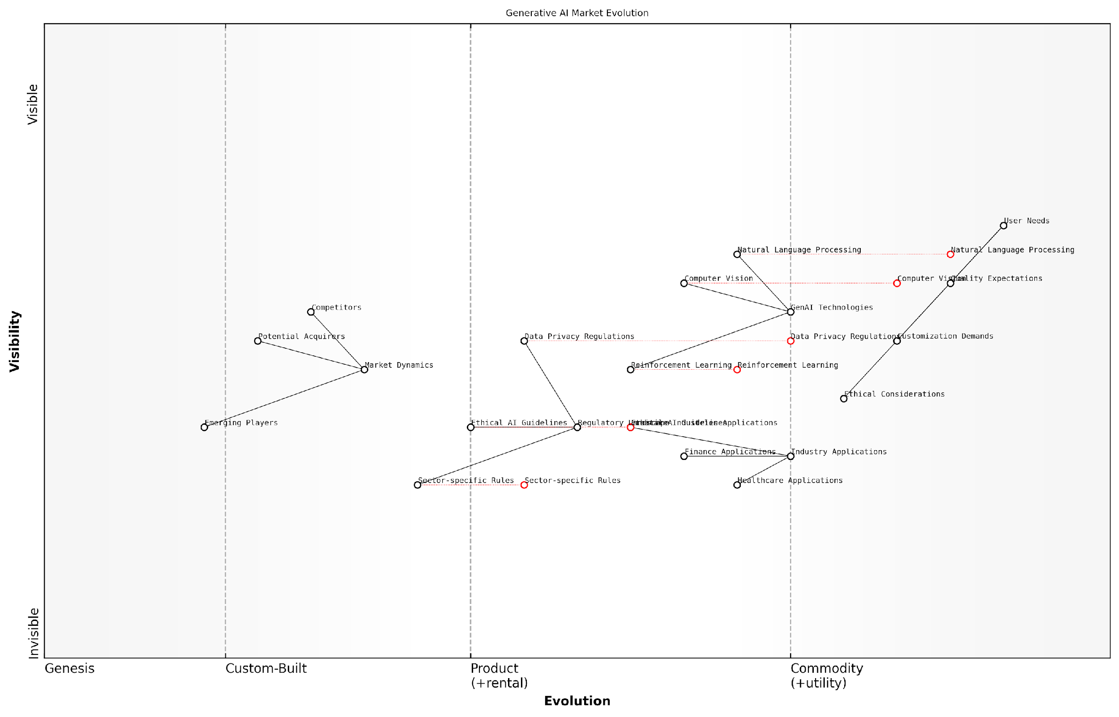

*Draft Wardley Map: [Insert Wardley Map: Anticipating Market Movements and Shifts]*

[Edit this draft Wardley Map](https://create.wardleymaps.ai/#clone:9364a574459f210603)

Wardley Map Assessment

The Generative AI market is at a critical juncture, with immense growth potential balanced by significant regulatory and ethical challenges. Success in this space will require not only technological excellence but also a strong commitment to ethical AI development and the ability to create tangible value across diverse industry applications. Companies that can navigate the complex regulatory landscape while continuously innovating and addressing user needs will be best positioned to lead in this dynamic market.

[View full Wardley Map report](http://markdown/wardley_map_reports/wardley_map_report_12_Anticipating_Market_Movements_and_Shifts.md)

In conclusion, anticipating market movements and shifts is a critical capability for GenAI startups. By leveraging Wardley Mapping in conjunction with other strategic tools and practices, startups can navigate the complex and rapidly changing GenAI landscape with greater confidence and agility. This foresight allows startups to make informed decisions, allocate resources effectively, and position themselves for long-term success in this exciting and transformative field.

## Regulatory and Ethical Considerations

### Mapping Current and Potential Future Regulations

In the rapidly evolving landscape of Generative AI (GenAI), understanding and anticipating regulatory frameworks is crucial for startups aiming to navigate this complex terrain. Wardley Mapping provides an invaluable tool for visualising the current regulatory environment and projecting potential future developments, enabling startups to strategically position themselves and adapt to changing legal requirements.

To effectively map the regulatory landscape, we must first identify the key components of the current regulatory framework. These typically include data protection laws, AI ethics guidelines, sector-specific regulations, and intellectual property considerations. Each of these components can be positioned on the Wardley Map based on their visibility to users and their evolutionary stage.

* Data Protection Laws (e.g., GDPR, CCPA)
* AI Ethics Guidelines
* Sector-specific Regulations (e.g., healthcare, finance)
* Intellectual Property Laws
* Consumer Protection Regulations
* Algorithmic Transparency Requirements

When mapping these components, it’s crucial to consider their current state of evolution. For instance, data protection laws like GDPR are relatively mature and visible, positioning them towards the right of the map. In contrast, AI-specific regulations are often in earlier stages of development, placing them further left on the evolutionary axis.

The regulatory landscape for AI is not just evolving; it’s undergoing a seismic shift. What we’re seeing now is just the tip of the iceberg.

To anticipate future regulatory developments, we must analyse trends and signals in the current environment. This involves monitoring policy discussions, draft legislation, and emerging ethical concerns. By mapping these potential future regulations, startups can prepare for various scenarios and adapt their strategies accordingly.

* AI Liability Frameworks
* Mandatory AI Impact Assessments
* Stricter Data Localisation Requirements
* AI Auditing and Certification Standards
* Regulations on AI-generated Content
* AI-specific Antitrust Measures

When mapping future regulations, it’s important to consider their potential impact and likelihood. High-impact, high-likelihood regulations should be positioned as emerging components on the map, while more speculative or long-term possibilities can be noted but placed further left on the evolutionary axis.

The dynamic nature of the regulatory landscape necessitates regular updates to the Wardley Map. Startups should establish a process for monitoring regulatory developments and adjusting their maps accordingly. This might involve designating a team member as a ‘regulatory scout’ or partnering with legal experts specialising in AI and technology law.

In the world of GenAI, regulatory compliance isn’t just about avoiding penalties; it’s about building trust and ensuring long-term sustainability.

By mapping both current and potential future regulations, GenAI startups can gain several strategic advantages:

* Proactive Compliance: Anticipating regulatory changes allows startups to build compliance into their products and processes from the ground up, rather than retrofitting later.
* Strategic Positioning: Understanding the regulatory landscape helps startups identify areas where they can differentiate themselves through strong compliance practices or by addressing emerging regulatory needs.
* Risk Mitigation: By visualising potential regulatory challenges, startups can develop contingency plans and allocate resources more effectively.
* Innovation Opportunities: Identifying regulatory gaps or areas of uncertainty can reveal opportunities for innovative solutions that address both market and regulatory needs.
* Investor Confidence: Demonstrating a clear understanding of the regulatory landscape can boost investor confidence in the startup’s long-term viability.

It’s worth noting that regulations can also act as catalysts for innovation. For example, stringent data protection laws have spurred the development of privacy-enhancing technologies. By mapping these regulatory-driven innovation opportunities, startups can align their R&D efforts with emerging compliance requirements, potentially creating new competitive advantages.

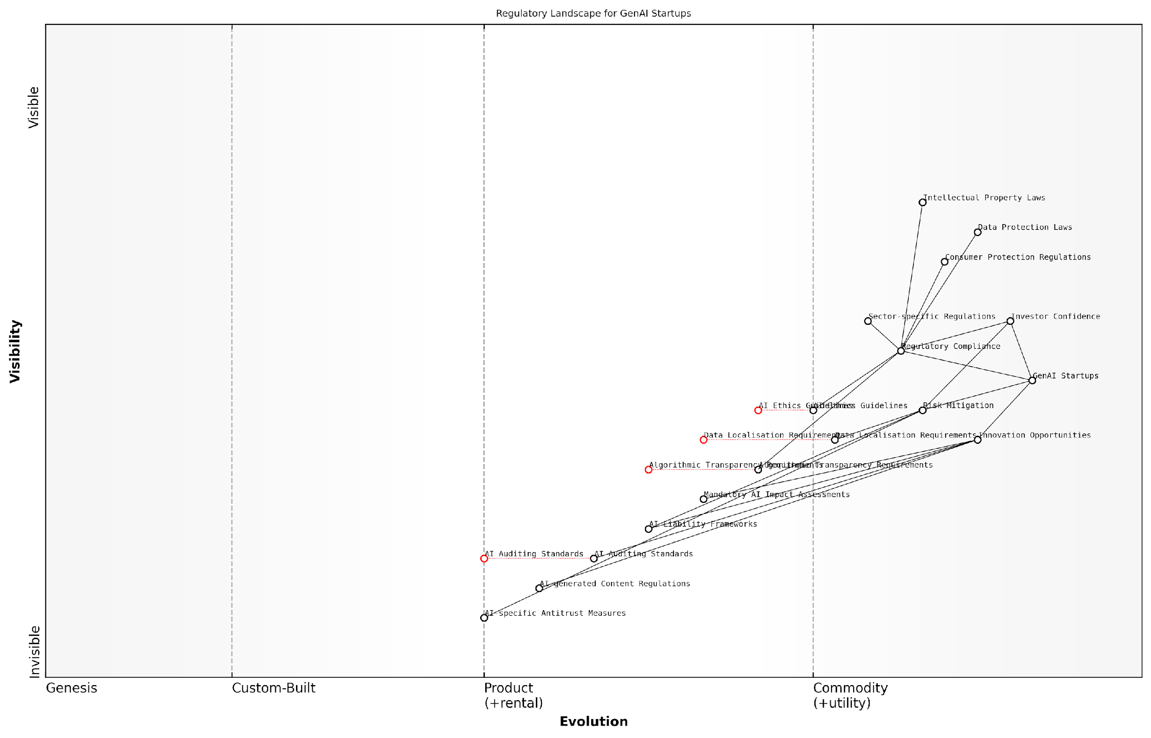

*Draft Wardley Map: [Insert Wardley Map: Mapping Current and Potential Future Regulations]*

[Edit this draft Wardley Map](https://create.wardleymaps.ai/#clone:75acc5d9b710636e5a)

Wardley Map Assessment

GenAI Startups face a complex and evolving regulatory landscape that presents both challenges and opportunities. Success will depend on balancing compliance with current regulations while proactively preparing for and shaping future AI-specific regulations. Key focus areas should include building robust compliance systems, investing in AI ethics and transparency capabilities, and actively engaging in the development of AI governance frameworks. The ability to navigate this landscape effectively will be a critical differentiator and source of competitive advantage in the GenAI space.

[View full Wardley Map report](http://markdown/wardley_map_reports/wardley_map_report_13_Mapping_Current_and_Potential_Future_Regulations.md)

In conclusion, mapping current and potential future regulations is a critical exercise for GenAI startups. It provides a visual framework for understanding the complex regulatory environment, anticipating changes, and strategically positioning the company for long-term success. By integrating regulatory considerations into their Wardley Maps, startups can navigate the challenges and opportunities of the GenAI landscape with greater confidence and agility.

### Ethical Considerations in GenAI Development and Deployment

As we navigate the rapidly evolving landscape of Generative AI (GenAI), it is imperative that startups not only focus on technological innovation but also place ethical considerations at the forefront of their development and deployment strategies. The ethical implications of GenAI are far-reaching and complex, requiring careful consideration and proactive measures to ensure responsible innovation.

When mapping the ethical landscape for GenAI startups, several key areas emerge as critical focal points:

* Bias and Fairness
* Transparency and Explainability
* Privacy and Data Protection
* Accountability and Governance
* Environmental Impact
* Societal Impact and Job Displacement

Bias and Fairness: GenAI systems are only as unbiased as the data they are trained on and the algorithms that process this data. Startups must actively work to identify and mitigate biases in their AI models to ensure fair and equitable outcomes for all users. This involves rigorous testing, diverse data sourcing, and ongoing monitoring of AI outputs.

A leading AI ethicist once remarked, ‘The greatest challenge in GenAI is not creating intelligent systems, but creating fair and unbiased ones that reflect the diversity of human experience.’

Transparency and Explainability: As GenAI systems become more complex, the need for transparency in their decision-making processes grows. Startups should strive to develop AI models that can provide clear explanations for their outputs, enabling users and stakeholders to understand and trust the system’s decisions. This is particularly crucial in sectors such as healthcare, finance, and law enforcement, where AI decisions can have significant real-world impacts.

Privacy and Data Protection: GenAI models often require vast amounts of data for training and operation. Startups must implement robust data protection measures and adhere to privacy regulations such as GDPR and CCPA. This includes ensuring informed consent for data usage, implementing data minimisation practices, and providing users with control over their personal information.

Accountability and Governance: As GenAI systems become more autonomous, questions of accountability become increasingly complex. Startups need to establish clear governance structures and accountability frameworks to address potential harms or unintended consequences of their AI systems. This may involve creating ethics boards, implementing rigorous testing protocols, and developing clear policies for addressing AI-related incidents.

Environmental Impact: The training and operation of large-scale GenAI models can be computationally intensive, leading to significant energy consumption. Startups should consider the environmental impact of their AI systems and explore ways to optimise efficiency and reduce carbon footprints. This could involve using more energy-efficient hardware, optimising algorithms, or offsetting carbon emissions.

Societal Impact and Job Displacement: As GenAI technologies advance, they have the potential to automate tasks currently performed by humans. Startups must consider the broader societal implications of their technologies, including potential job displacement. This may involve collaborating with policymakers and educational institutions to support reskilling initiatives and exploring ways for AI to augment rather than replace human workers.

A prominent tech industry leader noted, ‘The most successful GenAI startups will be those that not only push the boundaries of technology but also actively engage with the ethical implications of their innovations.’

When mapping these ethical considerations onto the Wardley Map, startups should position them as essential components that span across the value chain, from genesis to commodity. Ethical considerations should not be viewed as a separate entity but as an integral part of every stage of development and deployment.

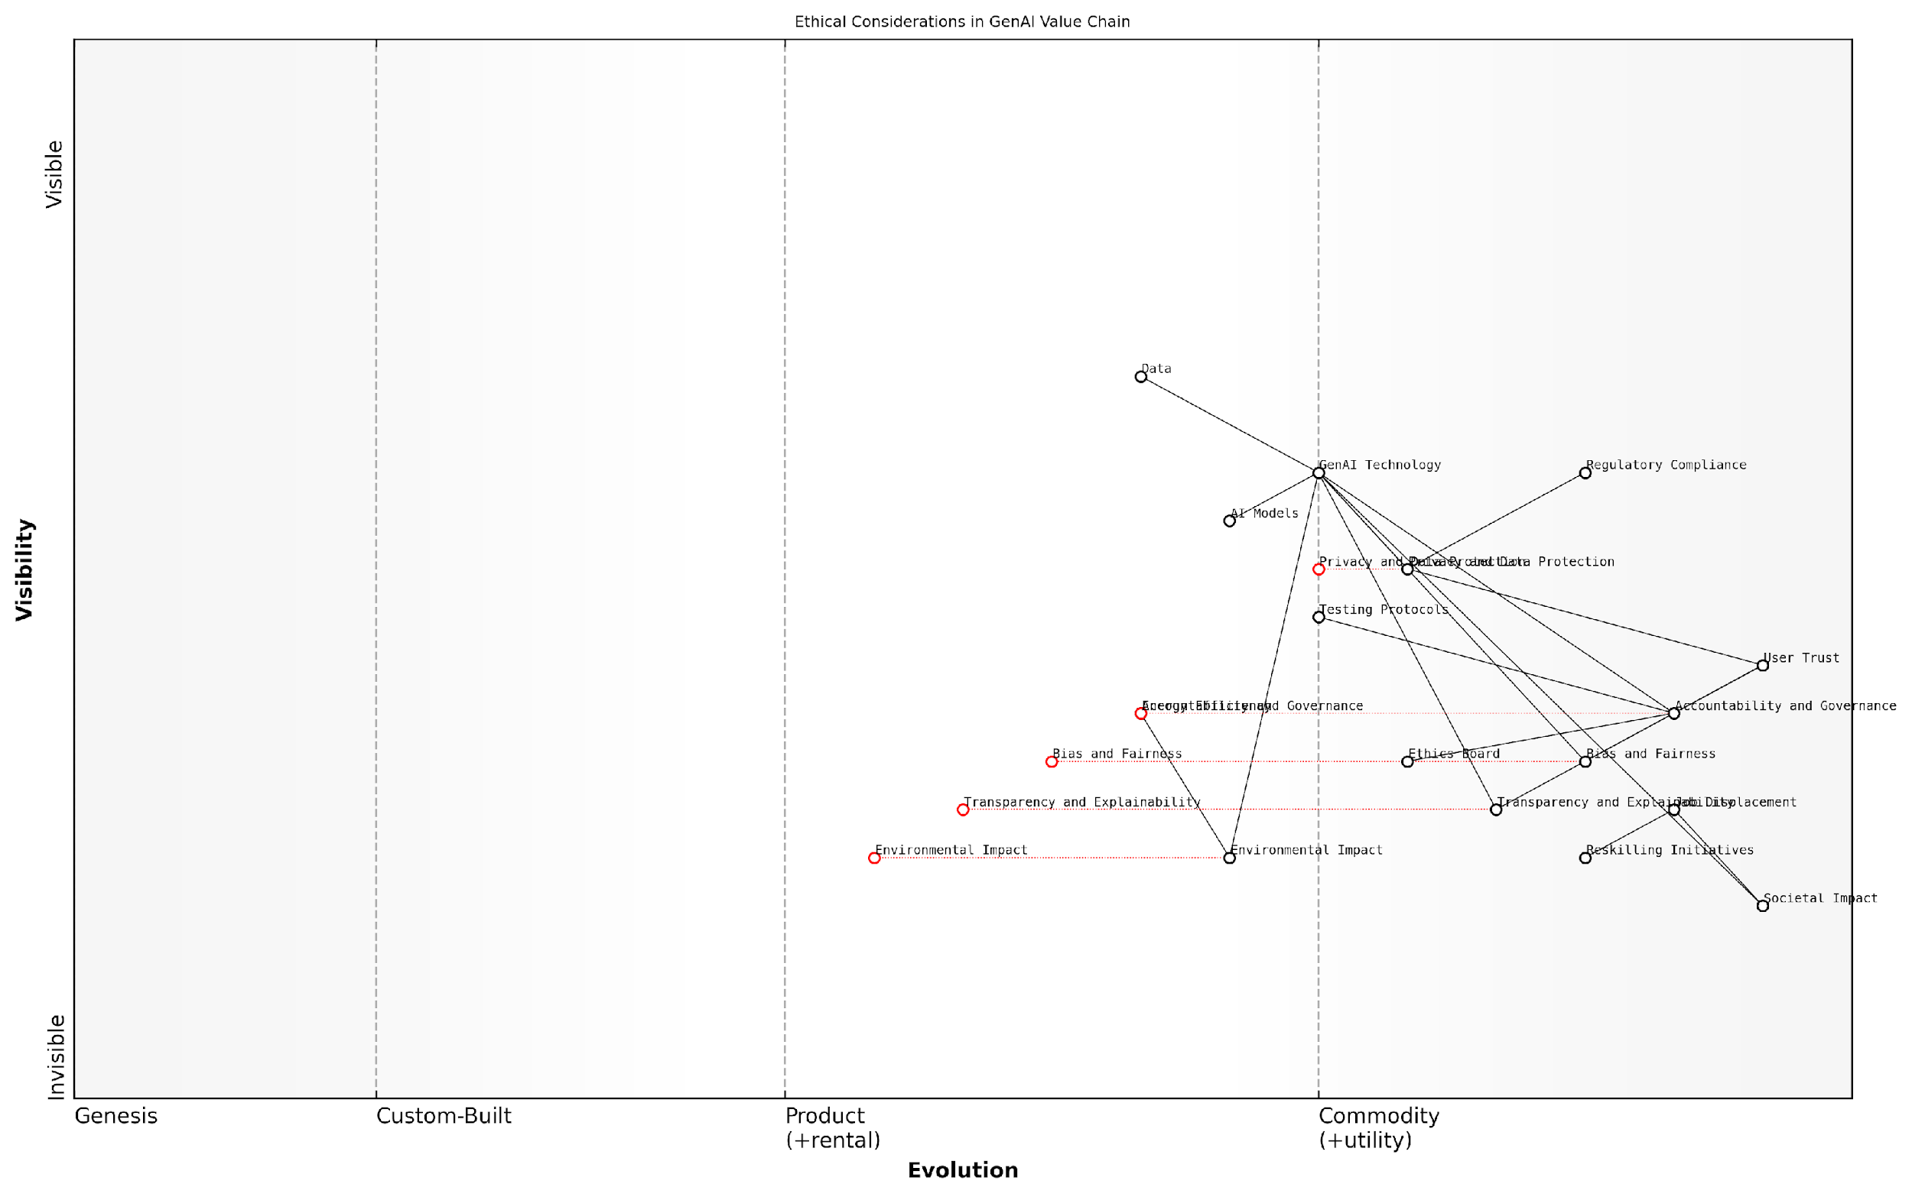

*Draft Wardley Map: [Insert Wardley Map: Ethical Considerations in GenAI Development and Deployment]*

[Edit this draft Wardley Map](https://create.wardleymaps.ai/#clone:5d4ffd5607e0b892d5)

Wardley Map Assessment

This Wardley Map reveals a strategic landscape where ethical considerations are recognized as crucial components in the GenAI value chain. The positioning of User Trust as the anchor underscores the importance of addressing these ethical concerns to ensure long-term success and acceptance of GenAI technologies. The map indicates a need for rapid evolution in areas such as bias mitigation, transparency, and governance to keep pace with technological advancements. Companies that can effectively navigate these ethical considerations while advancing their technical capabilities are likely to gain significant competitive advantage. The inclusion of broader societal and environmental impacts suggests a forward-thinking approach that could set new standards for responsible AI development and deployment.

[View full Wardley Map report](http://markdown/wardley_map_reports/wardley_map_report_14_Ethical_Considerations_in_GenAI_Development_and_De.md)

By integrating ethical considerations into their Wardley Maps, GenAI startups can gain a competitive advantage by demonstrating their commitment to responsible innovation. This not only helps in building trust with users and stakeholders but also positions the startup favourably in an increasingly regulated environment.

Moreover, startups should view ethical considerations as a dynamic component of their strategy, regularly reassessing and updating their approach as the technology and societal expectations evolve. This involves staying abreast of emerging ethical guidelines, participating in industry-wide discussions on AI ethics, and fostering a culture of ethical awareness within the organisation.

In conclusion, ethical considerations in GenAI development and deployment are not just a regulatory requirement or a public relations exercise, but a fundamental aspect of building sustainable and responsible AI businesses. By mapping these considerations and integrating them into every aspect of their operations, GenAI startups can navigate the complex ethical landscape, build trust with their users, and contribute to the responsible advancement of AI technology.

### Positioning Your Startup in the Ethical Landscape

In the rapidly evolving world of Generative AI (GenAI), positioning your startup within the ethical landscape is not just a moral imperative but a strategic necessity. As an expert in this field, I can attest that the ethical considerations surrounding GenAI are complex, multifaceted, and increasingly scrutinised by regulators, consumers, and investors alike. Navigating this terrain requires a nuanced understanding of current ethical standards, potential future developments, and the ability to proactively address ethical concerns in your startup’s operations and offerings.

In the AI industry, ethical considerations are not a constraint on innovation, but rather a catalyst for sustainable and responsible growth. Startups that position themselves at the forefront of ethical AI development are poised to gain significant competitive advantages in the long run.

To effectively position your GenAI startup in the ethical landscape, it’s crucial to employ Wardley Mapping techniques. This approach allows you to visualise the ethical components of your business model, identify potential ethical risks, and strategically plan for ethical innovation. Let’s explore the key aspects of this positioning process:

* Mapping Ethical Components: Identify and position the ethical considerations relevant to your GenAI services on the Wardley Map. This includes data privacy, algorithmic bias, transparency, and accountability.
* Assessing Ethical Maturity: Evaluate the evolution of ethical standards in the GenAI field and position your startup’s current ethical practices along this continuum.
* Identifying Ethical Differentiators: Determine unique ethical selling points that can set your startup apart in the competitive GenAI landscape.
* Anticipating Ethical Challenges: Use the map to forecast potential ethical issues that may arise as your GenAI technology evolves and plan mitigation strategies.
* Aligning with Regulatory Trends: Position your ethical stance in relation to current and anticipated regulatory requirements, ensuring compliance and future-proofing your operations.

One of the most critical aspects of positioning your startup in the ethical landscape is the development of a robust ethical framework. This framework should be deeply integrated into your business model and technological development processes. It’s not enough to simply comply with existing regulations; true ethical leadership in the GenAI space requires proactive engagement with ethical issues and a commitment to continuous improvement.

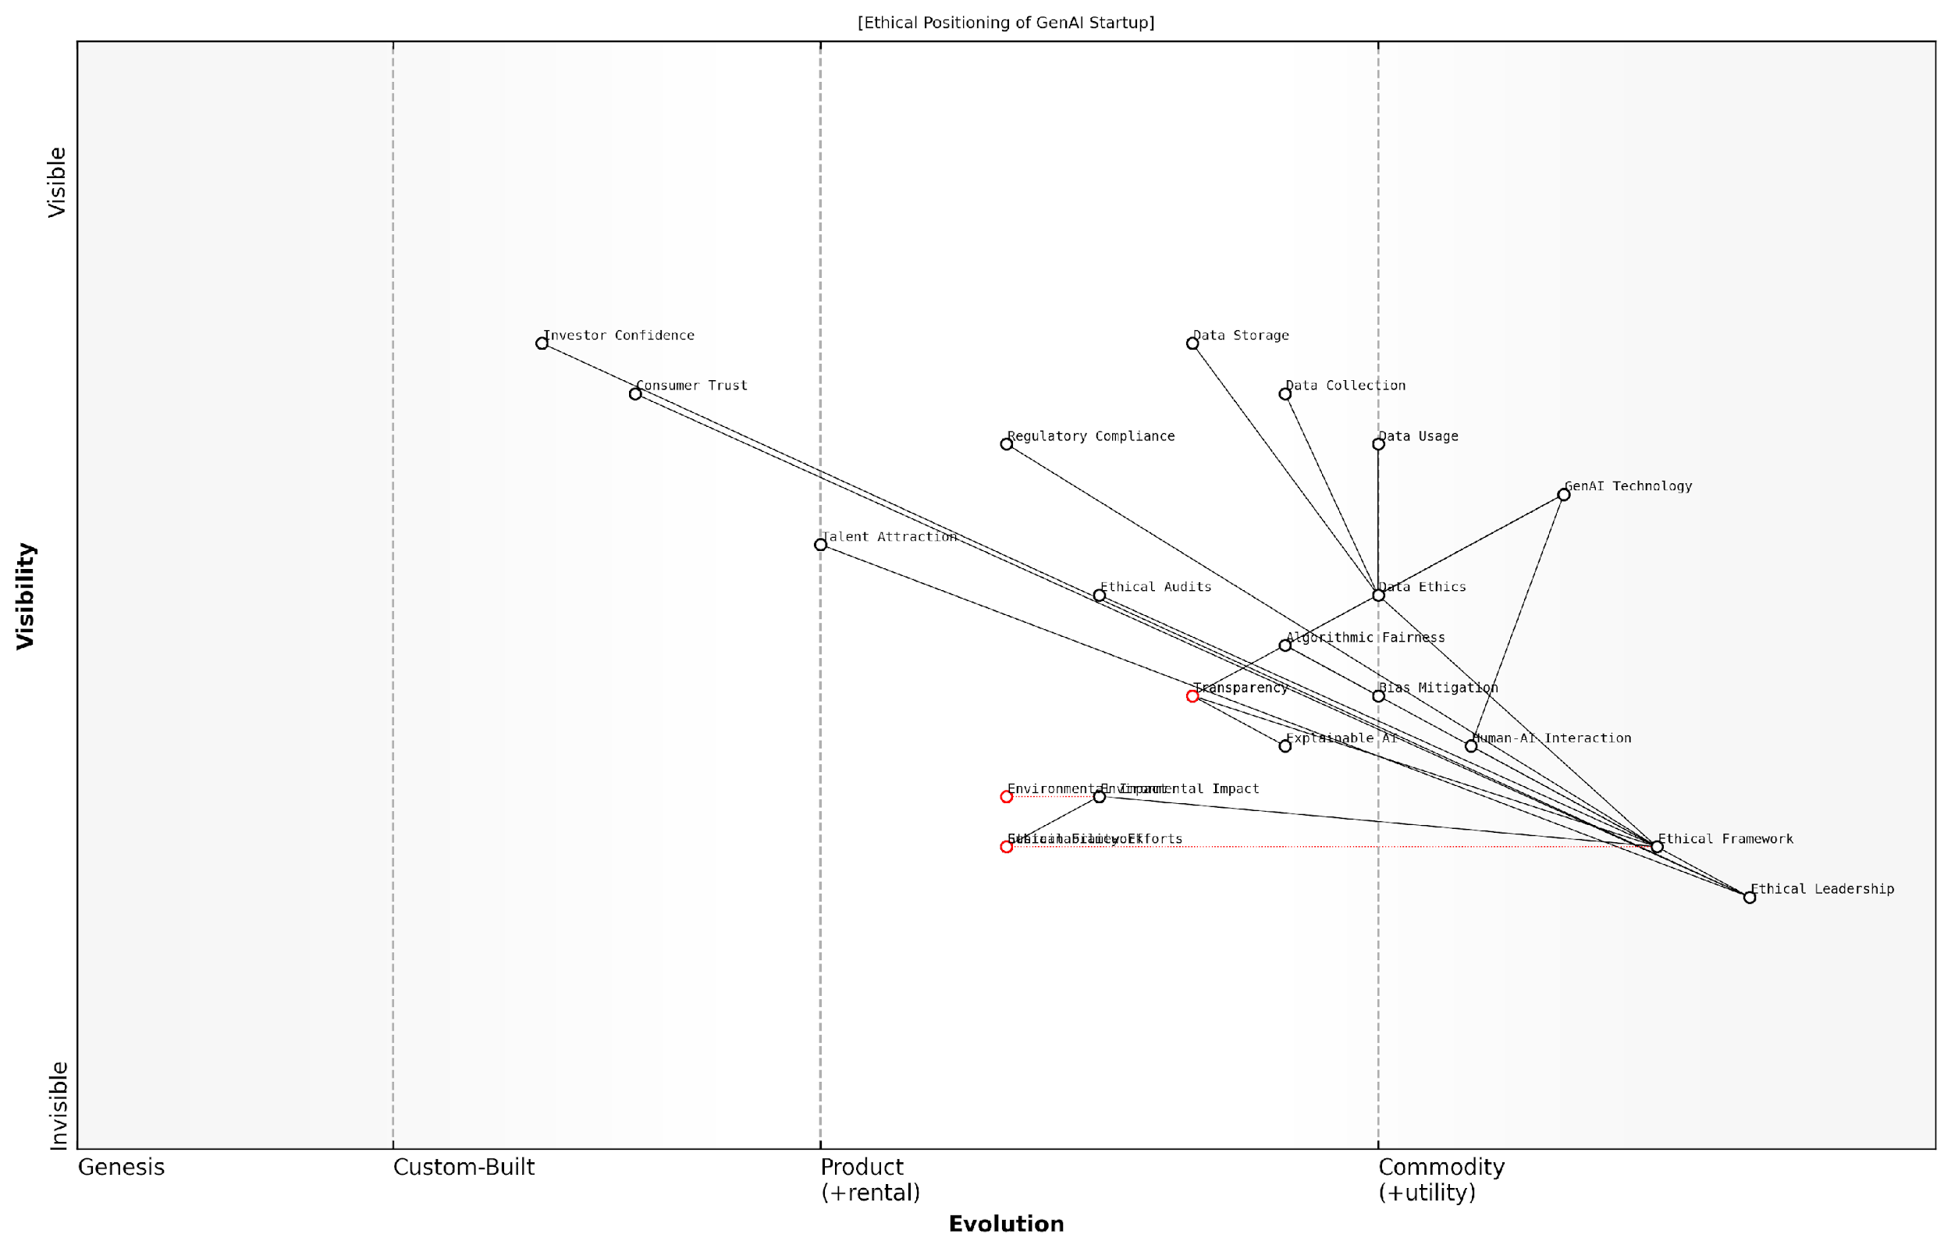

*Draft Wardley Map: [Insert Wardley Map: Positioning Your Startup in the Ethical Landscape]*

[Edit this draft Wardley Map](https://create.wardleymaps.ai/#clone:4f90f552192df3b284)

Wardley Map Assessment

The startup is well-positioned to become a leader in Ethical AI, with a strong foundation in ethical considerations and GenAI technology. To maintain this position, it must continue to innovate in areas like Explainable AI and Sustainability Efforts, while also working to set industry standards for Ethical Frameworks and Audits. The key to long-term success lies in balancing technological advancement with ethical considerations, always keeping Consumer Trust and Regulatory Compliance at the forefront of strategic decisions.

[View full Wardley Map report](http://markdown/wardley_map_reports/wardley_map_report_15_Positioning_Your_Startup_in_the_Ethical_Landscape.md)

When mapping your ethical position, consider the following key areas:

* Data Ethics: How does your startup handle data collection, storage, and usage? Position your data practices on the map, considering factors like consent, anonymisation, and data minimisation.
* Algorithmic Fairness: Map out your approach to ensuring fairness and mitigating bias in your GenAI models. This could include diverse training data, regular audits, and bias detection tools.
* Transparency and Explainability: Position your startup’s commitment to making AI decision-making processes understandable and accountable.
* Human-AI Interaction: Map the ethical considerations in how your GenAI technology interacts with and impacts human users.
* Environmental Impact: Consider the ecological footprint of your AI operations and position your sustainability efforts on the map.

By carefully mapping these ethical components, you can identify areas where your startup can take a leadership position in ethical AI development. This might involve pioneering new approaches to algorithmic transparency, setting industry standards for data privacy, or developing innovative solutions for reducing the environmental impact of AI computations.

Ethical considerations in AI are not static; they evolve as rapidly as the technology itself. Successful GenAI startups must be prepared to continuously reassess and reposition their ethical stance to remain at the forefront of responsible AI development.

It’s important to note that positioning your startup in the ethical landscape is not just about risk mitigation or compliance. It’s about creating a sustainable competitive advantage. Consumers, enterprise clients, and investors are increasingly prioritising ethical considerations in their decision-making processes. By positioning your startup as an ethical leader in the GenAI space, you can tap into this growing demand for responsible AI solutions.

Moreover, a strong ethical position can help attract and retain top talent in the highly competitive AI job market. Many skilled AI professionals are deeply concerned about the ethical implications of their work and are drawn to companies that demonstrate a genuine commitment to ethical AI development.

In conclusion, positioning your GenAI startup in the ethical landscape is a complex but crucial task. By leveraging Wardley Mapping techniques, you can visualise your ethical position, identify opportunities for ethical leadership, and create a strategic roadmap for responsible AI development. This approach not only helps navigate the current ethical and regulatory landscape but also prepares your startup for future challenges and opportunities in the rapidly evolving field of Generative AI.

# Chapter 2: Crafting Your GenAI Startup Strategy

## Identifying Your Unique Value Proposition

### Mapping Your Core Competencies and Assets

In the rapidly evolving landscape of Generative AI, identifying and leveraging your startup’s core competencies and assets is crucial for establishing a strong market position. Wardley Mapping provides an invaluable framework for visualising and analysing these elements, enabling you to craft a unique value proposition that sets you apart from competitors.

To begin mapping your core competencies and assets, it’s essential to conduct a thorough internal assessment. This process involves identifying your team’s expertise, proprietary technologies, data assets, and any unique insights or methodologies you’ve developed. These elements form the foundation of your competitive advantage in the GenAI space.

* Technical expertise: Assess your team’s proficiency in key AI technologies, such as natural language processing, computer vision, or reinforcement learning.
* Domain knowledge: Evaluate your understanding of specific industries or use cases where GenAI can be applied.
* Proprietary algorithms or models: Identify any unique AI models or algorithms you’ve developed that offer superior performance or novel capabilities.
* Data assets: Catalogue any proprietary datasets or data pipelines that give you an edge in training or fine-tuning GenAI models.
* Infrastructure and tooling: Consider any custom infrastructure or development tools that enhance your ability to build and deploy GenAI solutions efficiently.
* Partnerships and collaborations: Assess strategic relationships with academic institutions, industry partners, or other organisations that provide unique advantages.

Once you’ve identified these core competencies and assets, the next step is to position them on your Wardley Map. This visual representation allows you to see how your assets relate to the overall value chain and where they sit on the evolution axis. For instance, a novel AI algorithm might be positioned as a genesis or custom-built component, while established infrastructure could be placed further along the evolution towards commodity or utility.

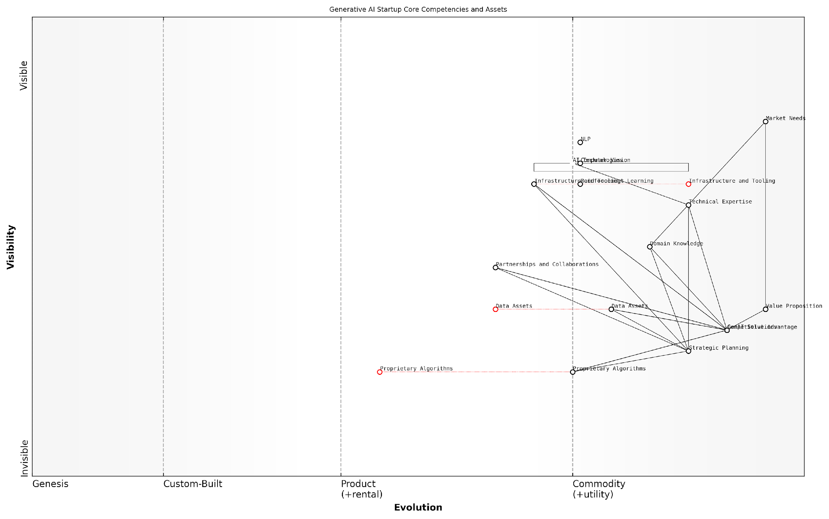

*Draft Wardley Map: [Insert Wardley Map: Mapping Your Core Competencies and Assets]*

[Edit this draft Wardley Map](https://create.wardleymaps.ai/#clone:cf2e5a7a7c15b10344)

Wardley Map Assessment

The startup is well-positioned in the Generative AI space with a clear focus on market needs and strong technical foundations. The key to maintaining competitive advantage lies in continuously evolving Proprietary Algorithms, enriching Data Assets, and strengthening Domain Knowledge. Strategic partnerships and a platform approach could significantly enhance the startup’s position in the ecosystem. Prioritising R&D in emerging AI technologies while maintaining a close connection to market needs will be crucial for long-term success.

[View full Wardley Map report](http://markdown/wardley_map_reports/wardley_map_report_16_Mapping_Your_Core_Competencies_and_Assets.md)

By mapping your core competencies and assets, you gain several strategic insights:

* Identify areas of unique strength that can be leveraged to create differentiated GenAI products or services
* Spot potential vulnerabilities where your assets may be at risk of commoditisation or disruption
* Recognise opportunities to develop new competencies that align with future market needs
* Visualise how your assets interact and support each other within the broader ecosystem

It’s crucial to approach this mapping process with honesty and objectivity. As a senior adviser in the field notes:

Many startups fall into the trap of overestimating their unique capabilities. In the GenAI space, it’s essential to rigorously assess what truly sets you apart and focus on amplifying those differentiators.

Remember that core competencies and assets are not static. The GenAI landscape is evolving rapidly, and what constitutes a unique advantage today may become commonplace tomorrow. Regular reassessment and updating of your map is crucial to maintain a clear understanding of your position in the market.

As you map your core competencies and assets, consider how they align with market needs and gaps. This alignment is crucial for developing a compelling value proposition. Look for intersections between your unique strengths and unmet market demands or emerging opportunities in the GenAI space.

For example, if your team has deep expertise in a specific domain (e.g., healthcare) and you’ve developed proprietary algorithms for processing medical imaging data, you might identify a unique opportunity to create GenAI solutions for medical diagnosis or treatment planning. This combination of domain knowledge, technical expertise, and proprietary technology could form the basis of a powerful value proposition in the healthcare AI market.

Additionally, consider how your core competencies and assets can be combined or leveraged in novel ways. Sometimes, the most compelling value propositions emerge from unexpected combinations of capabilities. Use your Wardley Map to explore potential synergies and innovative applications of your assets.

Finally, it’s important to view your core competencies and assets through the lens of sustainability and scalability. As you map these elements, consider:

* How easily can your core competencies be replicated or acquired by competitors?
* Are your assets scalable, or do they present limitations as you grow?
* How can you continue to develop and evolve your competencies to stay ahead in the fast-moving GenAI landscape?
* What investments or strategic moves are needed to strengthen or expand your core competencies and assets?

By thoroughly mapping your core competencies and assets using Wardley Mapping techniques, you lay the groundwork for developing a robust and differentiated strategy for your GenAI startup. This process not only helps you articulate your unique value proposition but also provides a strategic framework for decision-making, resource allocation, and future planning in the dynamic world of Generative AI.

### Analysing Gaps in the Market

In the rapidly evolving landscape of Generative AI, identifying and capitalising on market gaps is crucial for startup success. Wardley Mapping provides a powerful framework for visualising the current market state and uncovering opportunities that others may have overlooked. By systematically analysing gaps in the market, GenAI startups can position themselves strategically and develop offerings that address unmet needs or underserved segments.

To effectively analyse market gaps using Wardley Mapping, startups should focus on three key areas: identifying underserved needs, spotting technological gaps, and recognising emerging market shifts. Let’s explore each of these in detail.

* Identifying Underserved Needs
* Spotting Technological Gaps
* Recognising Emerging Market Shifts

Identifying Underserved Needs: Begin by mapping out the current GenAI landscape, including existing products, services, and their respective value chains. Look for areas where customer needs are not being fully met or where there’s a mismatch between what’s available and what users actually require. These gaps often appear as ‘white spaces’ on your Wardley Map, indicating potential opportunities for innovation.

A seasoned AI venture capitalist once remarked, ‘The most successful GenAI startups are those that can identify and address the pain points that established players have overlooked or deemed too niche to pursue.’

To uncover these underserved needs, consider conducting in-depth user research, analysing customer feedback on existing solutions, and engaging with industry experts. Look for patterns of dissatisfaction or areas where users are creating workarounds, as these often indicate unmet needs.

Spotting Technological Gaps: Examine the current state of GenAI technologies on your Wardley Map. Identify areas where there are significant leaps between the maturity levels of different components. These gaps often represent opportunities for technological innovation. For instance, you might notice that while natural language processing has advanced significantly, there’s a lack of solutions that effectively combine it with domain-specific knowledge in certain industries.

Pay close attention to components that are transitioning from the ‘custom-built’ to the ‘product’ or ‘commodity’ stages. These transitions often create opportunities for startups to develop specialised solutions or platforms that bridge the gap between cutting-edge research and practical applications.

As a prominent AI researcher noted, ‘The most impactful innovations in GenAI often come from bridging the gap between academic breakthroughs and real-world applications.’

Recognising Emerging Market Shifts: Wardley Mapping is particularly powerful in identifying emerging trends and potential market shifts. Look for components that are moving rapidly along the evolution axis or clusters of activity forming around certain areas of the map. These can indicate emerging opportunities that are not yet fully realised by the market.

For example, you might notice increased activity and evolution in privacy-preserving AI techniques. This could signal a growing market demand for GenAI solutions that prioritise data privacy, presenting an opportunity for startups to develop innovative approaches in this space.

Additionally, analyse the dependencies between different components on your map. Gaps often appear at the intersections of evolving technologies or where there’s a lack of integration between different parts of the value chain.

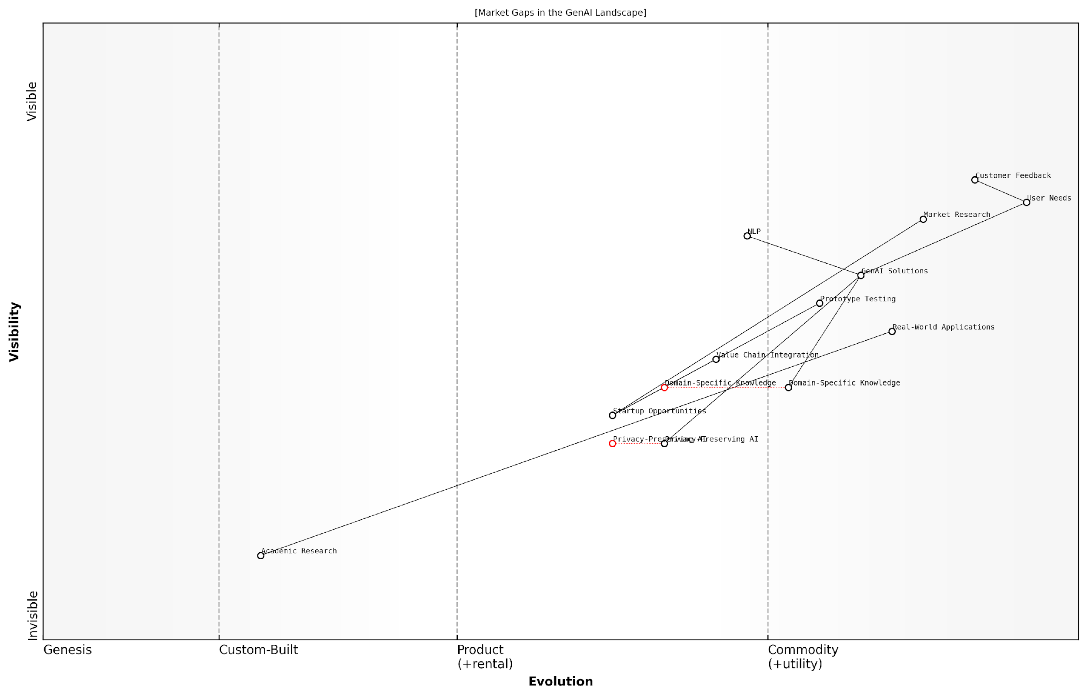

*Draft Wardley Map: [Insert Wardley Map: Analysing Gaps in the Market]*

[Edit this draft Wardley Map](https://create.wardleymaps.ai/#clone:cb7ada5472289f546e)

Wardley Map Assessment

The GenAI landscape presents significant opportunities for startups to create value by addressing underserved needs, particularly in privacy-preservation and domain-specific applications. While general-purpose GenAI solutions are maturing, the map indicates that innovation in specialised areas and integration across the value chain can provide substantial competitive advantages. Startups should focus on developing unique capabilities in privacy-preserving AI and domain-specific knowledge integration, while maintaining agility to adapt to the rapidly evolving technological landscape and user needs.

[View full Wardley Map report](http://markdown/wardley_map_reports/wardley_map_report_17_Analyzing_Gaps_in_the_Market.md)

Once you’ve identified potential gaps, it’s crucial to validate them through market research, customer interviews, and prototype testing. Not all gaps represent viable business opportunities, so thorough validation is essential before committing resources to development.

Remember that in the fast-paced world of GenAI, gaps in the market can appear and disappear quickly. Regular updates to your Wardley Maps and continuous market analysis are necessary to stay ahead of the curve and identify emerging opportunities as they arise.

A leading GenAI startup founder advised, ‘In this field, your ability to rapidly identify and act on market gaps is often the difference between leading the pack and playing catch-up.’

By leveraging Wardley Mapping to systematically analyse gaps in the GenAI market, startups can position themselves strategically, develop innovative solutions that address real needs, and create a strong foundation for sustainable growth in this dynamic and competitive landscape.

### Positioning Your Offering on the Value Chain

In the rapidly evolving landscape of Generative AI, positioning your startup’s offering on the value chain is a critical step in crafting a compelling and sustainable strategy. This process involves a deep understanding of your product or service’s place within the broader ecosystem, and how it creates unique value for your target customers. By leveraging Wardley Mapping techniques, we can visualise and analyse the GenAI value chain, identifying opportunities for differentiation and strategic positioning.

To begin, it’s essential to map out the entire GenAI value chain, from foundational technologies to end-user applications. This mapping exercise will help you identify where your offering fits and where it can potentially create the most value. Consider the following components of the GenAI value chain:

* Foundational AI models and algorithms
* Data preprocessing and management
* Model training and fine-tuning
* Inference and deployment infrastructure
* API and integration layers
* Application development and customisation
* User interfaces and experience design
* Industry-specific solutions and use cases

Once you’ve mapped these components, assess where your offering sits within this chain. Are you providing a novel AI model, a specialised training dataset, an efficient deployment solution, or a user-friendly application built on existing models? Understanding your position helps clarify your role in the ecosystem and informs your strategic decisions.

Next, consider the evolution axis of your Wardley Map. Where does your offering fall on the spectrum from genesis (novel and chaotic) to commodity (well-understood and stable)? This positioning will influence your approach to innovation, pricing, and market entry strategies. For instance, if you’re working with cutting-edge, genesis-stage technology, you may need to focus on education and proof-of-concept projects. Conversely, if you’re building on more commoditised components, your emphasis might be on efficiency, scale, and user experience.

Understanding where you sit on the evolution axis is crucial. It’s not just about being innovative; it’s about knowing exactly how innovative you need to be at each stage of your journey.

As you position your offering, consider the following strategic questions:

* What unique capabilities or assets do you bring to the value chain?
* How does your offering reduce friction or solve pain points in the existing process?
* Are there gaps in the current value chain that your solution can fill?
* How does your positioning align with market demands and customer needs?
* What potential for future evolution or expansion does your current position offer?

It’s also crucial to consider the interdependencies within the value chain. Your positioning should take into account both upstream suppliers and downstream customers. Identify key partnerships or integrations that could enhance your value proposition. For example, if you’re developing a specialised GenAI application for healthcare, you might need to partner with medical data providers upstream and electronic health record systems downstream.

Furthermore, don’t overlook the importance of ancillary services in your positioning strategy. These might include consulting, customisation, training, or ongoing support. These services can often provide significant value and differentiation, especially in the early stages of GenAI adoption where many customers require guidance and expertise.

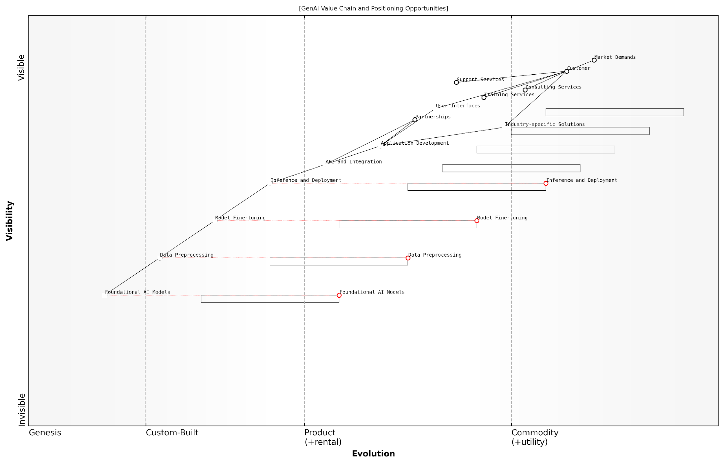

*Draft Wardley Map: [Insert Wardley Map: Positioning Your Offering on the Value Chain]*

[Edit this draft Wardley Map](https://create.wardleymaps.ai/#clone:8d2c063c4f962aaaa2)

Wardley Map Assessment

This Wardley Map reveals a maturing GenAI landscape with significant opportunities for startups to differentiate through industry-specific solutions and superior user experiences. The key to success lies in balancing investment across the value chain, with a focus on areas close to the customer while maintaining strong capabilities or partnerships in foundational technologies. The rapid evolution of lower-level components suggests a need for agility and continuous innovation. Startups should prioritise building unique industry solutions and efficient integration capabilities while leveraging partnerships for rapidly evolving foundational technologies. The inclusion of services alongside product components indicates potential for comprehensive solution offerings, but care must be taken to maintain focus and avoid overextension. Overall, the map points to a dynamic, competitive landscape with ample opportunities for well-positioned, strategically focused GenAI startups.

[View full Wardley Map report](http://markdown/wardley_map_reports/wardley_map_report_18_Positioning_Your_Offering_on_the_Value_Chain.md)

Remember that positioning is not a one-time exercise. The GenAI landscape is rapidly evolving, and your position within it will need to adapt. Regularly revisit and update your Wardley Map to ensure your positioning remains relevant and competitive. Be prepared to pivot or expand your offering as the market matures and new opportunities emerge.

In the world of GenAI startups, your position today is less important than your ability to anticipate and adapt to the position you’ll need tomorrow.

By thoughtfully positioning your offering on the GenAI value chain, you set the foundation for a compelling value proposition and a sustainable competitive advantage. This strategic clarity will guide your product development, marketing efforts, and business model decisions, ultimately increasing your chances of success in the dynamic and competitive world of GenAI startups.

## Developing a Sustainable Business Model

### Mapping Revenue Streams and Cost Structures

In the rapidly evolving landscape of Generative AI startups, mapping revenue streams and cost structures is a critical component of developing a sustainable business model. This process not only provides clarity on financial viability but also offers strategic insights that can drive decision-making and resource allocation. By leveraging Wardley Mapping techniques, GenAI startups can visualise their financial ecosystem, identify potential opportunities, and mitigate risks associated with their cost and revenue structures.

To begin mapping revenue streams, it’s essential to identify all potential sources of income for your GenAI startup. These may include:

* Direct sales of GenAI products or services
* Subscription-based models for ongoing access to AI capabilities
* Licensing fees for proprietary AI models or algorithms
* Consulting services for AI implementation and customisation
* Data monetisation (with appropriate ethical and legal considerations)
* API access fees for third-party developers
* Partnership revenue from collaborations with other tech companies

Once identified, these revenue streams should be positioned on the Wardley Map based on their evolution and value to the customer. This visualisation allows startups to assess which revenue streams are most mature and reliable, and which ones have the potential for future growth or disruption.

A seasoned AI venture capitalist once remarked, ‘The most successful GenAI startups are those that can identify and nurture multiple, complementary revenue streams that evolve with the technology and market demands.’

On the cost structure side, it’s crucial to map out all significant expenses associated with developing and delivering your GenAI solutions. Key cost categories often include:

* Research and development expenses
* Computing infrastructure and cloud services costs
* Data acquisition and management expenses
* Salaries for AI researchers, engineers, and support staff
* Marketing and sales expenditures
* Legal and compliance costs, particularly for data privacy and AI ethics
* Office space and operational overheads

Mapping these costs on the Wardley Map helps identify which expenses are essential for your core value proposition and which might be candidates for optimisation or outsourcing. It’s particularly important to consider the evolution of these costs over time. For instance, while initial R&D costs might be high, they may decrease as your AI models mature, whereas computing costs might scale with your user base.

A critical aspect of this mapping process is understanding the interplay between revenue streams and cost structures. By visualising both on the same map, you can identify potential synergies or conflicts. For example, a particular revenue stream might require disproportionate infrastructure costs, or a cost-saving measure might impact the quality of a key revenue-generating service.

As a prominent AI startup advisor notes, ‘The magic happens when you can align your cost structures with your revenue streams in a way that creates a virtuous cycle of growth and efficiency.’

It’s also crucial to consider the temporal aspect of your financial mapping. GenAI technologies and markets are evolving rapidly, so your revenue streams and cost structures today may look very different in 12 or 24 months. Use the Wardley Map to project how these elements might evolve over time, allowing you to anticipate and prepare for future shifts in your business model.

Furthermore, don’t overlook the importance of mapping potential future revenue streams and costs. The GenAI field is ripe with opportunities, and your startup should be prepared to pivot or expand as new possibilities emerge. This forward-thinking approach can help you stay ahead of the curve and maintain a competitive edge in the market.

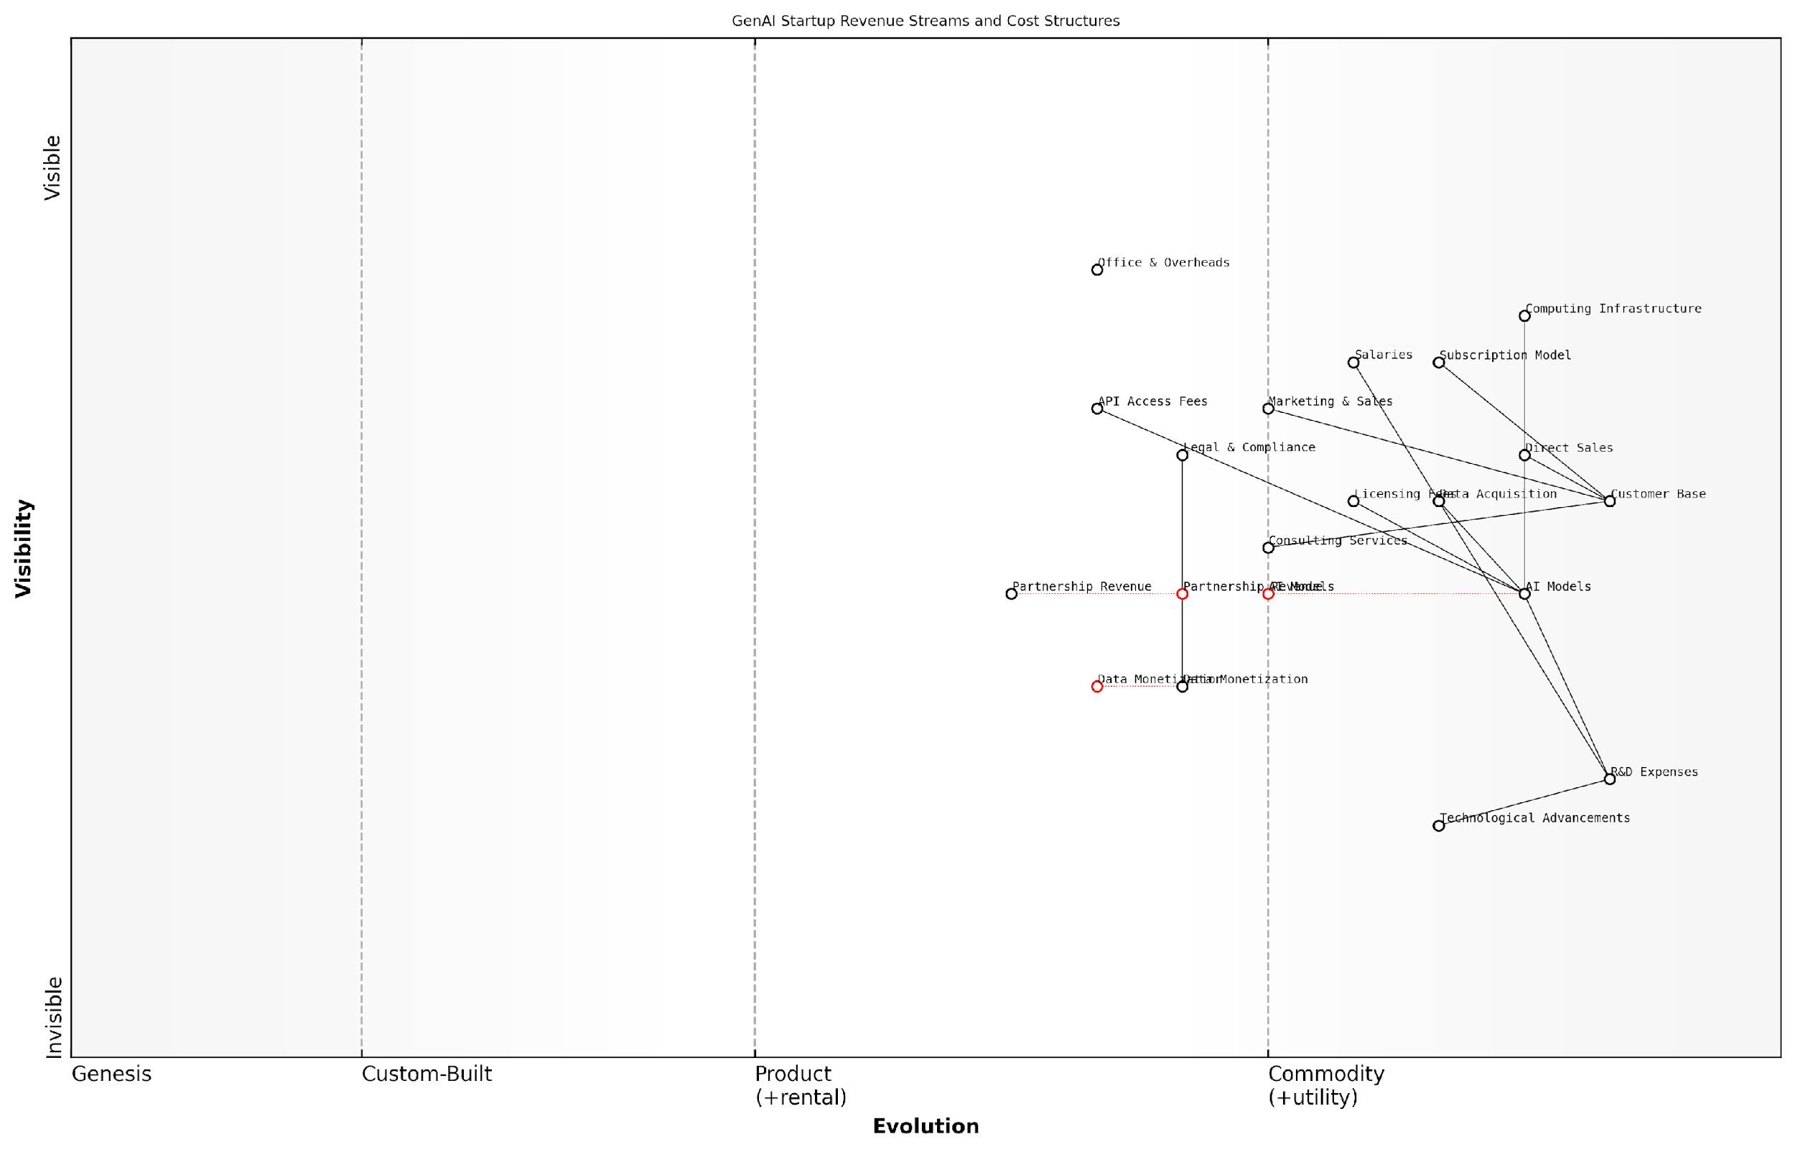

*Draft Wardley Map: [Insert Wardley Map: Mapping Revenue Streams and Cost Structures]*

[Edit this draft Wardley Map](https://create.wardleymaps.ai/#clone:70b54deacd78de1d84)

Wardley Map Assessment

The GenAI startup shows a strong foundation with diverse revenue streams and a focus on core AI capabilities. To maintain competitiveness, it should optimise costs, diversify revenue further, and build a robust ecosystem. The key to long-term success lies in balancing continuous AI innovation with the development of a scalable, efficient infrastructure and a thriving partner network.

[View full Wardley Map report](http://markdown/wardley_map_reports/wardley_map_report_19_Mapping_Revenue_Streams_and_Cost_Structures.md)

By thoroughly mapping your revenue streams and cost structures using Wardley Mapping techniques, you create a powerful tool for strategic decision-making. This visual representation can help you identify areas for investment, potential risks, and opportunities for optimisation. It also provides a common language for discussing financial strategy across your organisation, ensuring that all stakeholders have a clear understanding of the business model and its potential evolution.

Remember, the goal is not just to create a static map, but to use it as a dynamic tool for ongoing analysis and strategy refinement. Regularly revisiting and updating your financial map will help ensure that your GenAI startup remains agile and responsive to the ever-changing technological and market landscape, ultimately contributing to the development of a truly sustainable business model.

### Identifying Key Partnerships and Collaborations

In the rapidly evolving landscape of Generative AI, identifying and nurturing key partnerships and collaborations is crucial for developing a sustainable business model. As an expert in Wardley Mapping for GenAI startups, I cannot overstate the importance of strategic alliances in this field. These partnerships can provide access to essential resources, technologies, and markets that can significantly accelerate a startup’s growth and enhance its competitive position.

When mapping key partnerships and collaborations for a GenAI startup, it’s essential to consider the entire value chain and ecosystem. This includes not only direct business partners but also academic institutions, research centres, and even potential competitors. The goal is to create a network of relationships that can support and sustain your business model in the long term.

* Data providers: Essential for training and refining AI models
* Cloud infrastructure partners: Crucial for scalable and cost-effective computing resources
* API and platform providers: Can extend your service offerings and reach
* Industry-specific partners: Provide domain expertise and market access
* Research institutions: Offer cutting-edge insights and potential talent pipeline
* Regulatory bodies and ethics councils: Help navigate complex ethical and legal landscapes

When mapping these partnerships on a Wardley Map, consider their position along the evolution axis. Some partnerships, such as those with established cloud providers, may be more commoditised and sit towards the right of the map. Others, like collaborations with cutting-edge research institutions, might be positioned more towards the left, indicating their genesis or custom-built nature.

In the GenAI space, the right partnerships can be the difference between a startup that thrives and one that merely survives. It’s not just about what you know, but who you know and how you leverage those relationships.

It’s crucial to assess the strategic value of each potential partnership. Consider factors such as alignment with your core competencies, potential for innovation, market access, and risk mitigation. For instance, a partnership with a leading cloud provider might offer scalability and credibility, but it may also create dependencies that could limit future flexibility.

When mapping collaborations, pay particular attention to the flows between different components of your business model. How does each partnership contribute to your value proposition? How does it affect your cost structure or revenue streams? These connections will help you visualise the interdependencies and potential leverage points within your business ecosystem.

* Identify gaps in your current capabilities or resources
* Map potential partners based on their ability to fill these gaps
* Assess the strategic fit and potential risks of each partnership
* Consider the evolution of partnerships over time - will they become more or less critical?
* Evaluate the power dynamics within each partnership - aim for mutually beneficial relationships
* Plan for contingencies - what if a key partnership fails?

It’s also important to consider the ethical implications of your partnerships, especially in the GenAI field where issues of data privacy, bias, and societal impact are paramount. Collaborations with ethics boards or human rights organisations can provide valuable guidance and enhance your startup’s credibility and trustworthiness.

In the world of GenAI, your network is your net worth. But it’s not just about quantity - the quality and strategic alignment of your partnerships can make or break your startup’s success.

Remember that partnerships are not static. As your startup evolves and the GenAI landscape shifts, you’ll need to regularly reassess and potentially reconfigure your collaborations. Use your Wardley Map as a dynamic tool, updating it as partnerships mature, new opportunities emerge, or market conditions change.

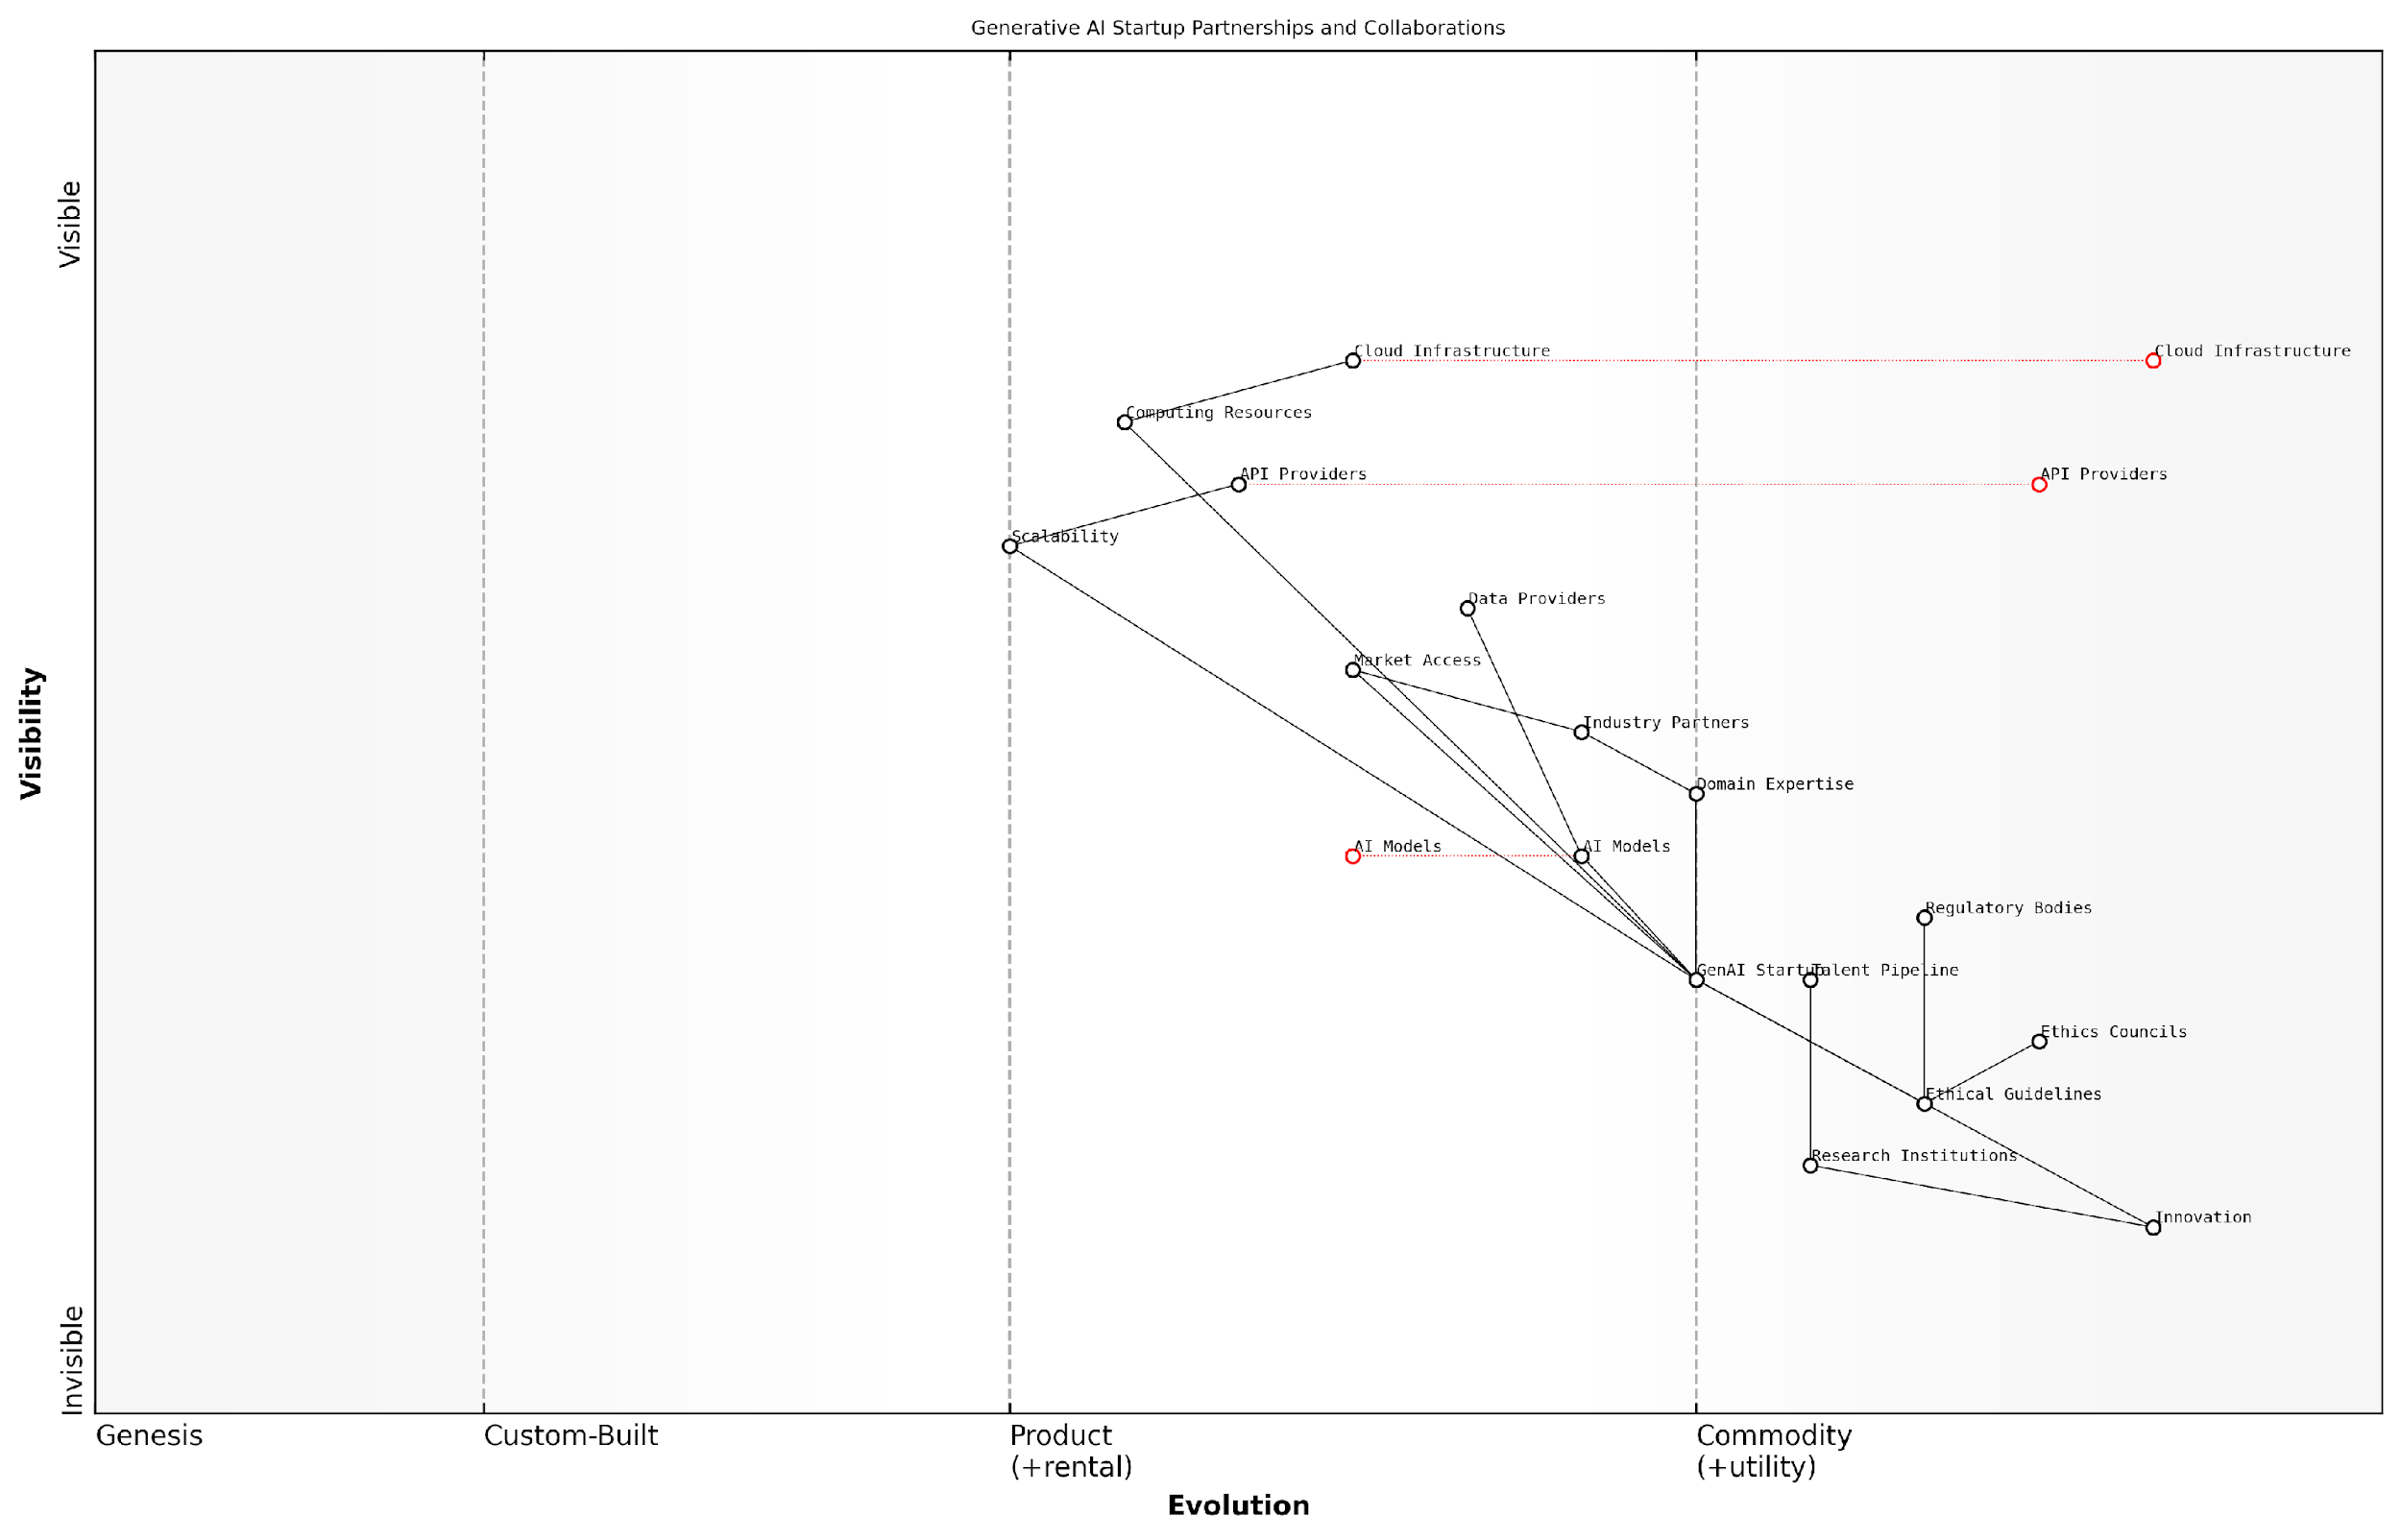

*Draft Wardley Map: [Insert Wardley Map: Identifying Key Partnerships and Collaborations]*

[Edit this draft Wardley Map](https://create.wardleymaps.ai/#clone:be47b7927a492e1128)

Wardley Map Assessment

The GenAI Startup is well-positioned to capitalise on the growing AI market by leveraging its central role in connecting various critical components. However, to maintain this advantage, it must navigate the rapid commoditization of core technologies, strengthen its ethical framework, and deepen industry-specific expertise. The key to long-term success lies in balancing technological innovation with ethical considerations and industry relevance, while preparing for the next wave of AI advancements such as quantum computing. Strategic partnerships, especially with Industry Partners and Ethics Councils, will be crucial in creating sustainable competitive advantages in an increasingly crowded and regulated AI landscape.

[View full Wardley Map report](http://markdown/wardley_map_reports/wardley_map_report_20_Identifying_Key_Partnerships_and_Collaborations.md)

By thoughtfully mapping and managing your partnerships and collaborations, you can create a robust and adaptable business model that leverages the strengths of your ecosystem while maintaining your startup’s unique value proposition. This strategic approach to collaboration is essential for navigating the complex and fast-paced world of GenAI startups.

### Balancing Innovation and Sustainability

In the rapidly evolving landscape of Generative AI, startups face the critical challenge of balancing innovation with sustainability. This delicate equilibrium is essential for long-term success, particularly when applying Wardley Mapping to develop a robust business model. As an expert in this field, I’ve observed that the most successful GenAI startups are those that can maintain a steady stream of innovative offerings while ensuring their business operations remain sustainable and scalable.

To achieve this balance, it’s crucial to map out both your innovation pipeline and your sustainability metrics on your Wardley Map. This visual representation allows you to identify potential conflicts and synergies between these two vital aspects of your business.

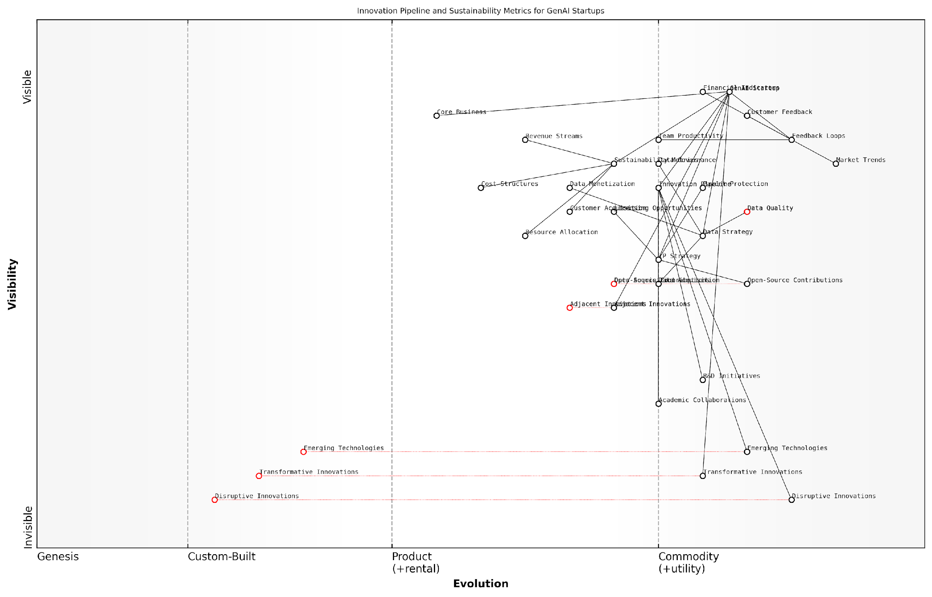

*Draft Wardley Map: [Insert Wardley Map: Balancing Innovation and Sustainability]*

[Edit this draft Wardley Map](https://create.wardleymaps.ai/#clone:cd2590db80c70c723b)

Wardley Map Assessment

The GenAI Startup depicted in this Wardley Map demonstrates a mature and balanced approach to innovation and sustainability. Its strategic positioning shows a strong foundation in data strategy and feedback loops, with a clear focus on both cutting-edge innovations and business sustainability. The key challenge lies in maintaining this balance as the company grows, particularly in translating disruptive innovations into the core business while continuing to meet sustainability metrics. The startup is well-positioned to leverage its data assets and innovation pipeline for competitive advantage, but must remain vigilant about emerging technologies and potential disruptions to its core business. Strategic priorities should include optimising resource allocation, enhancing data monetization strategies, and fostering a more integrated ecosystem that includes academic collaborations and selective open-source contributions. By addressing these areas, the GenAI Startup can strengthen its position and drive long-term success in the rapidly evolving AI landscape.

[View full Wardley Map report](http://markdown/wardley_map_reports/wardley_map_report_21_Balancing_Innovation_and_Sustainability.md)

When mapping your innovation pipeline, consider the following elements:

* Research and Development initiatives
* Emerging technologies in the GenAI space
* Potential disruptive innovations
* Collaborative projects with academic institutions or other startups

For sustainability metrics, focus on mapping:

* Revenue streams and their stability
* Cost structures and efficiency measures
* Customer acquisition and retention rates
* Resource allocation and utilisation

By visualising these elements on your Wardley Map, you can identify areas where innovation might be compromising sustainability, or where a focus on sustainability might be stifling innovation. This insight allows you to make informed decisions about resource allocation and strategic priorities.

A seasoned GenAI entrepreneur once told me, ‘The key to longevity in this field is not just about having the most cutting-edge technology, but about having a business model that can sustain the continuous development of that technology.’

One effective strategy for balancing innovation and sustainability is to implement a portfolio approach. This involves categorising your projects and initiatives into three buckets:

* Core Business: Stable, revenue-generating products or services that form the backbone of your sustainability
* Adjacent Innovations: Developments that build upon your core competencies but explore new markets or technologies
* Transformative Innovations: High-risk, high-reward projects that could potentially disrupt the market

By mapping these categories on your Wardley Map, you can ensure a balanced distribution of resources and attention across different levels of innovation while maintaining a sustainable core business.

Another crucial aspect of balancing innovation and sustainability is the strategic management of intellectual property (IP). In the GenAI space, where technological advancements occur rapidly, protecting your innovations while also fostering an environment of open collaboration can be challenging. Your Wardley Map should include an IP strategy that identifies:

* Core technologies that require robust patent protection
* Areas where open-source contributions can accelerate innovation and community building
* Potential licensing opportunities that can create additional revenue streams
* Collaborative research initiatives that can distribute the cost and risk of innovation

It’s also essential to consider the role of data in your GenAI startup’s innovation and sustainability balance. Data is often the lifeblood of AI companies, and your Wardley Map should reflect your data strategy, including:

* Data acquisition and generation methods
* Data quality and diversity measures
* Data governance and compliance frameworks
* Data monetisation opportunities

By mapping these data-related elements, you can identify opportunities to leverage your data assets for both innovation (e.g., training more advanced AI models) and sustainability (e.g., creating data-driven products or services).

As a prominent AI researcher recently noted, ‘In the world of GenAI, your data strategy is inseparable from your innovation strategy. The quality and uniqueness of your data can be as important as your algorithms in creating sustainable competitive advantage.’

Lastly, it’s crucial to incorporate feedback loops into your Wardley Map to ensure that your balance between innovation and sustainability remains dynamic and responsive to market changes. These feedback loops should include:

* Regular customer feedback and usage metrics
* Market trend analysis and competitive intelligence
* Financial performance indicators
* Team productivity and satisfaction measures

By continuously updating your Wardley Map with this information, you can make real-time adjustments to your innovation and sustainability strategies, ensuring that your GenAI startup remains agile and resilient in a rapidly evolving landscape.

In conclusion, balancing innovation and sustainability is not a one-time exercise but an ongoing process of strategic mapping, analysis, and adjustment. By leveraging Wardley Mapping techniques to visualise and manage this balance, GenAI startups can position themselves for long-term success in this exciting and challenging field.

## Planning for Scale and Growth

### Mapping Potential Growth Trajectories

Here’s the content reviewed and corrected for UK English:

For GenAI startups, mapping potential growth trajectories is a critical exercise in strategic foresight. It involves leveraging Wardley Mapping techniques to visualise and plan for various paths of expansion and development. This process is particularly crucial in the rapidly evolving landscape of generative AI, where market conditions and technological capabilities can shift dramatically in short periods.

To effectively map potential growth trajectories, GenAI startups must first establish a clear understanding of their current position within the value chain. This involves identifying core competencies, key dependencies, and areas of potential differentiation. With this baseline established, the startup can then project multiple possible futures, each representing a different growth path.

* Vertical Integration: Expanding control over the value chain
* Horizontal Expansion: Diversifying into adjacent markets or applications
* Geographic Scaling: Entering new regional or global markets
* Product Line Extension: Developing new AI models or services
* Ecosystem Development: Building a platform or network of complementary services

Each of these growth trajectories can be mapped using Wardley Mapping techniques, allowing startups to visualise the movement of components along the evolution axis over time. This process helps identify potential bottlenecks, dependencies, and opportunities that may arise as the company grows.

Mapping growth trajectories is not about predicting the future with certainty, but about preparing for multiple possible futures and being adaptable enough to navigate them successfully.

When mapping growth trajectories, it’s crucial to consider external factors that may influence the startup’s path. These can include regulatory changes, technological advancements, shifts in customer preferences, and competitive moves. By incorporating these factors into the maps, startups can develop more robust and resilient growth strategies.

One effective approach is to create multiple maps, each representing a different growth scenario. These scenarios might include: 1. Rapid Scaling: Focusing on aggressive market capture and rapid expansion 2. Niche Dominance: Deepening expertise and market share in a specific vertical 3. Technological Leadership: Prioritising R&D to maintain a cutting-edge advantage 4. Ecosystem Play: Building a platform or network of AI services and partners

By comparing these different trajectories, startups can identify common elements and critical decision points. This analysis helps in developing a flexible growth strategy that can adapt to changing market conditions while maintaining a clear long-term vision.

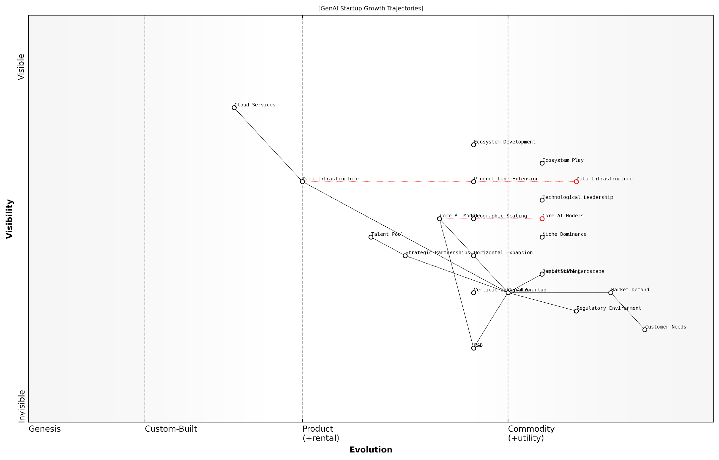

*Draft Wardley Map: [Insert Wardley Map: Mapping Potential Growth Trajectories]*

[Edit this draft Wardley Map](https://create.wardleymaps.ai/#clone:479ca7f5b0e9f78e46)

Wardley Map Assessment

The GenAI Startup is well-positioned for growth with multiple strategic options available. The key to success lies in balancing technological innovation, market expansion, and ecosystem development while navigating regulatory challenges. The startup should focus on maintaining its technological edge through R&D while exploring various growth trajectories, with a particular emphasis on vertical integration and ecosystem development in the short to medium term. Long-term success will depend on the ability to adapt to the evolving AI landscape, potentially shifting towards more specialised applications or platform-based models as core technologies commoditize.

[View full Wardley Map report](http://markdown/wardley_map_reports/wardley_map_report_22_Mapping_Potential_Growth_Trajectories.md)

It’s important to note that growth trajectories in the GenAI space often involve non-linear progression. Breakthroughs in AI capabilities, sudden shifts in market demand, or regulatory changes can create step-changes in a startup’s growth path. Wardley Mapping helps visualise these potential discontinuities and prepare for them.

When mapping growth trajectories, GenAI startups should also consider the evolution of key components within their value chain. For instance, as certain AI models or techniques become more commoditised, startups may need to shift their focus to higher-value activities or novel applications to maintain their competitive edge.

* Identify key inflection points where strategic decisions will be required
* Map the expected evolution of critical components and dependencies
* Visualise the impact of potential disruptive events or technologies
* Consider how growth trajectories align with or diverge from competitors
* Assess resource requirements and potential constraints for each growth path

By thoroughly mapping potential growth trajectories, GenAI startups can develop a more nuanced and adaptable approach to scaling their business. This strategic foresight enables them to anticipate challenges, seize opportunities, and navigate the complex and rapidly changing landscape of generative AI with greater confidence and agility.

The most successful GenAI startups will be those that can not only envision multiple growth paths but also rapidly adapt their strategies as the market evolves. Wardley Mapping provides the framework to achieve this level of strategic flexibility.

### Identifying Scalability Challenges and Solutions

As a GenAI startup poised for growth, identifying and addressing scalability challenges is crucial for long-term success. Wardley Mapping provides an invaluable framework for visualising these challenges and developing effective solutions. By mapping out your scalability landscape, you can anticipate bottlenecks, plan for infrastructure expansion, and ensure your GenAI services can meet growing demand without compromising quality or performance.

When mapping scalability challenges, it’s essential to consider both technical and operational aspects. On the technical side, you’ll need to examine your AI models, data processing capabilities, and infrastructure. Operationally, you’ll need to consider team structure, processes, and customer support mechanisms. Let’s delve into these areas and explore how Wardley Mapping can help identify and address key scalability challenges.

* Technical Scalability Challenges
* Operational Scalability Challenges
* Financial Scalability Considerations
* Market and Customer Scalability

Technical Scalability Challenges: As your GenAI startup grows, you’ll likely face several technical hurdles. One primary challenge is scaling your AI models to handle increased data volumes and user requests. This may require transitioning from single-instance models to distributed computing architectures. Another challenge is managing data storage and processing at scale, which might necessitate a shift from traditional databases to cloud-based, distributed storage solutions.

As a seasoned AI architect puts it, ‘The key to technical scalability in GenAI is not just about throwing more computing power at the problem. It’s about designing systems that can elegantly expand and contract based on demand, while maintaining consistent performance and accuracy.’

To address these challenges, your Wardley Map should include components such as your AI models, data storage systems, and computing infrastructure. Position these on the evolution axis to identify which components are likely to become bottlenecks as you scale. For instance, if your proprietary AI model is in the ‘custom-built’ phase, you might need to plan for its evolution towards a more standardised, scalable architecture.

Operational Scalability Challenges: As your user base grows, so too will the demands on your team and processes. You’ll need to scale your customer support, onboarding processes, and potentially your sales and marketing efforts. Your Wardley Map should include these operational components, helping you visualise how they need to evolve to support your growing business.

One common challenge is maintaining quality and consistency as you scale your team. You might need to transition from a flat structure where everyone does a bit of everything, to a more specialised team structure with dedicated roles. Your map can help you plan this transition by showing the evolution of different roles and responsibilities within your organisation.

* Implement robust knowledge management systems
* Develop standardised training and onboarding processes
* Automate routine tasks to free up human resources for complex problems
* Establish clear communication channels and escalation procedures

Financial Scalability Considerations: As you scale, you’ll need to ensure your financial model can support your growth. This includes managing cash flow, securing additional funding if necessary, and potentially adjusting your pricing model. Your Wardley Map should include financial components such as revenue streams, cost structures, and funding sources.

One challenge many GenAI startups face is the increasing cost of computing resources as they scale. Your map can help you visualise the relationship between your technical infrastructure and your cost structure, allowing you to identify opportunities for optimisation. For instance, you might identify a need to invest in more efficient AI algorithms or explore alternative cloud providers to manage costs as you scale.

A prominent venture capitalist in the AI space notes, ‘The most successful GenAI startups are those that can demonstrate not just technical innovation, but also a clear path to financial scalability. They understand how their costs will evolve as they grow and have strategies in place to maintain healthy margins.’

Market and Customer Scalability: As you expand, you may need to adapt your product or service to cater to a broader market or enter new geographical regions. Your Wardley Map should include components related to your target markets, customer segments, and potentially regulatory environments if you’re expanding internationally.

One challenge here is maintaining product-market fit as you scale. Your initial success might be based on serving a niche market exceptionally well, but as you grow, you may need to broaden your appeal without losing what made you special in the first place. Your map can help you visualise this balance, showing how your core offering needs to evolve to serve a larger market while maintaining its key value propositions.

* Conduct regular market research to understand evolving customer needs
* Develop a product roadmap that balances core functionality with new features for broader appeal
* Plan for localisation and internationalisation if expanding globally
* Monitor and adapt to changing regulatory landscapes in new markets

By mapping out these scalability challenges and potential solutions, you can create a comprehensive strategy for growth. Remember, scalability is not just about getting bigger – it’s about growing smarter. Your Wardley Map should be a living document, regularly updated as you encounter new challenges and opportunities in your scaling journey.

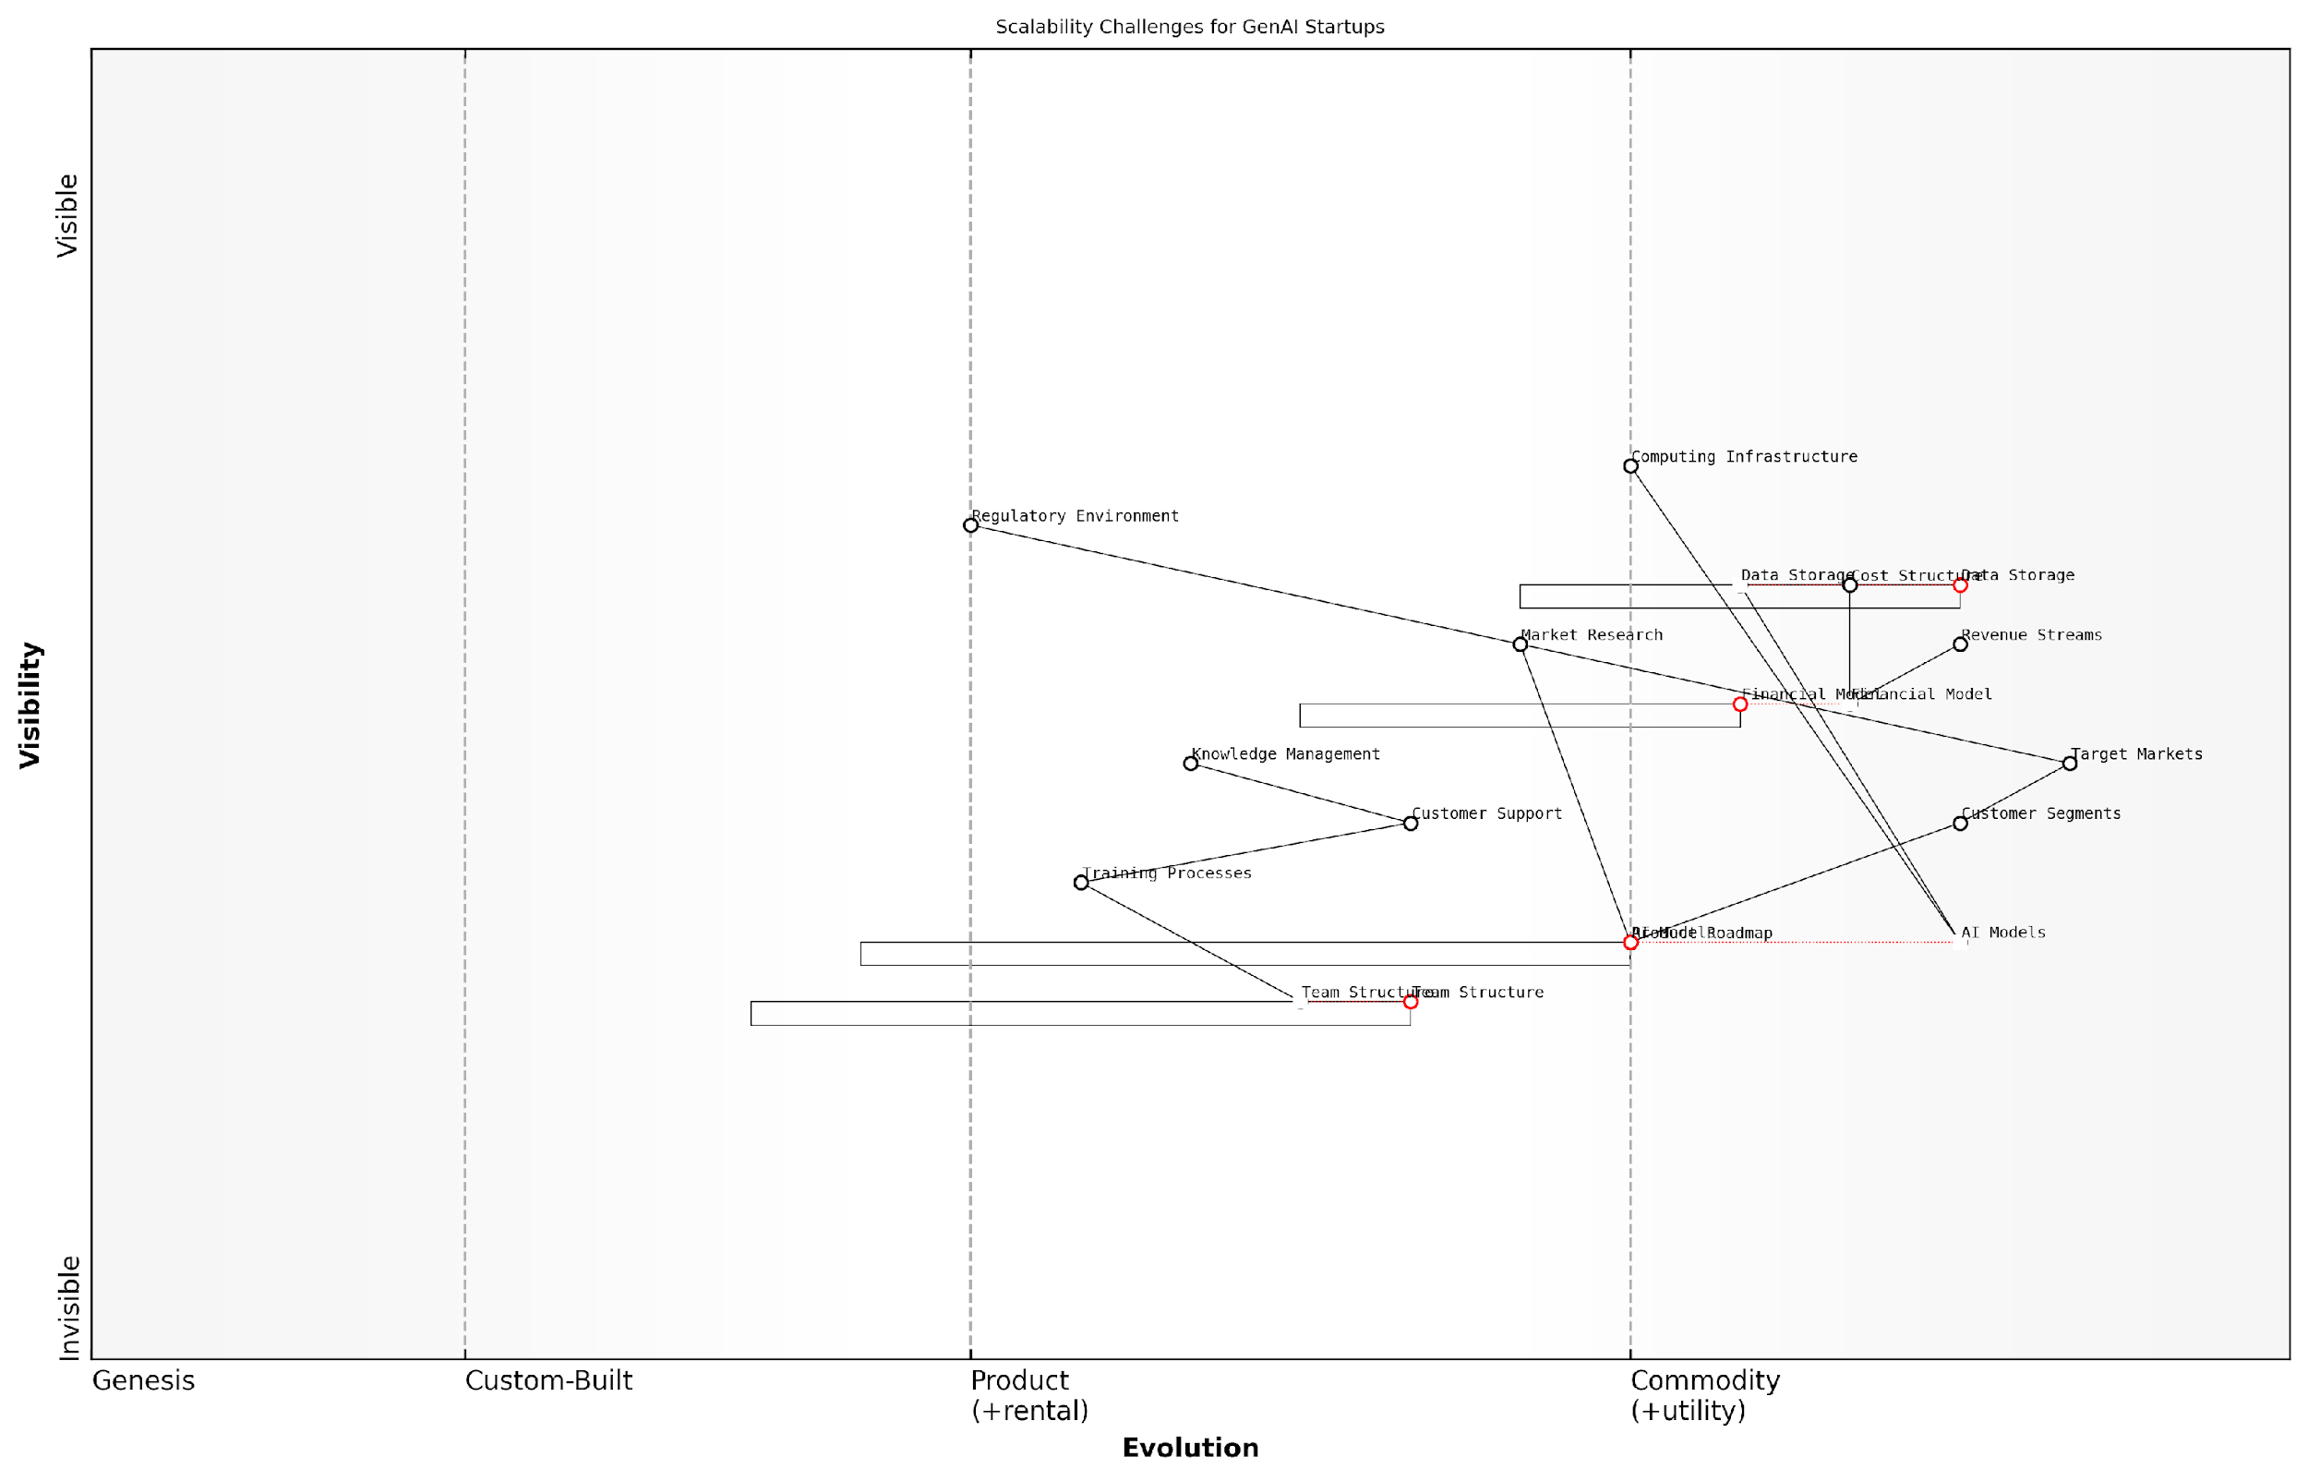

*Draft Wardley Map: [Insert Wardley Map: Identifying Scalability Challenges and Solutions]*

[Edit this draft Wardley Map](https://create.wardleymaps.ai/#clone:874eb0f7585cd4c175)

Wardley Map Assessment

The GenAI startup shows strong technical foundations but faces significant challenges in scaling its operations, particularly in areas of team structure, knowledge management, and adapting to regulatory environments. The key to success lies in balancing continued innovation in AI models with the development of robust, scalable organisational capabilities. Strategic focus should be on creating adaptive structures and processes that can evolve as rapidly as the core technology, while also navigating an increasingly complex regulatory landscape. Partnerships and ecosystem development will be crucial for addressing infrastructure scalability challenges, allowing the startup to focus on its core differentiators in AI innovation and market understanding.

[View full Wardley Map report](http://markdown/wardley_map_reports/wardley_map_report_23_Identifying_Scalability_Challenges_and_Solutions.md)

In conclusion, identifying scalability challenges and solutions is a critical exercise for any GenAI startup planning for growth. By leveraging Wardley Mapping, you can visualise your current position, anticipate future challenges, and develop strategies to overcome them. This proactive approach to scalability will help ensure that your startup is well-positioned to capitalise on the immense opportunities in the rapidly evolving GenAI landscape.

### Preparing for Market Expansion and Diversification

As a GenAI startup poised for growth, preparing for market expansion and diversification is crucial for long-term success. Wardley Mapping provides an invaluable framework for visualising and strategising these growth trajectories, allowing startups to anticipate challenges and capitalise on emerging opportunities in the rapidly evolving AI landscape.

When mapping your expansion and diversification strategies, it’s essential to consider both horizontal and vertical growth paths. Horizontal expansion involves entering new markets or geographies with your existing GenAI offerings, while vertical diversification entails developing new products or services that complement your core offerings or target adjacent markets.

* Identify potential new markets or use cases for your GenAI technology
* Map the competitive landscape and regulatory environment in target expansion areas
* Assess the evolution of customer needs and technological capabilities in different sectors
* Evaluate potential partnerships or acquisitions that could accelerate expansion
* Consider how your value chain might need to evolve to support new markets or offerings

One of the key advantages of using Wardley Mapping for expansion planning is its ability to highlight dependencies and potential bottlenecks in your growth strategy. By mapping out the entire value chain for new markets or offerings, you can identify critical components that may need to be developed or acquired to support your expansion.

Successful market expansion in the GenAI space requires a delicate balance between leveraging your core strengths and adapting to new market realities. Wardley Mapping helps you visualise this balance and make informed strategic decisions.

When considering diversification, it’s crucial to map out how new offerings or markets align with your existing capabilities and strategic positioning. This involves assessing the maturity of potential new technologies or markets and understanding how they might evolve over time. By doing so, you can identify opportunities to leverage your existing strengths while also pinpointing areas where you may need to develop new capabilities or forge strategic partnerships.

Another critical aspect of expansion planning is anticipating and preparing for potential challenges. These might include regulatory hurdles, cultural differences in new markets, or the need for specialised talent. By mapping these challenges alongside your expansion strategies, you can develop contingency plans and allocate resources more effectively.

* Map potential regulatory challenges in target markets and plan mitigation strategies
* Identify cultural factors that may impact adoption of your GenAI solutions in new regions
* Assess talent requirements for expansion and develop recruitment or training plans
* Evaluate infrastructure needs for scaling operations in new markets
* Consider data privacy and security implications of expansion, especially across borders

Diversification strategies should also be mapped with an eye towards creating synergies within your portfolio. By visualising how different offerings or markets interact and support each other, you can identify opportunities for cross-pollination of ideas, shared resources, or bundled solutions that create additional value for customers.

In the fast-paced world of GenAI, the ability to quickly identify and capitalise on adjacent opportunities can be a significant competitive advantage. Wardley Mapping provides a dynamic tool for continually reassessing and refining your expansion and diversification strategies.

As you map out your expansion and diversification plans, it’s crucial to consider the impact on your organisation’s culture and structure. Rapid growth can strain existing systems and processes, so it’s important to anticipate these challenges and plan accordingly. This might involve mapping out new organisational structures, communication channels, or decision-making processes that can scale with your growing business.

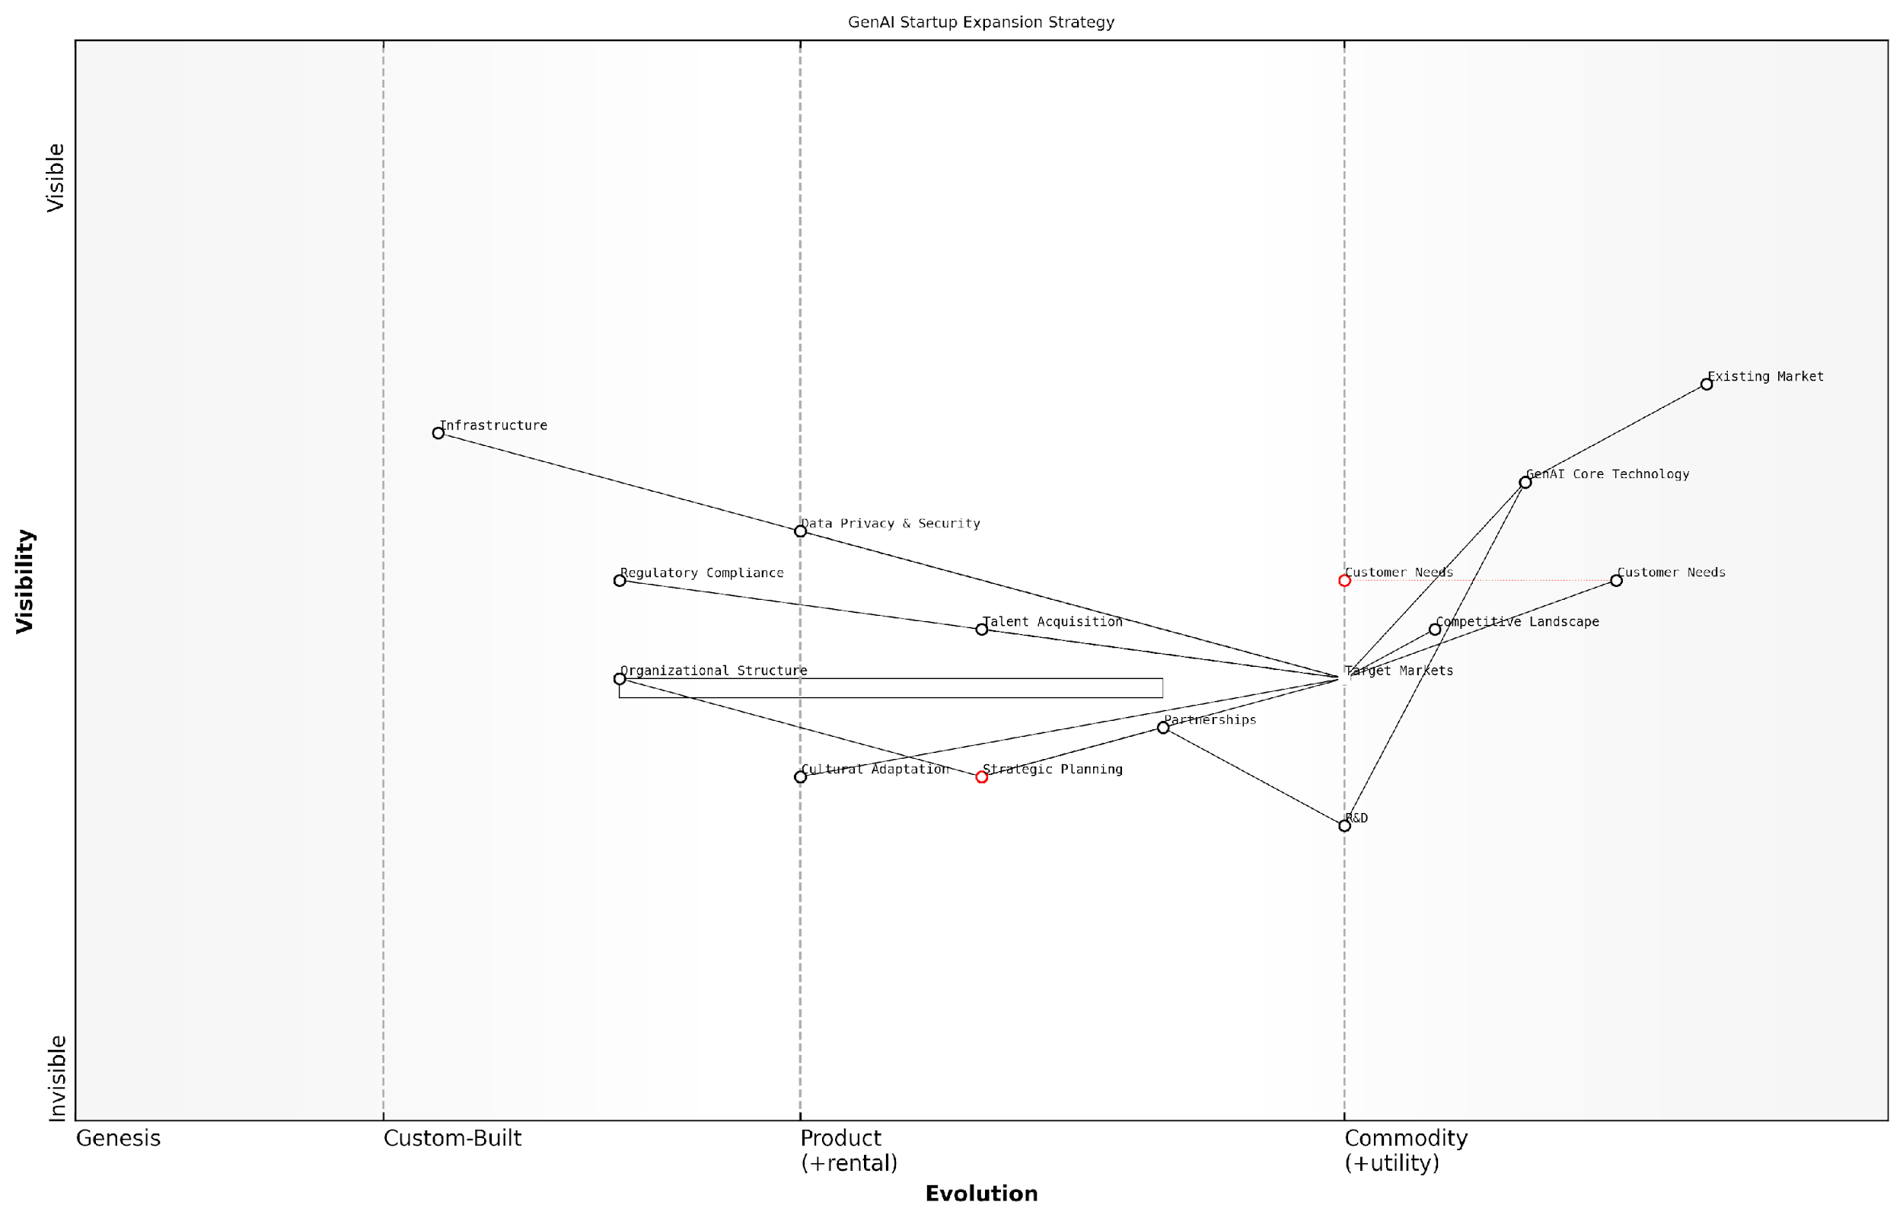

*Draft Wardley Map: [Insert Wardley Map: Preparing for Market Expansion and Diversification]*

[Edit this draft Wardley Map](https://create.wardleymaps.ai/#clone:6116871a45cd5f4ef1)

Wardley Map Assessment

The GenAI startup is well-positioned for expansion with strong core technology and strategic focus. However, success will hinge on effectively navigating regulatory challenges, adapting to diverse market needs, and maintaining technological leadership through R&D and partnerships. The startup should prioritise building capabilities in regulatory compliance and cultural adaptation while leveraging its technological strengths to create market-specific solutions. Long-term success will depend on fostering a robust ecosystem and staying ahead of the rapidly evolving customer needs and competitive landscape in the global GenAI market.

[View full Wardley Map report](http://markdown/wardley_map_reports/wardley_map_report_24_Preparing_for_Market_Expansion_and_Diversification.md)

Finally, remember that expansion and diversification strategies should be viewed as iterative processes. The GenAI landscape is constantly evolving, and your plans should evolve with it. Regularly revisiting and updating your Wardley Maps will help ensure that your growth strategies remain aligned with market realities and technological advancements.

* Establish regular review cycles for your expansion and diversification maps
* Incorporate feedback loops from early expansion efforts to refine future strategies
* Monitor emerging technologies and market trends that could impact your growth plans
* Develop scenario planning maps to prepare for different potential market outcomes
* Cultivate a culture of adaptability and continuous learning to support ongoing expansion

By leveraging Wardley Mapping in your expansion and diversification planning, you can create a robust, flexible strategy that positions your GenAI startup for sustainable growth in a dynamic market. This approach not only helps you identify and pursue promising opportunities but also ensures that your growth is strategic, sustainable, and aligned with your core strengths and long-term vision.

# Chapter 3: Navigating Technical Challenges and Opportunities

## Mapping Your Technical Stack

### Identifying Core GenAI Technologies and Their Evolution

As we delve into mapping the technical stack for GenAI startups, it’s crucial to begin by identifying the core technologies that underpin generative AI systems and understanding their evolutionary trajectory. This process is fundamental to creating a robust Wardley Map that accurately represents your startup’s technological landscape and informs strategic decision-making.

Core GenAI technologies can be broadly categorised into several key areas, each at different stages of evolution on the Wardley Map. Let’s explore these categories and their positioning:

* Foundation Models: These large-scale pre-trained models form the backbone of many GenAI applications. They’re rapidly evolving but are still in the custom-built to product stages on the evolution axis.
* Natural Language Processing (NLP): This field has seen significant advancements and is moving towards the product/commodity stage for many applications.
* Computer Vision: While mature for many tasks, it’s still evolving rapidly for generative applications, placing it in the product stage.
* Reinforcement Learning: This technology is still largely in the genesis to custom-built stages for most GenAI applications.
* Neural Architecture Search: An emerging field that automates model design, currently in the genesis stage.
* Federated Learning: A privacy-preserving technique that’s gaining traction, positioned between genesis and custom-built stages.

When mapping these technologies, it’s essential to consider not just their current position but also their trajectory. For instance, while foundation models are currently in the custom-built to product stages, they’re rapidly moving towards commoditisation. This movement has significant implications for startups, as it may shift the focus from model development to model application and fine-tuning.

In the fast-paced world of GenAI, what’s cutting-edge today may be commonplace tomorrow. Our mapping must reflect not just the current state, but the velocity of change.

To effectively map your technical stack, consider the following steps:

* Identify which core technologies are critical to your startup’s value proposition
* Position these technologies on the evolution axis of your Wardley Map
* Analyse the dependencies between these technologies
* Consider the rate of evolution for each technology and how this might impact your strategy
* Identify potential disruptors or emerging technologies that could impact your stack

It’s also crucial to consider the infrastructure and tooling that support these core technologies. This includes:

* Cloud Computing Platforms: Often in the commodity stage, but with evolving AI-specific offerings
* GPU/TPU Resources: Critical for model training, moving from product to commodity stages
* MLOps Tools: Rapidly evolving, currently spanning from custom-built to product stages
* Data Storage and Processing: Largely commoditised, but with evolving needs for AI workloads
* API Management: Essential for deploying models, generally in the product to commodity stages

By mapping these elements alongside your core technologies, you can gain a comprehensive view of your entire technical stack. This holistic perspective is invaluable for identifying potential bottlenecks, areas for investment, and opportunities for differentiation.

A well-mapped technical stack isn’t just a snapshot of your current capabilities; it’s a strategic tool for navigating the evolving GenAI landscape.

Remember, the goal of this mapping exercise is not just to document your current stack, but to inform strategic decisions. By understanding the evolution of these technologies, you can better anticipate market shifts, identify areas where you can gain a competitive advantage, and make informed build vs. buy decisions.

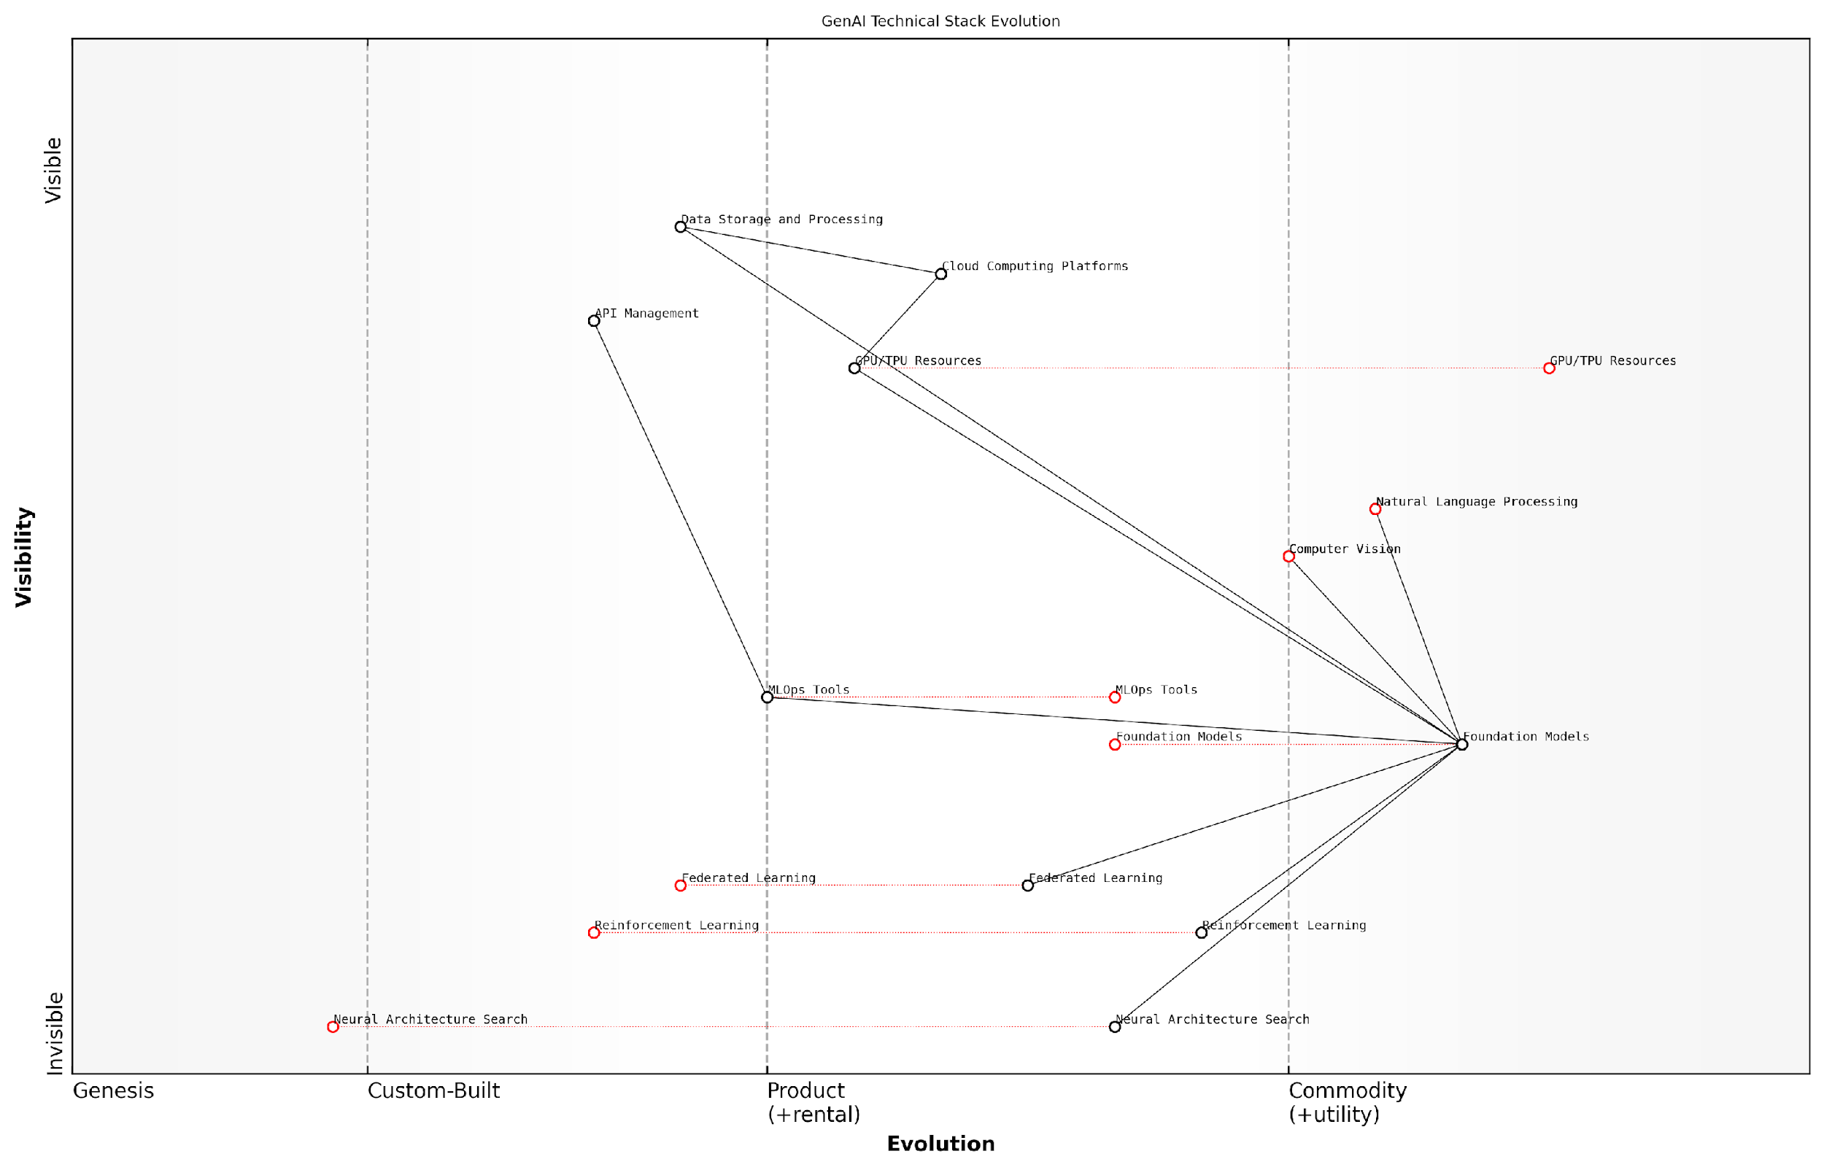

*Draft Wardley Map: [Insert Wardley Map: Identifying Core GenAI Technologies and Their Evolution]*

[Edit this draft Wardley Map](https://create.wardleymaps.ai/#clone:804f086bb32f9656be)

Wardley Map Assessment

The map reveals a strong foundation in core AI technologies with significant opportunities in emerging areas. To maintain a competitive edge, the focus should be on advancing Foundation Models, integrating cutting-edge technologies like Neural Architecture Search and Reinforcement Learning, and developing unique AI applications. Balancing investment in proprietary technologies with participation in the broader AI ecosystem will be crucial for long-term success.

[View full Wardley Map report](http://markdown/wardley_map_reports/wardley_map_report_25_Identifying_Core_GenAI_Technologies_and_Their_Evol.md)

As you map your technical stack, be prepared to revisit and update your map regularly. The GenAI field is characterised by rapid advancements, and what seems cutting-edge today may become table stakes tomorrow. By maintaining an up-to-date map of your core technologies and their evolution, you’ll be better equipped to navigate the challenges and seize the opportunities in the dynamic world of generative AI.

### Mapping Infrastructure and Platform Requirements

In the rapidly evolving landscape of Generative AI (GenAI), mapping your infrastructure and platform requirements is a critical step for startups aiming to build robust, scalable, and efficient services. This process involves a comprehensive analysis of the technical foundations necessary to support your GenAI applications, ensuring that your startup is well-positioned to meet both current demands and future growth.

To effectively map your infrastructure and platform requirements using Wardley Mapping, we need to consider several key components and their positions on the evolution axis. This approach will help identify which elements are commoditised and which are still in the custom-built or product stages, informing strategic decisions about resource allocation and technological investments.

* Compute Resources: GPUs, TPUs, and specialised AI hardware
* Storage Solutions: Data lakes, distributed file systems, and caching mechanisms
* Networking Infrastructure: Low-latency interconnects and content delivery networks
* AI Development Platforms: Model training frameworks and deployment tools
* Data Processing Pipelines: ETL tools and real-time streaming capabilities
* Security and Compliance Systems: Encryption, access controls, and audit trails
* Monitoring and Observability Tools: Performance metrics and debugging utilities

When mapping these components, it’s crucial to consider their current state of evolution and their trajectory. For instance, while cloud-based GPU resources might be positioned as a product on the evolution axis, specialised AI accelerators could be in the custom-built phase, indicating potential for differentiation but also higher investment requirements.

The key to successful infrastructure mapping is not just understanding where components are today, but anticipating where they’ll be tomorrow. This foresight allows startups to make strategic bets on emerging technologies that could provide a competitive edge.

As you map your infrastructure and platform requirements, pay close attention to the interdependencies between components. For example, your choice of AI development platform may influence your compute resource needs, while your data processing pipeline will impact your storage solution requirements. These relationships should be clearly represented in your Wardley Map to provide a holistic view of your technical ecosystem.

It’s also important to consider the trade-offs between building custom solutions and leveraging existing platforms or services. While custom-built components can offer unique capabilities and competitive advantages, they often come with higher development and maintenance costs. Conversely, relying on established platforms can accelerate development but may limit flexibility or differentiation.

* Evaluate the maturity and reliability of existing platforms
* Assess the strategic value of custom-built components
* Consider the long-term costs of maintenance and scalability
* Analyse the impact on time-to-market and resource allocation
* Examine the potential for vendor lock-in and mitigation strategies

As you map your infrastructure and platform requirements, it’s crucial to align them with your startup’s overall strategy and growth projections. Consider how your technical foundation will need to evolve as you scale, enter new markets, or introduce new features. This forward-thinking approach will help you build a flexible and resilient infrastructure that can adapt to changing business needs and technological advancements.

In the world of GenAI startups, your infrastructure is not just a cost centre—it’s a strategic asset that can drive innovation and competitive advantage. Mapping it effectively is the first step towards harnessing its full potential.

Remember that the process of mapping infrastructure and platform requirements is not a one-time exercise. As the GenAI landscape evolves, new technologies emerge, and your startup grows, you’ll need to regularly revisit and update your map. This iterative approach ensures that your technical foundation remains aligned with your business objectives and positioned to capitalise on new opportunities.

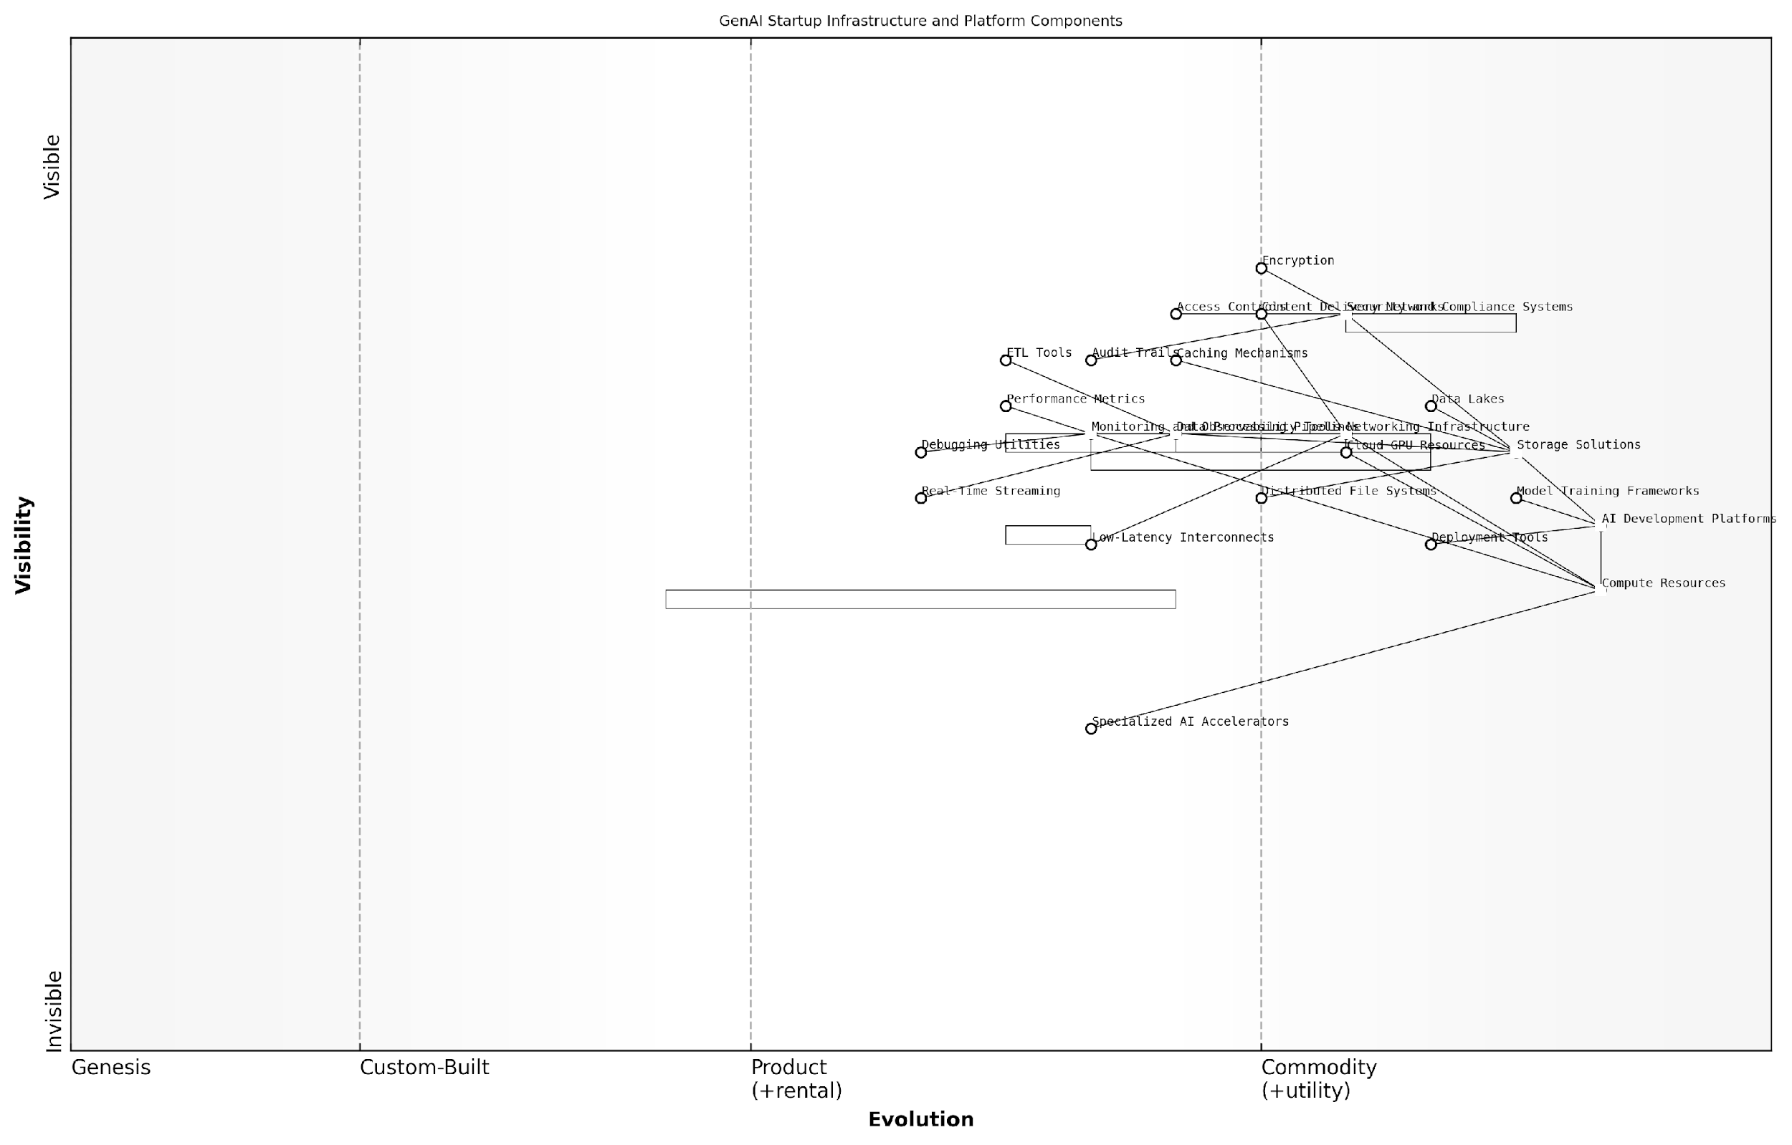

*Draft Wardley Map: [Insert Wardley Map: Mapping Infrastructure and Platform Requirements]*

[Edit this draft Wardley Map](https://create.wardleymaps.ai/#clone:40d48bd89a9e30a985)

Wardley Map Assessment

The GenAI startup has a solid foundation with a well-integrated infrastructure and platform stack. Its strategic focus on AI Development Platforms positions it well in the competitive landscape. To maintain and enhance its position, the startup should focus on developing proprietary technologies in key evolving areas like Specialized AI Accelerators and advanced debugging tools, while continuously optimising its core AI development and deployment capabilities. The company should also stay agile, ready to adapt to rapid technological changes in the AI field, and consider strategic partnerships to fill capability gaps and drive innovation.

[View full Wardley Map report](http://markdown/wardley_map_reports/wardley_map_report_26_Mapping_Infrastructure_and_Platform_Requirements.md)

By thoroughly mapping your infrastructure and platform requirements, you’ll gain a clearer understanding of your technical landscape, identify potential bottlenecks or areas for optimisation, and make more informed decisions about where to invest your resources. This strategic approach to infrastructure planning will position your GenAI startup for success in a highly competitive and rapidly changing market.

### Balancing Build vs. Buy Decisions

In the rapidly evolving landscape of Generative AI, startups face a critical decision when mapping their technical stack: whether to build custom solutions or leverage existing technologies. This build vs. buy dilemma is particularly crucial for GenAI startups, as it can significantly impact their agility, resource allocation, and competitive advantage. Wardley Mapping provides an invaluable framework for navigating this complex decision-making process, allowing startups to visualise their technical components and make informed strategic choices.

To effectively balance build vs. buy decisions, startups must first map their technical stack using Wardley Mapping principles. This involves identifying all the components of their GenAI service, from foundational infrastructure to user-facing applications, and positioning them on the evolution axis. By doing so, startups can gain a clear understanding of which components are commoditised and which are still in the genesis or custom-built stages.

* Identify all technical components of your GenAI service
* Position each component on the evolution axis
* Assess the strategic importance of each component
* Evaluate the availability and maturity of off-the-shelf solutions
* Consider the long-term implications of build vs. buy for each component

Once the technical stack is mapped, startups can begin to assess which components are candidates for building in-house and which are better suited for procurement. Components in the genesis or custom-built stages that are core to the startup’s value proposition are often strong candidates for in-house development. These might include proprietary AI models, unique data processing pipelines, or novel user interfaces that differentiate the service in the market.

In my experience advising GenAI startups, I’ve observed that those who successfully balance build vs. buy decisions are able to focus their limited resources on developing truly innovative components while leveraging existing solutions for more commoditised aspects of their stack.

Conversely, components that are further along the evolution axis and approaching commodity status are typically better suited for procurement. These might include cloud infrastructure, standard databases, or well-established AI frameworks. By purchasing these components, startups can benefit from the economies of scale and reliability offered by established providers, allowing them to focus their resources on core differentiators.

However, the decision is not always straightforward. Startups must also consider factors such as cost, scalability, integration complexity, and vendor lock-in. Wardley Mapping can help visualise these considerations by incorporating additional layers of information onto the map, such as cost structures or strategic importance.

* Cost analysis: Compare long-term costs of building vs. buying
* Scalability assessment: Evaluate the ability to scale both built and bought solutions
* Integration complexity: Consider the effort required to integrate third-party solutions
* Vendor lock-in: Assess the risks and implications of relying on external providers
* Intellectual property: Determine the strategic value of owning vs. licensing technology

Another crucial aspect to consider is the pace of evolution in the GenAI field. Components that are custom-built today may become commoditised rapidly, potentially rendering significant development efforts obsolete. Wardley Mapping helps startups anticipate these shifts by encouraging them to consider the future movement of components along the evolution axis.

A senior technology strategist once told me, ‘In the world of GenAI, what you choose to build today should still be a differentiator tomorrow. Everything else is a candidate for procurement.’

Startups should also consider the impact of their build vs. buy decisions on their team’s focus and expertise. Building in-house requires dedicated resources and can lead to the development of deep, specialised knowledge. However, it can also divert attention from other critical areas of the business. Buying solutions, while potentially limiting deep technical expertise in certain areas, can allow the team to focus on higher-level integration and application of AI technologies.

Ultimately, the goal is to strike a balance that maximises the startup’s competitive advantage while optimising resource allocation. This balance will be unique to each startup, based on their specific value proposition, available resources, and market positioning. Regular review and updating of the Wardley Map is essential, as the optimal balance may shift as the startup grows and the GenAI landscape evolves.

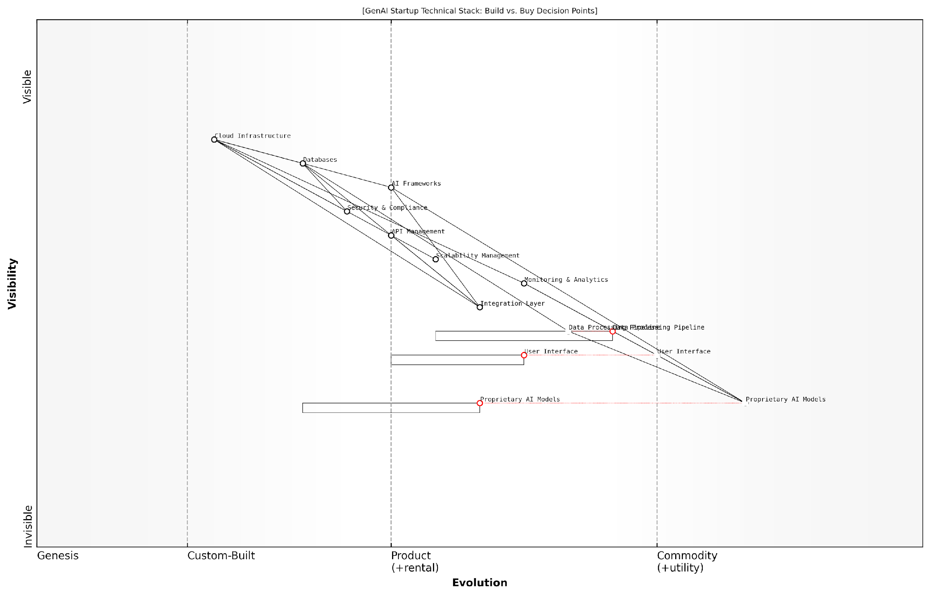

*Draft Wardley Map: [Insert Wardley Map: Balancing Build vs. Buy Decisions]*

[Edit this draft Wardley Map](https://create.wardleymaps.ai/#clone:c5cc6fd0a96780bbd5)

Wardley Map Assessment

This GenAI startup is well-positioned with a balanced approach to build vs. buy decisions. The focus on proprietary AI models and custom user interfaces provides strong differentiation potential. However, there’s a need to carefully manage the evolution of key components, particularly in data processing and integration, to maintain competitive advantage. The startup should prioritize innovation in its core AI capabilities while leveraging commodity services for non-core functions, always with an eye towards future scalability and security needs. Strategic partnerships and ecosystem development will be crucial for long-term success in the rapidly evolving GenAI landscape.

[View full Wardley Map report](http://markdown/wardley_map_reports/wardley_map_report_27_Balancing_Build_vs._Buy_Decisions.md)

In conclusion, balancing build vs. buy decisions is a critical aspect of mapping and developing a GenAI startup’s technical stack. By leveraging Wardley Mapping, startups can visualise their technical landscape, assess the strategic value of each component, and make informed decisions that align with their overall business strategy. This approach enables GenAI startups to focus their resources on areas that truly differentiate their offering, while leveraging existing solutions to accelerate development and reduce risk in non-core areas.

## Data Strategy and Management

### Mapping Data Sources and Quality

In the realm of Generative AI startups, data is the lifeblood that fuels innovation and drives competitive advantage. As we navigate the complex landscape of GenAI development, understanding and mapping our data sources and quality becomes a critical strategic imperative. This process not only informs our technical decisions but also shapes our overall business strategy and potential for success in the market.

Wardley Mapping provides an invaluable framework for visualising and analysing our data ecosystem. By mapping our data sources and quality, we can gain crucial insights into our competitive positioning, identify potential vulnerabilities, and uncover opportunities for innovation and differentiation.

* Identify and categorise all data sources
* Assess the quality and reliability of each source
* Map the evolution of data sources along the value chain
* Analyse dependencies and potential bottlenecks
* Identify gaps and opportunities in the data landscape

When mapping data sources, it’s crucial to consider both internal and external sources. Internal sources might include proprietary datasets, user-generated content, or operational data. External sources could encompass public datasets, third-party APIs, or data partnerships. Each of these sources should be positioned on the Wardley Map based on their visibility to users and their evolutionary stage.

In the world of GenAI, the quality of your output is directly proportional to the quality of your input data. Mapping your data sources isn’t just about quantity; it’s about understanding the strategic value and potential limitations of each source.

Quality assessment is a critical component of this mapping process. We need to evaluate each data source based on factors such as accuracy, completeness, timeliness, and relevance to our specific GenAI applications. This assessment should be reflected in our Wardley Map, perhaps through colour coding or additional annotations.

* Accuracy: How reliable and error-free is the data?
* Completeness: Are there gaps or missing elements in the dataset?
* Timeliness: How current is the data? How frequently is it updated?
* Relevance: How well does the data align with our specific use cases?
* Consistency: Is the data format and structure uniform across sources?
* Volume: Do we have sufficient data to train robust GenAI models?
* Diversity: Does our data represent a wide range of scenarios and edge cases?

As we map our data sources and quality, we may uncover strategic insights that inform our broader business strategy. For instance, we might identify a high-quality, underutilised data source that could give us a competitive edge in a specific market segment. Conversely, we might discover that a critical data source is of lower quality than we initially thought, necessitating investment in data cleaning and enrichment processes.

It’s also crucial to consider the evolution of data sources over time. Some data sources may be commoditising, becoming widely available and thus less of a competitive differentiator. Others may be in the early stages of evolution, offering potential first-mover advantages for startups that can effectively leverage them.

The most successful GenAI startups don’t just consume data; they cultivate it. They treat data as a strategic asset, constantly seeking ways to improve its quality, expand its scope, and derive unique insights that drive innovation.

As we map our data sources and quality, we should also be mindful of potential risks and challenges. These might include data privacy concerns, regulatory compliance issues, or dependencies on third-party data providers. By visualising these factors on our Wardley Map, we can develop more robust risk mitigation strategies and ensure the long-term sustainability of our data strategy.

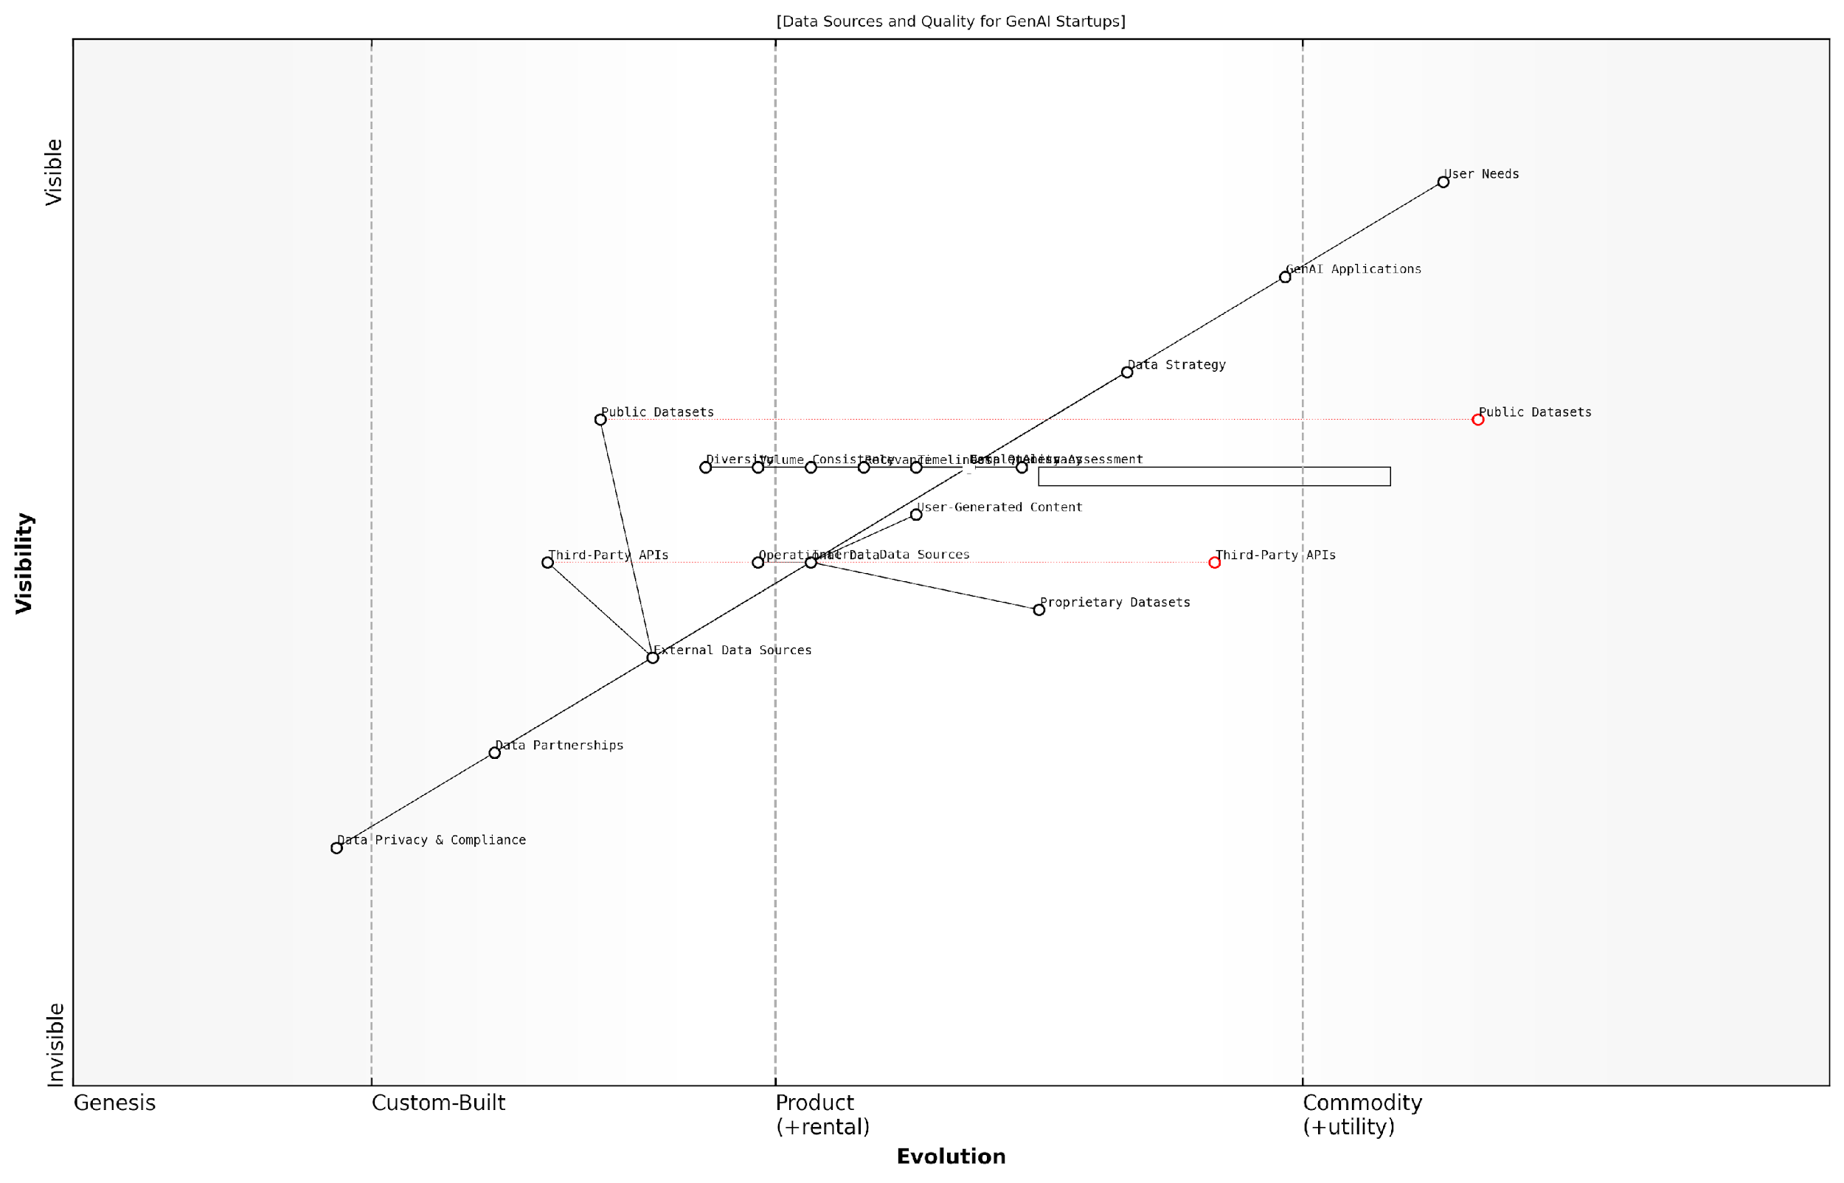

*Draft Wardley Map: [Insert Wardley Map: Mapping Data Sources and Quality]*

[Edit this draft Wardley Map](https://create.wardleymaps.ai/#clone:3691bd5f9d78a4bec2)

Wardley Map Assessment

The map reveals a strong foundation in proprietary data and GenAI applications, with opportunities for growth in external data integration and partnerships. To maintain a competitive edge, the startup should focus on enhancing data quality, diversifying data sources, and strengthening privacy compliance while continuing to innovate in GenAI applications.

[View full Wardley Map report](http://markdown/wardley_map_reports/wardley_map_report_28_Mapping_Data_Sources_and_Quality.md)

Finally, it’s important to view our data strategy as a dynamic, evolving entity. Regular reassessment and remapping of our data sources and quality should be an integral part of our strategic planning process. This iterative approach allows us to stay agile, respond to market changes, and continuously refine our competitive positioning in the fast-paced world of GenAI startups.

By leveraging Wardley Mapping to visualise and analyse our data sources and quality, we can make more informed decisions, identify strategic opportunities, and build a robust foundation for our GenAI startup’s success. This approach not only enhances our technical capabilities but also provides a powerful tool for communicating our data strategy to stakeholders, investors, and team members.

### Addressing Data Privacy and Security Concerns

In the realm of Generative AI startups, addressing data privacy and security concerns is not merely a compliance issue; it’s a fundamental aspect of building trust, ensuring ethical operations, and maintaining a competitive edge. As we map this critical component of our data strategy, we must consider the evolving landscape of regulations, user expectations, and technological capabilities.

When applying Wardley Mapping to data privacy and security, we typically position these concerns towards the right side of the evolution axis, as they are constantly evolving and require ongoing innovation. However, the specific positioning can vary depending on the industry and regulatory environment.

* Map current data protection regulations and anticipate future changes
* Identify key stakeholders and their privacy expectations
* Assess the sensitivity of different data types used in your GenAI models
* Evaluate existing security measures and identify gaps
* Plan for data localisation and cross-border data transfer requirements

One of the unique challenges for GenAI startups is the vast amount of data required to train and operate AI models. This data often includes sensitive information, making privacy and security paramount. As we map our data flows, we must consider each stage of the data lifecycle: collection, processing, storage, use, and deletion.

In the age of AI, data is not just an asset; it’s a responsibility. How we protect and secure that data will define our relationship with users and our position in the market.

When mapping your privacy and security strategy, consider the following key areas:

* Data Minimisation: Map out strategies to collect and retain only necessary data
* Anonymisation and Pseudonymisation: Identify opportunities to de-identify data where possible
* Encryption: Map encryption needs across data at rest and in transit
* Access Controls: Design and map robust access management systems
* Audit Trails: Plan for comprehensive logging and monitoring capabilities
* Incident Response: Develop and map out incident response and breach notification processes

It’s crucial to map not just your current state but also your desired future state in terms of privacy and security. This forward-looking approach allows you to identify gaps and plan strategic moves to enhance your capabilities over time.

For GenAI startups, privacy by design and security by default should be core principles. As you map your technical stack and data flows, continuously ask how privacy and security can be embedded at each stage. This approach not only helps in compliance but also builds trust with users and partners.

Privacy and security should not be afterthoughts in AI development. They must be woven into the fabric of your startup’s DNA from day one.

When addressing regulatory compliance, it’s important to map out the specific requirements of relevant laws such as GDPR, CCPA, or sector-specific regulations. Your map should include components for consent management, data subject rights fulfilment, and compliance reporting.

As AI models become more sophisticated, new privacy challenges emerge. For instance, the risk of model inversion attacks or membership inference attacks must be considered. Map out potential vulnerabilities and plan for mitigation strategies, including differential privacy techniques or federated learning approaches where appropriate.

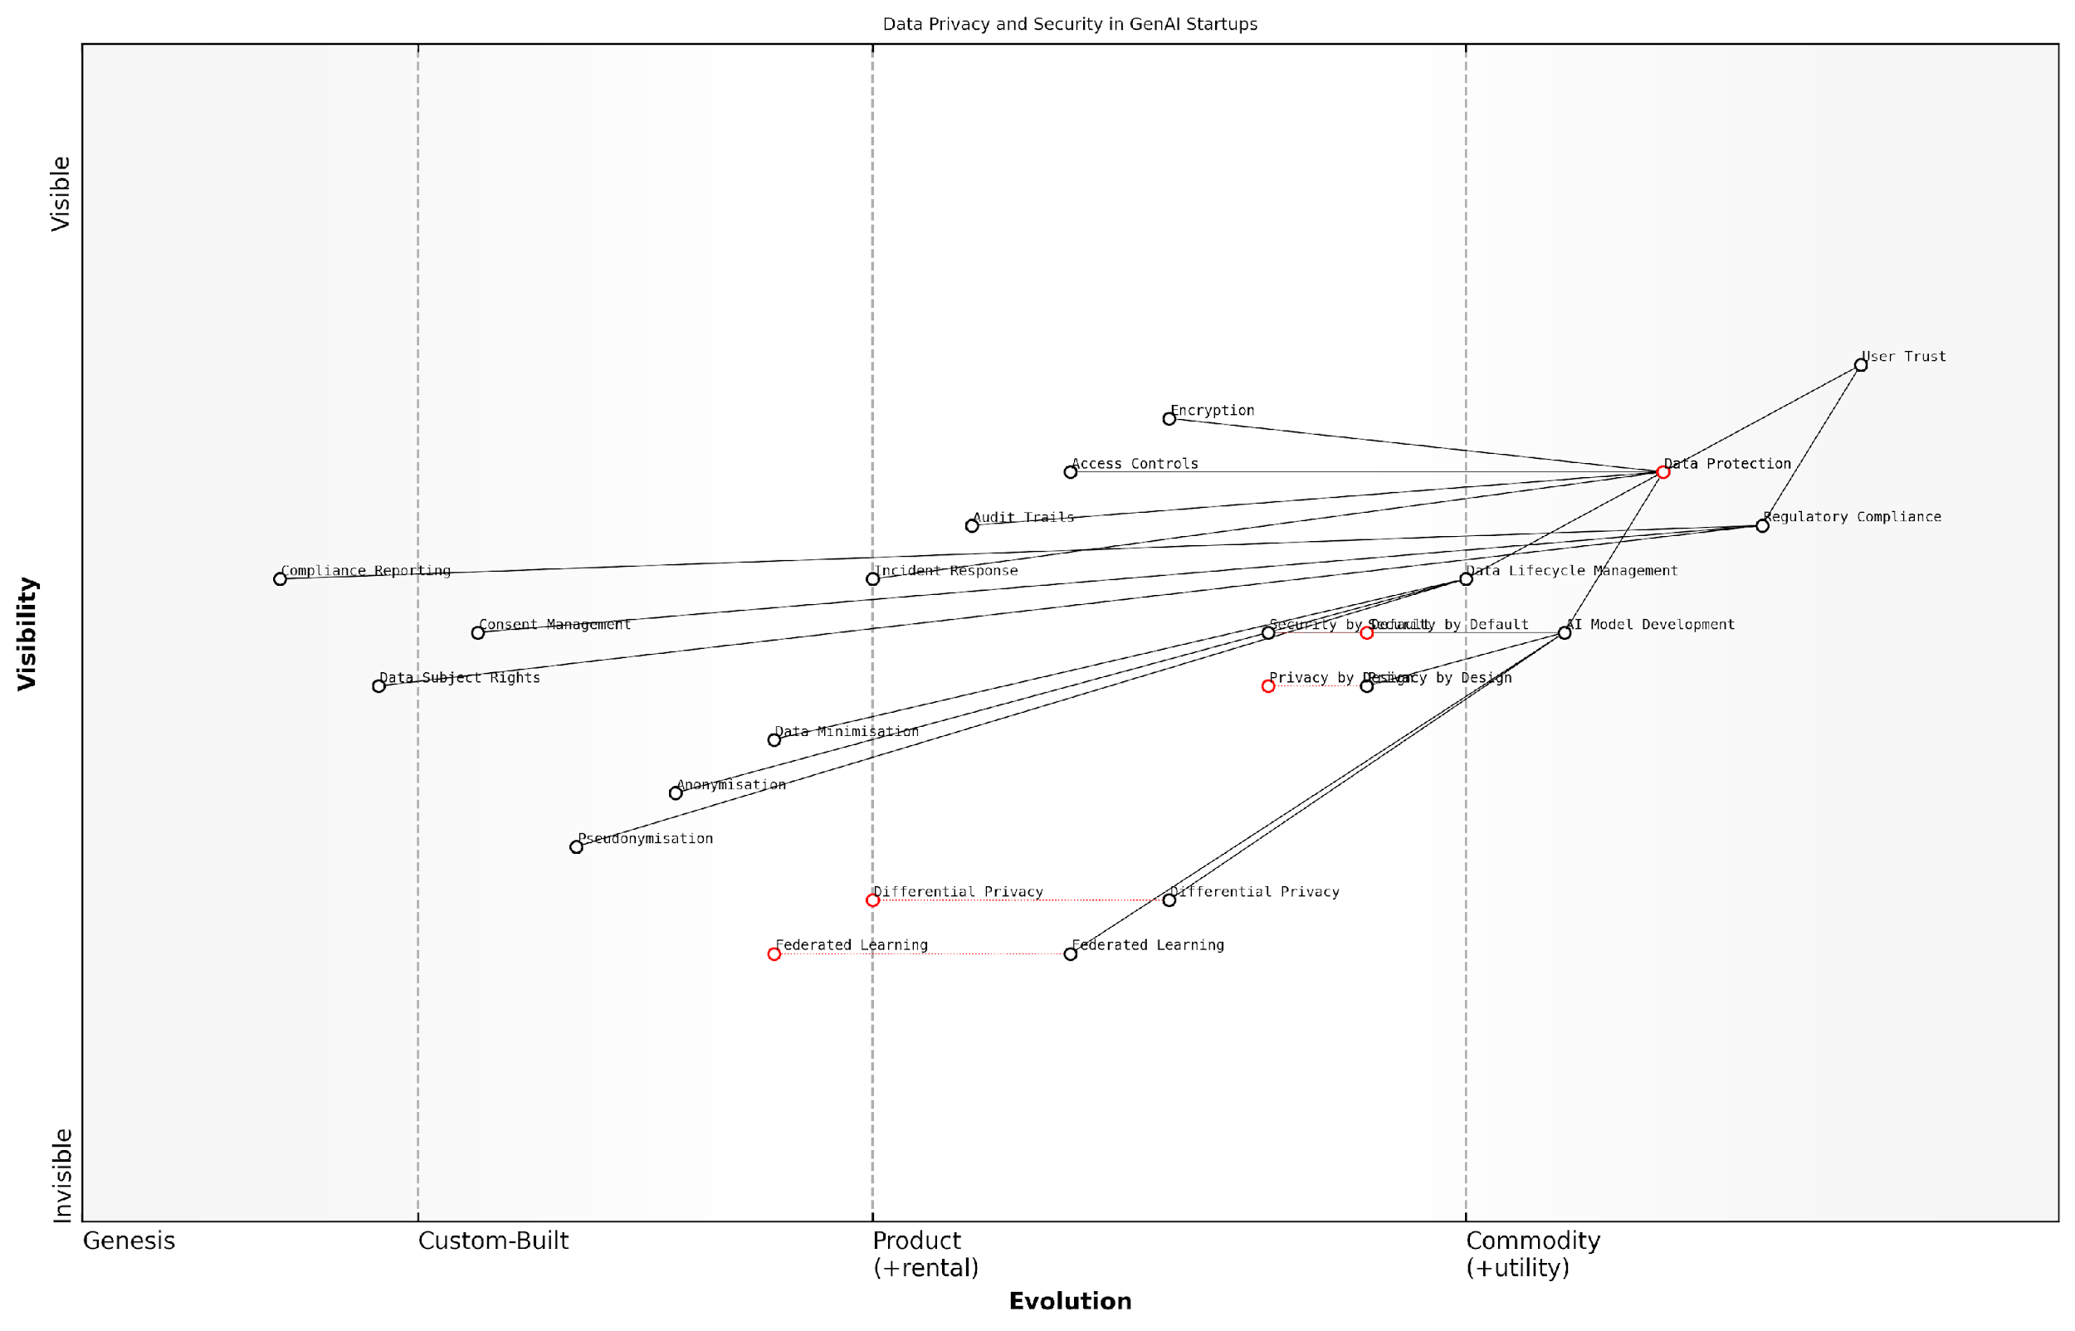

*Draft Wardley Map: [Insert Wardley Map: Addressing Data Privacy and Security Concerns]*

[Edit this draft Wardley Map](https://create.wardleymaps.ai/#clone:079bc846e5918e84ca)

Wardley Map Assessment

The map reveals a GenAI startup landscape that is acutely aware of the importance of data privacy and security. While foundational elements are well-established, there are significant opportunities for competitive advantage in advanced privacy-preserving techniques. The key to success lies in balancing rapid AI innovation with robust privacy measures, all while maintaining a steadfast focus on user trust and regulatory compliance. Startups that can effectively integrate emerging technologies like Differential Privacy and Federated Learning into their core AI development processes will be well-positioned for future success in this evolving ecosystem.

[View full Wardley Map report](http://markdown/wardley_map_reports/wardley_map_report_29_Addressing_Data_Privacy_and_Security_Concerns.md)

Remember that privacy and security are not static targets. Your Wardley Map should be regularly updated to reflect new threats, technologies, and regulatory changes. Establish a process for continuous assessment and improvement of your privacy and security posture.

Lastly, consider the competitive advantage that robust privacy and security measures can provide. In an era of increasing data breaches and privacy concerns, startups that can demonstrate strong data protection practices may find themselves in a favourable position with both users and investors.

In the GenAI landscape, privacy and security are not just about protection; they’re about building a sustainable competitive advantage through trust and responsible innovation.

By thoroughly mapping and addressing data privacy and security concerns, GenAI startups can build a solid foundation for growth, innovation, and long-term success in a complex and evolving regulatory landscape.

### Strategies for Continuous Learning and Model Improvement

In the rapidly evolving landscape of Generative AI, continuous learning and model improvement are not just advantageous—they’re essential for survival and success. As an expert in Wardley Mapping for GenAI startups, I’ve observed that the most successful ventures are those that embed continuous learning into their core strategy. This subsection will explore how to leverage Wardley Mapping to create robust strategies for ongoing model enhancement and adaptation.

Firstly, it’s crucial to understand that in the context of GenAI, your models are not static assets but dynamic entities that require constant nurturing. Wardley Mapping can help visualise this evolution and identify key areas for improvement.

* Map your current model’s capabilities and performance metrics
* Identify areas of high uncertainty or rapid evolution in your map
* Plot competitor capabilities and industry benchmarks
* Visualise potential future states and improvement trajectories

Once you have this visual representation, you can start to formulate strategies for continuous improvement. One key approach is to implement a robust feedback loop system. This involves not just collecting data on model performance, but also creating mechanisms to rapidly incorporate insights back into the development process.

In my experience advising government AI initiatives, those organisations that establish clear, measurable feedback mechanisms consistently outperform those that rely on ad-hoc improvement strategies.

Another critical strategy is to adopt a modular approach to model architecture. By breaking down your GenAI system into discrete, interchangeable components on your Wardley Map, you create opportunities for targeted improvements without disrupting the entire system. This approach also allows for more agile responses to emerging technologies or shifting market demands.

* Identify core model components on your Wardley Map
* Assess the evolution stage of each component
* Prioritise improvement efforts based on strategic importance and evolution stage
* Develop a roadmap for incremental enhancements

Collaboration and knowledge sharing are also crucial elements of a successful continuous learning strategy. In the fast-paced world of GenAI, no single organisation can stay ahead of every development. Wardley Mapping can help identify potential collaboration opportunities and knowledge gaps that could be filled through strategic partnerships.

A senior AI researcher once told me, ‘In GenAI, your biggest competitive advantage is often your ability to learn and adapt faster than others, not necessarily having the best model at any given moment.’

It’s also important to consider the role of automated machine learning (AutoML) and neural architecture search (NAS) in your continuous improvement strategy. These technologies, when properly integrated, can significantly accelerate the pace of model refinement. On your Wardley Map, you might position these as evolving components that feed into your core model improvement process.

Ethical considerations should also be a key part of your continuous learning strategy. As models improve, they may develop capabilities that weren’t initially anticipated, potentially raising new ethical concerns. Regular ethical audits should be integrated into your improvement cycle, with clear positions marked on your Wardley Map.

* Establish ethical guidelines for model improvement
* Integrate ethical checkpoints into your development pipeline
* Map potential ethical risks and mitigation strategies
* Engage with external ethics boards or advisors for ongoing guidance

Finally, it’s crucial to align your continuous learning strategy with your overall business objectives. Use your Wardley Map to visualise how model improvements connect to user needs, market positioning, and long-term strategic goals. This alignment ensures that your technical improvements translate into tangible business value.

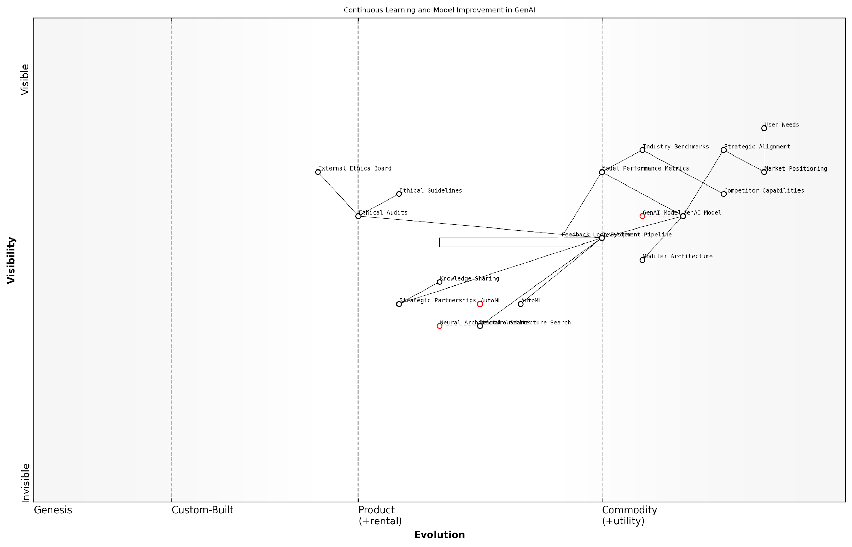

*Draft Wardley Map: [Insert Wardley Map: Strategies for Continuous Learning and Model Improvement]*

[Edit this draft Wardley Map](https://create.wardleymaps.ai/#clone:25b3f12ce7b326d130)

Wardley Map Assessment

The map reveals a strategically positioned GenAI development ecosystem with a strong focus on continuous improvement, ethical considerations, and emerging technologies. The key to success lies in balancing rapid technological advancement with robust ethical practices, while leveraging automation and partnerships to stay ahead in a competitive landscape. Prioritising the evolution of AutoML and Neural Architecture Search, alongside strengthening ethical frameworks, will be crucial for long-term success and industry leadership.

[View full Wardley Map report](http://markdown/wardley_map_reports/wardley_map_report_30_Strategies_for_Continuous_Learning_and_Model_Impro.md)

By employing these strategies and leveraging the power of Wardley Mapping, GenAI startups can create a robust framework for continuous learning and model improvement. This approach not only enhances technical capabilities but also ensures strategic alignment, ethical responsibility, and long-term competitive advantage in the dynamic world of Generative AI.

## Innovation and R&D Planning

### Mapping Potential Technological Advancements

In the rapidly evolving landscape of Generative AI, mapping potential technological advancements is crucial for startups to maintain a competitive edge and drive innovation. This process involves not only identifying emerging technologies but also understanding their potential impact on your business model, product offerings, and the broader AI ecosystem. By leveraging Wardley Mapping techniques, startups can visualise the trajectory of technological evolution and make informed decisions about where to focus their R&D efforts.

To effectively map potential technological advancements, we need to consider several key aspects:

* Identifying emerging technologies and their position on the evolution axis
* Assessing the potential impact of these technologies on your value chain
* Evaluating the readiness and maturity of new technologies
* Considering the interdependencies between different technological advancements
* Anticipating potential disruptors and game-changing innovations

Let’s delve deeper into each of these aspects and explore how they can be incorporated into your Wardley Map for strategic R&D planning.

Identifying emerging technologies and their position on the evolution axis is the first step in mapping potential advancements. In the context of GenAI, this might include technologies such as advanced natural language processing models, multimodal AI systems, or quantum machine learning algorithms. On your Wardley Map, these technologies would typically be positioned towards the left side of the evolution axis, indicating their nascent or emerging status.

Assessing the potential impact of these technologies on your value chain is crucial for understanding their strategic importance. For instance, a breakthrough in transfer learning could significantly reduce the data requirements for training AI models, potentially disrupting the entire data acquisition and preparation pipeline. On your map, you would need to consider how such advancements might shift the position of existing components or introduce new ones.

Evaluating the readiness and maturity of new technologies helps in prioritising R&D efforts. Some technologies, while promising, may be too immature for immediate integration into your products. Others might be on the cusp of practical application. Your Wardley Map should reflect this by positioning more mature technologies further to the right on the evolution axis, indicating their progression towards commoditisation.

As a senior AI researcher once noted, ‘The key to successful R&D in AI is not just identifying promising technologies, but understanding when they’re ready for real-world application. Timing is everything.’

Considering the interdependencies between different technological advancements is vital for a holistic R&D strategy. For example, advancements in hardware acceleration might enable more complex AI models, which in turn could drive innovations in AI applications. Your Wardley Map should capture these relationships, showing how movement in one area of technology can catalyse changes in others.

Anticipating potential disruptors and game-changing innovations is perhaps the most challenging aspect of mapping technological advancements. This requires a combination of deep domain knowledge, creative thinking, and continuous market sensing. On your Wardley Map, you might represent potential disruptors as speculative components, positioned far to the left of the evolution axis, with arrows indicating their potential to impact multiple existing components.

To illustrate these concepts, let’s consider a hypothetical Wardley Map for a GenAI startup focusing on natural language processing:

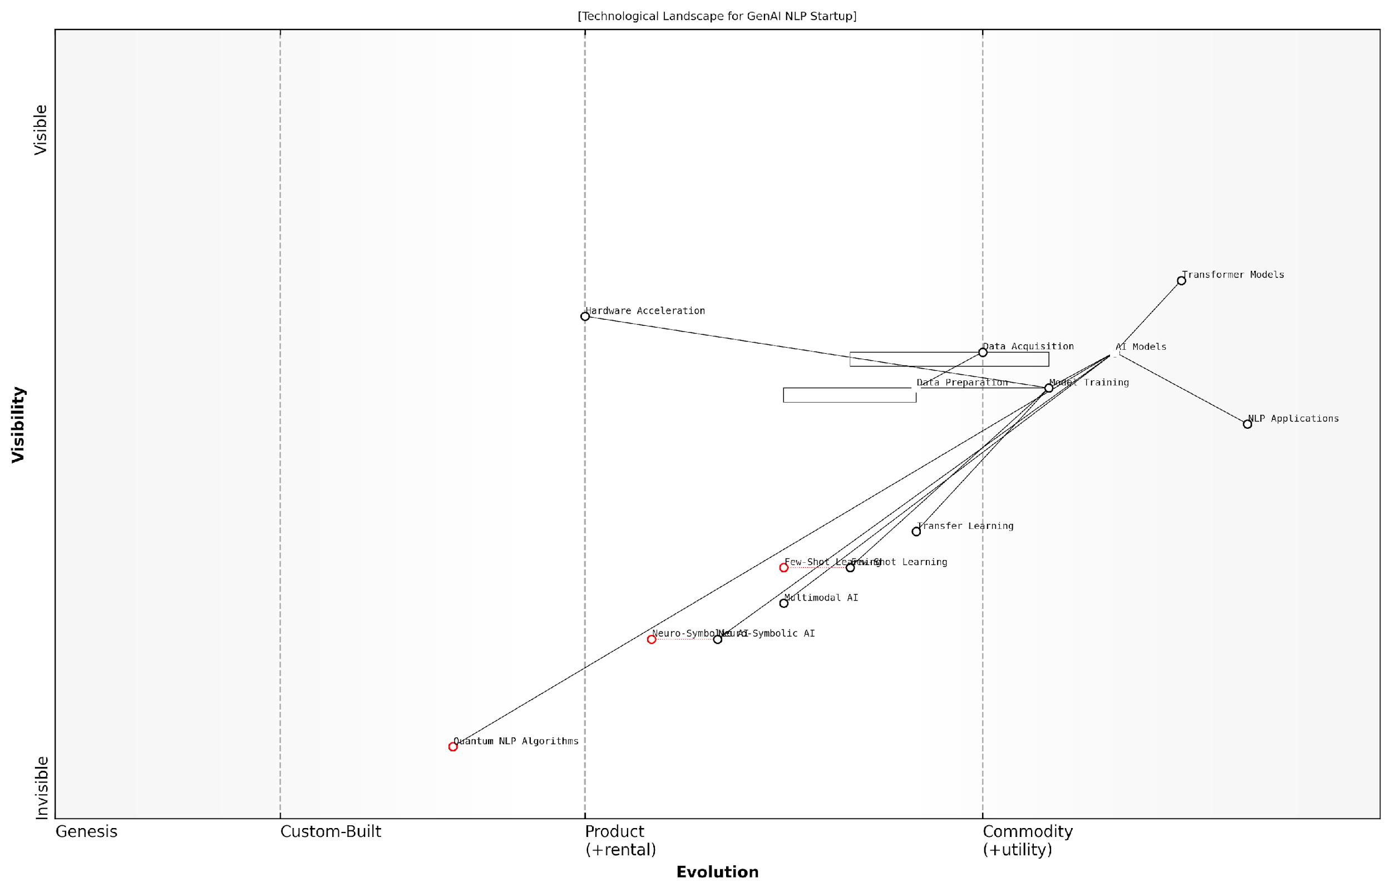

*Draft Wardley Map: [Insert Wardley Map: Mapping Potential Technological Advancements]*

[Edit this draft Wardley Map](https://create.wardleymaps.ai/#clone:aebd10a6e314b40a8d)

Wardley Map Assessment

The startup is well-positioned in the current NLP landscape but must balance optimization of existing technologies with investment in emerging fields to maintain long-term competitiveness. Key focus areas should include enhancing data pipelines, advancing Few-Shot Learning, and strategically exploring Quantum NLP and Neuro-Symbolic AI to stay ahead of potential disruptions.

[View full Wardley Map report](http://markdown/wardley_map_reports/wardley_map_report_31_Mapping_Potential_Technological_Advancements.md)

In this map, we might see established technologies like transformer models positioned towards the right, indicating their relative maturity. Emerging technologies like few-shot learning or neuro-symbolic AI might be positioned further left. Potential game-changers like quantum NLP algorithms could be represented as speculative components on the far left, with arrows indicating their potential to disrupt multiple areas of the value chain.

By regularly updating and refining this map, startups can maintain a dynamic view of the technological landscape, informing their R&D priorities and strategic decision-making. This process should be collaborative, involving inputs from technical teams, business strategists, and external experts to ensure a comprehensive perspective.

A leading AI strategist once remarked, ‘In the world of GenAI, your Wardley Map is never finished. It’s a living document that evolves as rapidly as the technology itself.’

To effectively use this map for R&D planning, startups should:

* Regularly review and update the map, incorporating new insights and market developments
* Use the map to identify potential ‘white spaces’ or areas of opportunity where new technologies could create competitive advantage
* Align R&D investments with the strategic direction indicated by the map, balancing short-term needs with long-term innovation goals
* Foster a culture of continuous learning and adaptation, encouraging teams to stay abreast of emerging technologies and their potential applications
* Use the map as a communication tool to align technical and business stakeholders on the company’s technological trajectory

By integrating Wardley Mapping into their technological foresight and R&D planning processes, GenAI startups can navigate the complex and rapidly evolving landscape more effectively. This approach enables them to make informed decisions about where to focus their innovation efforts, how to allocate resources, and when to pivot in response to technological shifts. In the fast-paced world of GenAI, this strategic approach to mapping potential technological advancements can be the difference between leading the market and being left behind.

### Identifying Areas for Focused Research

In the rapidly evolving landscape of Generative AI, identifying areas for focused research is crucial for startups aiming to maintain a competitive edge. This process requires a strategic approach that leverages Wardley Mapping to pinpoint high-potential research areas that align with the startup’s core competencies and market opportunities. By mapping the current technological landscape and anticipating future developments, GenAI startups can allocate their limited R&D resources more effectively, ensuring they remain at the forefront of innovation.

To begin the process of identifying research focus areas, startups should first map out the current state of GenAI technologies, including foundational models, training methodologies, and application domains. This mapping exercise provides a visual representation of the technological landscape, highlighting areas of maturity and potential gaps where breakthrough innovations could emerge.

* Map current GenAI technologies and their evolution stages
* Identify gaps and emerging trends in the technological landscape
* Assess the startup’s core competencies and unique strengths
* Analyse market demands and unmet needs in the GenAI space
* Consider ethical implications and potential regulatory developments

Once the current landscape is mapped, startups should overlay their own capabilities and strategic objectives onto this map. This alignment process helps identify areas where the startup’s expertise intersects with emerging opportunities or underserved segments of the market. It’s crucial to focus on research areas that not only push the boundaries of GenAI technology but also have clear pathways to commercialisation and value creation for the startup.

Successful R&D in GenAI isn’t just about chasing the latest technological trends. It’s about finding the sweet spot where your startup’s unique capabilities can create transformative value in an evolving market landscape.

When identifying research focus areas, consider the following key factors:

* Technological feasibility: Assess whether the research area is within reach given current technological constraints and the startup’s resources.
* Market potential: Evaluate the potential market size and growth trajectory for innovations in the chosen research area.
* Competitive advantage: Determine if the research focus aligns with the startup’s unique strengths and can provide a sustainable competitive edge.
* Ethical considerations: Ensure that the research direction aligns with responsible AI development principles and anticipates potential ethical challenges.
* Resource requirements: Estimate the time, talent, and financial resources needed to make meaningful progress in the research area.
* Regulatory landscape: Consider current and potential future regulations that may impact the research direction and its applications.

One effective approach to identifying promising research areas is to focus on the ‘adjacent possible’ – areas that are just beyond the current technological frontier but are becoming increasingly feasible. These areas often represent the most fertile ground for breakthrough innovations that can leapfrog existing solutions.

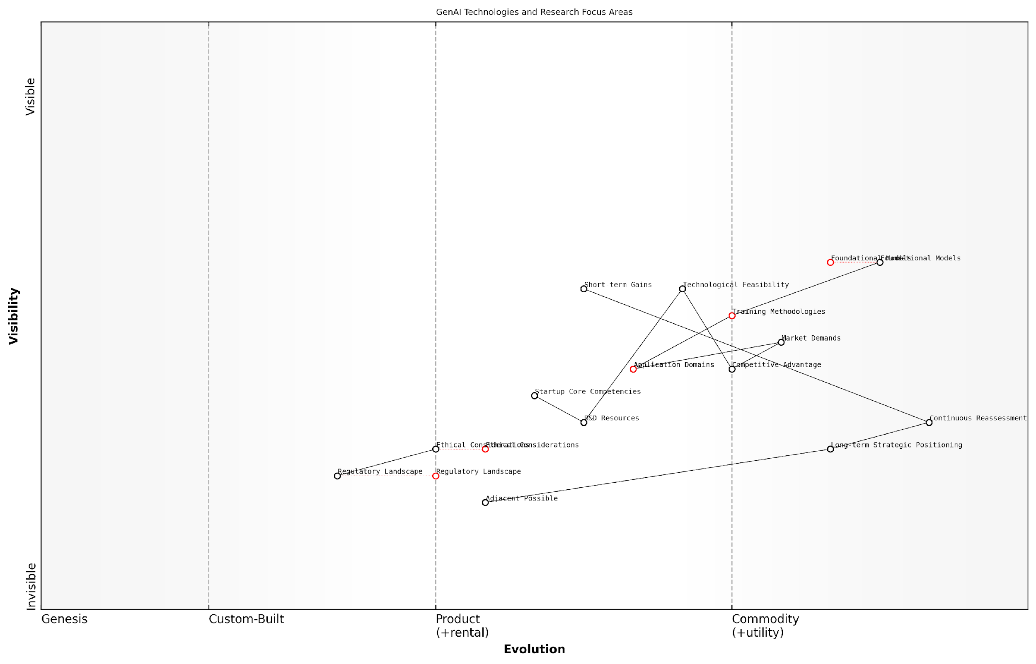

*Draft Wardley Map: [Insert Wardley Map: Identifying Areas for Focused Research]*

[Edit this draft Wardley Map](https://create.wardleymaps.ai/#clone:4ebae1d89e25250a8b)

Wardley Map Assessment

The map reveals a dynamic and rapidly evolving landscape for GenAI startups. Success will hinge on balancing technological innovation with ethical considerations and regulatory compliance. Startups should focus on developing unique competencies in specific Application Domains while preparing for a future where Ethical Considerations and Regulatory Landscape play increasingly critical roles. Continuous reassessment and adaptability will be key to long-term success in this ecosystem.

[View full Wardley Map report](http://markdown/wardley_map_reports/wardley_map_report_32_Identifying_Areas_for_Focused_Research.md)

It’s also crucial to consider the long-term implications of chosen research areas. While some areas may offer quick wins, others might require sustained investment but could potentially yield more transformative results. Balancing short-term gains with long-term strategic positioning is key to building a robust R&D pipeline.

In the world of GenAI startups, the most successful research strategies are those that can anticipate where the puck is going, not just where it is now. It’s about making informed bets on the future of AI technology and its applications.

Finally, startups should establish a process for regularly reassessing their research focus areas. The GenAI landscape is evolving at an unprecedented pace, and what seems like a promising area today may become obsolete or commoditised tomorrow. By continuously updating their Wardley Maps and reassessing their research priorities, startups can ensure they remain agile and responsive to technological shifts and market dynamics.

In conclusion, identifying areas for focused research is a critical strategic exercise for GenAI startups. By leveraging Wardley Mapping to visualise the technological landscape, aligning research priorities with core competencies and market opportunities, and maintaining a balance between short-term gains and long-term positioning, startups can build a robust R&D strategy that drives innovation and creates sustainable competitive advantage in the dynamic world of Generative AI.

### Balancing Short-term Needs with Long-term Innovation

In the rapidly evolving landscape of Generative AI, startups face the constant challenge of balancing immediate operational needs with long-term innovation goals. This balancing act is crucial for survival and growth, particularly when viewed through the lens of Wardley Mapping. By mapping out both short-term requirements and long-term innovation trajectories, GenAI startups can make informed decisions about resource allocation, technology investments, and strategic partnerships.

Short-term needs often revolve around immediate product development, customer acquisition, and revenue generation. These are essential for startup survival and can be mapped as components closer to the ‘visible’ end of the value chain. Long-term innovation, on the other hand, involves research into emerging technologies, exploration of new use cases, and development of proprietary algorithms. These components typically sit further back in the value chain, often in the ‘genesis’ or ‘custom-built’ phases.

Balancing short-term needs with long-term innovation is not about choosing one over the other, but about finding the right equilibrium that allows a startup to thrive today while building for tomorrow.

To effectively balance these competing priorities, GenAI startups should consider the following strategies:

* Allocate resources based on strategic importance: Use Wardley Maps to visualise the relative importance of different components and allocate resources accordingly.
* Leverage ecosystem partnerships: Identify areas where partnerships can help meet short-term needs, freeing up internal resources for long-term innovation.
* Implement agile R&D processes: Adopt iterative development cycles that allow for quick wins while progressing towards long-term goals.
* Cultivate a culture of continuous learning: Encourage team members to stay abreast of emerging technologies and industry trends.
* Establish an innovation pipeline: Create a structured process for evaluating and developing new ideas, from concept to commercialisation.

When mapping out the balance between short-term needs and long-term innovation, it’s crucial to consider the evolution of key technologies and market demands. For instance, while current language models might be sufficient for immediate product needs, investing in research for more advanced, efficient, or specialised models could provide a significant competitive advantage in the future.

One effective approach is to create a dual-track Wardley Map: one focusing on the current product and market landscape, and another projecting future scenarios. By overlaying these maps, startups can identify areas where short-term investments align with long-term goals, as well as potential conflicts or trade-offs.

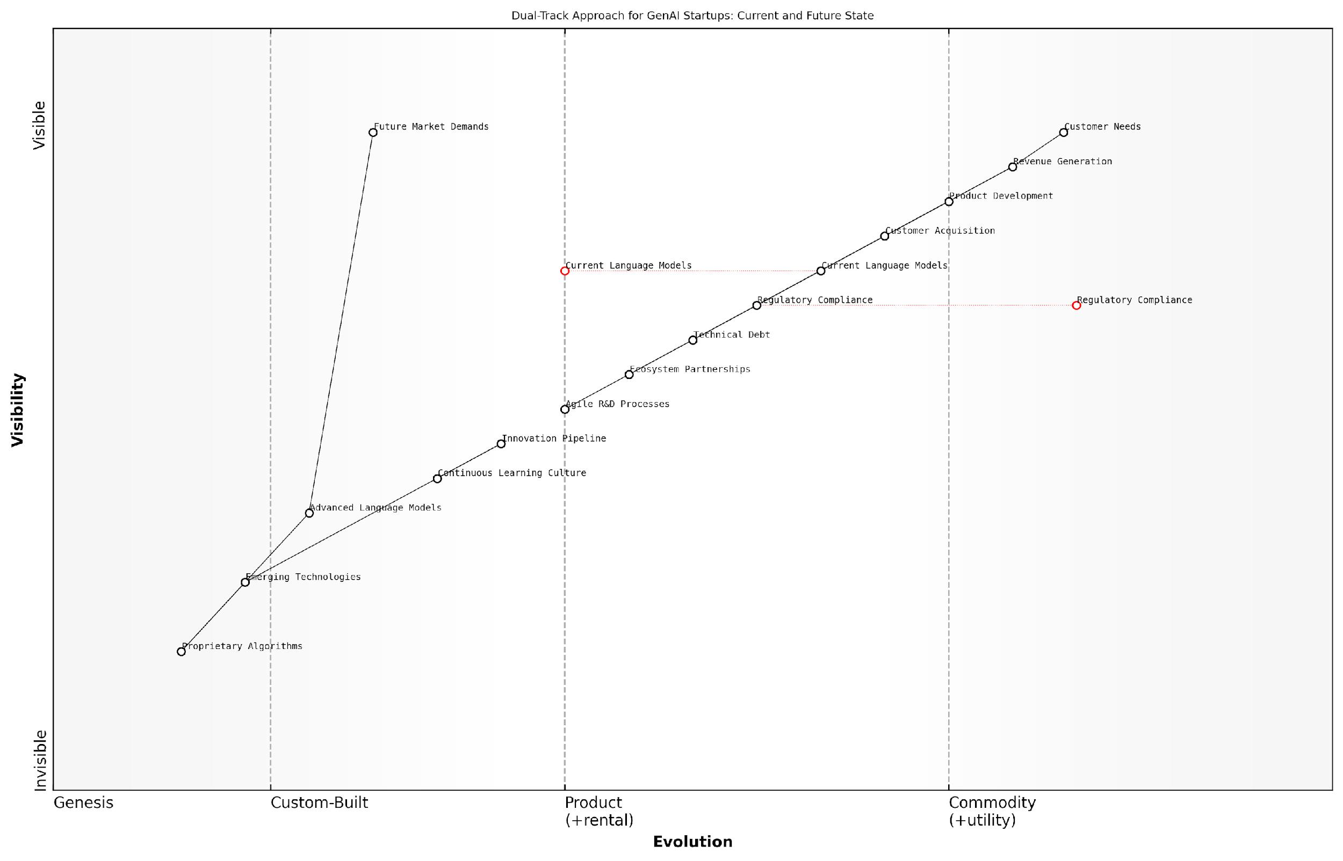

*Draft Wardley Map: [Insert Wardley Map: Balancing Short-term Needs with Long-term Innovation]*

[Edit this draft Wardley Map](https://create.wardleymaps.ai/#clone:d153d12a80014cadb3)

Wardley Map Assessment

This Wardley Map reveals a GenAI startup strategically positioned to navigate the challenges of current market demands while investing in future innovations. The dual-track approach balances short-term revenue generation with long-term technological advancement. Key focus areas should include managing technical debt, accelerating the development of advanced language models, and cultivating a strong innovation pipeline. The startup’s success will depend on its ability to evolve current offerings rapidly while simultaneously building capabilities in emerging technologies and proprietary algorithms. The emphasis on continuous learning and agile R&D processes provides a solid foundation for this challenging but potentially highly rewarding journey.

[View full Wardley Map report](http://markdown/wardley_map_reports/wardley_map_report_33_Balancing_Short-term_Needs_with_Long-term_Innovati.md)

It’s also important to consider the role of technical debt in this balancing act. While rapid development to meet short-term needs can accumulate technical debt, strategic planning using Wardley Mapping can help identify when and where to invest in refactoring or rebuilding components to support long-term innovation.

In the world of GenAI startups, those who can effectively balance short-term execution with long-term vision are the ones who will not just survive, but thrive and lead the industry forward.

Another critical aspect to consider is the regulatory landscape. GenAI startups must navigate current regulations while also anticipating future legal and ethical requirements. Wardley Mapping can help visualise the regulatory environment, allowing startups to plan for compliance in both the short and long term.

Lastly, it’s crucial to remember that the balance between short-term needs and long-term innovation is not static. It requires constant reassessment and adjustment. Regular review and updating of Wardley Maps can help GenAI startups stay agile, responding to market changes while keeping sight of their long-term innovation goals.

By mastering this balance through strategic use of Wardley Mapping, GenAI startups can position themselves to capitalise on immediate opportunities while building the foundations for sustained success and industry leadership in the dynamic world of artificial intelligence.

# Chapter 4: Building and Managing Your GenAI Startup Team

## Mapping Skill Requirements

### Identifying Critical Roles and Competencies

In the rapidly evolving landscape of Generative AI (GenAI) startups, identifying and mapping critical roles and competencies is paramount to building a robust and effective team. As an expert in Wardley Mapping for GenAI startups, I cannot overstate the importance of this process in ensuring your venture’s success. The unique challenges posed by GenAI development and deployment require a carefully curated blend of technical expertise, business acumen, and ethical understanding.

To begin mapping the skill requirements for your GenAI startup, it’s crucial to understand the core components of your value chain and the evolutionary stage of the technologies you’re working with. This understanding forms the foundation of your Wardley Map and will guide your decisions on team composition.

* AI/ML Engineers and Data Scientists: These roles are at the heart of GenAI development, responsible for designing, implementing, and optimising AI models.
* Software Engineers: Essential for building the infrastructure and platforms that support GenAI applications.
* Data Engineers: Critical for managing the vast amounts of data required for training and improving GenAI models.
* UX/UI Designers: Vital for creating intuitive interfaces for GenAI applications, ensuring user adoption and satisfaction.
* Product Managers: Key to bridging the gap between technical capabilities and market needs, guiding product development.
* Ethics and Compliance Specialists: Increasingly important in navigating the complex ethical landscape of AI development and deployment.
* Business Development and Sales Professionals: Crucial for market penetration and revenue generation, with a deep understanding of GenAI applications.
* Legal Experts: Necessary for navigating the evolving regulatory landscape surrounding AI and data privacy.

When mapping these roles onto your Wardley Map, consider their position along the evolution axis. For instance, while AI/ML engineering might be in the custom-built or product stages for many startups, roles like ethics specialists might still be in the genesis or custom-built phases, reflecting the nascent nature of AI governance frameworks.

In my experience advising GenAI startups, I’ve observed that the most successful teams are those that not only possess deep technical expertise but also demonstrate a keen understanding of the ethical implications and business applications of their technology. It’s this holistic approach that often sets apart thriving GenAI ventures from those that struggle to gain traction.

Beyond identifying these roles, it’s crucial to map the specific competencies required within each. For AI/ML engineers, this might include expertise in specific frameworks like TensorFlow or PyTorch, experience with large language models, or proficiency in reinforcement learning techniques. For ethics specialists, it could involve a background in philosophy, experience with AI governance frameworks, or knowledge of global AI regulations.

It’s also important to consider the interdependencies between these roles and how they align with your startup’s strategic goals. For example, a GenAI startup focusing on developing conversational AI for customer service might prioritise natural language processing expertise in their AI engineers and emphasise UX design skills to ensure seamless human-AI interactions.

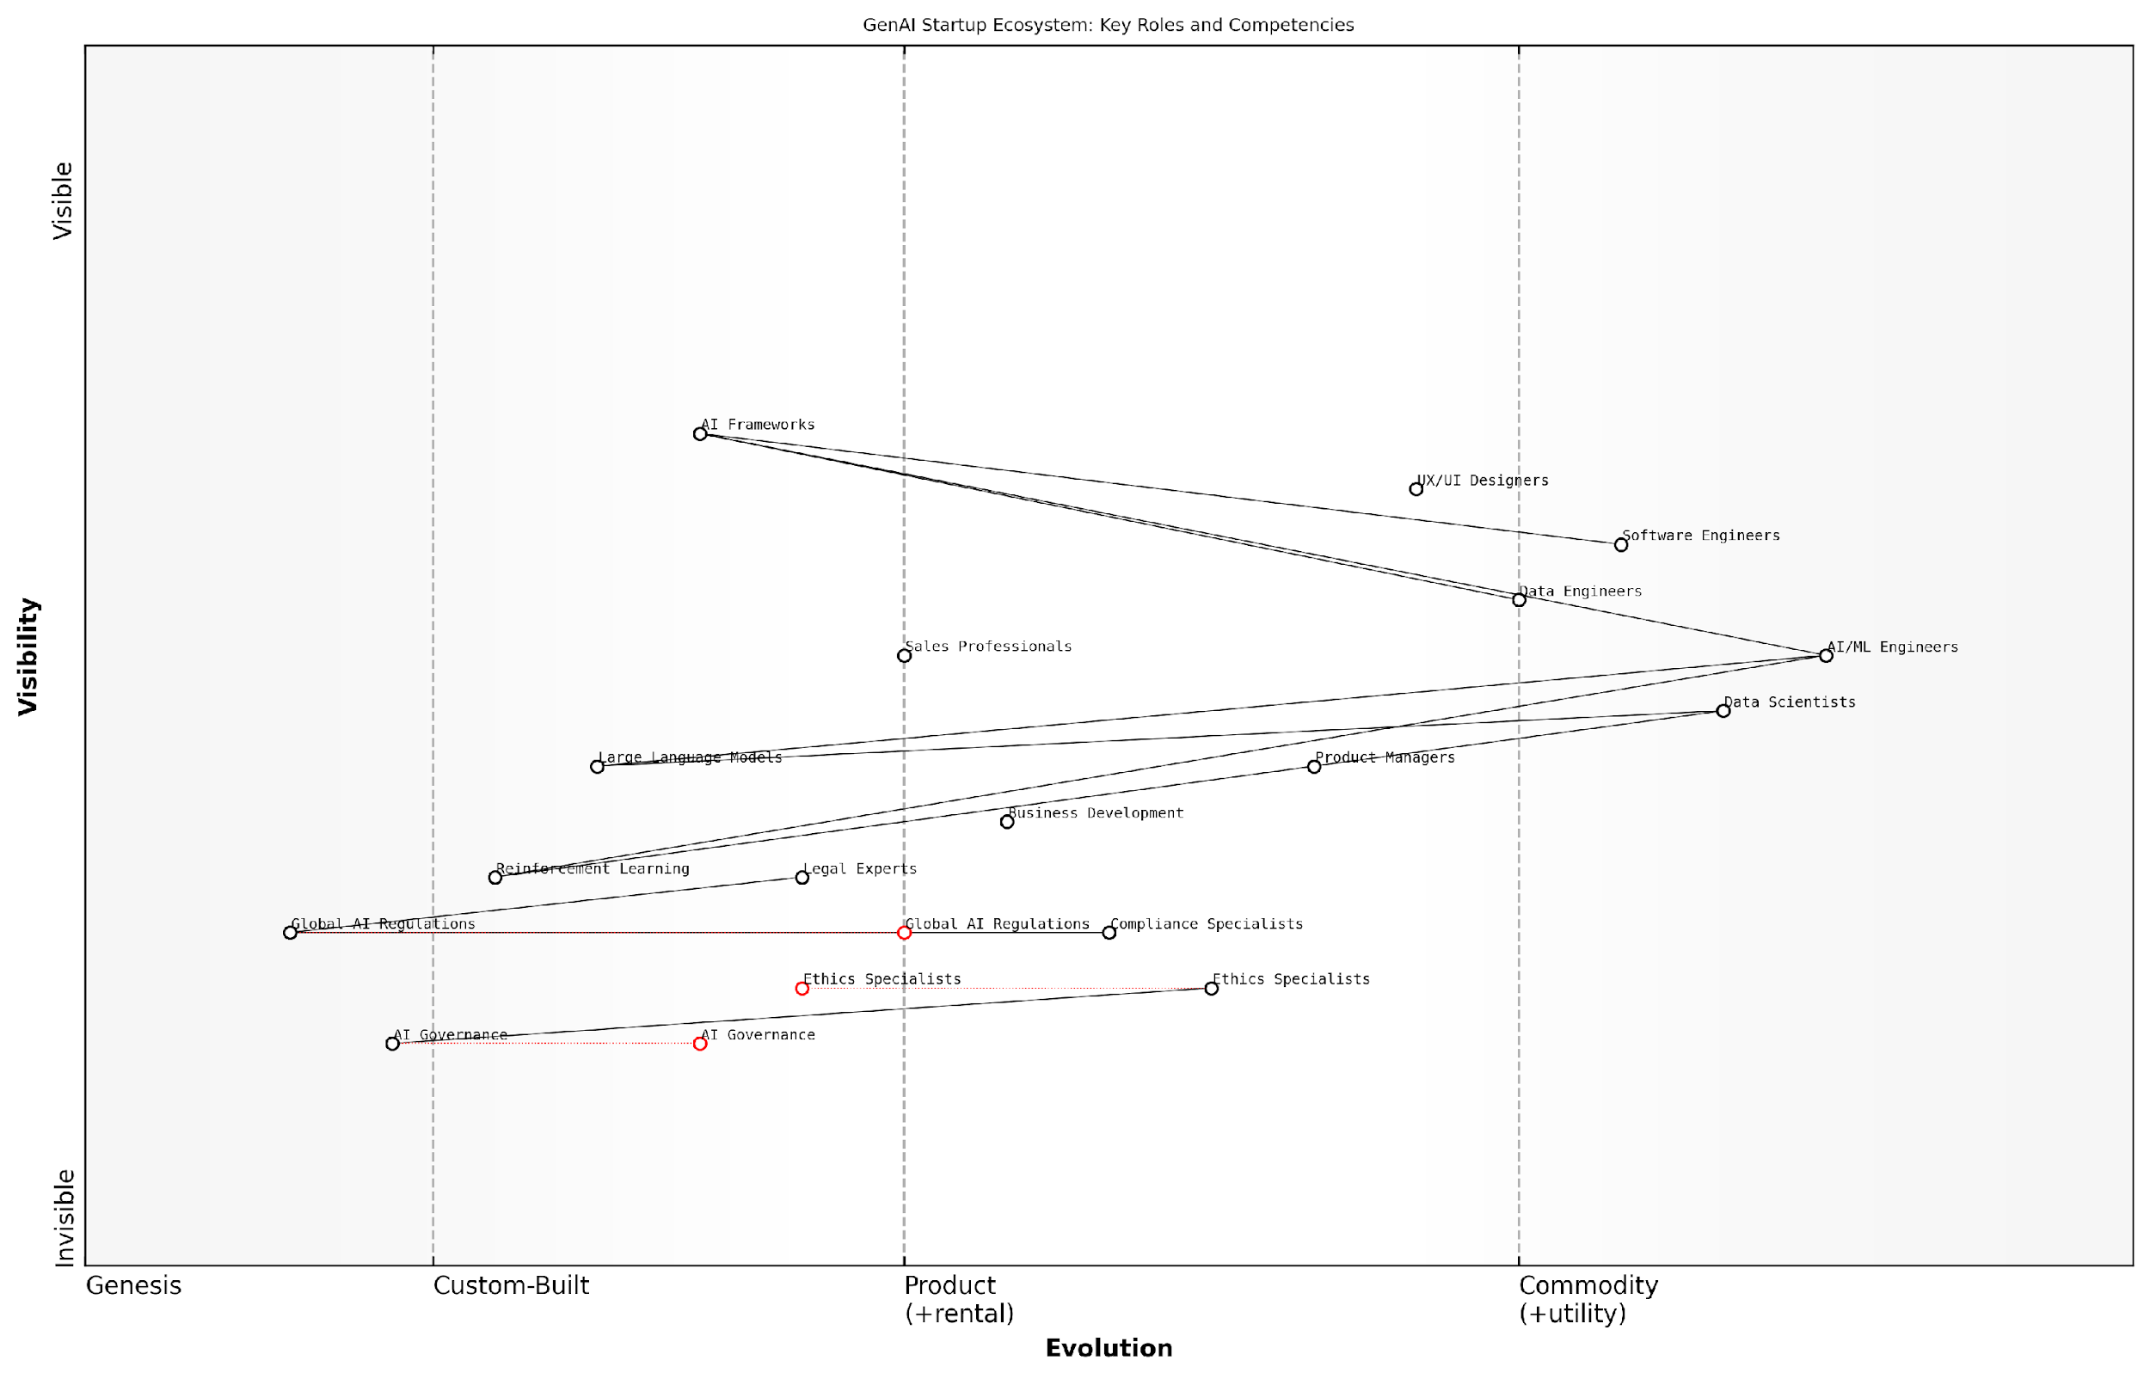

*Draft Wardley Map: [Insert Wardley Map: Identifying Critical Roles and Competencies]*

[Edit this draft Wardley Map](https://create.wardleymaps.ai/#clone:4b414ce38d825b0fd5)

Wardley Map Assessment

This map represents a GenAI startup ecosystem with a strong technical foundation and an emerging focus on ethical AI development. The strategic opportunity lies in leading the industry in integrating ethical considerations and governance into AI development, potentially creating a sustainable competitive advantage. Key challenges include rapidly evolving ethical and regulatory landscapes, which require agile adaptation and investment in emerging roles and competencies. The startup is well-positioned to innovate in both technical and ethical domains of AI, with the potential to shape industry standards and practices.

[View full Wardley Map report](http://markdown/wardley_map_reports/wardley_map_report_34_Identifying_Critical_Roles_and_Competencies.md)

As you map these roles and competencies, it’s crucial to also consider the evolutionary trajectory of the skills required. The GenAI field is advancing rapidly, and the competencies that are cutting-edge today may become commonplace in the near future. Your Wardley Map should reflect this dynamism, allowing you to anticipate future skill requirements and plan for upskilling or recruitment accordingly.

* Regularly reassess the positioning of roles and competencies on your Wardley Map
* Identify emerging skills that may become critical in the near future
* Plan for continuous learning and development within your team
* Consider partnerships or outsourcing for highly specialised or rapidly evolving skill sets

By meticulously mapping critical roles and competencies using Wardley Mapping techniques, GenAI startups can ensure they have the right blend of skills to navigate the complex and rapidly evolving AI landscape. This strategic approach to team building not only enhances your startup’s ability to innovate and compete but also positions you to address the unique challenges and opportunities presented by the GenAI revolution.

A senior government AI advisor once told me, ‘The success of GenAI initiatives often hinges not on the sophistication of the technology itself, but on the diversity and adaptability of the team behind it.’ This insight underscores the critical importance of thoughtful and strategic team composition in the GenAI startup ecosystem.

### Balancing Technical and Business Expertise

In the rapidly evolving landscape of GenAI startups, striking the right balance between technical prowess and business acumen is crucial for success. As an expert in Wardley Mapping for AI-driven ventures, I’ve observed that many startups falter not due to a lack of innovative technology, but because of an imbalance in their team’s skill set. This section delves into the art of mapping and balancing the technical and business expertise required to navigate the complex GenAI ecosystem.

Wardley Mapping provides an invaluable framework for visualising the skills landscape within your startup. By mapping both technical and business competencies, you can identify gaps, overlaps, and potential areas for cross-pollination of ideas. This approach allows for a more strategic allocation of resources and helps in building a well-rounded team capable of addressing the multifaceted challenges of the GenAI market.

* Identify core technical competencies: AI/ML expertise, data engineering, cloud infrastructure
* Map essential business skills: market analysis, product management, business development
* Assess the current evolution stage of each skill within your organisation
* Identify dependencies between technical and business functions
* Highlight areas where technical and business expertise intersect

When mapping your skill requirements, it’s crucial to consider the evolutionary stage of different competencies within the GenAI field. For instance, while deep learning algorithms might be in the ‘custom-built’ phase, requiring highly specialised expertise, business models for AI applications could be in the ‘product’ phase, necessitating individuals with experience in scaling AI businesses.

The most successful GenAI startups are those that can seamlessly blend cutting-edge technical innovation with robust business strategy. It’s not enough to have brilliant AI researchers; you need people who can translate that brilliance into market value.

One effective strategy I’ve seen implemented in successful GenAI startups is the creation of cross-functional teams. These teams bring together technical experts and business strategists to work on specific projects or product features. This approach not only ensures a balance of perspectives but also fosters a culture of mutual understanding and respect between the technical and business sides of the organisation.

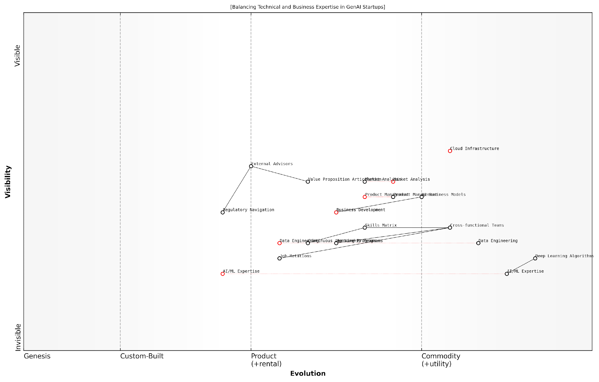

*Draft Wardley Map: [Insert Wardley Map: Balancing Technical and Business Expertise]*

[Edit this draft Wardley Map](https://create.wardleymaps.ai/#clone:79355d9884faefcc82)

Wardley Map Assessment

This Wardley Map presents a well-balanced view of the technical and business aspects crucial for GenAI startup success. It highlights the importance of integrating diverse skill sets through cross-functional teams and continuous learning. The strategic focus should be on maintaining cutting-edge AI/ML expertise while simultaneously developing strong business acumen and market understanding. Key areas for development include AI business models, regulatory navigation, and value proposition articulation. The emphasis on skills integration and adaptability through components like Cross-functional Teams and Continuous Learning Programs positions the startup well for navigating the rapidly evolving GenAI landscape. To maintain competitive advantage, the startup should prioritise the development of unique AI business models while ensuring a strong foundation of technical expertise and business understanding.

[View full Wardley Map report](http://markdown/wardley_map_reports/wardley_map_report_35_Balancing_Technical_and_Business_Expertise.md)

It’s important to note that the balance of technical and business expertise is not static. As your GenAI startup evolves, so too will your skill requirements. Regular reassessment of your skills map is essential to ensure you’re adapting to market changes and technological advancements. This might involve upskilling existing team members, bringing in new talent, or forming strategic partnerships to fill skill gaps.

* Implement continuous learning programmes to bridge the gap between technical and business knowledge
* Encourage job rotations or shadowing opportunities to broaden team members’ perspectives
* Create mentorship programmes pairing technical experts with business-focused team members and vice versa
* Regularly review and update your skills map to align with evolving market demands and technological advancements
* Consider the role of external advisors or board members in providing complementary expertise

One challenge I’ve frequently encountered in GenAI startups is the tendency to overemphasise technical skills at the expense of business acumen. While cutting-edge AI capabilities are undoubtedly crucial, it’s equally important to have team members who understand market dynamics, can articulate the value proposition to potential customers and investors, and navigate the complex regulatory landscape surrounding AI technologies.

In the world of GenAI startups, your competitive advantage lies not just in your algorithms, but in your ability to create real-world value from them. This requires a delicate balance of technical innovation and business savvy.

To achieve this balance, consider implementing a skills matrix that maps both technical and business competencies against your startup’s current and future needs. This visual representation can help identify areas where you need to bolster your expertise and guide your hiring and professional development strategies. Remember, the goal is not to have every team member be an expert in everything, but rather to ensure that your team as a whole has the right mix of skills to drive your GenAI startup forward.

In conclusion, balancing technical and business expertise is a critical factor in the success of GenAI startups. By leveraging Wardley Mapping techniques to visualise and strategically manage your skill requirements, you can build a team that’s not only capable of developing cutting-edge AI technologies but also adept at turning those innovations into sustainable business success. This balanced approach will position your startup to navigate the complexities of the GenAI landscape and capitalise on the immense opportunities it presents.

### Planning for Skill Evolution and Training

In the rapidly evolving landscape of Generative AI (GenAI), planning for skill evolution and training is not just a necessity but a critical strategic imperative for startups. As an expert in Wardley Mapping for GenAI startups, I cannot overstate the importance of this aspect in building a resilient and adaptable team. The pace of technological advancement in AI demands a proactive approach to skill development, ensuring that your team remains at the cutting edge of innovation while maintaining operational efficiency.

To effectively plan for skill evolution and training, we must first understand the current skill landscape within the context of Wardley Mapping. This involves mapping out the existing skills within your team, identifying potential skill gaps, and anticipating future skill requirements based on the evolution of GenAI technologies and market demands.

* Map current team skills across the Wardley Map axes
* Identify skill gaps in relation to your strategic goals
* Anticipate future skill requirements based on technology evolution
* Develop a training roadmap aligned with your Wardley Map

When mapping current team skills, it’s crucial to position them along the evolution axis of your Wardley Map. This will help you visualise which skills are commoditised and which are still in the genesis or custom-built stages. For instance, basic programming skills might be positioned towards the commodity end, while expertise in cutting-edge GenAI algorithms could be placed closer to the genesis stage.

In my experience advising GenAI startups, those who actively map and plan for skill evolution consistently outperform their peers in terms of innovation and market adaptability.

Identifying skill gaps requires a thorough analysis of your strategic goals and the components necessary to achieve them. By overlaying your team’s current skill map with the map of required skills for your GenAI products or services, you can pinpoint areas that need development or external acquisition.

Anticipating future skill requirements is perhaps the most challenging aspect of this process. It requires a deep understanding of the GenAI landscape and the ability to foresee technological trends. Utilise your Wardley Map to plot the expected evolution of key technologies and extrapolate the skills that will be necessary to leverage these advancements.

* Monitor emerging GenAI technologies and their potential impact on skill requirements
* Engage with academic institutions and research labs to stay ahead of the curve
* Participate in industry conferences and workshops to identify skill trends
* Collaborate with other startups and established players to share insights on skill evolution

Once you have a clear picture of your current skills, gaps, and future requirements, it’s time to develop a comprehensive training roadmap. This roadmap should be directly aligned with your Wardley Map, ensuring that skill development efforts are strategically focused and resource-efficient.

Your training roadmap should include a mix of internal and external training initiatives. Internal initiatives might involve peer-to-peer learning sessions, mentorship programmes, and hands-on project experience. External initiatives could include partnerships with educational institutions, online courses, and attendance at specialised workshops or bootcamps.

A senior technology leader in a successful GenAI startup once told me, ‘Our ability to rapidly upskill our team in response to market shifts has been our secret weapon in staying ahead of the competition.’

It’s important to note that skill evolution is not a one-time exercise but an ongoing process. Regular reassessment of your skill map and training roadmap is essential to ensure alignment with your evolving GenAI strategy and market dynamics.

* Implement quarterly skill mapping exercises
* Establish a continuous feedback loop between project outcomes and training initiatives
* Encourage a culture of self-directed learning and knowledge sharing
* Allocate dedicated time and resources for skill development activities

Finally, consider the role of cross-functional training in your skill evolution plan. In the world of GenAI, the lines between traditionally distinct roles are often blurred. Encouraging developers to understand business strategy, or product managers to grasp the basics of AI algorithms, can lead to more innovative solutions and smoother collaboration.

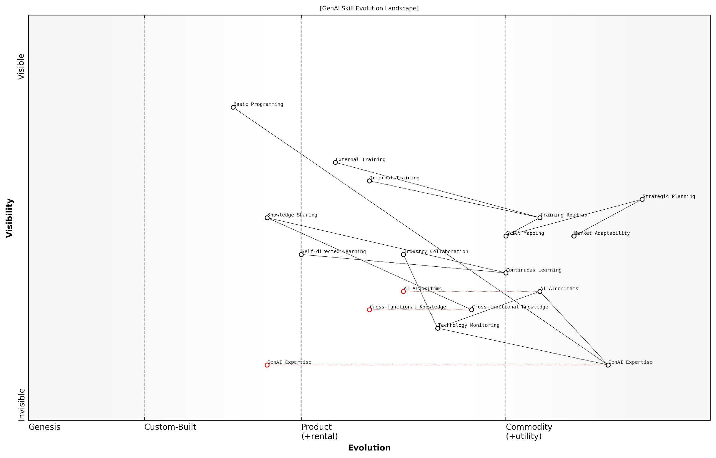

*Draft Wardley Map: [Insert Wardley Map: Planning for Skill Evolution and Training]*

[Edit this draft Wardley Map](https://create.wardleymaps.ai/#clone:9b0f7e6e32059b5fc1)

Wardley Map Assessment

This Wardley Map reveals a strategic landscape where GenAI startups must navigate the challenges of rapidly evolving technology while building robust internal capabilities. The key to success lies in balancing specialised GenAI expertise with broader market adaptability and fostering a culture of continuous learning. Startups should focus on developing unique AI algorithms, strengthening internal training mechanisms, and leveraging cross-functional knowledge to create competitive advantages. The map also highlights the importance of strategic planning and skill mapping to ensure the team’s capabilities evolve in tandem with the GenAI field. By addressing the identified gaps and leveraging the suggested opportunities, GenAI startups can position themselves for long-term success in this dynamic and high-potential market.

[View full Wardley Map report](http://markdown/wardley_map_reports/wardley_map_report_36_Planning_for_Skill_Evolution_and_Training.md)

By meticulously planning for skill evolution and training, and aligning these efforts with your Wardley Map, you position your GenAI startup to not just react to change, but to proactively shape the future of the industry. This approach ensures that your team remains agile, innovative, and capable of seizing new opportunities as they emerge in the dynamic world of Generative AI.

## Organisational Structure and Culture

### Designing an Agile and Adaptive Org Structure

In the rapidly evolving landscape of GenAI startups, designing an agile and adaptive organisational structure is not just beneficial—it’s essential for survival and success. As an expert in Wardley Mapping for GenAI startups, I’ve observed that traditional hierarchical structures often struggle to keep pace with the dynamic nature of AI innovation and market demands. Instead, GenAI startups need to embrace flexible, responsive structures that can evolve as quickly as the technology they’re developing.

To design such a structure, we must first understand the unique challenges faced by GenAI startups. These include rapid technological advancements, shifting regulatory landscapes, and the need for cross-functional collaboration between AI researchers, software engineers, domain experts, and business strategists. A well-designed organisational structure should address these challenges while fostering innovation, agility, and ethical AI development.

* Flat hierarchies to promote rapid decision-making and information flow
* Cross-functional teams organised around specific AI products or services
* Flexible role definitions that allow for skill development and knowledge sharing
* Dedicated innovation teams or ‘skunkworks’ for exploring cutting-edge AI concepts
* Clear ethical guidelines and governance structures embedded throughout the organisation

One effective approach is to implement a matrix structure, where employees are grouped by both function (e.g., AI research, engineering, product management) and project or product line. This allows for specialisation while also promoting cross-pollination of ideas and rapid resource allocation as market needs shift. It’s crucial to balance this flexibility with clear lines of accountability and decision-making authority to prevent confusion or paralysis.

In my experience advising GenAI startups, I’ve found that the most successful organisations are those that view their structure as a living entity, constantly evolving based on market feedback and internal learnings. Static structures simply can’t keep up with the pace of AI innovation.

Another key consideration is the integration of ethical AI principles into the organisational structure. This could involve creating a dedicated ethics board or embedding ethics specialists within each product team. The goal is to ensure that ethical considerations are not an afterthought but are woven into the fabric of the organisation’s decision-making processes.

When applying Wardley Mapping to organisational design, we can visualise different structural components along the evolution axis. For instance, certain roles or teams might be positioned in the ‘genesis’ or ‘custom-built’ stages, focusing on cutting-edge AI research and development. Others might be in the ‘product’ or ‘commodity’ stages, dealing with more established AI technologies or business functions. This mapping can help identify where flexibility is most crucial and where more standardised processes might be appropriate.

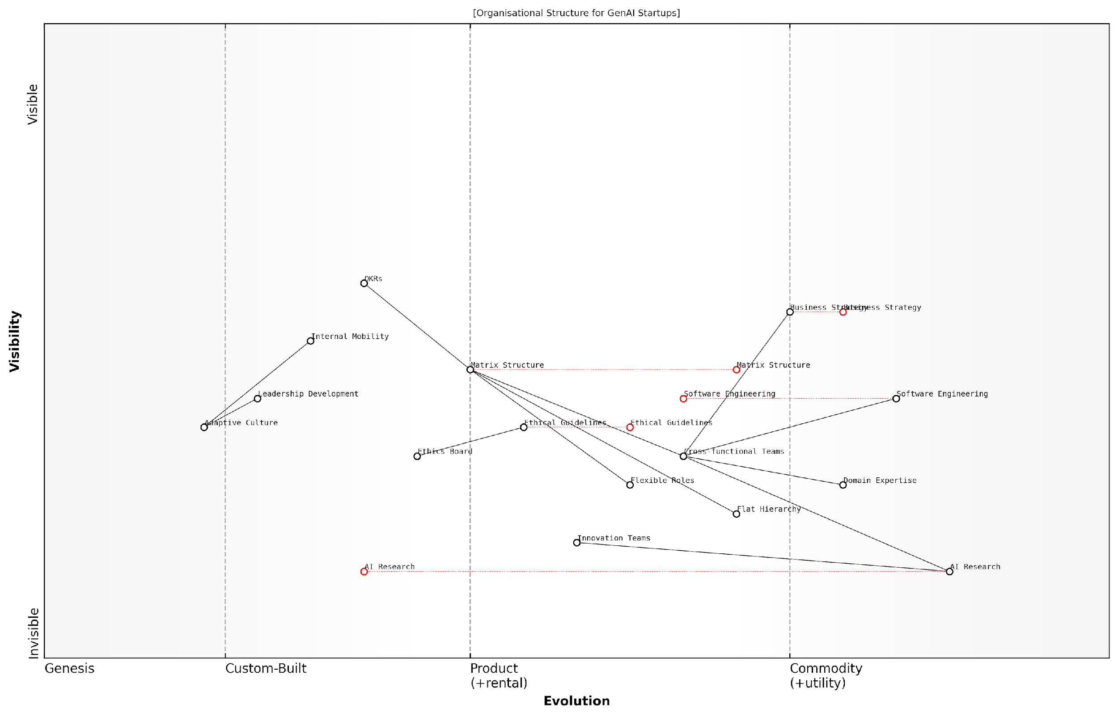

*Draft Wardley Map: [Insert Wardley Map: Designing an Agile and Adaptive Org Structure]*

[Edit this draft Wardley Map](https://create.wardleymaps.ai/#clone:288cb851746a274f3b)

Wardley Map Assessment

This Wardley Map depicts a GenAI startup with a strong foundation in AI research and software engineering, supported by an adaptive organisational structure. The emphasis on cross-functional teams and ethical considerations positions the company well for innovation. However, there’s a need to strengthen the connection between research and business strategy, and to further develop leadership and ethical AI capabilities to ensure long-term success and responsible growth in the rapidly evolving GenAI landscape.

[View full Wardley Map report](http://markdown/wardley_map_reports/wardley_map_report_37_Designing_an_Agile_and_Adaptive_Org_Structure.md)

It’s also vital to consider the scalability of the organisational structure. While a completely flat structure might work for a small team, it can become unwieldy as the startup grows. Planning for scalability might involve designing modular team structures that can be replicated or split as the company expands, or implementing ‘fractal’ organisational patterns that maintain agility at different scales.

* Implement regular organisational retrospectives to assess and adjust the structure
* Use OKRs (Objectives and Key Results) to align teams and maintain focus on key goals
* Encourage internal mobility to prevent silos and promote knowledge sharing
* Establish clear communication channels and decision-making protocols to prevent chaos in a flexible structure
* Invest in leadership development to ensure managers can effectively navigate a dynamic organisation

Finally, it’s crucial to recognise that organisational structure is deeply intertwined with company culture. An agile structure will only be effective if it’s supported by a culture that values adaptability, continuous learning, and open communication. Leaders must actively cultivate these values and model the behaviours they wish to see throughout the organisation.

A senior AI researcher I’ve worked with once remarked, ‘The best GenAI startups don’t just develop adaptive algorithms—they become adaptive algorithms themselves, constantly learning and evolving in response to new data and challenges.’

By thoughtfully designing an agile and adaptive organisational structure, GenAI startups can position themselves to navigate the complex and rapidly changing landscape of AI innovation. This approach not only enhances their ability to develop cutting-edge AI technologies but also enables them to respond swiftly to market opportunities, regulatory changes, and ethical challenges. In the high-stakes world of GenAI, this organisational agility can be the difference between leading the field and being left behind.

### Fostering a Culture of Innovation and Ethical AI Development

In the rapidly evolving landscape of Generative AI (GenAI), fostering a culture of innovation and ethical AI development is not just a desirable trait—it’s a critical necessity for startups aiming to make a lasting impact. This cultural foundation serves as the bedrock upon which successful GenAI ventures are built, enabling them to navigate the complex interplay between technological advancement and ethical considerations.

To effectively cultivate this culture, GenAI startups must strategically position various elements on their Wardley Map, considering both the evolution of AI technologies and the maturity of ethical frameworks. Let’s explore the key components and strategies for fostering this crucial cultural dynamic.

* Embedding Ethics in the Core Value Chain
* Cultivating a Growth Mindset
* Encouraging Cross-Functional Collaboration
* Implementing Ethical AI Governance
* Promoting Transparency and Accountability

Embedding Ethics in the Core Value Chain: On your Wardley Map, position ethical considerations as a fundamental component that spans across all stages of your value chain. This ensures that ethical deliberations are not an afterthought but an integral part of every decision-making process, from research and development to product deployment and customer engagement.

Ethical AI is not a constraint on innovation, but rather a catalyst for sustainable and responsible growth in the GenAI sector.

Cultivating a Growth Mindset: Position continuous learning and adaptability high on your map’s value chain. In the fast-paced world of GenAI, fostering a culture where team members are encouraged to experiment, learn from failures, and constantly upskill is crucial. This growth mindset should be reflected in your organisational policies, training programmes, and performance evaluations.

Encouraging Cross-Functional Collaboration: Map out collaborative structures that bring together diverse expertise—data scientists, ethicists, domain experts, and business strategists. This cross-pollination of ideas not only drives innovation but also ensures a holistic approach to AI development that considers multiple perspectives and potential impacts.

Implementing Ethical AI Governance: Establish a robust ethical AI governance framework and position it as a key component on your map. This framework should include clear guidelines, review processes, and accountability measures to ensure that all AI development aligns with your ethical standards and societal values.

A well-structured ethical AI governance framework acts as a compass, guiding innovation towards responsible and sustainable outcomes.

Promoting Transparency and Accountability: Position transparency as a core value in your organisational culture. This includes being open about your AI development processes, decision-making criteria, and the potential limitations or biases in your AI systems. Encourage a culture where team members feel safe to raise ethical concerns and where such concerns are taken seriously and addressed promptly.

By mapping these elements and understanding their interdependencies, GenAI startups can create a cohesive culture that balances innovation with ethical responsibility. This culture becomes a strategic asset, differentiating the startup in a crowded market and building trust with stakeholders, from investors to end-users.

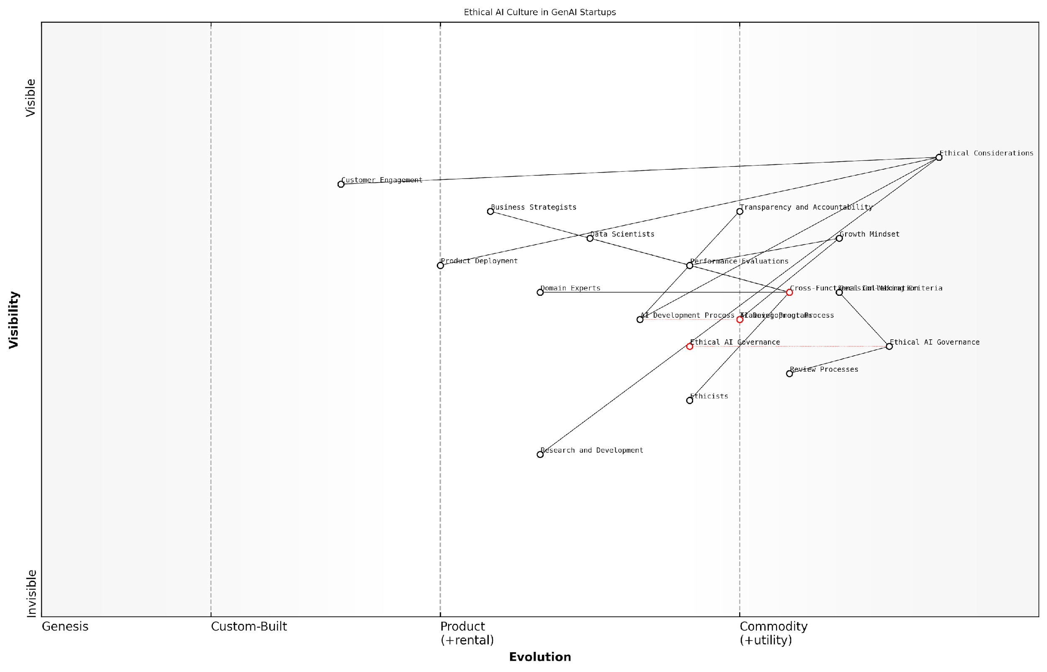

*Draft Wardley Map: [Insert Wardley Map: Fostering a Culture of Innovation and Ethical AI Development]*

[Edit this draft Wardley Map](https://create.wardleymaps.ai/#clone:907249ee92b0c96f82)

Wardley Map Assessment

This Wardley Map presents a forward-thinking approach to GenAI startup development, placing strong emphasis on ethical considerations and governance. The strategic positioning of ethical elements as key differentiators offers a unique competitive advantage. However, the company needs to focus on evolving its AI development process to more seamlessly integrate ethical considerations, while also working on standardising its governance and review processes. The future success in the GenAI market will likely depend on the ability to balance rapid innovation with strong ethical foundations, positioning the company as a trusted leader in responsible AI development.

[View full Wardley Map report](http://markdown/wardley_map_reports/wardley_map_report_38_Fostering_a_Culture_of_Innovation_and_Ethical_AI_D.md)

Remember, fostering this culture is an ongoing process. Regularly revisit and update your Wardley Map to reflect the evolving landscape of GenAI technologies and ethical standards. By doing so, you ensure that your startup remains at the forefront of responsible AI innovation, well-positioned to tackle the challenges and opportunities that lie ahead in this transformative field.

### Managing Remote and Distributed Teams in the AI Era

In the rapidly evolving landscape of GenAI startups, managing remote and distributed teams has become not just a necessity but a strategic advantage. The AI era has ushered in unprecedented opportunities for collaboration across geographical boundaries, allowing startups to tap into global talent pools and operate with increased flexibility. However, this shift also presents unique challenges that require a thoughtful approach to team management and organisational structure.

As an expert in this field, I’ve observed that successful GenAI startups are those that embrace the distributed nature of work while maintaining a cohesive company culture and efficient operational processes. The key lies in leveraging technology, establishing clear communication protocols, and fostering a sense of shared purpose among team members, regardless of their physical location.

* Implement robust digital collaboration tools
* Establish clear communication protocols
* Create virtual spaces for informal interactions
* Develop a strong remote work policy
* Invest in cybersecurity measures
* Foster a culture of trust and autonomy
* Prioritise outcome-based performance metrics

One of the most critical aspects of managing remote teams in the AI era is the implementation of robust digital collaboration tools. These tools should go beyond basic video conferencing and instant messaging. They should integrate project management, code repositories, and AI-powered productivity enhancements. For instance, many successful GenAI startups are utilising platforms that incorporate machine learning to optimise task allocation and predict potential bottlenecks in distributed workflows.

In our experience, the most successful distributed AI teams are those that have mastered the art of asynchronous communication while maintaining real-time collaboration capabilities when needed.

Establishing clear communication protocols is paramount. This includes defining expectations for response times, scheduling regular check-ins, and creating channels for both work-related and social interactions. Many GenAI startups are adopting a ‘documentation-first’ approach, where all important decisions and discussions are recorded in accessible, searchable formats. This not only aids in knowledge sharing but also helps in onboarding new team members more efficiently.

Creating virtual spaces for informal interactions is crucial for maintaining team cohesion and fostering innovation. Some startups have implemented virtual ‘water cooler’ channels or regular online social events to replicate the spontaneous interactions that occur in physical offices. These informal touchpoints can be particularly valuable for cross-pollination of ideas in the fast-paced world of GenAI development.

Developing a strong remote work policy is essential. This should cover aspects such as work hours, availability expectations, equipment provisions, and data security protocols. Given the sensitive nature of AI development, it’s crucial to have clear guidelines on handling proprietary algorithms and datasets when working remotely.

Investing in robust cybersecurity measures is non-negotiable for GenAI startups managing distributed teams. This includes implementing multi-factor authentication, virtual private networks (VPNs), and regular security audits. Some startups are even exploring AI-powered security solutions to detect and prevent potential breaches in real-time.

Fostering a culture of trust and autonomy is critical in remote AI teams. This involves moving away from micromanagement and towards a results-oriented approach. Leaders must trust their team members to manage their time effectively and deliver high-quality work, regardless of when or where they choose to work.

Prioritising outcome-based performance metrics rather than time-based ones is a shift many successful GenAI startups have made. This approach aligns well with the nature of AI development, where breakthroughs can happen at any time and creative problem-solving is more valuable than hours logged.

The most innovative GenAI solutions often emerge from diverse, distributed teams where different perspectives and expertise converge, unrestricted by geographical boundaries.

It’s worth noting that managing remote teams in the AI era also presents unique opportunities for leveraging AI itself in team management. For instance, some startups are experimenting with AI-powered tools for sentiment analysis in team communications, predictive analytics for project timelines, and even AI assistants that can help coordinate across different time zones and work styles.

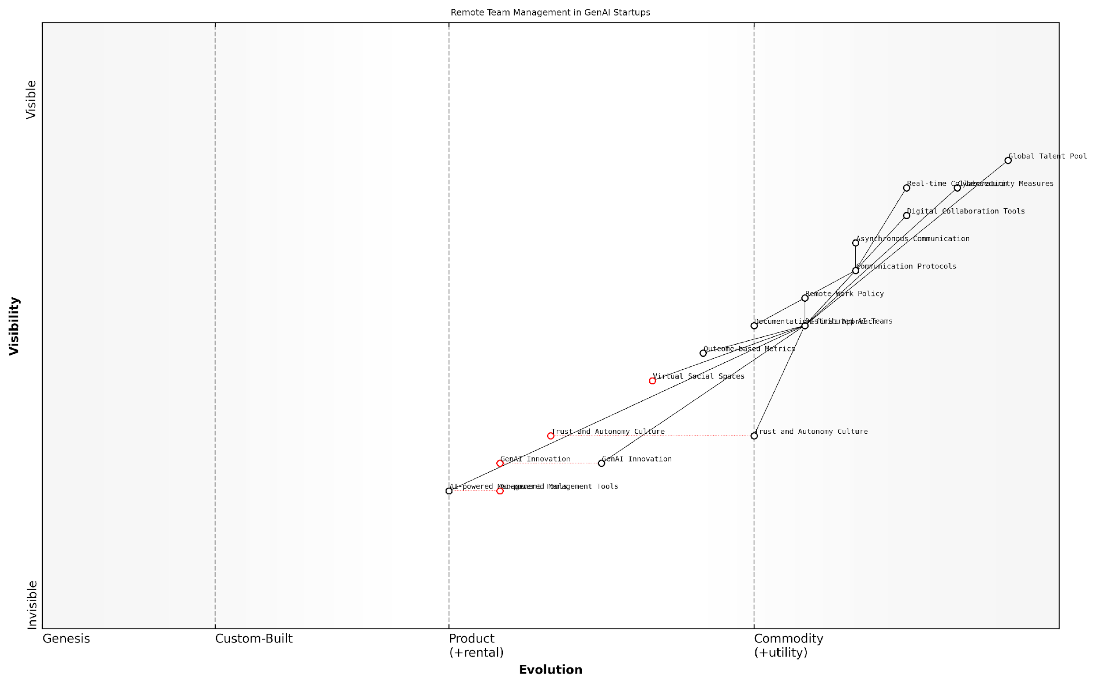

*Draft Wardley Map: [Insert Wardley Map: Managing Remote and Distributed Teams in the AI Era]*

[Edit this draft Wardley Map](https://create.wardleymaps.ai/#clone:d77051e7ca5c7e5a6a)

Wardley Map Assessment

This Wardley Map reveals a strategic focus on leveraging global talent through distributed AI teams, with a clear emphasis on evolving AI-powered management tools and cultivating a trust-based remote work culture. The key to success lies in balancing the rapid innovation in AI with the development of effective remote collaboration practices. GenAI startups should prioritise the evolution of AI-powered management tools and virtual social spaces while maintaining a strong foundation of digital collaboration and cybersecurity. The unique combination of advanced AI capabilities and distributed team management presents a significant opportunity for competitive advantage in the GenAI startup ecosystem.

[View full Wardley Map report](http://markdown/wardley_map_reports/wardley_map_report_39_Managing_Remote_and_Distributed_Teams_in_the_AI_Er.md)

In conclusion, managing remote and distributed teams in the AI era requires a multifaceted approach that combines technological solutions with human-centric management practices. By embracing the distributed nature of modern work and leveraging the very AI technologies they are developing, GenAI startups can create highly effective, innovative teams that are not constrained by geographical boundaries. The key is to view remote work not as a limitation, but as an opportunity to access global talent and foster a diverse, dynamic work environment that drives innovation in the cutting-edge field of Generative AI.

## Talent Acquisition and Retention Strategies

### Mapping the AI Talent Landscape

In the rapidly evolving field of Generative AI, mapping the talent landscape is crucial for startups aiming to build and maintain a competitive edge. As an expert in Wardley Mapping for GenAI startups, I can attest that understanding the nuances of the AI talent ecosystem is as critical as mapping your technical stack or market position. This subsection will delve into the intricacies of talent mapping, providing insights that can help startups navigate the complex and often turbulent waters of AI recruitment and retention.

To effectively map the AI talent landscape, we must first recognise the unique characteristics of this domain. The GenAI field is marked by rapid technological advancements, a high demand for specialised skills, and a relatively small pool of experienced professionals. This creates a highly competitive environment where startups must be strategic and innovative in their approach to talent acquisition and retention.

* Identify key roles and skills essential for GenAI development
* Map the current distribution of talent across industries and geographies
* Analyse the evolution of AI skills and predict future talent needs
* Understand the competitive landscape for AI talent acquisition
* Identify potential talent pools and non-traditional sources of AI expertise

When applying Wardley Mapping to the AI talent landscape, we begin by positioning different skill sets and roles along the evolution axis. For instance, general machine learning skills might be positioned further along the evolution curve, while expertise in cutting-edge GenAI techniques would be closer to the genesis stage. This mapping helps startups identify where they need to focus their recruitment efforts and where they might face the stiffest competition for talent.

In the GenAI talent landscape, the most valuable assets are often not just technical skills, but the ability to innovate and adapt rapidly to new paradigms. Startups that can identify and nurture these qualities will have a significant advantage.

Another crucial aspect of mapping the AI talent landscape is understanding the movement of talent between academia, large tech companies, and startups. This flow of expertise can significantly impact a startup’s ability to attract top talent. By mapping these movements, startups can identify potential sources of talent and develop strategies to position themselves as attractive alternatives to more established players.

It’s also essential to consider the global nature of the AI talent pool. While certain regions may have concentrations of AI expertise, the rise of remote work has opened up new possibilities for talent acquisition. Startups should map potential talent sources globally, considering factors such as time zones, cultural fit, and regulatory environments that might affect remote hiring.

* Map the global distribution of AI talent and expertise centres
* Identify emerging AI talent hubs and educational institutions
* Analyse the impact of remote work on talent accessibility
* Consider cultural and regulatory factors in global talent acquisition
* Explore opportunities for building distributed AI teams

When mapping the AI talent landscape, it’s crucial to look beyond traditional indicators like degrees and years of experience. The fast-paced nature of GenAI means that practical skills, project experience, and contributions to open-source AI projects can be equally, if not more, valuable. Startups should map these alternative indicators of expertise and consider how they can be incorporated into their talent acquisition strategies.

The most successful GenAI startups are those that can look beyond conventional talent pools and identify individuals with the potential to drive innovation, regardless of their background or formal qualifications.

Finally, it’s important to map the evolving nature of AI roles themselves. As GenAI technologies mature, new specialisations emerge, and existing roles evolve. Startups must anticipate these changes and adjust their talent strategies accordingly. This might involve mapping potential career paths within the organisation, identifying opportunities for skill development, and creating a culture that attracts forward-thinking AI professionals.

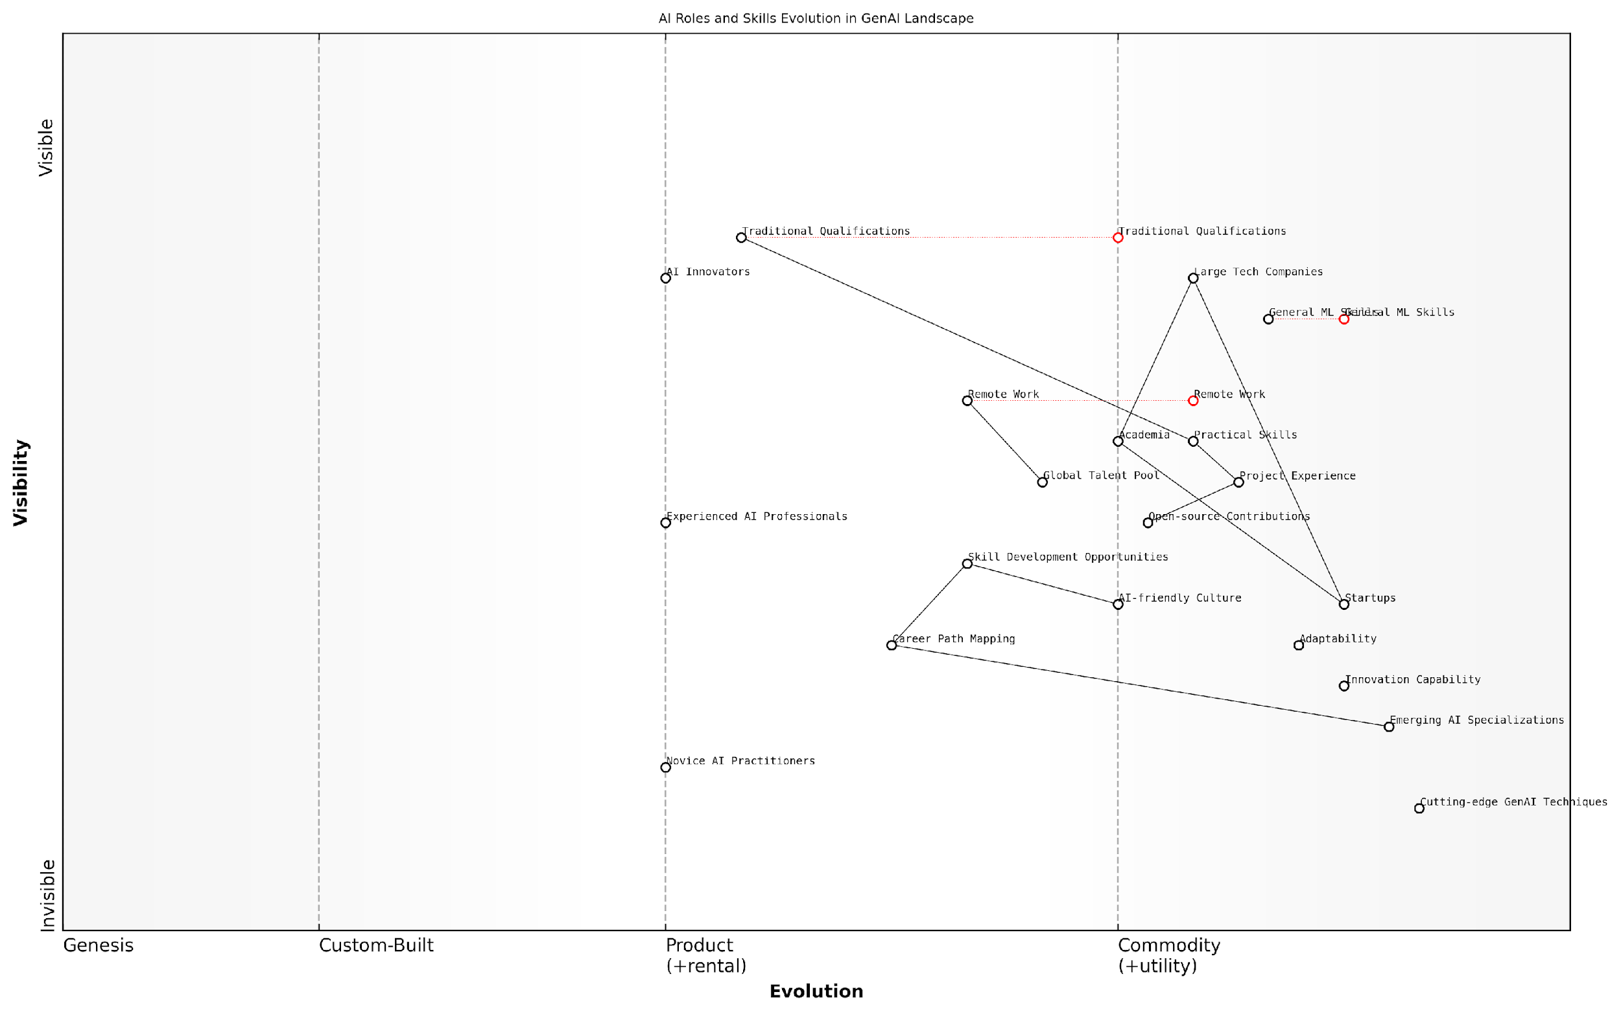

*Draft Wardley Map: [Insert Wardley Map: Mapping the AI Talent Landscape]*

[Edit this draft Wardley Map](https://create.wardleymaps.ai/#clone:9ff33f172e2f3d55ff)

Wardley Map Assessment

The GenAI talent landscape is rapidly evolving, with a clear shift towards practical skills, innovation, and specialisation. Organisations must focus on cultivating cutting-edge expertise while maintaining a strong foundation in general AI skills. The key to success lies in creating an AI-friendly culture that attracts top talent, fostering innovation, and maintaining adaptability in a fast-changing field. Strategic partnerships across academia, industry, and the open-source community will be crucial for staying at the forefront of GenAI advancements.

[View full Wardley Map report](http://markdown/wardley_map_reports/wardley_map_report_40_Mapping_the_AI_Talent_Landscape.md)

By thoroughly mapping the AI talent landscape, GenAI startups can gain a significant competitive advantage in attracting and retaining the expertise they need to succeed. This mapping process should be ongoing, regularly updated to reflect the rapid changes in the field, and integrated into the startup’s overall strategic planning. With a clear understanding of the talent landscape, startups can make informed decisions about recruitment, skill development, and organisational structure, positioning themselves for success in the dynamic world of Generative AI.

### Developing Compelling Value Propositions for Top Talent

In the fiercely competitive landscape of GenAI startups, attracting and retaining top talent is a critical factor for success. As we navigate this challenge through the lens of Wardley Mapping, we can identify unique strategies to create compelling value propositions that resonate with high-calibre professionals in the AI field. This approach not only helps in positioning your startup as an employer of choice but also aligns with the overall strategic mapping of your organisation’s growth trajectory.

To begin, it’s essential to understand that top AI talent is not merely seeking competitive salaries; they are looking for opportunities that offer intellectual stimulation, cutting-edge technology exposure, and the potential to make a significant impact. By mapping these desires against your startup’s unique offerings, we can craft value propositions that truly stand out in the crowded GenAI talent market.

* Mapping Intellectual Challenges: Identify and highlight the complex problems your startup is tackling in the GenAI space. Use Wardley Mapping to visualise how these challenges align with the evolution of AI technologies, demonstrating to potential hires the cutting-edge nature of your work.
* Showcasing Technology Stack: Map out your current and planned technology stack, emphasising areas where you’re pushing the boundaries of GenAI. This visual representation can be a powerful tool in attracting technologists who are eager to work with state-of-the-art systems.
* Impact Visualisation: Use Wardley Maps to illustrate the potential impact of your startup’s work on the broader AI ecosystem or specific industries. This can appeal to professionals who are motivated by the opportunity to create meaningful change.
* Growth Trajectory Mapping: Demonstrate your startup’s growth plans and how individual roles fit into this larger picture. This can be particularly compelling for ambitious professionals looking for rapid career advancement opportunities.
* Cultural Alignment: Map out your company culture and values, showing how they align with the ethical considerations and professional growth aspirations of top AI talent.

When developing these value propositions, it’s crucial to consider the evolving nature of the GenAI field. What might be a compelling offer today could become commonplace tomorrow. This is where the dynamic nature of Wardley Mapping becomes particularly valuable, allowing you to continuously reassess and adjust your value propositions as the landscape shifts.

In my experience advising GenAI startups, I’ve observed that the most successful companies in attracting top talent are those that can articulate a clear vision of the future and demonstrate how potential hires can play a pivotal role in shaping that future.

One effective strategy is to create personalised value propositions for different segments of talent. For instance, for seasoned AI researchers, you might emphasise the autonomy and resources available for groundbreaking research. For talented engineers, you could highlight the opportunity to work on scalable systems that push the boundaries of what’s possible with GenAI. For business-oriented professionals, showcase how their expertise can shape the strategic direction of a cutting-edge AI company.

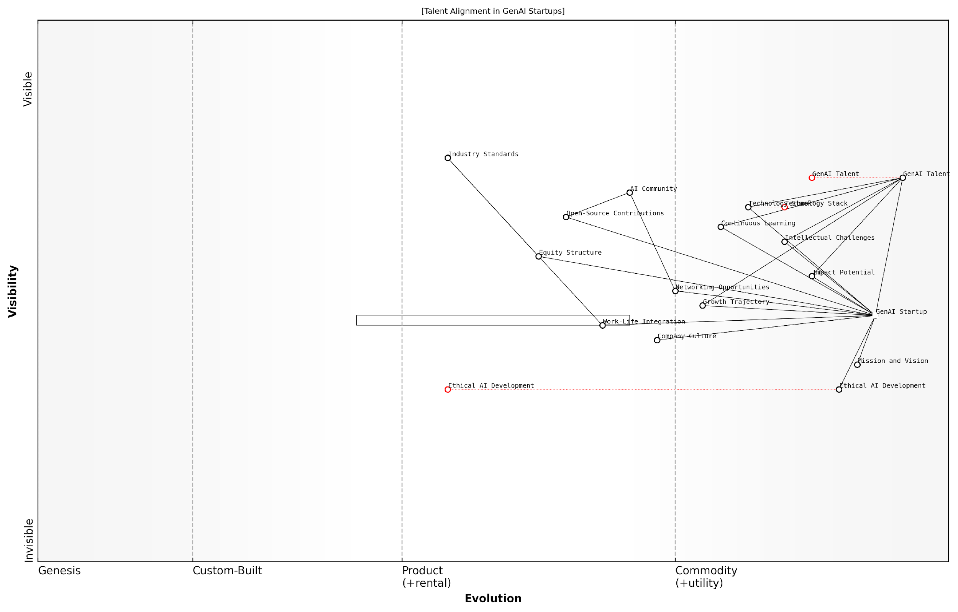

*Draft Wardley Map: [Insert Wardley Map: Developing Compelling Value Propositions for Top Talent]*

[Edit this draft Wardley Map](https://create.wardleymaps.ai/#clone:0bca50ac65203633cd)

Wardley Map Assessment

This Wardley Map presents a comprehensive view of talent alignment strategies for GenAI startups. It highlights the critical importance of balancing technical excellence with ethical considerations and a strong company culture. The startup is well-positioned in terms of its Technology Stack and ability to offer Intellectual Challenges, but has significant opportunities for differentiation through Ethical AI Development and innovative approaches to Work-Life Integration. By focusing on these areas, along with strengthening ties to the AI Community and enhancing Open-Source Contributions, the startup can create a compelling value proposition for top GenAI talent. The evolving nature of the industry, particularly in terms of ethical standards and work practices, presents both challenges and opportunities for establishing thought leadership and attracting the best minds in the field.

[View full Wardley Map report](http://markdown/wardley_map_reports/wardley_map_report_41_Developing_Compelling_Value_Propositions_for_Top_T.md)

It’s also important to consider the competitive landscape when crafting your value propositions. Use Wardley Mapping to analyse what other GenAI startups and established tech giants are offering. This will help you identify unique selling points that set your startup apart. Perhaps it’s the opportunity to work on a specific type of GenAI application, or the chance to collaborate with renowned experts in the field, or a unique approach to ethical AI development.

Remember that transparency is key in your value propositions. While it’s important to highlight the exciting aspects of joining your startup, it’s equally crucial to be honest about the challenges and risks. Top talent appreciates authenticity, and a clear-eyed view of the landscape you’re navigating can actually be a strong selling point for professionals who thrive in dynamic, challenging environments.

* Equity and Ownership: Clearly map out your equity structure and how it compares to industry standards. For many top professionals, the opportunity for significant ownership in a potentially disruptive GenAI startup can be a major draw.
* Work-Life Integration: In the fast-paced world of GenAI startups, traditional work-life balance may not always be feasible. Instead, focus on work-life integration, mapping out how your startup supports personal growth, learning, and wellbeing alongside professional development.
* Networking and Industry Exposure: Highlight opportunities for talent to engage with the broader AI community through conferences, collaborations, and open-source contributions. Map out how these activities align with both individual career growth and your startup’s strategic goals.
* Continuous Learning: Emphasise your commitment to ongoing education and skill development. Map out learning pathways that align with the evolving GenAI landscape, demonstrating how professionals can stay at the cutting edge while working with you.

Finally, don’t underestimate the power of your startup’s mission and vision in attracting top talent. Many professionals in the AI field are driven by the desire to work on projects that have the potential to positively impact society. Use Wardley Mapping to illustrate how your startup’s goals align with broader trends in ethical AI development, societal benefit, or technological advancement. This can create a compelling narrative that resonates with value-driven professionals.

The most effective value propositions I’ve seen in the GenAI startup space are those that paint a vivid picture of the future and clearly articulate how joining the company is an opportunity to be at the forefront of shaping that future.

By leveraging Wardley Mapping in developing your value propositions for top talent, you create a dynamic, strategic approach to talent acquisition. This method not only helps you attract the best minds in GenAI but also ensures that your talent strategy remains aligned with your overall business strategy, positioning your startup for long-term success in the rapidly evolving world of artificial intelligence.

### Creating Growth and Development Pathways

In the rapidly evolving landscape of Generative AI (GenAI), creating robust growth and development pathways is crucial for attracting and retaining top talent. As an expert in Wardley Mapping for GenAI startups, I’ve observed that the most successful companies are those that not only offer competitive compensation but also provide clear opportunities for professional advancement and skill development. This subsection will explore strategies for crafting these pathways, leveraging Wardley Mapping principles to align individual growth with organisational objectives.

To begin, it’s essential to understand that growth and development pathways in GenAI startups are not linear. The field is too dynamic for traditional career ladders. Instead, we need to think in terms of skill maps and evolving competencies. Using Wardley Mapping, we can visualise the current and future states of skills and roles within the organisation, allowing us to create flexible, adaptive pathways that evolve with the technology and market demands.

* Map current and future skill requirements across the organisation
* Identify potential career trajectories based on evolving market needs
* Create personalised development plans that align with both individual aspirations and company goals
* Establish mentorship programmes and knowledge-sharing initiatives
* Implement continuous learning opportunities, including partnerships with academic institutions and industry leaders

One of the key challenges in creating growth pathways for GenAI startups is the rapid pace of technological change. Skills that are cutting-edge today may become obsolete within a few years. To address this, we must focus on developing adaptability and a growth mindset alongside technical skills. This approach aligns with the Wardley Mapping principle of considering the evolution of components over time.

In my experience advising GenAI startups, I’ve found that the most successful companies are those that view talent development as a strategic imperative, not just an HR function. They use Wardley Mapping to anticipate future skill needs and create learning pathways that prepare their teams for tomorrow’s challenges.

Another critical aspect of creating effective growth pathways is the integration of ethical considerations and responsible AI development practices. As GenAI technologies become more powerful and pervasive, there’s an increasing need for professionals who can navigate the complex ethical landscape. By incorporating ethics training and decision-making frameworks into development pathways, startups can not only attract conscientious talent but also position themselves as leaders in responsible AI development.

To implement these strategies effectively, GenAI startups should consider the following steps:

* Conduct regular skills mapping exercises to identify gaps and opportunities
* Develop a competency framework that includes both technical and soft skills
* Create cross-functional project opportunities to broaden skill sets
* Establish clear criteria for advancement and regularly communicate growth opportunities
* Invest in learning and development resources, including AI-powered personalised learning platforms
* Encourage and support employees in contributing to open-source projects and academic research
* Implement a feedback system that provides continuous insights into individual performance and potential

It’s also crucial to recognise that growth doesn’t always mean vertical progression. In the dynamic world of GenAI startups, lateral moves that expand an individual’s skill set can be equally valuable. By using Wardley Mapping to visualise the entire ecosystem of roles and skills within the organisation, startups can create non-traditional career paths that keep talented individuals engaged and growing.

A senior technology leader I’ve worked with once remarked, ‘In GenAI, your ability to learn is more important than what you already know. Our job is to create an environment where continuous learning is not just encouraged, but essential for success.’

Finally, it’s important to note that creating growth and development pathways is not a one-time exercise. The GenAI landscape is constantly shifting, and startups must be prepared to adapt their talent development strategies accordingly. Regular review and refinement of these pathways, informed by ongoing Wardley Mapping exercises, will ensure that both the organisation and its employees remain at the cutting edge of the field.

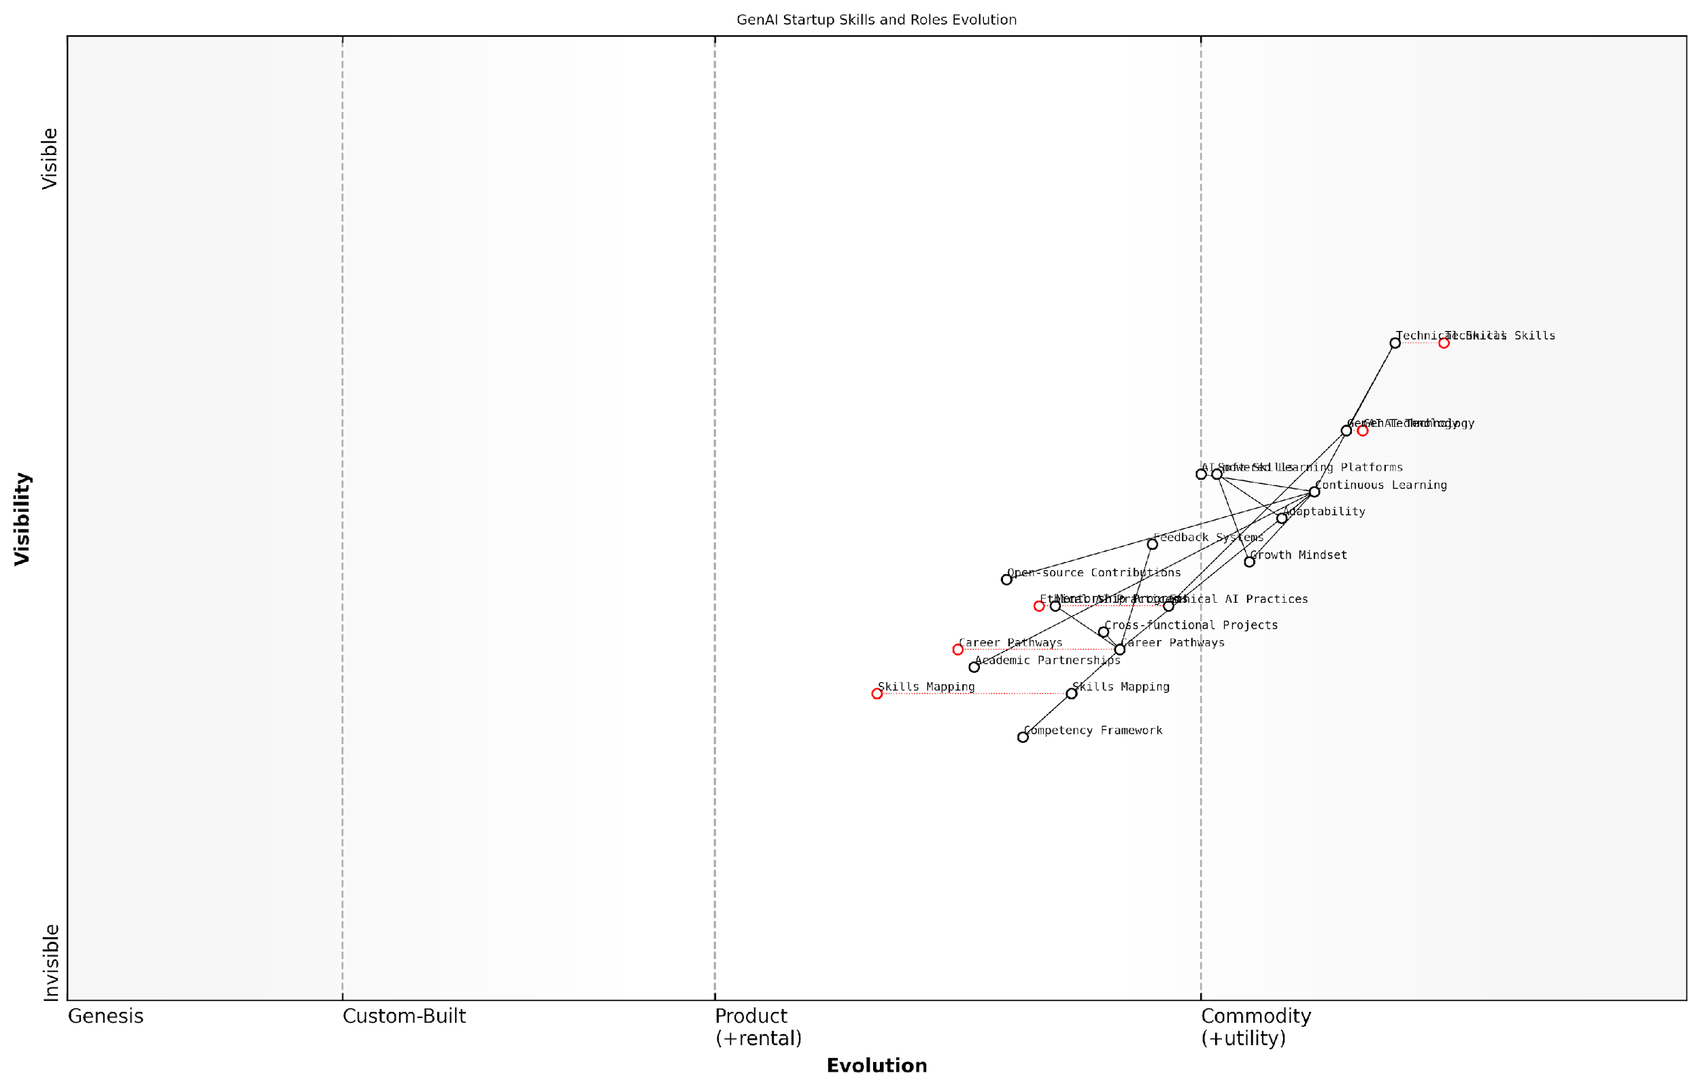

*Draft Wardley Map: [Insert Wardley Map: Creating Growth and Development Pathways]*

[Edit this draft Wardley Map](https://create.wardleymaps.ai/#clone:2e3c263ae2fbeca5e4)

Wardley Map Assessment

The GenAI startup shows strong technical capabilities but needs to significantly enhance its talent development and ethical AI practices to maintain a competitive edge. By focusing on creating robust growth and development pathways, implementing advanced learning systems, and leading in ethical AI, the startup can position itself as an industry leader in the rapidly evolving GenAI landscape. The key to success lies in balancing technical innovation with strategic talent development and ethical considerations.

[View full Wardley Map report](http://markdown/wardley_map_reports/wardley_map_report_42_Creating_Growth_and_Development_Pathways.md)

By implementing these strategies and continuously refining them through the lens of Wardley Mapping, GenAI startups can create a compelling value proposition for top talent. This not only aids in recruitment but also fosters long-term retention by demonstrating a commitment to employee growth and development. In the competitive landscape of GenAI, where talent is often the key differentiator, these growth pathways can become a significant strategic advantage.

# Chapter 5: Executing and Iterating Your GenAI Strategy

## Implementing Wardley Mapping in Decision Making

### Using Maps for Strategic Planning and Pivots

In the dynamic landscape of GenAI startups, the ability to make informed strategic decisions and pivot when necessary is paramount. Wardley Mapping serves as an invaluable tool in this process, providing a visual and analytical framework for understanding your current position, anticipating market movements, and charting a course for success. This section explores how GenAI startups can leverage Wardley Maps for strategic planning and executing pivots with precision and confidence.

Strategic planning in the GenAI space requires a deep understanding of the evolving technological landscape, market dynamics, and competitive forces. Wardley Maps offer a unique advantage by visualising these elements in a coherent and actionable format. By mapping your current position, desired future state, and the components that bridge this gap, you can develop strategies that are both ambitious and grounded in reality.

* Identify strategic gaps and opportunities
* Anticipate market movements and technological shifts
* Align resources with strategic priorities
* Communicate strategy clearly across the organisation
* Monitor progress and adjust course as needed

One of the key strengths of Wardley Mapping in strategic planning is its ability to reveal hidden dependencies and potential bottlenecks. For GenAI startups, this is particularly crucial when dealing with complex technological stacks and rapidly evolving AI capabilities. By mapping out these dependencies, you can identify critical path items that require immediate attention or investment, ensuring that your strategic plans are built on a solid foundation.

Wardley Mapping has transformed our strategic planning process. It’s like having a GPS for navigating the GenAI landscape, allowing us to spot opportunities and threats that we might have otherwise missed.

When it comes to pivots, Wardley Maps prove equally valuable. In the fast-paced world of GenAI, the ability to pivot quickly and effectively can mean the difference between success and failure. Maps provide a clear visualisation of your current strategy, making it easier to identify when a pivot is necessary and what form it should take. By comparing your current map with potential future scenarios, you can assess the impact of different pivot options and choose the most promising path forward.

* Identify triggers for pivots (e.g., market shifts, technological breakthroughs)
* Assess the impact of potential pivots on your value chain
* Evaluate resource requirements for different pivot options
* Communicate the rationale for pivots to stakeholders
* Plan and execute pivots with minimal disruption

It’s important to note that using Wardley Maps for strategic planning and pivots is not a one-time exercise. The GenAI landscape is constantly evolving, and your maps should evolve with it. Regular mapping sessions should be integrated into your strategic planning cycles, allowing you to maintain an up-to-date view of your position and the broader market context.

Moreover, the collaborative nature of Wardley Mapping makes it an excellent tool for aligning your team around strategic decisions. By involving key stakeholders in the mapping process, you can leverage diverse perspectives, build consensus, and ensure that everyone understands the rationale behind strategic choices and pivots.

The visual nature of Wardley Maps has been a game-changer for us. It’s much easier to get buy-in for strategic decisions when everyone can see the logic laid out clearly on the map.

To effectively use Wardley Maps for strategic planning and pivots, GenAI startups should consider the following best practices:

* Regularly update your maps to reflect changes in the GenAI landscape
* Use scenario planning to explore multiple potential futures
* Integrate mapping sessions into your strategic planning and review processes
* Encourage cross-functional participation in mapping exercises
* Develop metrics to track progress against your strategic map
* Be prepared to challenge assumptions and update your strategy based on map insights

By embracing Wardley Mapping as a core tool for strategic planning and pivots, GenAI startups can navigate the complex and rapidly changing landscape with greater confidence and agility. The insights gained from this approach can lead to more informed decision-making, better resource allocation, and ultimately, a stronger competitive position in the market.

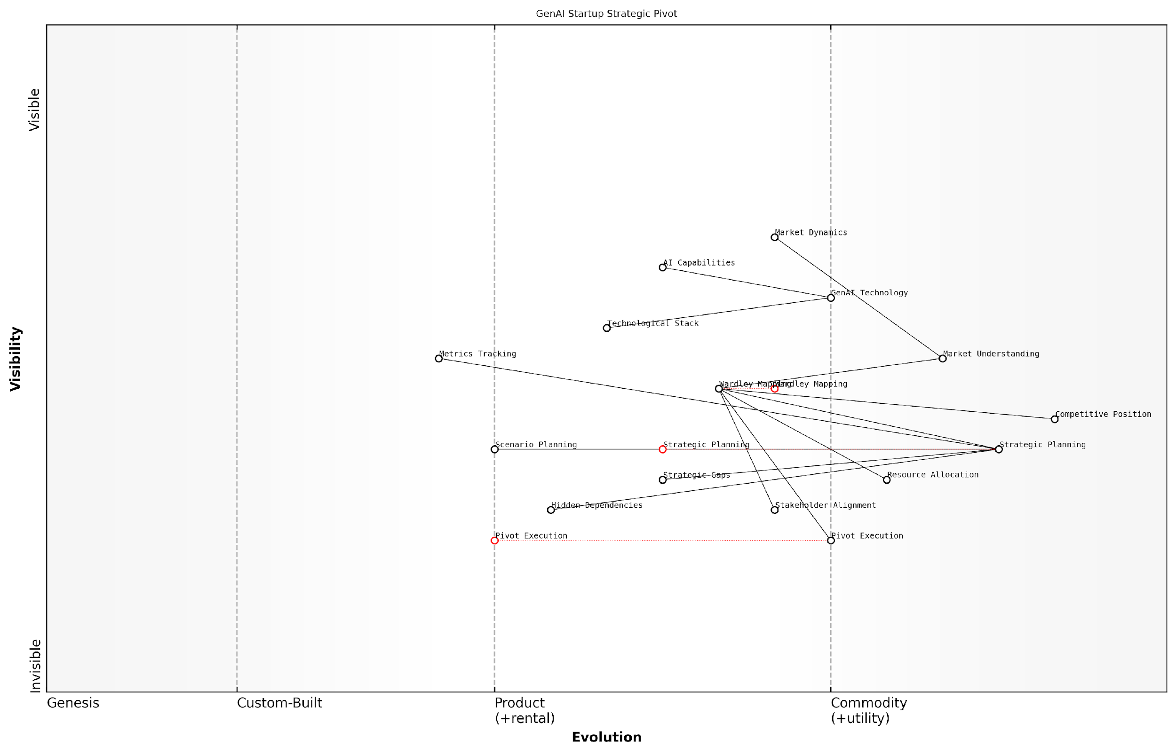

*Draft Wardley Map: [Insert Wardley Map: Using Maps for Strategic Planning and Pivots]*

[Edit this draft Wardley Map](https://create.wardleymaps.ai/#clone:f88d7620914151d50d)

Wardley Map Assessment

The startup is well-positioned strategically with strong planning and mapping capabilities. However, it needs to focus on improving execution, stakeholder alignment, and adaptability to fully capitalise on its strategic insights and navigate the rapidly evolving GenAI landscape effectively. The use of Wardley Mapping as a central strategic tool provides a unique advantage, but this must be balanced with practical execution and continuous technological innovation to maintain a competitive edge.

[View full Wardley Map report](http://markdown/wardley_map_reports/wardley_map_report_43_Using_Maps_for_Strategic_Planning_and_Pivots.md)

As you implement Wardley Mapping in your strategic planning and pivot processes, remember that the true value lies not just in the maps themselves, but in the discussions, insights, and aligned understanding they generate. Used effectively, Wardley Maps can become a powerful catalyst for strategic thinking and agile decision-making in your GenAI startup.

### Communicating Strategy Across the Organization

Effective communication of strategy is paramount for GenAI startups to ensure alignment, foster innovation, and drive successful execution. Wardley Mapping provides a powerful visual tool for articulating complex strategic concepts across diverse teams within an organisation. By leveraging these maps, leaders can create a shared understanding of the competitive landscape, technological evolution, and strategic priorities.

One of the primary challenges in communicating strategy within GenAI startups is bridging the gap between technical and non-technical stakeholders. Wardley Maps serve as a common language, allowing data scientists, engineers, business strategists, and executives to collaborate effectively. This visual representation helps to demystify the complexities of GenAI technologies and market dynamics, making strategic discussions more inclusive and productive.

* Use Wardley Maps in all-hands meetings to provide context for company-wide initiatives
* Incorporate maps into departmental briefings to illustrate how team objectives align with overall strategy
* Leverage maps in onboarding processes to quickly bring new hires up to speed on the company’s strategic position
* Employ maps in investor communications to clearly articulate market opportunities and competitive advantages

To maximise the effectiveness of Wardley Mapping in strategy communication, it’s crucial to develop a consistent approach across the organisation. This involves standardising the mapping process, establishing clear guidelines for map creation and interpretation, and providing training to ensure all team members can contribute to and understand the maps.

Wardley Mapping has revolutionised how we communicate strategy across our GenAI startup. It’s like having a shared strategic language that everyone, from our ML engineers to our sales team, can understand and contribute to.

Another key aspect of using Wardley Maps for strategy communication is the ability to illustrate strategic movement over time. By creating a series of maps that show the evolution of the company’s position, leaders can effectively communicate both short-term tactics and long-term vision. This temporal dimension is particularly valuable in the fast-paced GenAI sector, where technological advancements and market shifts can rapidly alter the competitive landscape.

It’s important to note that while Wardley Maps are powerful tools, they should be used in conjunction with other communication methods. Complementing maps with narrative explanations, data visualisations, and concrete examples can provide a more comprehensive understanding of the strategy. This multi-faceted approach ensures that the strategy resonates with different learning styles and perspectives within the organisation.

* Combine Wardley Maps with storytelling techniques to create compelling strategic narratives
* Use interactive digital tools to allow team members to explore maps in detail
* Create ‘strategy rooms’ or digital spaces where maps are prominently displayed and regularly updated
* Encourage team members to create their own maps to foster engagement and diverse perspectives

Effective strategy communication also involves creating feedback loops and encouraging dialogue. Wardley Maps can serve as a starting point for strategic discussions, allowing team members to question assumptions, propose alternatives, and contribute insights. This collaborative approach not only improves the quality of strategic decision-making but also increases buy-in and commitment across the organisation.

The iterative nature of Wardley Mapping aligns perfectly with the agile mindset required in GenAI startups. It allows us to continuously refine our strategy and ensure everyone is moving in the same direction, despite the rapid changes in our industry.

In the context of GenAI startups, where the ethical implications of technology development are increasingly scrutinised, Wardley Maps can also be used to communicate the company’s ethical stance and responsible AI practices. By mapping ethical considerations alongside technical and market factors, leaders can demonstrate a holistic approach to strategy that aligns with societal values and regulatory requirements.

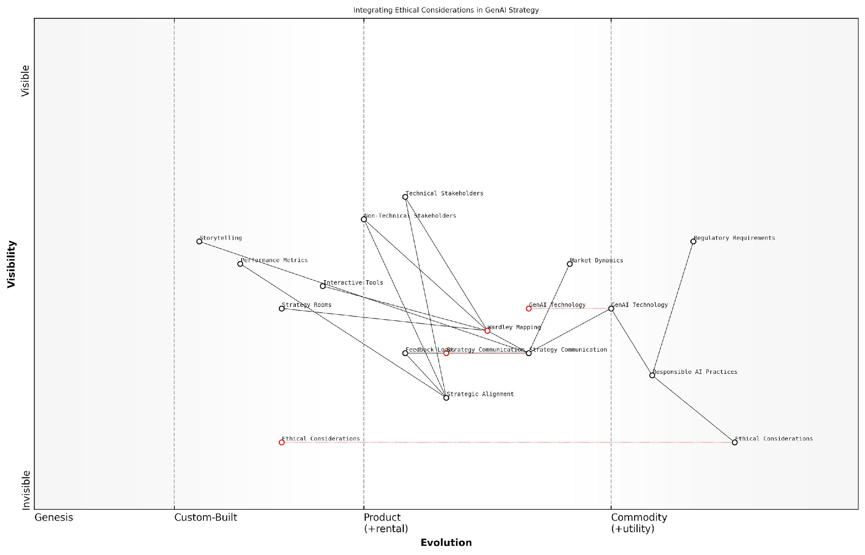

*Draft Wardley Map: [Insert Wardley Map: Communicating Strategy Across the Organization]*

[Edit this draft Wardley Map](https://create.wardleymaps.ai/#clone:68f8c1955146cc5269)

Wardley Map Assessment

This Wardley Map reveals a strategically positioned organisation at the forefront of ethical GenAI development. The strong foundation in ethical considerations, coupled with advanced GenAI technology and strategic communication methods, provides a competitive edge. However, the organisation must navigate the challenges of rapidly evolving technology and regulations while ensuring effective communication across diverse stakeholders. The key to success lies in maintaining the balance between innovation, ethical responsibility, and clear strategy communication, while continuously adapting to market dynamics and regulatory requirements.

[View full Wardley Map report](http://markdown/wardley_map_reports/wardley_map_report_44_Communicating_Strategy_Across_the_Organization.md)

Finally, it’s crucial to measure the effectiveness of strategy communication efforts. This can be done through regular surveys, focus groups, and performance metrics that assess the level of strategic alignment across the organisation. By continuously refining the communication approach based on feedback and results, GenAI startups can ensure that Wardley Mapping remains a valuable tool for fostering a shared understanding of strategy and driving collective action towards strategic goals.

### Integrating Mapping into Agile Development Processes

In the fast-paced world of GenAI startups, agile development methodologies have become the norm for their ability to adapt quickly to changing requirements and market conditions. However, integrating strategic tools like Wardley Mapping into these iterative processes can present both challenges and opportunities. This section explores how GenAI startups can effectively incorporate Wardley Mapping into their agile development cycles, enhancing decision-making and strategic alignment without sacrificing the speed and flexibility that agile methodologies provide.

At its core, the integration of Wardley Mapping into agile development processes requires a shift in mindset. While agile methodologies focus on short-term iterations and immediate value delivery, Wardley Mapping encourages a longer-term, strategic view of the landscape. The key lies in finding the right balance and using each approach to complement the other.

* Incorporate Wardley Mapping into Sprint Planning
* Use Maps to Guide Backlog Prioritisation
* Align User Stories with Strategic Position
* Conduct Regular Map Reviews
* Integrate Mapping into Retrospectives

Incorporating Wardley Mapping into sprint planning sessions can provide valuable context for short-term development goals. By referencing the current strategic map, teams can ensure that each sprint’s objectives align with the overall strategic direction of the GenAI startup. This approach helps prevent the common pitfall of losing sight of the big picture while focusing on immediate tasks.

Using Wardley Maps to guide backlog prioritisation is another effective integration point. By mapping user stories and features onto the strategic landscape, product owners and development teams can make more informed decisions about which items should take precedence. This ensures that development efforts are always aligned with the startup’s strategic positioning in the GenAI market.

Wardley Mapping has revolutionised our sprint planning. It’s like having a strategic compass that guides our daily development decisions, ensuring we’re always moving in the right direction.

Aligning user stories with the startup’s strategic position on the Wardley Map can provide additional context and value to the development process. For each user story, teams can consider its position on the evolution axis and its relationships to other components on the map. This practice helps developers understand the strategic importance of their work and can lead to more thoughtful implementation decisions.

Regular map reviews should be integrated into the agile process, perhaps as part of sprint reviews or in dedicated sessions. These reviews allow the team to assess how recent development work has impacted the strategic landscape and whether any adjustments to the map or strategy are needed. This iterative approach to mapping aligns well with the agile philosophy of continuous improvement and adaptation.

Integrating Wardley Mapping into sprint retrospectives can provide a powerful tool for reflection and improvement. Teams can use the map to evaluate whether their recent work has moved the startup closer to its strategic goals and identify areas where they may need to pivot or adjust their approach in future sprints.

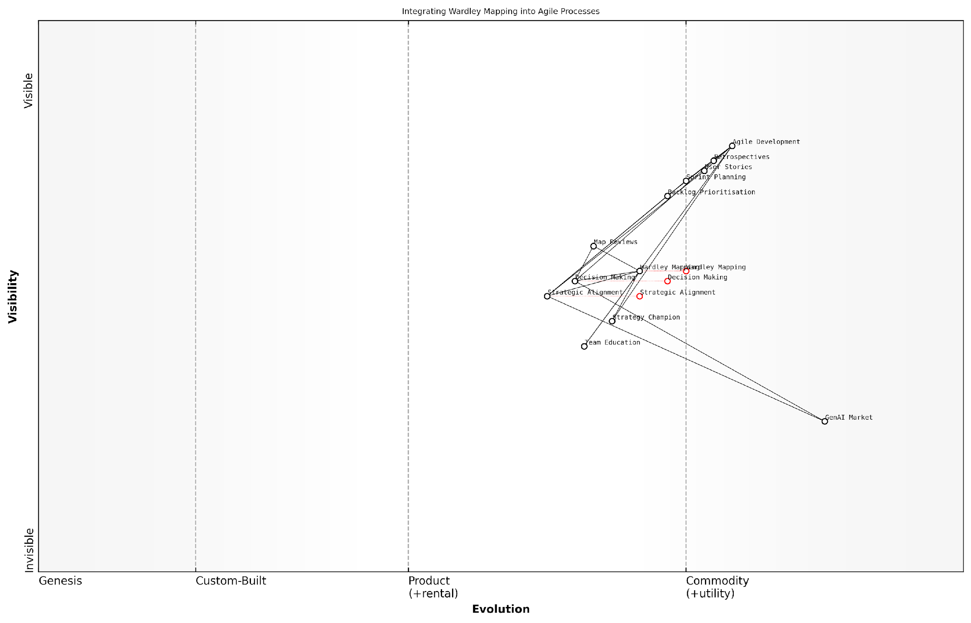

*Draft Wardley Map: [Insert Wardley Map: Integrating Mapping into Agile Development Processes]*

[Edit this draft Wardley Map](https://create.wardleymaps.ai/#clone:4dd6f35e433df49806)

Wardley Map Assessment

This map represents an organisation at the forefront of integrating strategic thinking into Agile development processes, specifically tailored for the GenAI market. The focus on evolving Wardley Mapping and Strategic Alignment capabilities alongside established Agile practices positions the organisation well for adapting to rapid market changes. Key challenges lie in effectively disseminating these new methodologies throughout the organisation and ensuring seamless integration with existing processes. Success in this endeavour could provide a significant competitive advantage in the fast-moving GenAI sector.

[View full Wardley Map report](http://markdown/wardley_map_reports/wardley_map_report_45_Integrating_Mapping_into_Agile_Development_Process.md)

It’s important to note that integrating Wardley Mapping into agile processes may require some initial adjustment and training. GenAI startup leaders should be prepared to invest time in educating their teams about the principles of Wardley Mapping and its strategic importance. This investment can pay significant dividends in terms of improved decision-making and strategic alignment across the organisation.

One challenge that GenAI startups may face in this integration is the potential for analysis paralysis. The depth of insight provided by Wardley Mapping can sometimes lead teams to over-analyse decisions, potentially slowing down the rapid iteration cycles that are a hallmark of agile development. To mitigate this, it’s crucial to establish clear guidelines on when and how to reference the maps during the development process.

We found that by setting clear boundaries for when to dive deep into our Wardley Maps and when to trust our agile instincts, we were able to maintain our development speed while significantly improving our strategic decision-making.

Another effective practice is to assign a ‘strategy champion’ role within the development team. This individual is responsible for maintaining and updating the Wardley Maps, and for bringing relevant strategic insights into agile ceremonies such as sprint planning and daily stand-ups. This ensures that strategic considerations are consistently represented without burdening the entire team with the details of map maintenance.

By thoughtfully integrating Wardley Mapping into their agile development processes, GenAI startups can create a powerful synergy between short-term agility and long-term strategic thinking. This integration enables teams to make more informed decisions, align their daily work with overarching strategic goals, and navigate the complex and rapidly evolving landscape of generative AI with greater confidence and clarity.

## Monitoring and Adapting to Market Changes

### Establishing Key Performance Indicators (KPIs)

In the rapidly evolving landscape of Generative AI (GenAI), establishing and monitoring Key Performance Indicators (KPIs) is crucial for startups to navigate market changes effectively. As an expert in Wardley Mapping for GenAI startups, I cannot overstate the importance of selecting the right KPIs to guide your strategic decisions and measure progress. These indicators serve as the compass for your startup, helping you stay on course amidst the turbulent waters of technological advancement and market shifts.

When establishing KPIs for your GenAI startup, it’s essential to align them with your Wardley Map and overall strategic objectives. Your KPIs should reflect the various stages of evolution on your map, from genesis to commodity, and cover different aspects of your business, including technical performance, market traction, and financial health.

* Technical KPIs: These measure the performance and efficiency of your GenAI models and systems.
* Market KPIs: These track your startup’s position and growth in the market.
* Financial KPIs: These monitor the financial health and sustainability of your startup.
* Ethical and Compliance KPIs: These ensure your GenAI solutions adhere to ethical standards and regulatory requirements.

Let’s delve deeper into each category and explore specific KPIs that are particularly relevant for GenAI startups:

Technical KPIs are crucial for GenAI startups as they directly reflect the quality and efficiency of your core product or service. Some key technical KPIs to consider include:

* Model Accuracy: Measure the precision of your GenAI models in performing their intended tasks.
* Inference Time: Track the speed at which your models generate outputs.
* Scalability: Monitor how well your system handles increasing loads and data volumes.
* Data Efficiency: Measure the amount of training data required to achieve desired performance levels.
* Energy Efficiency: Track the computational resources and energy consumed by your models.

Market KPIs help you gauge your startup’s position and growth in the competitive GenAI landscape. Consider tracking:

* User Adoption Rate: Measure how quickly new users are adopting your GenAI solution.
* Market Share: Track your share of the GenAI market relative to competitors.
* Customer Satisfaction: Use Net Promoter Score (NPS) or similar metrics to measure user satisfaction.
* API Calls or Usage Metrics: For B2B GenAI startups, track the volume of API calls or usage of your services.
* Partnerships and Integrations: Monitor the number and quality of partnerships or integrations with other platforms.

Financial KPIs are essential for ensuring the sustainability and growth of your GenAI startup. Key metrics to track include:

* Monthly Recurring Revenue (MRR): Track the predictable and recurring revenue generated by your GenAI services.
* Customer Acquisition Cost (CAC): Measure the cost of acquiring new customers.
* Lifetime Value (LTV): Calculate the total value a customer brings over their entire relationship with your startup.
* Burn Rate: Monitor how quickly you’re using your available capital.
* Research and Development (R&D) Efficiency: Measure the return on investment for your R&D efforts.

Ethical and Compliance KPIs are increasingly important in the GenAI space, given the potential societal impact and regulatory scrutiny. Consider tracking:

* Bias Metrics: Measure and track any biases in your GenAI models’ outputs.
* Privacy Compliance: Monitor adherence to data protection regulations like GDPR or CCPA.
* Transparency Score: Develop a metric for how explainable and transparent your AI decision-making processes are.
* Ethical Review Pass Rate: Track the percentage of new features or models that pass your ethical review process.

In my experience advising GenAI startups, those that rigorously track and act on a balanced set of KPIs are far more likely to navigate market changes successfully and achieve sustainable growth.

When establishing your KPIs, it’s crucial to ensure they are SMART: Specific, Measurable, Achievable, Relevant, and Time-bound. Additionally, regularly review and adjust your KPIs as your startup evolves and as you update your Wardley Map. This iterative approach allows you to stay agile and responsive to market changes.

Remember that while KPIs are powerful tools, they should inform, not dictate, your decision-making process. Use them in conjunction with your Wardley Map and other strategic tools to gain a holistic view of your startup’s performance and market position.

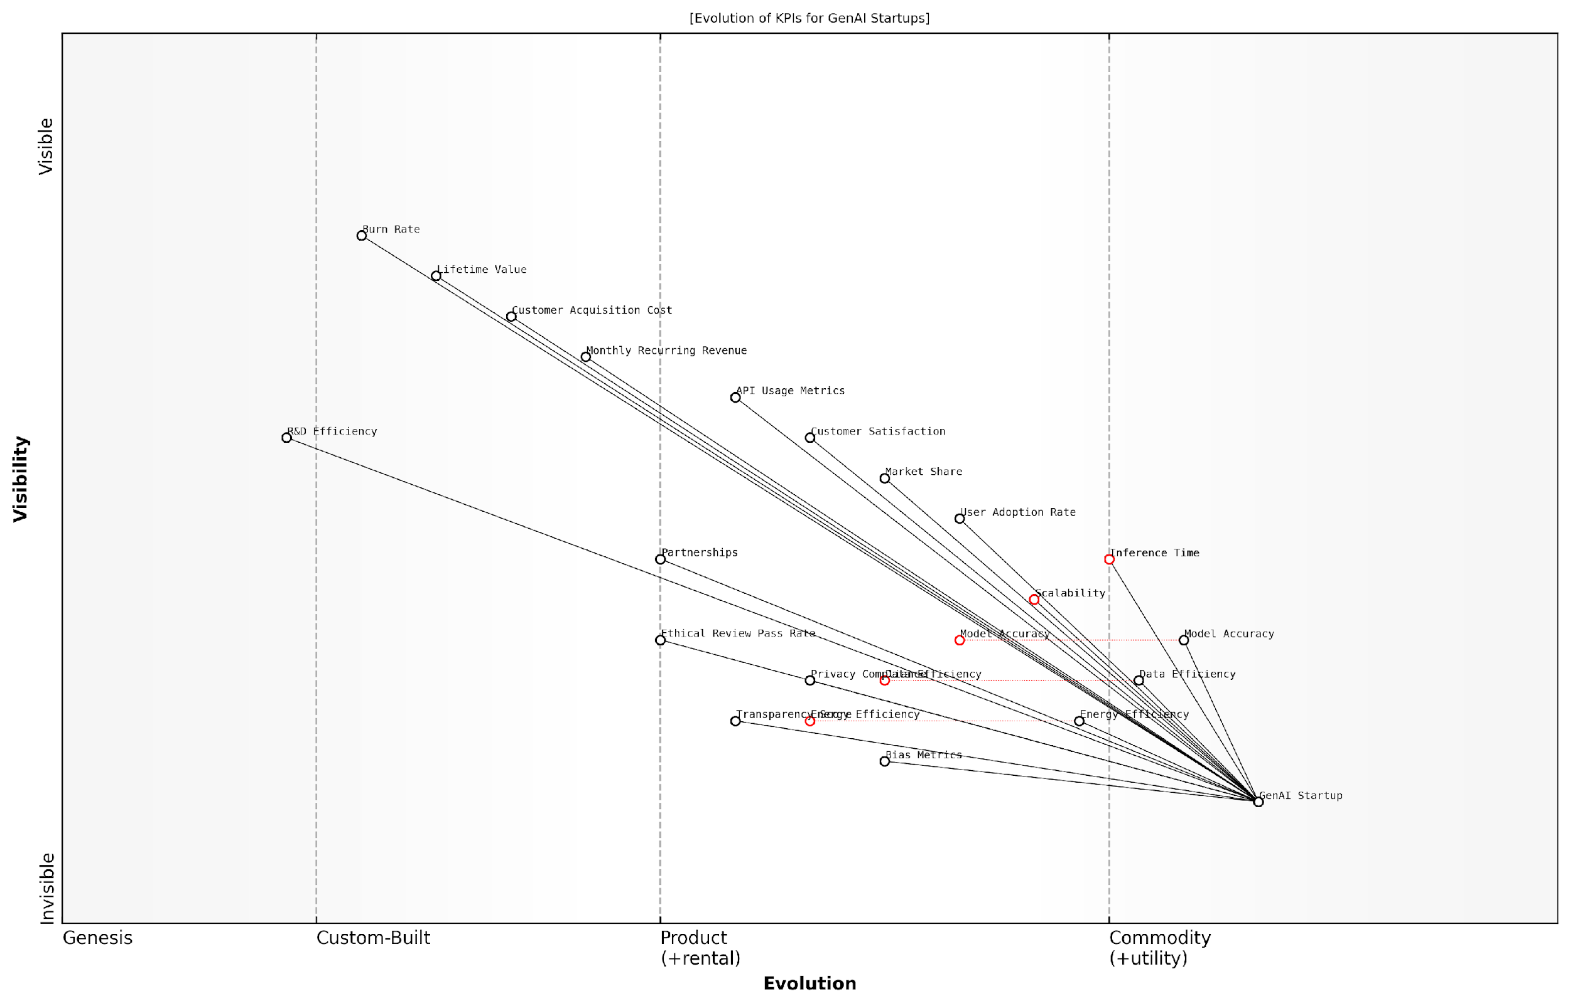

*Draft Wardley Map: [Insert Wardley Map: Establishing Key Performance Indicators (KPIs)]*

[Edit this draft Wardley Map](https://create.wardleymaps.ai/#clone:52c25531591202f72e)

Wardley Map Assessment

The Wardley Map reveals a GenAI startup at a critical juncture, balancing technical innovation with ethical considerations and market demands. The strategic focus should be on maintaining technical leadership while rapidly evolving ethical and compliance capabilities. Financial sustainability through efficient operations and strategic partnerships will be key to long-term success. The startup must navigate the complex interplay between technical, market, financial, and ethical KPIs to establish a strong, differentiated position in the rapidly evolving GenAI landscape.

[View full Wardley Map report](http://markdown/wardley_map_reports/wardley_map_report_46_Establishing_Key_Performance_Indicators_(KPIs).md)

By establishing a robust set of KPIs aligned with your Wardley Map, you create a powerful framework for monitoring and adapting to market changes. This data-driven approach, combined with the strategic insights from Wardley Mapping, positions your GenAI startup to thrive in the dynamic and competitive landscape of artificial intelligence.

### Continuous Market Sensing and Map Updates

In the rapidly evolving landscape of Generative AI, continuous market sensing and regular map updates are not just beneficial—they’re essential for survival and success. As an expert in Wardley Mapping for GenAI startups, I cannot overstate the importance of maintaining an up-to-date understanding of your market position and the ever-shifting technological terrain.

Continuous market sensing involves the systematic collection, analysis, and interpretation of market data to inform strategic decision-making. For GenAI startups, this process is particularly crucial due to the field’s rapid pace of innovation and the potential for disruptive breakthroughs. By integrating continuous market sensing with Wardley Mapping, startups can maintain a dynamic, real-time view of their strategic landscape.

* Implement automated data collection tools to gather market intelligence
* Establish a cross-functional team dedicated to market analysis and map updates
* Develop a systematic process for translating market insights into map revisions
* Create a schedule for regular map reviews and updates, with flexibility for ad-hoc updates in response to significant market events

One of the key challenges in continuous market sensing for GenAI startups is the sheer volume and velocity of information. To address this, it’s crucial to develop robust filtering mechanisms and prioritisation frameworks. These should align with your startup’s strategic goals and focus areas, ensuring that you’re not overwhelmed by irrelevant data while remaining alert to critical developments.

In the GenAI space, the ability to rapidly sense and respond to market changes is often the difference between leading the pack and becoming obsolete. Your Wardley Map should be a living document, constantly evolving with your understanding of the market.

When updating your Wardley Maps, pay particular attention to the following areas:

* Movement of components along the evolution axis
* Emergence of new components or technologies
* Changes in the relationships and dependencies between components
* Shifts in the competitive landscape and market dynamics
* Evolving customer needs and expectations
* Regulatory changes and their impact on the GenAI ecosystem

It’s important to note that map updates should not be merely reactive. As you gain insights from your continuous market sensing efforts, use these to anticipate future movements and potential disruptions. This proactive approach allows you to position your startup advantageously, potentially even influencing the direction of market evolution.

One effective technique for maintaining up-to-date maps is to implement a version control system for your Wardley Maps. This allows you to track changes over time, understand the rationale behind past decisions, and even run scenario analyses based on different market assumptions. Such a system can be invaluable for strategic planning and for communicating changes to stakeholders.

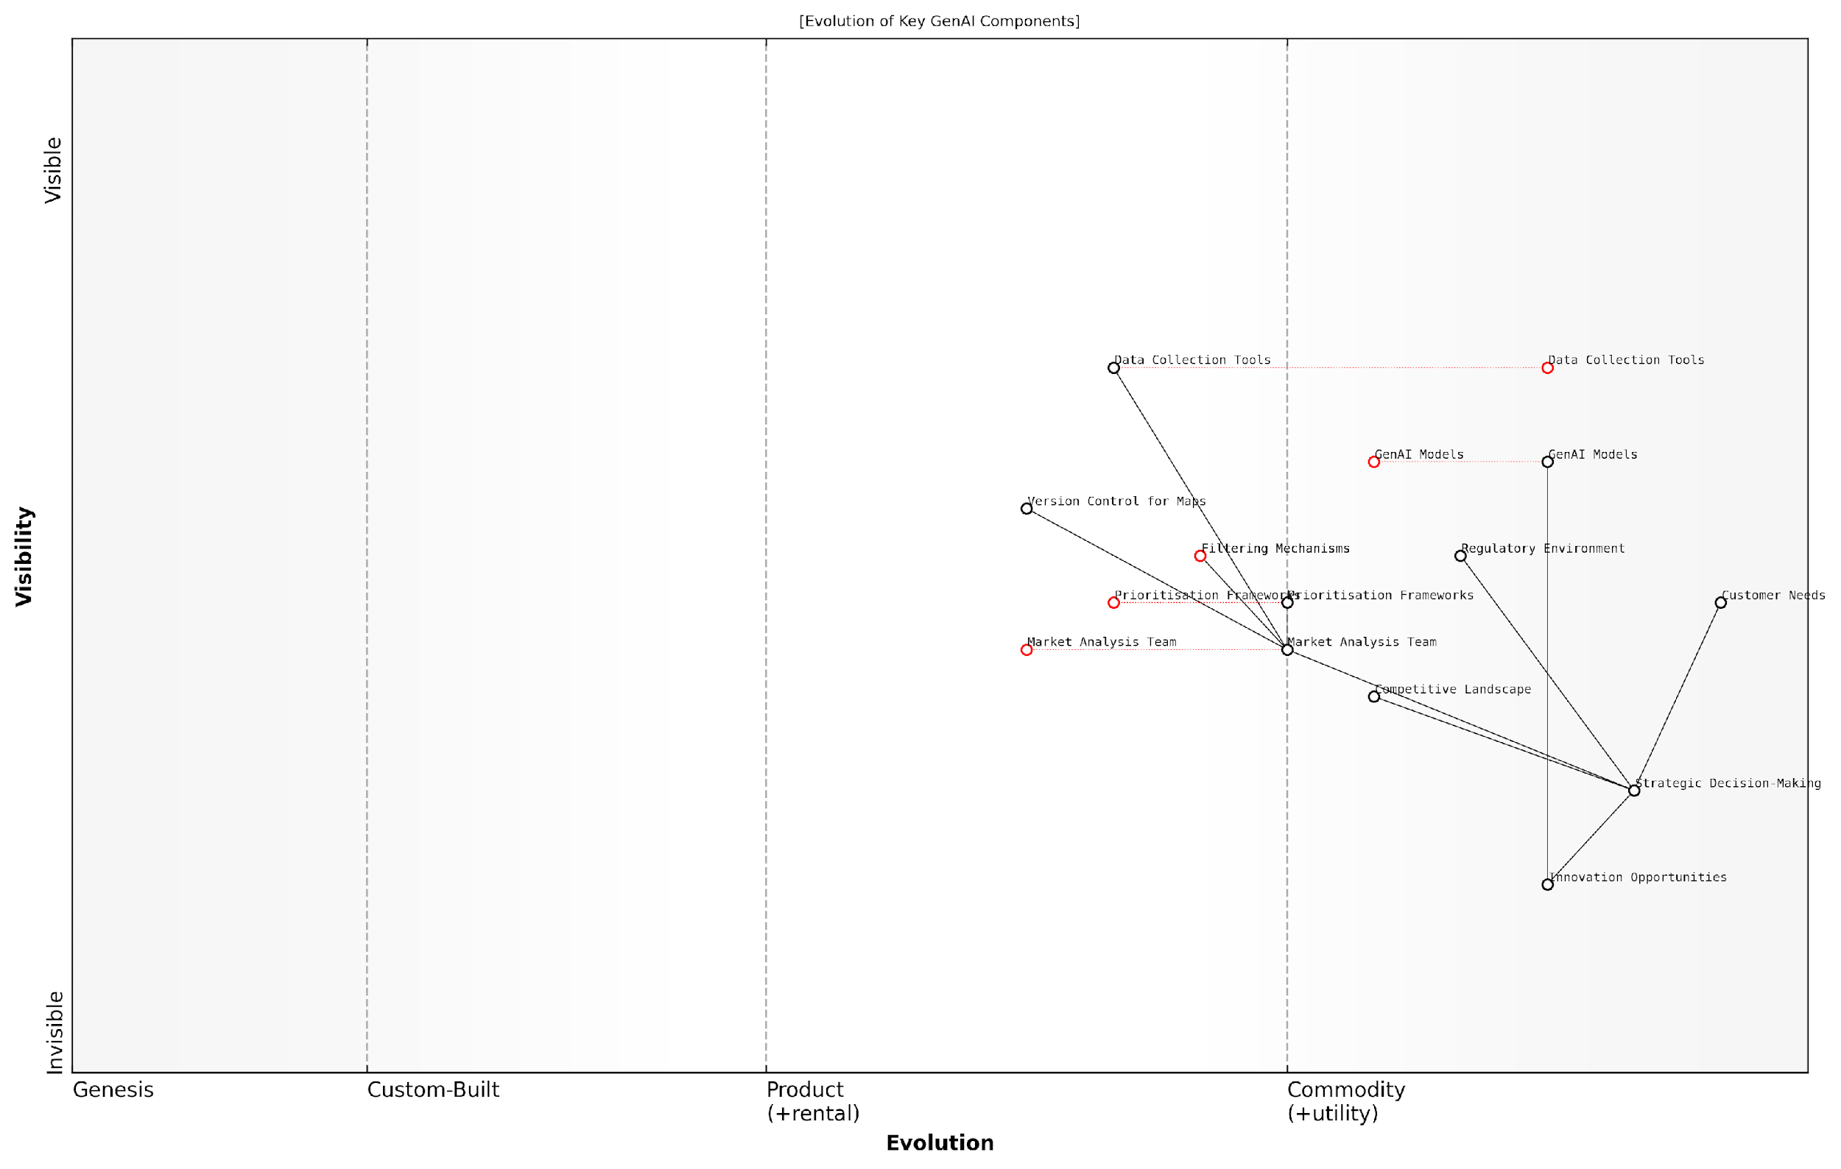

*Draft Wardley Map: [Insert Wardley Map: Continuous Market Sensing and Map Updates]*

[Edit this draft Wardley Map](https://create.wardleymaps.ai/#clone:6a469f1ceee19dc8cc)

Wardley Map Assessment

This map represents a GenAI startup ecosystem focused on continuous market sensing and strategic adaptation. The key to success lies in balancing technological innovation with market understanding and strategic agility. As GenAI Models commoditize, the competitive edge will increasingly come from superior market analysis, strategic decision-making, and the ability to rapidly identify and capitalise on innovation opportunities. Startups should focus on developing adaptive capabilities, leveraging AI across their operations, and maintaining a strong focus on evolving customer needs and regulatory landscapes.

[View full Wardley Map report](http://markdown/wardley_map_reports/wardley_map_report_47_Continuous_Market_Sensing_and_Map_Updates.md)

Remember that the goal of continuous market sensing and map updates is not just to react to changes, but to position your startup to shape the future of the GenAI landscape. By maintaining an up-to-date, dynamic view of your strategic environment, you can identify opportunities for innovation, anticipate potential threats, and make informed decisions that drive your startup’s success in this exciting and rapidly evolving field.

The most successful GenAI startups don’t just adapt to change—they anticipate and drive it. Your Wardley Map should be your crystal ball, constantly refined by market insights to reveal the path forward.

In conclusion, continuous market sensing and regular map updates are not optional extras for GenAI startups—they are fundamental to strategic agility and long-term success. By embedding these practices into your organisational DNA, you position your startup to not just survive but thrive in the dynamic world of Generative AI.

### Strategies for Rapid Adaptation and Pivoting

In the fast-paced world of GenAI startups, the ability to rapidly adapt and pivot in response to market changes is not just an advantage—it’s a necessity for survival. As an expert in Wardley Mapping for GenAI startups, I’ve observed that the most successful companies are those that can quickly sense shifts in the landscape and adjust their strategies accordingly. This section will explore key strategies for rapid adaptation and pivoting, leveraging the power of Wardley Mapping to navigate the turbulent waters of the GenAI market.

The foundation of rapid adaptation lies in maintaining an up-to-date and dynamic Wardley Map of your business landscape. This living document should be regularly reviewed and updated to reflect the latest market conditions, technological advancements, and competitive movements. By doing so, you create a visual representation of your strategic position that can quickly highlight areas requiring attention or adaptation.

* Establish a regular cadence for map reviews and updates
* Involve cross-functional teams in the mapping process to gain diverse perspectives
* Use collaborative tools to facilitate real-time updates and discussions around the map

One of the most powerful strategies for rapid adaptation is the implementation of scenario planning based on your Wardley Maps. By anticipating potential future states of the market and mapping out your response to each, you can significantly reduce reaction time when changes occur. This approach allows you to pre-emptively consider various pivot options and their implications.

Scenario planning is not about predicting the future, but about being prepared for multiple futures. In the GenAI space, where disruption is the norm, this preparation is invaluable.

Another crucial strategy is the development of modular and flexible systems within your startup. This applies to both technical architecture and business processes. By designing your systems with modularity in mind, you create natural pivot points that allow for rapid reconfiguration in response to market changes. Your Wardley Map can help identify which components of your business should be designed for maximum flexibility.

* Identify core components that are likely to remain stable
* Design flexible interfaces between components to allow for easy substitution or upgrade
* Regularly assess the modularity of your systems and processes using your Wardley Map

Cultivating a culture of experimentation and learning is also critical for rapid adaptation. Encourage your team to run small-scale experiments based on insights from your Wardley Map. These experiments can help validate assumptions, test new ideas, and provide valuable data for decision-making. The key is to create a safe environment where failure is seen as a learning opportunity rather than a setback.

In the world of GenAI startups, those who learn fastest, win. Create a culture where every team member is empowered to contribute to the company’s adaptive capacity.

Leveraging external partnerships and ecosystems can significantly enhance your ability to adapt quickly. Your Wardley Map can help identify potential partners or services that can provide capabilities you need without having to develop them in-house. This approach allows you to rapidly pivot by reconfiguring your partnerships rather than rebuilding internal capabilities.

* Regularly assess your partnership landscape using your Wardley Map
* Maintain a network of potential partners for different scenarios
* Develop clear processes for rapidly integrating new partners or services

Finally, it’s crucial to develop a robust feedback loop that connects your market sensing mechanisms directly to your decision-making processes. This might involve creating dashboards that visualise key market indicators alongside your Wardley Map, or establishing regular strategy sessions where market insights are discussed in the context of your map. The goal is to minimise the time between detecting a need for change and implementing that change.

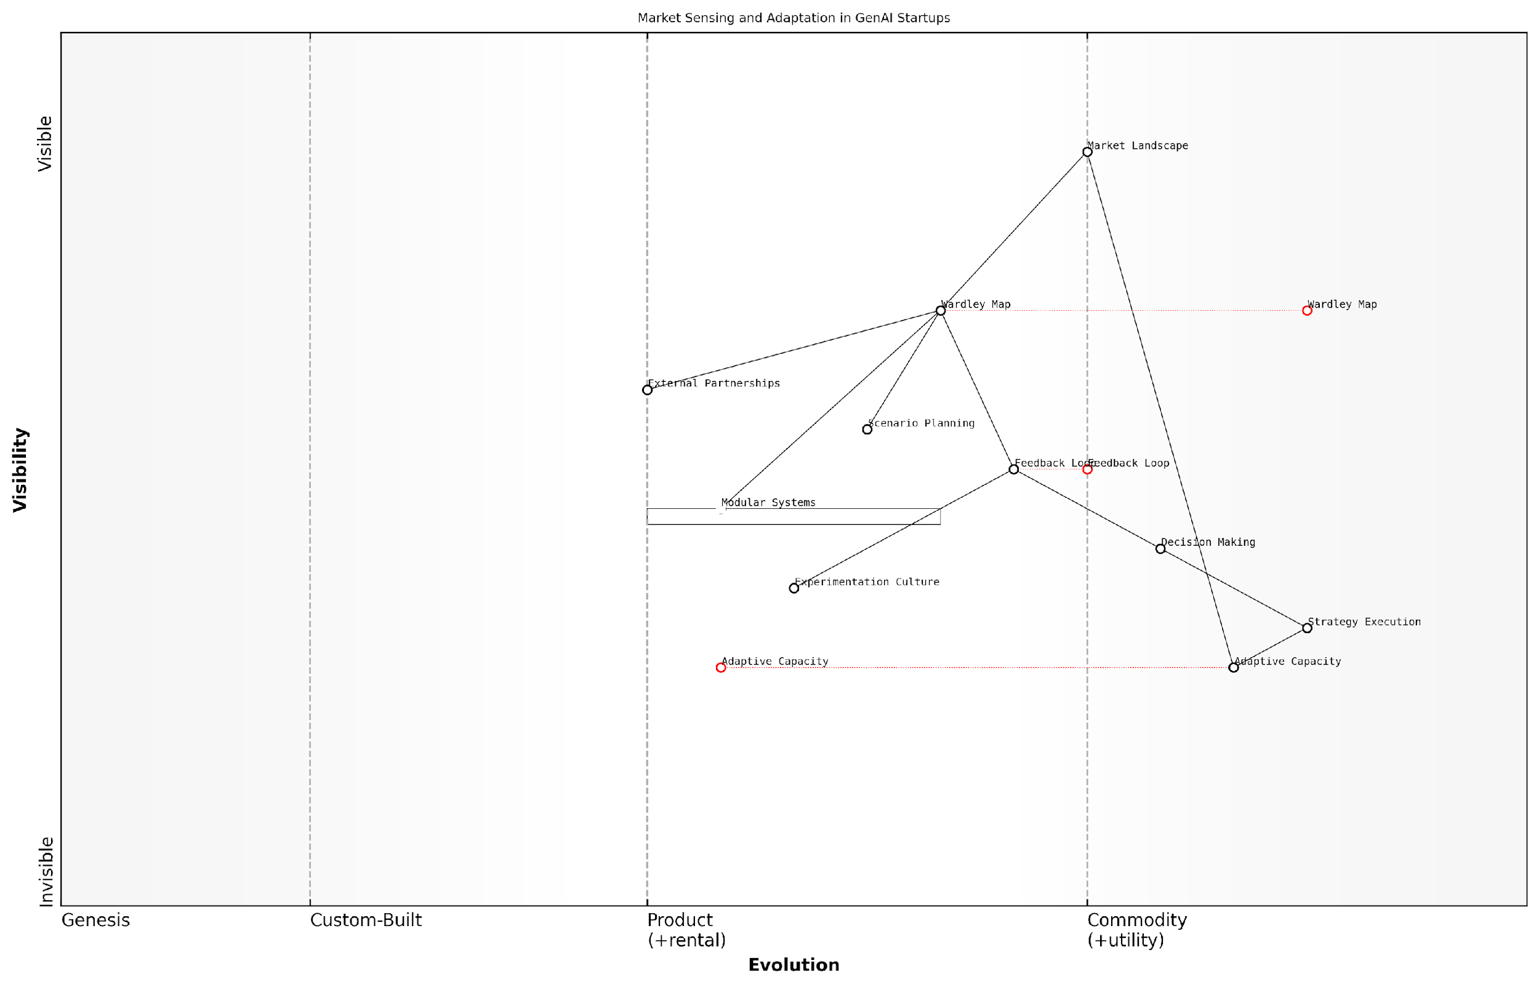

*Draft Wardley Map: [Insert Wardley Map: Strategies for Rapid Adaptation and Pivoting]*

[Edit this draft Wardley Map](https://create.wardleymaps.ai/#clone:9dc11caf011c4640be)

Wardley Map Assessment

This Wardley Map reveals a GenAI startup with strong market sensing capabilities but potential room for improvement in rapid execution and adaptation. The key to success lies in closing the gap between market understanding and adaptive response, primarily through enhancing decision-making processes, developing more sophisticated modular systems, and fostering a strong experimentation culture. By focusing on these areas, the startup can build a sustainable competitive advantage in the fast-paced GenAI market.

[View full Wardley Map report](http://markdown/wardley_map_reports/wardley_map_report_48_Strategies_for_Rapid_Adaptation_and_Pivoting.md)

In conclusion, rapid adaptation and pivoting in the GenAI startup space require a combination of strategic foresight, operational flexibility, and a culture of continuous learning. By leveraging Wardley Mapping as a central tool in your adaptive strategy, you can create a visual and dynamic representation of your business landscape that facilitates quick decision-making and agile responses to market changes. Remember, in the world of GenAI, the ability to adapt is not just about survival—it’s about seizing opportunities faster than your competitors and shaping the future of the industry.

## Building a Culture of Strategic Thinking

### Training Teams in Wardley Mapping Techniques

In the rapidly evolving landscape of GenAI startups, fostering a culture of strategic thinking is paramount. At the heart of this culture lies the ability to effectively utilise Wardley Mapping techniques. Training teams in these techniques is not merely about imparting a new skill; it’s about fundamentally reshaping how your organisation approaches strategic decision-making in the complex and dynamic world of generative AI.

Effective training in Wardley Mapping techniques requires a multi-faceted approach that combines theoretical understanding with practical application. It’s crucial to remember that Wardley Mapping is as much an art as it is a science, requiring both analytical rigour and creative thinking.

* Start with the basics: Ensure all team members understand the fundamental concepts of Wardley Mapping, including the axes of evolution and value chain, and the symbols used in maps.
* Emphasise the importance of context: Teach teams to always consider the specific context of their GenAI startup when creating and interpreting maps.
* Encourage regular practice: Provide opportunities for teams to create maps for various aspects of the business, from technical infrastructure to market positioning.
* Foster cross-functional collaboration: Encourage teams from different departments to map together, promoting a holistic view of the organisation.
* Integrate mapping into existing processes: Incorporate Wardley Mapping into strategic planning sessions, product development cycles, and team meetings.

One effective training method is the ‘map-off’ exercise, where teams compete to create the most insightful map for a given scenario. This not only hones their skills but also demonstrates the diversity of perspectives that Wardley Mapping can reveal. As a senior consultant in the field notes, ‘The true power of Wardley Mapping emerges when teams start to see their business through this strategic lens consistently.’

Wardley Mapping is not just a tool, but a language for strategic thinking. When your entire organisation becomes fluent in this language, you unlock unprecedented levels of strategic alignment and agility.

It’s crucial to tailor the training to the specific needs of a GenAI startup. This means focusing on mapping exercises that are directly relevant to the challenges and opportunities in the AI space. For instance, teams could be tasked with mapping the evolution of key AI technologies, the changing landscape of data privacy regulations, or the shifting competitive dynamics in their target markets.

Another important aspect of training is teaching teams how to use Wardley Maps in conjunction with other strategic tools and methodologies. For example, combining Wardley Mapping with scenario planning can be particularly powerful for GenAI startups operating in a highly uncertain environment. This integrated approach helps teams not only visualise the current landscape but also anticipate and prepare for potential future states.

* Conduct regular workshops and training sessions
* Provide resources such as books, online courses, and access to expert consultants
* Establish a mentoring system where more experienced mappers can guide newcomers
* Create a repository of example maps relevant to your GenAI startup for reference and learning
* Encourage participation in the broader Wardley Mapping community through conferences and online forums

It’s important to recognise that proficiency in Wardley Mapping is developed over time. Encourage a culture of continuous learning and improvement, where teams are comfortable sharing and critiquing each other’s maps. This not only improves mapping skills but also fosters a deeper understanding of the business and its environment.

The most successful GenAI startups are those where Wardley Mapping becomes second nature, informing every strategic decision from product development to market entry strategies.

Finally, it’s crucial to measure the impact of your Wardley Mapping training efforts. This can be done by tracking metrics such as the frequency of map usage in decision-making processes, the quality and depth of strategic discussions, and ultimately, the improved strategic outcomes for your GenAI startup. Regular feedback sessions can help refine the training process and ensure it continues to meet the evolving needs of your organisation.

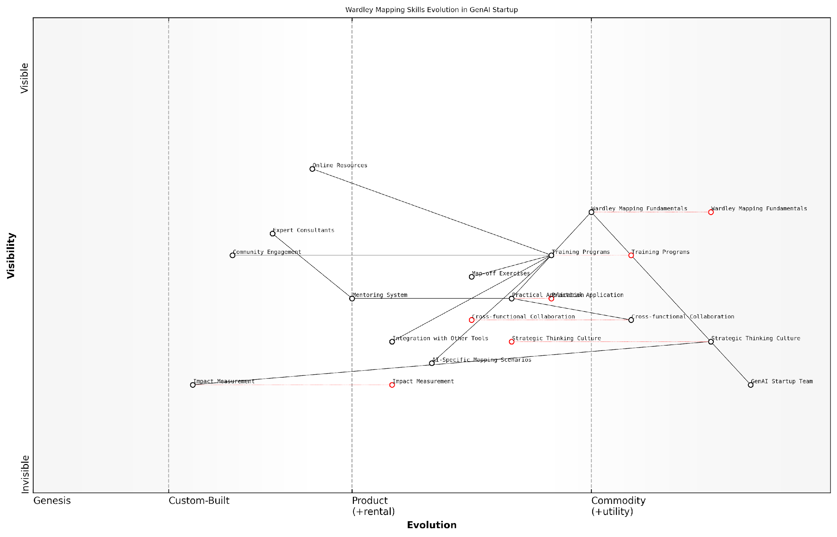

*Draft Wardley Map: [Insert Wardley Map: Training Teams in Wardley Mapping Techniques]*

[Edit this draft Wardley Map](https://create.wardleymaps.ai/#clone:18c20d2932e536ec18)

Wardley Map Assessment

The Wardley Map reveals a thoughtful approach to developing strategic mapping capabilities within a GenAI startup. The focus on creating a Strategic Thinking Culture and evolving Wardley Mapping Fundamentals provides a strong foundation. However, to maintain a competitive edge, the startup should accelerate the development of AI-Specific Mapping Scenarios and robust Impact Measurement systems. By doing so, they can translate mapping skills into tangible business outcomes and position themselves as leaders in strategic AI implementation.

[View full Wardley Map report](http://markdown/wardley_map_reports/wardley_map_report_49_Training_Teams_in_Wardley_Mapping_Techniques.md)

By investing in comprehensive training in Wardley Mapping techniques, GenAI startups can build a robust culture of strategic thinking. This not only enhances their ability to navigate the complex and rapidly evolving AI landscape but also provides a sustainable competitive advantage in an industry where strategic agility is often the difference between success and failure.

### Encouraging Collaborative Mapping and Strategy Sessions

In the fast-paced world of GenAI startups, fostering a culture of collaborative strategic thinking is paramount. Wardley Mapping, when used as a collective exercise, becomes a powerful tool for aligning teams, uncovering insights, and driving innovation. This section explores how to encourage and facilitate collaborative mapping and strategy sessions, transforming them into a cornerstone of your startup’s strategic culture.

Collaborative Wardley Mapping sessions serve multiple purposes within a GenAI startup. They break down silos between departments, encourage cross-functional thinking, and leverage the diverse expertise within your team. By bringing together individuals from various backgrounds – technical, business, ethical, and operational – you create a holistic view of your startup’s position in the GenAI landscape and can identify opportunities and challenges that might otherwise be overlooked.

* Create a safe space for open discussion and idea sharing
* Establish regular mapping sessions as part of your strategic rhythm
* Rotate session leadership to encourage diverse perspectives
* Use digital collaboration tools to facilitate remote participation
* Implement a system for capturing and acting on insights from sessions

To make these sessions truly effective, it’s crucial to create an environment where all participants feel comfortable contributing. This means fostering a culture where ideas are valued regardless of their source, and where constructive debate is encouraged. As a leader, you should model this behaviour by actively participating in sessions, asking probing questions, and showing appreciation for diverse viewpoints.

In our experience, the most innovative solutions often emerge when we bring together minds from different disciplines to collaboratively map our strategic landscape. It’s not just about the map itself, but the conversations and insights that arise during the process.

One effective approach is to structure your collaborative mapping sessions around specific strategic questions or challenges facing your GenAI startup. For example, you might focus a session on mapping the evolving regulatory landscape and its potential impact on your business model. Another session could explore the future of data acquisition and management in light of privacy concerns. By framing sessions around concrete issues, you provide a clear focus while still allowing for wide-ranging discussions.

It’s also important to establish a cadence for these sessions that aligns with your startup’s strategic planning cycle. Quarterly mapping sessions can provide a regular checkpoint for reviewing and updating your strategic position, while more frequent, focused sessions can address specific challenges or opportunities as they arise. This rhythm helps embed strategic thinking into your company’s DNA, ensuring that Wardley Mapping becomes a living, breathing part of your decision-making process rather than a one-off exercise.

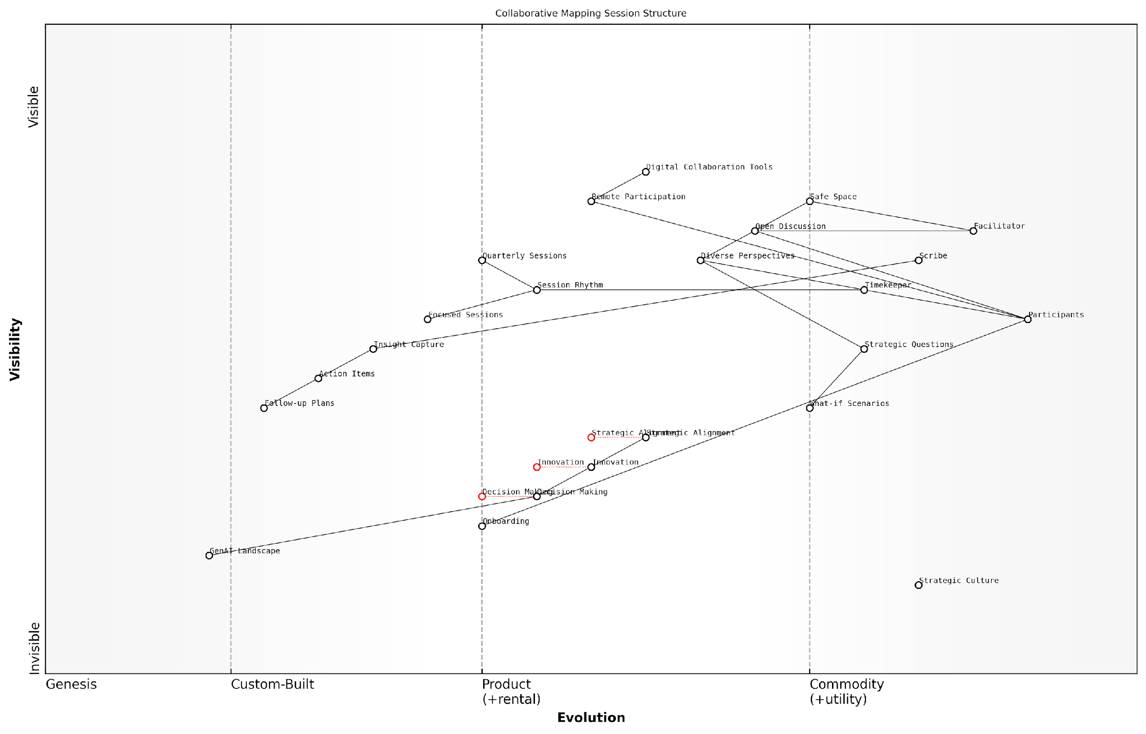

*Draft Wardley Map: [Insert Wardley Map: Encouraging Collaborative Mapping and Strategy Sessions]*

[Edit this draft Wardley Map](https://create.wardleymaps.ai/#clone:6458557a7c0f86caec)

Wardley Map Assessment

The map reveals a thoughtful approach to collaborative strategic thinking in the GenAI startup context. The structure balances immediate operational needs (like facilitation and digital tools) with longer-term strategic elements (like culture development and innovation). To maximise effectiveness, the company should focus on evolving its strategic culture, enhancing AI integration in the planning process, and ensuring a tight link between collaborative sessions and actual decision-making. The rapid evolution of the GenAI landscape presents both a challenge and an opportunity, requiring continuous adaptation of the strategic planning process itself.

[View full Wardley Map report](http://markdown/wardley_map_reports/wardley_map_report_50_Encouraging_Collaborative_Mapping_and_Strategy_Ses.md)

To maximise the value of these collaborative sessions, it’s crucial to have a system in place for capturing and acting on the insights generated. This might involve designating a session scribe to document key discussions and decisions, using collaborative software to create and store maps, and establishing a clear process for translating mapping insights into actionable strategic initiatives.

* Assign roles for each session (facilitator, scribe, timekeeper)
* Use a mix of small group breakouts and full team discussions
* Incorporate ‘what-if’ scenarios to explore potential future states
* Encourage participants to challenge assumptions and status quo
* End each session with clear action items and follow-up plans

Remember that the goal of these sessions is not just to create maps, but to foster a deeper understanding of your strategic landscape and to drive meaningful action. Encourage participants to think beyond the immediate mapping exercise and consider how insights can be applied to their day-to-day work and decision-making processes.

The true power of collaborative mapping lies not in the maps themselves, but in the shared understanding and aligned vision they create across the organisation. When everyone can see and contribute to the strategic picture, decision-making becomes more informed, agile, and effective.

As your GenAI startup grows, these collaborative mapping and strategy sessions can also serve as a powerful onboarding tool for new team members. By involving new hires in these sessions, you quickly immerse them in your strategic thinking process and give them a comprehensive view of the company’s position and direction in the GenAI landscape.

In conclusion, encouraging collaborative mapping and strategy sessions is about more than just creating maps together. It’s about building a culture of strategic thinking that permeates every level of your GenAI startup. By making these sessions a regular, inclusive, and action-oriented part of your operations, you create a powerful engine for continuous strategic alignment and innovation, essential for navigating the complex and rapidly evolving world of Generative AI.

# Conclusion: Thriving in the GenAI Future

## Recap of Key Strategies and Insights

### Summary of Critical Success Factors for GenAI Startups

As we conclude our exploration of Wardley Mapping for GenAI startups, it’s crucial to distil the key strategies and insights that will drive success in this rapidly evolving landscape. The journey of a GenAI startup is fraught with challenges, but armed with the right approach and tools, these ventures can navigate the complexities of the AI frontier and carve out their niche in this transformative field.

Throughout this book, we’ve delved into various aspects of strategic planning, technical development, and operational execution. Now, let’s synthesise these insights into a comprehensive summary of critical success factors that will serve as a roadmap for GenAI startups aiming to thrive in this dynamic ecosystem.

* Strategic Positioning through Wardley Mapping: Leveraging Wardley Maps to visualise the GenAI landscape, identify opportunities, and position the startup strategically within the value chain.
* Agile Adaptation to Market Dynamics: Continuously monitoring and adapting to rapid changes in technology, market demands, and competitive forces.
* Ethical AI Development: Prioritising responsible AI practices, addressing bias, and ensuring transparency to build trust and long-term sustainability.
* Data Strategy Excellence: Developing robust data acquisition, management, and governance strategies to fuel AI models and maintain competitive advantage.
* Technical Innovation Balance: Striking the right balance between leveraging existing technologies and investing in proprietary innovations to differentiate the startup’s offerings.
* Talent Acquisition and Retention: Building and nurturing a diverse team of AI experts, domain specialists, and business strategists to drive innovation and growth.
* Scalable Infrastructure: Designing and implementing a scalable technical infrastructure that can accommodate rapid growth and evolving AI capabilities.
* Strategic Partnerships: Forging key alliances with technology providers, data sources, and industry partners to enhance capabilities and market reach.
* Regulatory Navigation: Staying ahead of the regulatory curve, actively participating in policy discussions, and building compliance into the core of the business model.
* Customer-Centric AI Solutions: Focusing on developing AI solutions that address real-world problems and deliver tangible value to customers.
* Continuous Learning Culture: Fostering an organisational culture that emphasises continuous learning, experimentation, and knowledge sharing.
* Financial Sustainability: Balancing the need for innovation and growth with sound financial management and sustainable business models.
* Intellectual Property Strategy: Developing a robust IP strategy to protect innovations and create barriers to entry for competitors.
* Ethical Leadership: Demonstrating thought leadership in ethical AI development and setting industry standards for responsible innovation.

These critical success factors are interconnected and mutually reinforcing. By focusing on these areas, GenAI startups can build a strong foundation for growth, innovation, and long-term success in the AI-driven future.

The most successful GenAI startups will be those that can navigate the complex interplay of technology, ethics, and market dynamics while remaining agile and customer-focused.

It’s important to note that the relative importance of these factors may shift as the GenAI landscape evolves. Startups must remain vigilant and continuously reassess their strategies using Wardley Mapping techniques to stay ahead of the curve.

As we look to the future, it’s clear that the GenAI field will continue to present both unprecedented opportunities and formidable challenges. The startups that can effectively leverage Wardley Mapping to navigate this complex landscape, while embodying these critical success factors, will be best positioned to lead the next wave of AI innovation and shape the future of technology and society.

# Appendix: Further Reading on Wardley Mapping

The following books, primarily authored by Mark Craddock, offer comprehensive insights into various aspects of Wardley Mapping:

## Core Wardley Mapping Series

1. **Wardley Mapping, The Knowledge: Part One, Topographical Intelligence in Business**
   * Author: Simon Wardley
   * Editor: Mark Craddock
   * Part of the Wardley Mapping series (5 books)
   * Available in Kindle Edition
   * [Amazon Link](https://www.amazon.com/dp/B0BVSXB5W5)

* This foundational text introduces readers to the Wardley Mapping approach:
  + Covers key principles, core concepts, and techniques for creating situational maps
  + Teaches how to anchor mapping in user needs and trace value chains
  + Explores anticipating disruptions and determining strategic gameplay
  + Introduces the foundational doctrine of strategic thinking
  + Provides a framework for assessing strategic plays
  + Includes concrete examples and scenarios for practical application
* The book aims to equip readers with:
  + A strategic compass for navigating rapidly shifting competitive landscapes
  + Tools for systematic situational awareness
  + Confidence in creating strategic plays and products
  + An entrepreneurial mindset for continual learning and improvement

1. **Wardley Mapping Doctrine: Universal Principles and Best Practices that Guide Strategic Decision-Making**
   * Author: Mark Craddock
   * Part of the Wardley Mapping series (5 books)
   * Available in Kindle Edition
   * [Amazon Link](https://www.amazon.com/dp/B0C2SFTR7Z)

* This book explores how doctrine supports organisational learning and adaptation:
  + Standardisation: Enhances efficiency through consistent application of best practices
  + Shared Understanding: Fosters better communication and alignment within teams
  + Guidance for Decision-Making: Offers clear guidelines for navigating complexity
  + Adaptability: Encourages continuous evaluation and refinement of practices
* Key features:
  + In-depth analysis of doctrine’s role in strategic thinking
  + Case studies demonstrating successful application of doctrine
  + Practical frameworks for implementing doctrine in various organisational contexts
  + Exploration of the balance between stability and flexibility in strategic planning
* Ideal for:
  + Business leaders and executives
  + Strategic planners and consultants
  + Organisational development professionals
  + Anyone interested in enhancing their strategic decision-making capabilities

1. **Wardley Mapping Gameplays: Transforming Insights into Strategic Actions**
   * Author: Mark Craddock
   * Part of the Wardley Mapping series (5 books)
   * Available in Kindle Edition
   * [Amazon Link](https://www.amazon.com/dp/B0C7CR9R9Q)

* This book delves into gameplays, a crucial component of Wardley Mapping:
  + Gameplays are context-specific patterns of strategic action derived from Wardley Maps
  + Types of gameplays include:
    - User Perception plays (e.g., education, bundling)
    - Accelerator plays (e.g., open approaches, exploiting network effects)
    - De-accelerator plays (e.g., creating constraints, exploiting IPR)
    - Market plays (e.g., differentiation, pricing policy)
    - Defensive plays (e.g., raising barriers to entry, managing inertia)
    - Attacking plays (e.g., directed investment, undermining barriers to entry)
    - Ecosystem plays (e.g., alliances, sensing engines)
* Gameplays enhance strategic decision-making by:
  1. Providing contextual actions tailored to specific situations
  2. Enabling anticipation of competitors’ moves
  3. Inspiring innovative approaches to challenges and opportunities
  4. Assisting in risk management
  5. Optimising resource allocation based on strategic positioning
* The book includes:
  + Detailed explanations of each gameplay type
  + Real-world examples of successful gameplay implementation
  + Frameworks for selecting and combining gameplays
  + Strategies for adapting gameplays to different industries and contexts

1. **Navigating Inertia: Understanding Resistance to Change in Organisations**
   * Author: Mark Craddock
   * Part of the Wardley Mapping series (5 books)
   * Available in Kindle Edition
   * [Amazon Link](https://www.amazon.com/dp/B0C34FX8XC)

* This comprehensive guide explores organisational inertia and strategies to overcome it:
* Key Features:
  + In-depth exploration of inertia in organisational contexts
  + Historical perspective on inertia’s role in business evolution
  + Practical strategies for overcoming resistance to change
  + Integration of Wardley Mapping as a diagnostic tool
* The book is structured into six parts:
  1. Understanding Inertia: Foundational concepts and historical context
  2. Causes and Effects of Inertia: Internal and external factors contributing to inertia
  3. Diagnosing Inertia: Tools and techniques, including Wardley Mapping
  4. Strategies to Overcome Inertia: Interventions for cultural, behavioural, structural, and process improvements
  5. Case Studies and Practical Applications: Real-world examples and implementation frameworks
  6. The Future of Inertia Management: Emerging trends and building adaptive capabilities
* This book is invaluable for:
  + Organisational leaders and managers
  + Change management professionals
  + Business strategists and consultants
  + Researchers in organisational behaviour and management

1. **Wardley Mapping Climate: Decoding Business Evolution**
   * Author: Mark Craddock
   * Part of the Wardley Mapping series (5 books)
   * Available in Kindle Edition
   * [Amazon Link](https://www.amazon.com/dp/B0BVHF2MBH)

* This comprehensive guide explores climatic patterns in business landscapes:
* Key Features:
  + In-depth exploration of 31 climatic patterns across six domains: Components, Financial, Speed, Inertia, Competitors, and Prediction
  + Real-world examples from industry leaders and disruptions
  + Practical exercises and worksheets for applying concepts
  + Strategies for navigating uncertainty and driving innovation
  + Comprehensive glossary and additional resources
* The book enables readers to:
  + Anticipate market changes with greater accuracy
  + Develop more resilient and adaptive strategies
  + Identify emerging opportunities before competitors
  + Navigate complexities of evolving business ecosystems
* It covers topics from basic Wardley Mapping to advanced concepts like the Red Queen Effect and Jevon’s Paradox, offering a complete toolkit for strategic foresight.
* Perfect for:
  + Business strategists and consultants
  + C-suite executives and business leaders
  + Entrepreneurs and startup founders
  + Product managers and innovation teams
  + Anyone interested in cutting-edge strategic thinking

## Practical Resources

1. **Wardley Mapping Cheat Sheets & Notebook**
   * Author: Mark Craddock
   * 100 pages of Wardley Mapping design templates and cheat sheets
   * Available in paperback format
   * [Amazon Link](https://www.amazon.com/dp/B09TPDM9PP)

* This practical resource includes:
  + Ready-to-use Wardley Mapping templates
  + Quick reference guides for key Wardley Mapping concepts
  + Space for notes and brainstorming
  + Visual aids for understanding mapping principles
* Ideal for:
  + Practitioners looking to quickly apply Wardley Mapping techniques
  + Workshop facilitators and educators
  + Anyone wanting to practise and refine their mapping skills

## Specialized Applications

1. **UN Global Platform Handbook on Information Technology Strategy: Wardley Mapping The Sustainable Development Goals (SDGs)**
   * Author: Mark Craddock
   * Explores the use of Wardley Mapping in the context of sustainable development
   * Available for free with Kindle Unlimited or for purchase
   * [Amazon Link](https://www.amazon.com/dp/B09PNKFHG4)

* This specialised guide:
  + Applies Wardley Mapping to the UN’s Sustainable Development Goals
  + Provides strategies for technology-driven sustainable development
  + Offers case studies of successful SDG implementations
  + Includes practical frameworks for policy makers and development professionals

1. **AIconomics: The Business Value of Artificial Intelligence**
   * Author: Mark Craddock
   * Applies Wardley Mapping concepts to the field of artificial intelligence in business
   * [Amazon Link](https://www.amazon.com/dp/B0C6V9VZ9B)

* This book explores:
  + The impact of AI on business landscapes
  + Strategies for integrating AI into business models
  + Wardley Mapping techniques for AI implementation
  + Future trends in AI and their potential business implications
* Suitable for:
  + Business leaders considering AI adoption
  + AI strategists and consultants
  + Technology managers and CIOs
  + Researchers in AI and business strategy

These resources offer a range of perspectives and applications of Wardley Mapping, from foundational principles to specific use cases. Readers are encouraged to explore these works to enhance their understanding and application of Wardley Mapping techniques.

Note: Amazon links are subject to change. If a link doesn’t work, try searching for the book title on Amazon directly.